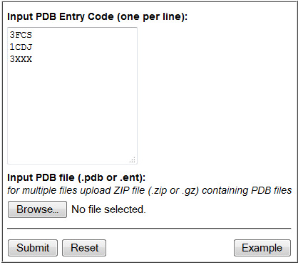

**Enter list of PDB**

**IDs – one per**

**line**

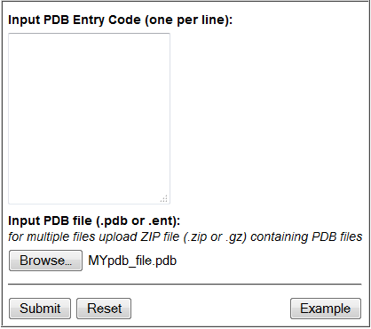

**Custom PDB file**

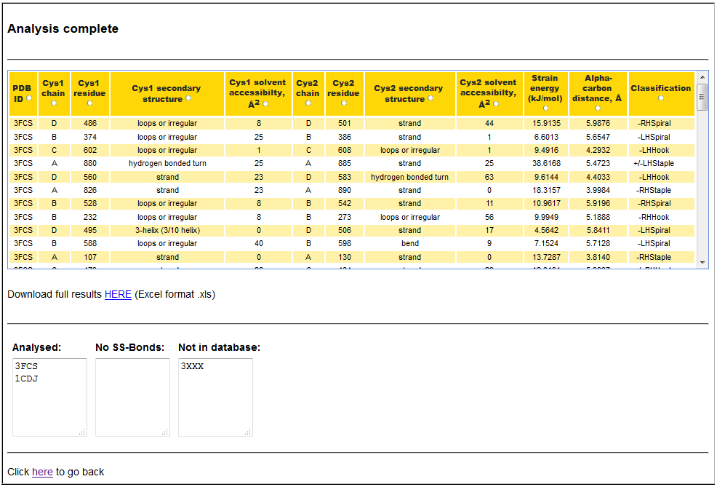

**Displays which of the submitted PDB structures were analyzed successfully**

**Link to download full results**

**Summary of results**