Niranjana Arun Menon (z5417727)

Jacky Wong (z5115789)

Sarah Zheng (z5306098)

Richard Tochtermann (z5413793)

Planning Documentation

M15b_CRUNCHIE

2022

# **ELICITATION**

**Name:** Eva Chor

**Email:** cmseva@hotmail.com

***Q1. What collaboration tools do you currently use for work/school?***

WhatsApp.

***Q2. Why do you choose WhatsApp over other platforms/apps for teamwork?***

All my friends and work mates use it to communicate with one another. You don’t have to log in to check notifications since the app on your phone or the web version has you logged in almost all the time. I can voice call and video call people pretty easily whenever I need to contact someone.

***Q3. In your opinion, what advantages would there be using Treats over WhatsApp?***

I guess, having a designated platform for work would allow me to separate my personal and workspace easier. I wouldn’t want to get constantly notified by family and friends while I’m discussing work with my manager or someone. WhatsApp doesn’t really allow me to separate work from personal chats.

***Q4. What issues could you encounter when using Treats?***

It would be nice to have a function where I can find all important messages in one location. I can just go to a channel or specific location in a channel where I can find important due dates or milestones that my manager or project lead has pinned or marked as important. It’ll save so much time instead of search through backlogs of information.

**Name:** Vanessa Liu

**Email:** ilovepotatpchips@gmail.com

***Q1. What collaboration tools do you currently use for work/school?***

Discord

***Q2. Why do you choose discord over other platforms/apps for teamwork?***

Discord has a simple user interface that allows for seamless screensharing and voice calling. We also have the option to create servers which can be further separated into different channels that can be used to discuss separate topics such as different components of project. I also like the different stickers discord offers.

***Q3. In your opinion, what advantages would there be using Treats over Discord?***

I believe Treats is more collaboration-focussed, almost a clone of Microsoft Teams and seems to be more work / project-oriented. However, for Discord, I use it to game with my friends as well as discuss project work which can really distract you if you don’t organise your servers and notifications properly. Imagine getting pinged from one of my servers with my gaming friends on Discord when I also have a group project, I need to discuss with people on the same platform…very distract. At least with Treats, I would be able to detract myself from my personal space and focus on work.

***Q4. What issues could you encounter when using Treats?***

The problem with Treats is that it is a website designed for teamwork. Barely anyone uses websites for communication and collaboration when there are apps readily available. I can just download Discord, for example, log in and use it seamlessly whereas a website seems more clunky to use. Plus, with apps like Discord and the mobile version of Microsoft Teams, I can get pinged with notifications and ping other people in case of emergencies and they will receive the notification pretty much immediately. However, with Treats, you’d have to log in before you can see the notifications which I can imagine would be a hassle for a lot of people.

**Name:** Jamie Wong

**Email:** jamie.wong600@gmail.com

***Q1. What collaboration tools do you currently use for work/school?***

Microsoft Teams and occasionally, Facebook Messenger.

***Q2. Why do you choose Microsoft Teams over other platforms/apps for teamwork?***

Mostly because school tells us to, but it is a pretty easy-to-use platform where I can see pretty easily what my teacher has posted and pinned in the channel. I can easily navigate to notifications and mentions in posts or messages about homework and assessment tasks. Also, when we were studying from home, I liked to use the screen-recording function on Teams so that I can watch the recording later especially when I get distracted during the lesson.

***Q3. In your opinion, what advantages would there be using Treats over Microsoft Teams?***

I don’t really see much advantage in using Treats over Microsoft Teams, because they both function almost the same way. They both allow the user to send DMs and create channels and send messages into these channels. Though Treats is a website that aims to be a collaborative tool, it doesn’t even have a voice call or video call function. I feel like things won’t be misinterpreted as often over voice call and screen-sharing as when ideas are communicated over text. It would be nice if Treats had an app version as well because no one likes specifically logging onto a website to check a notification, its like using Facebook on your browser instead of the app itself. Its just much easier to check notifications as a desktop or mobile app.

***Q4. What issues could you encounter when using Treats?***

As a collaboration tool, I think it’ll be nice if Treats has a poll function so that when someone in a group raises an idea, we can all vote on an idea and proceed with the concept proposed. Currently in Treats, you could communicate numerous ideas across in a DM or channel, but it would be drowned out by other messages and would be hard to gather everyone’s’ preferences efficiently.

# **ANALYSIS & SPECIFICATION – USE CASES**

## **User Story 1**

As a member of a DM or channel in Treats, I would like to view a compiled list of messages marked as important to avoid constant scrolling through a backlog of messages.

**General Outline of Functionality:**

* A new ‘Important’ object is added to the channel and DM function. ‘Important’ object will contain an array of messages that consists of the messages marked as important and the sender’s name.
* A message sent in a channel or DM can be marked as ‘Important’ and will be added to the ‘Important’ section of the channel or DM.
* When inside the ‘Important’ object, a user can ‘Unmark from Important’ and the message will be removed from the list of ‘Important’ messages.

|  |  |
| --- | --- |
| **USE CASE 1** | |
| **Use Case** | Collecting important messages from channels or DMs |
| **Goal In Context** | Authorised user wants to gather important / pinned messages in a single location and filter through using customised filters i.e. sort by date, channel, sender, etc. |
| **Scope** | Front-end user interface, Treat’s back-end database |
| **Level** | Primary Task |
| **Pre-conditions** | The authorised user must be registered user of Treats, have a logged-in status and be a member of the channel or DM that the messages are sourced from. |
| **Success End Condition** | The message is added to ‘Important’ list of messages and can be found in the ‘important’ section of Treats |
| **Failed End Condition** | The message cannot be added to ‘Important’ (the message may already exist in ‘Important’) |
| **Primary Actor** | Authorised user |
| **Trigger** | Right-clicking on message and click ‘Mark as Important’ |

**USE CASE SUCCESSFUL SCENARIO**

1. Authorised user A sends a message ‘Milestone 1: Due Date’ in channel or DM.
2. Authorised user B sends a message ‘Milestone 2: Due Date’ in the same channel or DM.
3. Authorised user C right-clicks messages from user A and user B, and clicks ‘Mark as Important’.
4. Authorised user C navigates to and clicks on ‘Important’.
5. Treats provides a list of ‘Important’ messages that contains ‘Milestone 1: Due Date’ from user A and ‘Milestone 2: Due Date’ from user B.
6. User C right-clicks ‘Unmark from Important’ on ‘Milestone 2: Due Date’.
7. User C refreshes ‘Important’ list on Treats, and sees only 1 message remain: ‘Milestone 1: Due Date’ from user A.

## **User Story 2**

When using Treats, I want my colleagues or project members to receive a notification even when they are not logged into Treats. This allows them to not miss out on any emergency/important information when they not logged into Treats.

**General Outline of Functionality:**

* When a message is sent in a channel or DM, you can notify the people in the channel or DM by right-clicking on the message and click ‘send notification as email’.
* The person who sends the notification must have a valid Treats token and be an authorised member and have owner permissions to DM/channel.
* The notification email sent to the members include the name of the authorised sender and the information in the message.

|  |  |
| --- | --- |
| **USE CASE 2** | |
| **Use Case** | Send notification to members in channel or DM |
| **Goal In Context** | Authorised user wants to send a message and notify members in channel or DM of a deadline for a milestone in a project that they are working on. |
| **Scope** | Treats database, front-end interface |
| **Level** | Primary Task |
| **Pre-conditions** | The sender must be logged into Treats and be an authorised member and have owner permissions to DM/channel. |
| **Success End Condition** | Notification email has been sent successfully |
| **Failed End Condition** | Notification email has failed to send |
| **Primary Actor** | Authorised user |
| **Trigger** | Right-clicking on message and click ‘Send notification as email’ |

**USE CASE SUCCESSFUL SCENARIO**

1. Authorised user sends a message in channel or DM.
2. Authorised user right-clicks on message and clicks on ‘send notification as email’
3. All members in the DM or channel receives the notification in the email they used to register with on Treats.

## **User Story 3**

As a group member of a DM or channel in Treats, I want to include a poll feature that would allow all members of the DM or channel to vote on their preferred option.

**General Outline of Functionality:**

* Channel or DM page features a ‘Create Poll’ button at top of the interface.
* Poll creator and voters must have a valid token for treats and is a valid member in the channel or DM.
* Each option in the poll must be between 1 and 35 characters.
* The poll is displayed in the channel / DM message interface.
* Members in the channel or DM can click on each option to vote which adds onto the vote counter displayed immediately adjacent to each option.

|  |  |
| --- | --- |
| **USE CASE 3** | |
| **Use Case** | Conduct a voting/poll feature within a channel or DM |
| **Goal In Context** | A user wants to create a poll to vote on numerous preferred options / ideas. |
| **Scope** | Treats database, front-end interface |
| **Level** | Primary Task |
| **Pre-conditions** | The sender must be logged into Treats and be an authorised member of the DM or channel |
| **Success End Condition** | A poll display appears in the DM or channel body along with the number of votes accumulated appearing next to each option |
| **Failed End Condition** | No options have been entered, unable to display polling feature, options cannot be voted on |
| **Primary Actor** | Authorised user |
| **Trigger** | Right-clicking on message and click ‘Send notification as email’ |

**USE CASE SUCCESSFUL SCENARIO**

1. Authorised user A create a poll in the channel.
2. User A fills in the title of the poll and types the first option in as ‘Morning’ and the second option as ‘Evening’.
3. The poll with the two options is displayed with the title and the two options.
4. The number of votes for each option is currently showing zero.
5. Authorised user B votes on ‘Morning’. The number of votes for this option will now show 1.
6. Authorised user C votes on ‘Evening’. The number of votes for this option will also show 1.
7. Authorised user B votes on ‘Evening.’ Since user B has already voted, the vote for ‘Morning’ will be removed and the number of votes for this option will now show 0.
8. The vote counter for ‘Evening’ will now show 2.

# **VALIDATION**

**USER CASE 1 COMMENTS:**

Marking a message as important is definitely a useful feature and something that I would use quite often. However, I do some double-up in functionality with ‘pinned’ messages, and then consider having a search function where you can filter through only ‘pinned’ messages. This kind of eliminates the need for an entirely new feature, I guess.

**USER CASE 2 COMMENTS:**

This does achieve what I look for in a collaborative tool, especially when people do check their emails more often than not. The only problem now is that the email notifications, if there’s too many notifications, could be marked as spam and end being not read anyways. I guess if only the owner of the channel / DM can create these notifications, then it shouldn’t be a problem.

**USER CASE 3 COMMENTS:**

Yep, this definitely outlines what I need, just a simple polling feature in the chat with a count of the number of votes for each option. Though, I do believe you’ll need to ‘pin’ this poll feature or at least have it appear in its own location in the channel / DM interface because it could still get drowned out by the messages in the chat.

# **INTERFACE DESIGN**

Table 1: Interface design for collecting important messages

|  |  |  |  |  |  |
| --- | --- | --- | --- | --- | --- |
| Function  Name | HTTP method | Parameters | Return type | Exceptions | Description |
| message/  important | POST | {token, messageId } | {} | **Return 400** when:   * messageId is not a valid message * message is already pinned   **Return 403** when:   * messageId refers to a valid message in a joined channel/DM and the user has no owner permissions to access the message | Given a messageId for a message, this message is pinned in a channel/Dm  Frontend implements this function while right-clicking the message and finding a “important message” option.  Returns an empty array {} if successful. |
| Message/  show Important | GET | {token} | {  Important  Messages  } | **Return 403** when:   * authorised user is not in the channel/DM | Returns the pinned messages in a channel/DM  Frontend will be able to access this once they right-click on a message and receive an option that allows them to see a list of ImportantMessages.  Returns an array of pinned messages if successful. |

Table 2: Interface design for sending notification to members

|  |  |  |  |  |  |
| --- | --- | --- | --- | --- | --- |
| Function Name | HTTP method | Parameters | Return type | Exceptions | Description |
| message/send | POST | {token, channelId, message } | { messageId } | **Return 400** when:   * channelId does not refer to a valid channel * length of the message is less than 1 or over 1000 characters   **Return 403** when:   * channelId is valid and the authorised user does not have owner permissions in the channel | Sends a message from the authorised user to the channel.  Returns a unique messageId if it is successful |
| message/  notification | POST | { token, messageId } | {isSuccessful} | **Return 400** when:   * messageId is invalid   **Return 403** when:   * authorised user is not in the channel | Sends a notification when a messageId is given  Returns **true** if the notification is sent successfully. |

Table 3: Interface design for conducting a voting/poll feature

|  |  |  |  |  |  |
| --- | --- | --- | --- | --- | --- |
| Function Name | HTTP method | Parameters | Return type | Exceptions | Description |
| Poll/create | POST | {token, channelId, options} | {pollId, options} | **Return 400** when:   * channelId is invalid * no valid option (no or one option) * option length is not between 1 and 50   **Return 403:** when:   * token is not valid * authorised user is not in the channel | Creates a poll given a channelId  Will return a pollId and set of options if successful |
| Poll/vote | POST | {token, pollId, option} | {  pollResult  } | **Return 400** when:   * pollId is invalid * the option does not exist   **Return 403** when:   * token is invalid * user is not in the channel | In a poll, the user can choose between the options of the poll  Will return the results of the poll if successfull |

**Typesetting**

|  |  |
| --- | --- |
| **Variable** | **Type** |
| token | string |
| Variable with ‘id’ | Number |
| ImportantMessages | String [] (string array) |
| options | String | Number[] (string or number array) |
| option | string |
| pollResult | String[] (string array) |
| isSuccessful | boolean |

# **CONCEPTUAL MODELLING (STATE)**

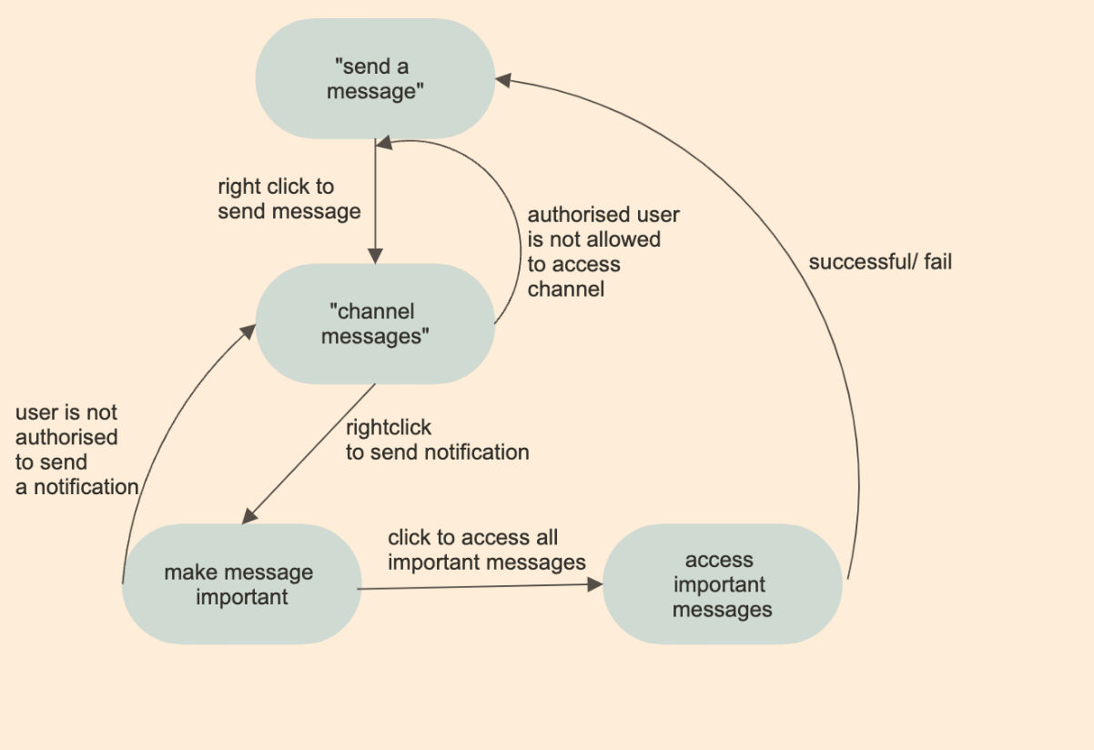

*Figure 1: State diagram to access important messages*

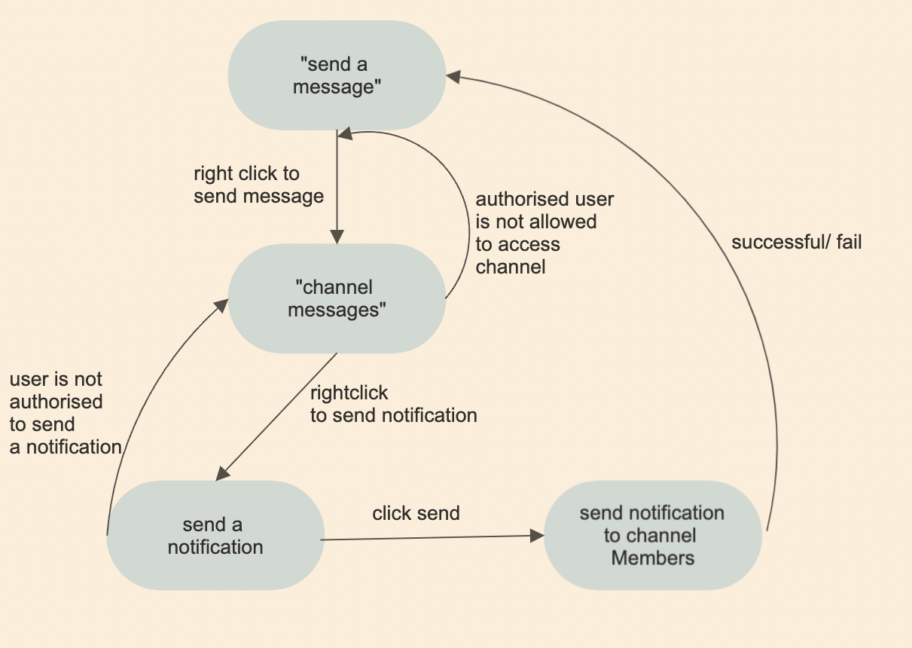

*Figure 2: State diagram to send a notification*

*Figure 3: State diagram to create a poll*