Step1
Screenshot of IAM dashboard showing “MFA on root user: Enabled”
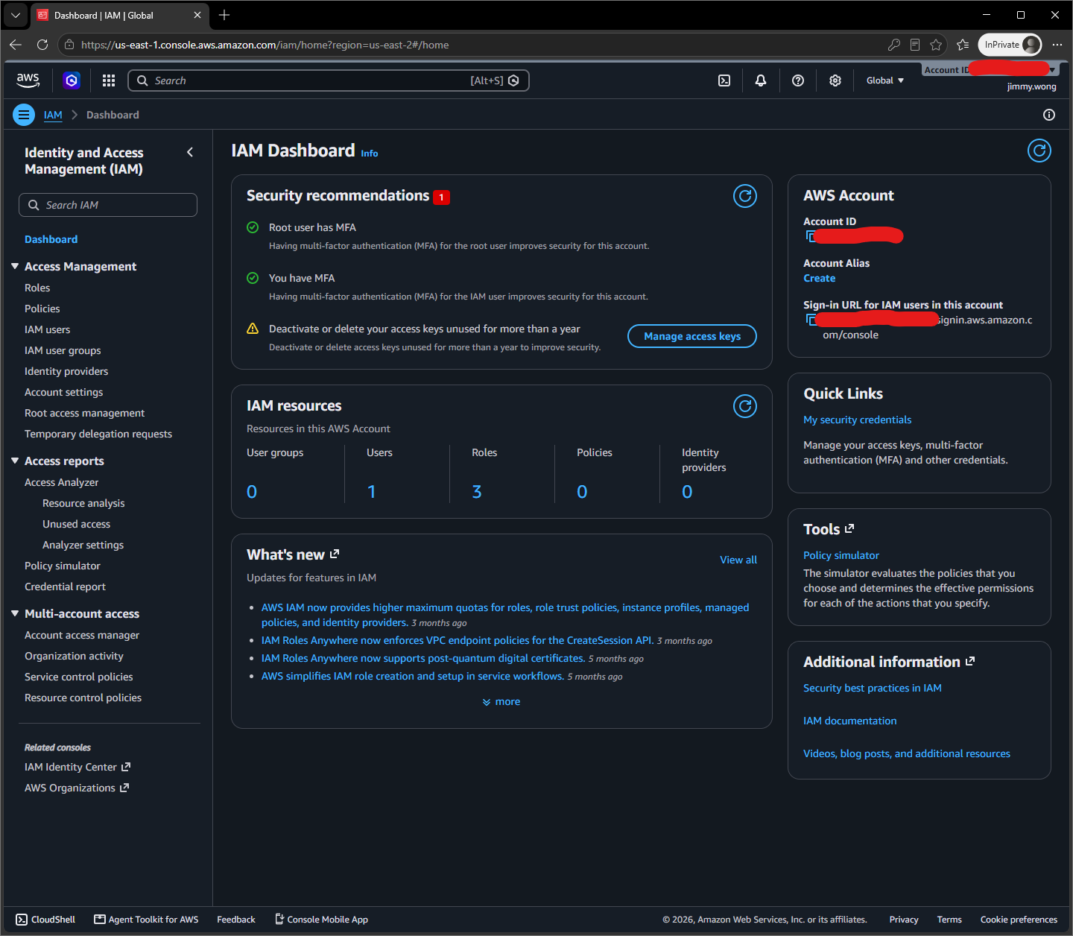

Screenshot of IAM Users list showing your lab user
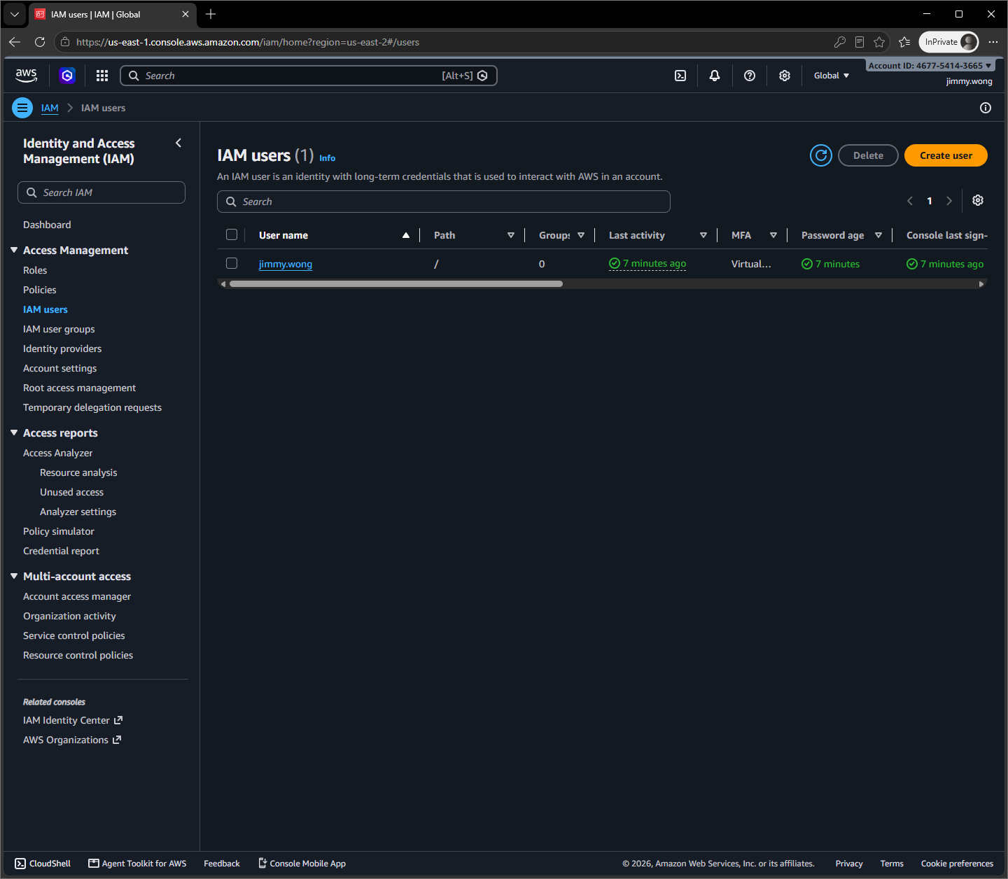

Screenshot showing MFA enabled on the IAM user
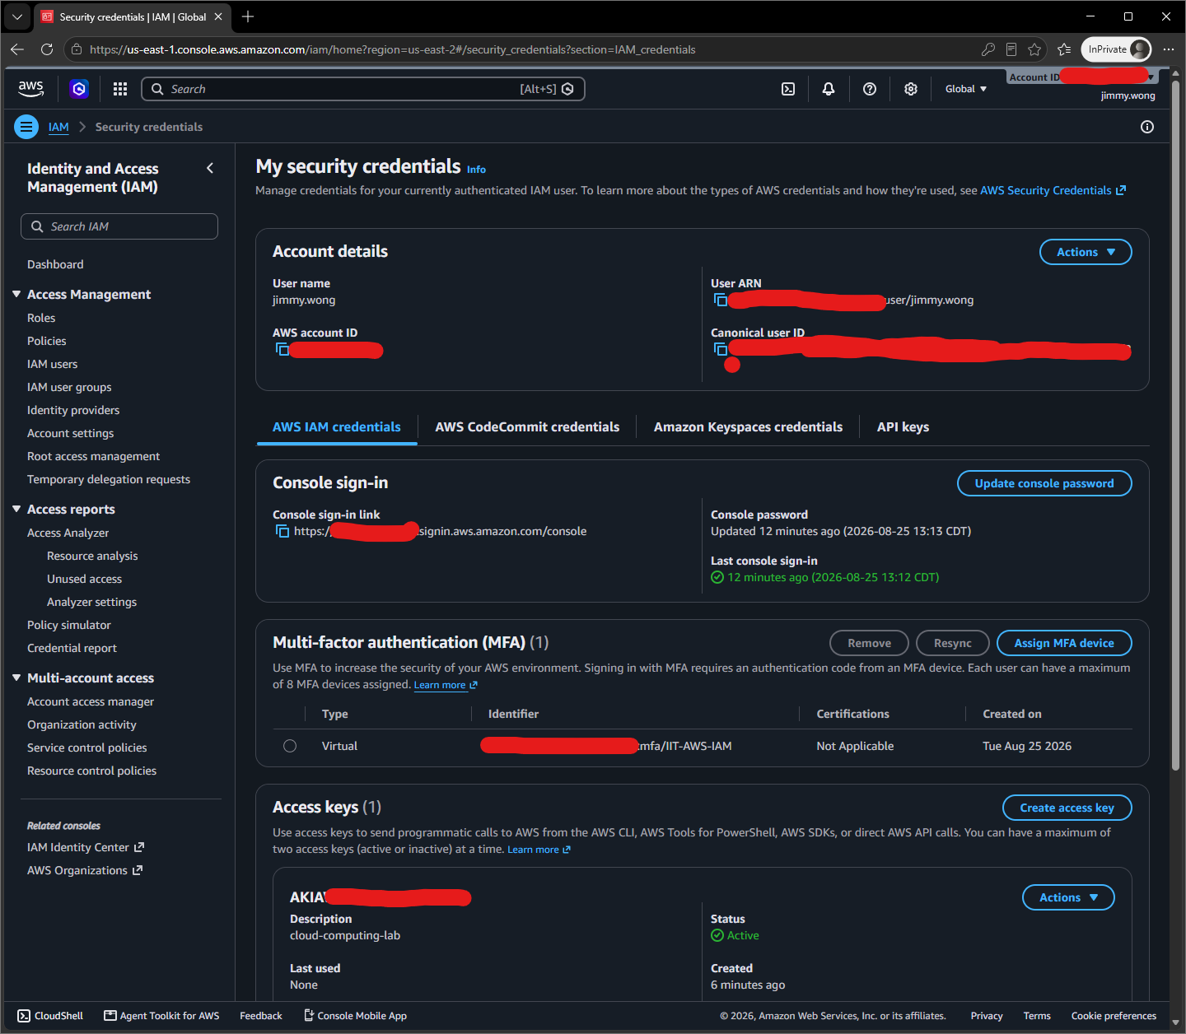

Confirmation access key is AKIA***DTRB

One paragraph reflecting on why root user MFA and least-privilege IAM users matter for cloud security.
As a root user, I have access to everything including deletions which pose risks for businesses. An IAM user can have root permissions to do what is necessary to reduce use of root logins. As an IAM user, a root user makes a limited number of permissions on an IAM user to do what tasks require. If an IAM user is created to do accounting tasks, number of permissions are focused on billing and costing, financial related, etc. And the IAM user doesn’t need to do cloud engineering.

Step2
Screenshot of Docker Version
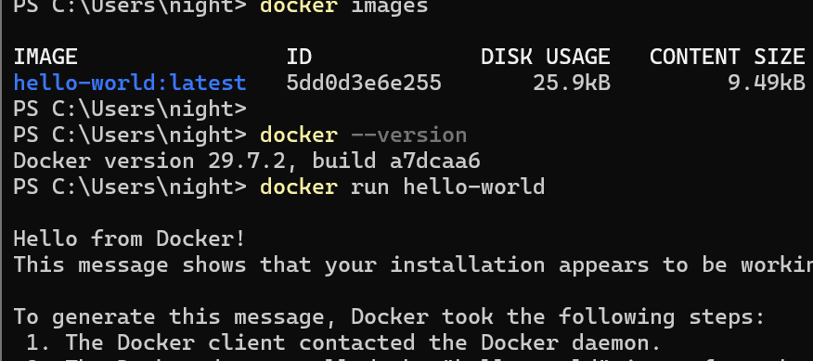

Screenshot of the hello-world container output
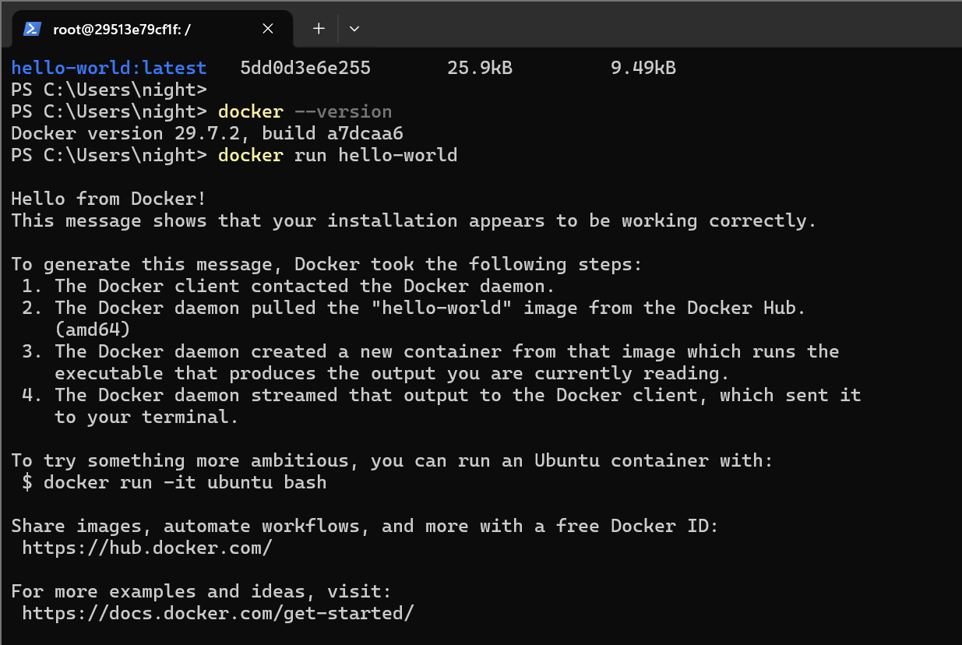

Screenshot of cat /etc/os-release run inside the ubuntu container
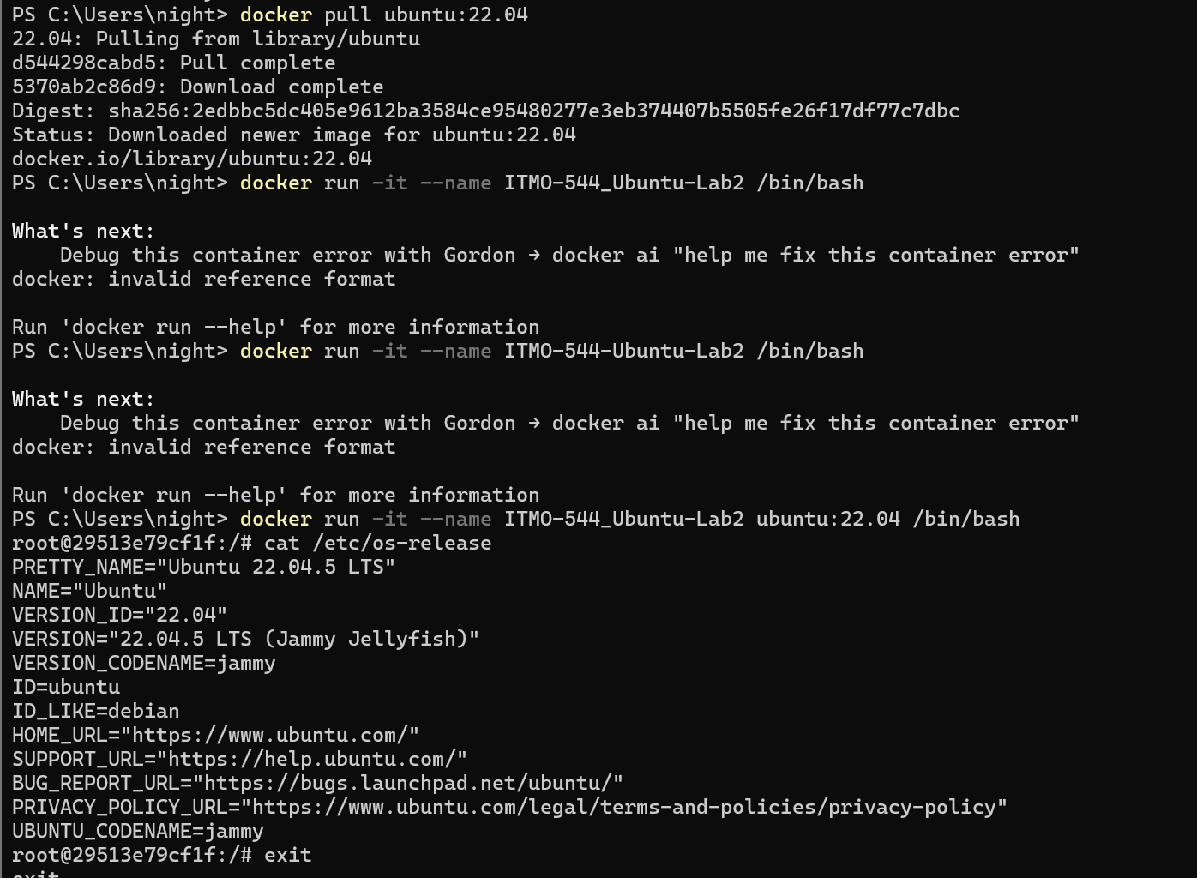

Screenshot of docker ps -a before and after removing my-ubuntu
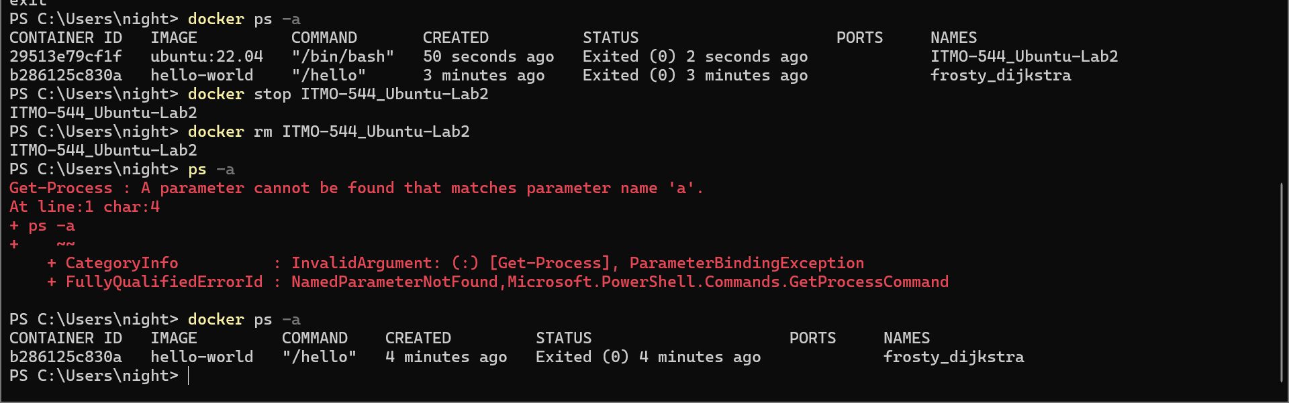

One paragraph explaining, in your own words, the difference between a Docker image and a Docker container.
A docker image is to build an image that will become a template to allow developers to use/pull into their own containers. A docker container is to use an image into a container with a service developer applies to run.

Step 3
Screenshot of aws --version output

Screenshot of aws sts get-caller-identity
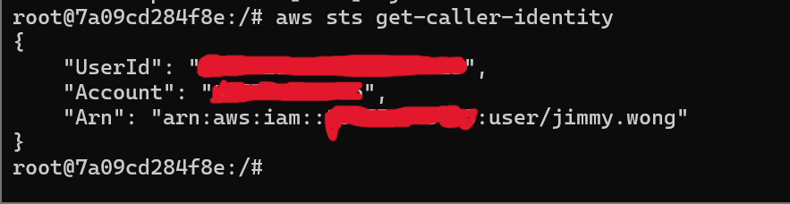

Screenshot of git config --global --list
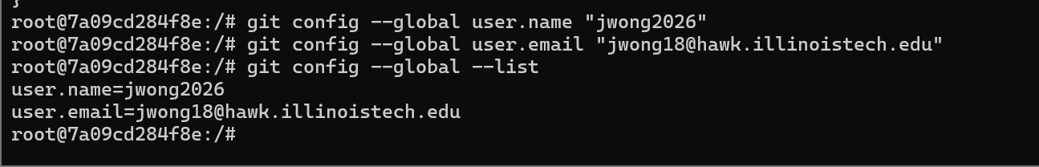

Screenshot of github repository showing list_buckets.sh successfully published
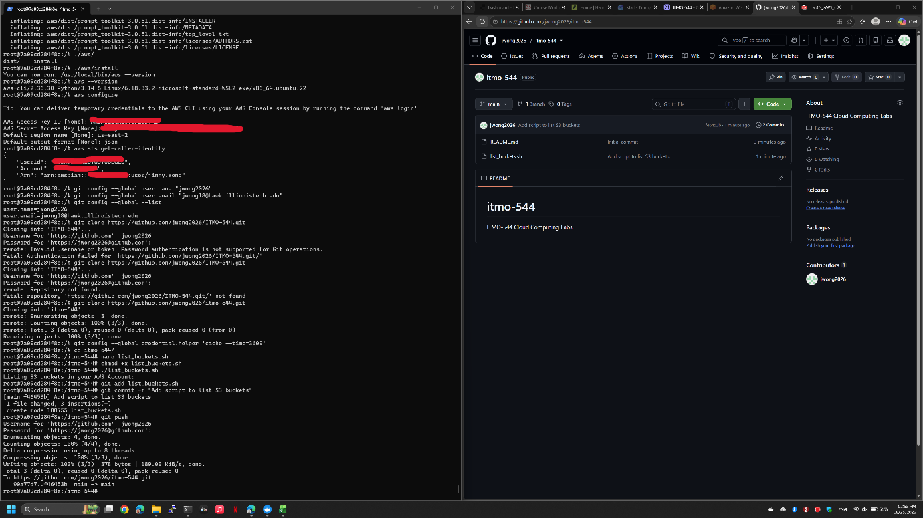

One paragraph explaining why you should never commit AWS credentials or GitHub tokens to a repository, even a private one.
AWS credentials or GitHub tokens will never be published to the internet for security reasons, such as preventing hackers from accessing data that should never be leaked to the public. If a key or token is leaked, data can also be leaked at any time. For a repository on GitHub, any credentials or tokens should never be committed to a repository because a repository isn’t safe to store your keys or tokens, which can be accessed easily by anyone who discovers that keys and tokens are a key to access data or break into infrastructure to take control of whichever service is exposed. A developer can make mistakes while reconfiguring a repository’s settings and leak keys or tokens for a moment.

