Rochester desinusoid software (v2)

Alf Dubra (adubra@cvs.rochester.edu) & Jennifer L. Norris (jsentiff@cvs.rochester.edu)
Table of Contents

Introduction 3
Installation 4
Creating the desinusoid matrix 5
Batch desinusoiding 11
Acknowledgments 12

Introduction

The Rochester desinusoid software consists of two Matlab graphical user interfaces (GUIs):

- roc_create_desinusoid_matrix_2, that calculates a matrix for removing horizontal (or vertical) sinusoidal warp on images using the sinc interpolation, and,

- roc_desinusoid_batch_process_2, that uses this matrix to desinusoid monochrome AVI movies.

The sinusoidal warping in the image can be estimated either from recorded images from a 1D periodic structure or a single 2D periodic structure with equal periods along the horizontal and vertical dimensions. In what follows, we refer to these periodic structures as calibration grids.In the case of the 1D calibration grid, the user needs to record AVI movies of the same calibration grid in a vertical and horizontal orientation, as shown in figure 1. When the calibration grid is two-dimensional, a single AVI movie must be recorded, with the fringes oriented along the horizontal and vertical image axis, as shown in figure 2.
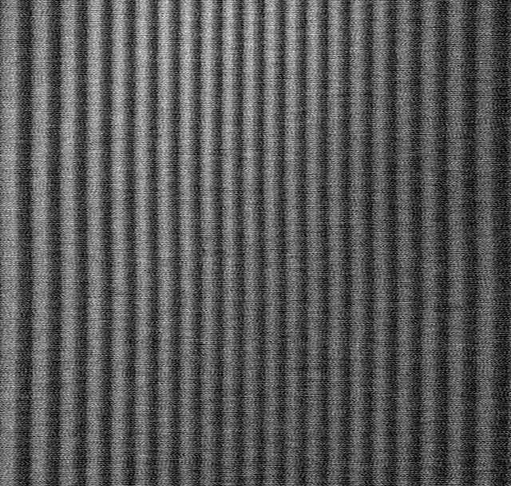
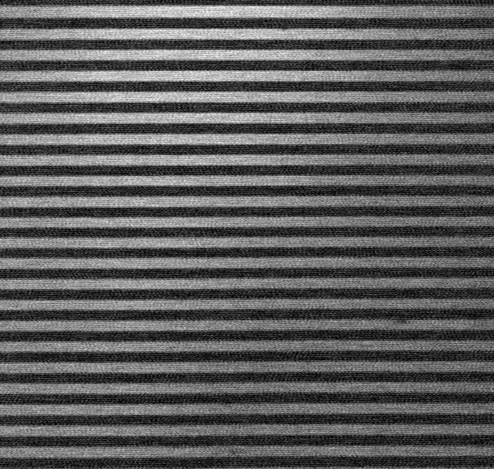
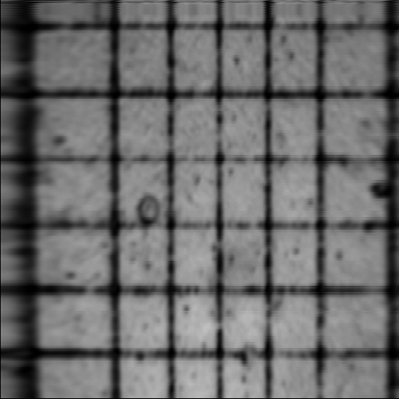
Figure 1 – 1D calibration grid in horizontal (left) and vertical (right) orientations.
Figure 2 – single 2D calibration grid.

In both cases, the accurate orientation of the grids is critical. If the fringe pattern(s) is (are) binary, it is preferable to record the image slightly out-of-focus (see page 6).

In principle, only one grid is required for desinusoiding; but the other grid provides scaling information, so that after desinusoiding the pixel spacing is equal in both the horizontal and vertical directions (i.e. the pixels are square).

The programs use the sinc interpolation method for calculating the desinusoided AVI movies, according to the sampling theorem. The correct implementation of this formula requires an infinite number of pixels along the warping dimension, but in practice only a few additional pixels are required at both edges of the image (a reasonable number is 16).

Installation

1) Make sure you have the Matlab Image Processing Toolbox (IPT) installed, by going to the Matlab command window and typing ver (for version). This will retrieve the current Matlab version and installed toolboxes.

1) Copy the folder with the desinusoid software to a desired location on your computer hard disk and then add this folder to the Matlab path. To do this, go to the “File” menu and then “Set path” option. Remember to save before closing the “set path” window.

2) If you have not done this before (for other Rochester software), de-compress and move the function alf_aviread_fast to the folder where the native aviread function is (this is the function for which you need the IPT). The folder name should be something like C:\Program Files\MATLAB71\toolbox\matlab\audiovideo, but it might be different depending on the current Matlab version or installation folders. Once you move alf_aviread_fast.m, make sure you delete all other de-compressed copies of the file anywhere else in the Matlab path directories.

3) Update the toolbox cache, by clicking on the file menu of the Matlab command window and then select “Preferences …”. A window should pop up. On the menu on the left, select “General”, and then click on the “Update Toolbox Path Cache”. Finally, click on “Apply” (bottom right of the window) and then “OK”.

This software has been tested on computers with MS Windows XP and Vista, using Matlab 7.1 R2007b. The minimum screen resolution to view the full GUIs required is 1024x768 pixels.

Creating the desinusoid matrix
Open a Matlab session, and in the command window type (remember that Matlab is case sensitive)

>> roc_create_desinusoid_matrix_2

This should open the GUI shown below.
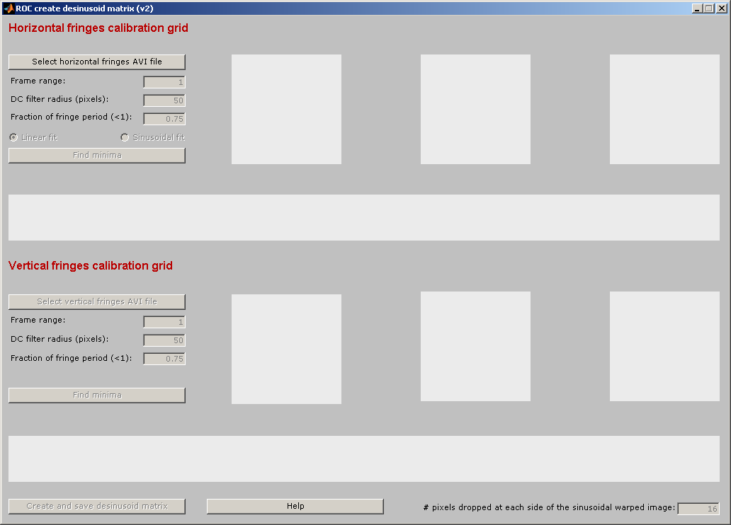
Figure 2 - roc_create_desinusoid_matrix_2 GUI (initial state).

When clicking on the “Select horizontal fringes AVI file” button, a window will pop for the user to select an existing AVI movie file with horizontal fringes (see the Introduction). When selecting the AVI file the file name and its path will appear on the top right side of the GUI, and the following controls will be activated: frame range, DC filter radius, fraction of fringe period, radio buttons (linear/sinusoidal fit) and find minima button (see figure 3).

Frame range is the sequence of frames that will be used to produce an average frame for finding the fringe pattern periodicity. By default, this sequence includes all the frames in the movie. The frame range control allows entering sequences of the form start : increment : end or start : end (i.e. increment = 1).

The program searches for an AC peak in the absolute value of the image 1D-DFT (spectrum). Because the image values are all positive, the spectrum has a dominant DC peak that needs to be filtered, so that the fringes’ period can be estimated. The DC filter radius value is used to define the cut-off frequency of a high-pass filter. The user can modify the default not satisfied with the (displayed) outcome upon pressing the “Find minima” button.

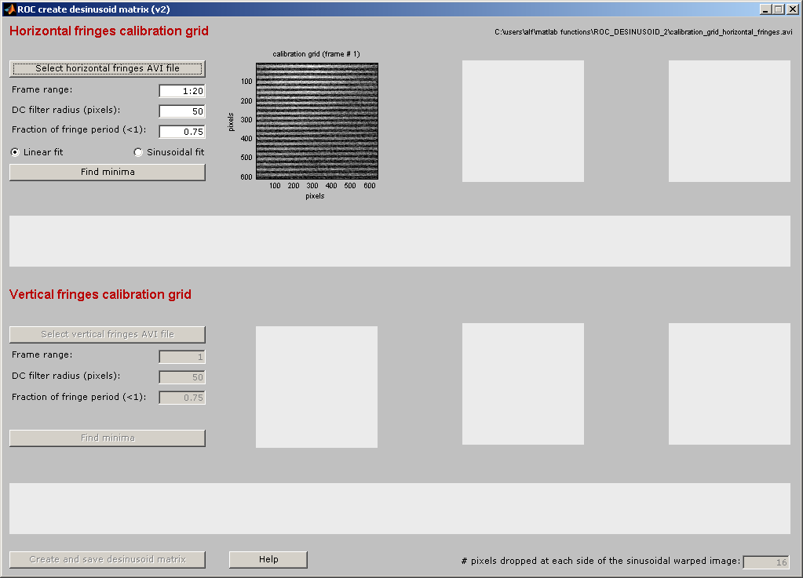
Figure 1 - roc_create_desinusoid_matrix_2 GUI state after loading a horizontal grid AVI file

The sinusoidal image warping could be along the horizontal or vertical direction. If the warping happens along the horizontal direction, then the user must select the linear fit radio button; and sinusoidal fit for the vertical direction.

Note: In the following, refer to the plots in Figure 4. When pressing the “Find minima button”, the program:

- Averages the images entered in the frame range control, and displays the result on the top left plot.
- Sums this average frame along the horizontal direction and plots it (1D fringes’ average) and its spectrum (top middle plot).
- Coarsely estimates the fringes’ period by finding the spatial frequency corresponding to the highest unfiltered AC peak, indicated by a red cross on the spectrum plot. The red line in this plot corresponds to the high-pass filter defined by the DC filter radius in pixels.
- Finds all the local minima of the 1D fringes’ average, and then discards the ones separated by less than the fraction of fringe period entered in the GUI.
- The position of the minima is indicated by red crosses and fitted to either a line or a sinusoid on the top right plot, depending on the selected radio button.

By clicking on the red crosses on the 1D fringes’ average plot, local minima can be removed and/or added at will to improve the fitting by minimizing the error (ε) and making sure there is only one cross per local minimum. The fitting plot (top right) is automatically updated to reflect the changes. Error: Reference source not found shows the state of the GUI after finding the minima of the horizontal fringes (for a linear fit). Note that the select vertical fringes AVI file button is now enabled.

Note that the fringe period appearing in the title of the top middle plot is only a coarse estimation, that it is only used as an initial value to search for the local minima. Once the local minima are found/selected, the program will perform a least-squares fit to a line in order to get a much more accurate estimation of the fringes period, that appears in the title of the right-most plots.

Important: The out-of-focus fringes will produce well defined single-pixel local minima positions, as opposed to, for example, a sharply imaged binary grid (Ronchi ruling). A poor estimation of the minima could translate either in poor scaling and/or desinusoiding.

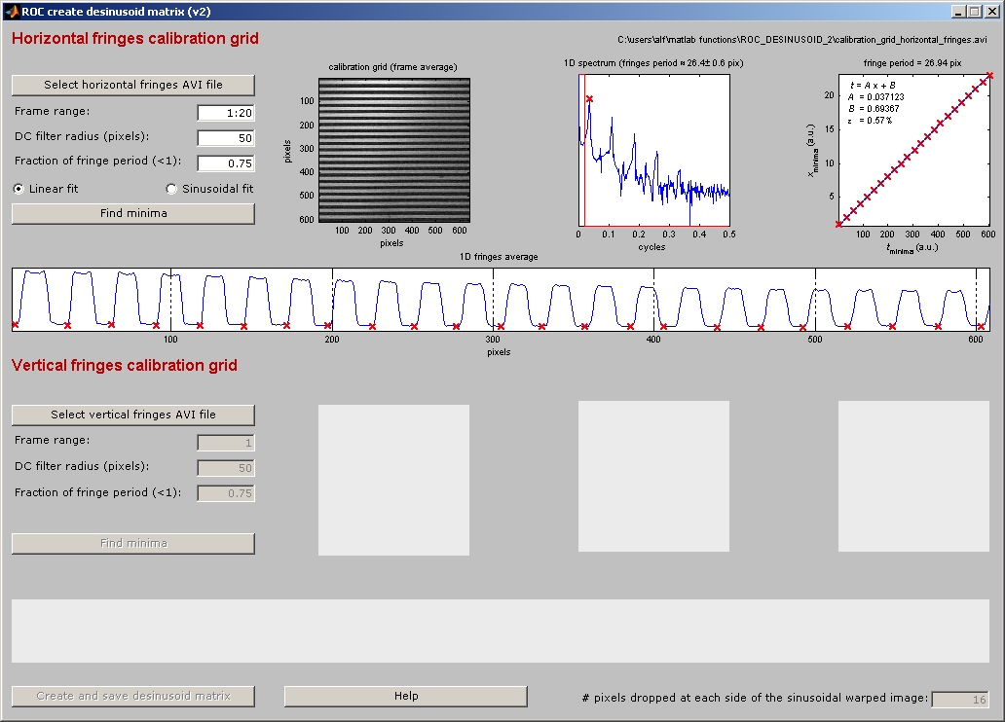
The selection of the vertical fringes AVI file and finding its minima is analogous to those of the horizontal fringes, with the only difference being that there is no radio button. This is because the program is based on the assumption that the images are sinusoidally warped either along the horizontal or the vertical direction, but not both. Figure 5 shows the GUI state after finding the minima of the vertical fringes.
Figure 4 - roc_create_desinusoid_matrix GUI after finding the horizontal fringes’ minima.

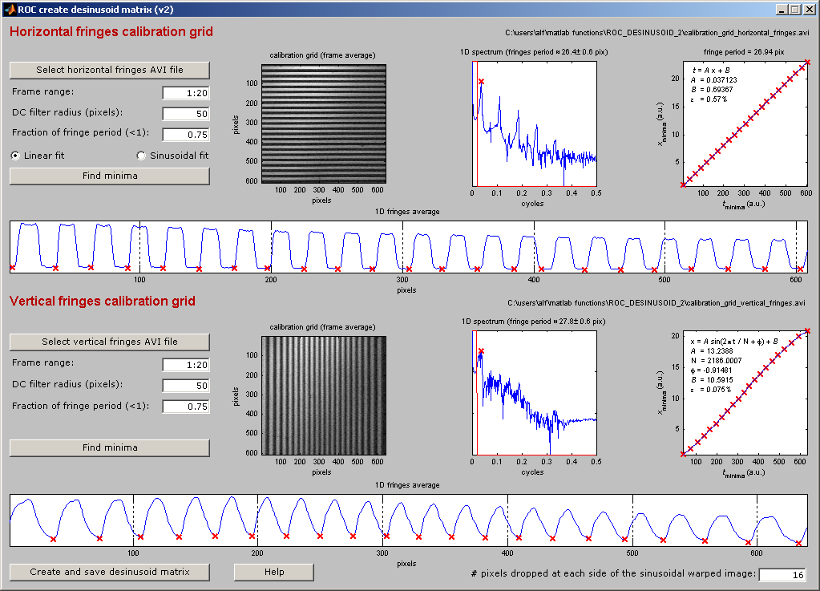
Figure 2 - roc_create_desinusoid_matrix GUI after finding the vertical fringes’ minima.
The sinc reconstruction formula used to calculate the desinusoid matrix requires an infinite number of pixels. A way to increase the accuracy of the calculations is to record a few additional pixels at both ends of the image, along the warped dimension. The more additional pixels, the higher the accuracy achieved in the desinusoid matrix.

If, for example, one wants to desinusoid a 512x512 pixel image, one can increase the accuracy of the desinusoiding by recording an additional 16 pixels at each end of the image along the warped dimension, thus recording (512+16x2)x512 pixel images instead. This requires modifying your acquisition method. Then, just before creating the desinusoid matrix, the user would enter the number of additional pixels (on just one side of the image) in the box on the bottom-right GUI textbox. Keep in mind that because of the sinusoidal warp, throwing away the 16 pixels in the recorded image would result in reducing the output image by less than 16 pixels (because of the warping).

By pressing the “Create and save desinusoid matrix” button, the desinusoid matrix is created and the user is prompted to enter a filename to save it in a MAT file. The saved MAT file contains a single variable, desinusoid_data, which is a data structure that also contains the estimated fitting parameters. The actual desinusoid matrix can be recovered as

if desinusoid_data.horizontal_warping
desinusoid_matrix = single(desinusoid_data.vertical_fringes.desinusoid_matrix);
else
desinusoid_matrix = single(desinusoid_data.horizontal_fringes.desinusoid_matrix);
end

Note that we convert the matrix to single accuracy, because the desinusoided images will only have 256 gray levels, and hence more accuracy is not required, and performing the matrix multiplication with single accuracy is faster than with double. Also note that the horizontal_warping variable is a Boolean that indicates whether the sinusoidal warping is along the horizontal (true) or vertical direction (false).

Undistorted images can be obtained by matrix multiplication on the right or the left of the sinusoidally warped image, depending on the direction of warping, as follows

if desinusoid_data.horizontal_warping
new_frame = uint8(distorted_frame * desinusoid_matrix’);
else
new_frame = uint8(desinusoid_matrix * distorted_frame);
end

The “Create and save desinusoid matrix” button also displays the sinusoidally warped average image, its corrected version and the desinusoid matrix in a secondary Matlab figure. A sample of this output can be seen below.
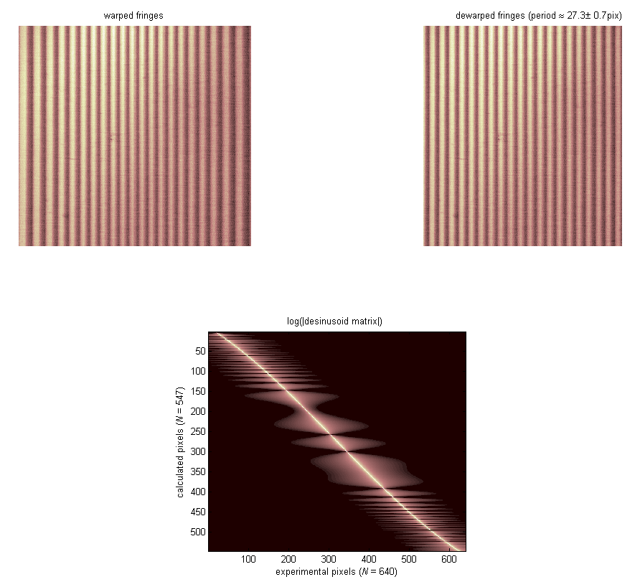
Figure 6 - additional outputs from the Create and save desinusoid matrix button.

Batch desinusoiding

Once the desinusoid matrix has been created, a second program, roc_desinusoid_batch_process_2 can be invoked in the Matlab command window, for removing the sinusoidal warp from a number of monochrome AVI movies.

The first step when using this program is to select a MAT file generated with roc_create_desinusoid_matrix_2. Then, a number of files can be selected through the “Add AVI files to the TODO list.” This button can be used multiple times before starting the batch processing, so that for example files in different folders can be added.

When pressing the “Start batch processing” button, every frame of every movie will be read, desinusoided and then saved in a new monochrome AVI movie (with no data compression) in a file with the same name plus “_desinusoided.” As the files are being processed their name will be moved from the TODO to the DONE list box. When the dimensions of the images in the AVI files do not match those of the desinusoid matrix, the file name will be moved to the failed list. Other errors encountered along the processing might also lead to having their names moved to the failed list.

The figure below shows a typical screenshot of the program.

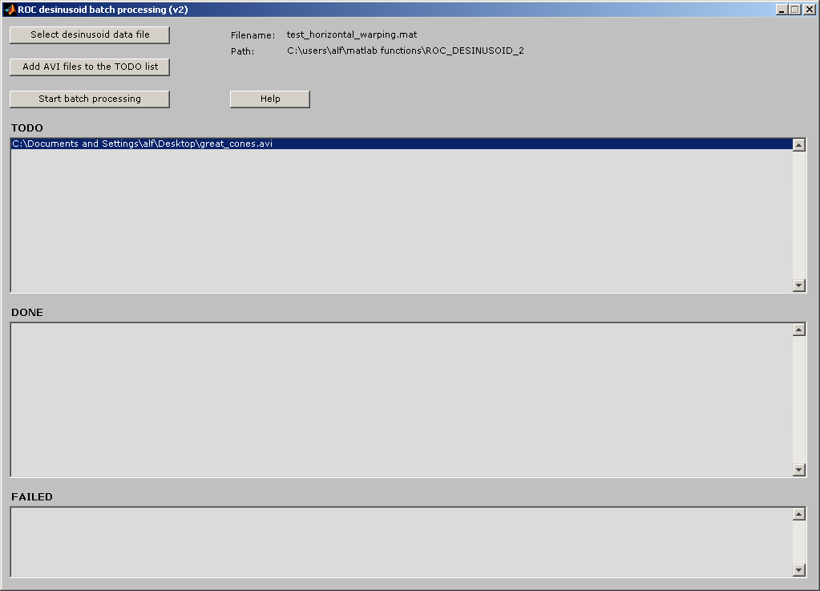
Figure 3 - roc_desinusoid_batch_process_2 screenshot .

Acknowledgments

Special thanks to Jen Norris, Ben Masella and Nicole Putnam for spotting bugs.

The use of this software either in its original form or modified should be acknowledged using the following text:

The Rochester desinusoid software was developed by Alfredo Dubra with funding provided by the NIH grant BRP- EY01437 and NSF Science and Technology Center for Adaptive Optics, managed by UC Santa Cruz under cooperative agreement AST 98-76783. Alfredo Dubra-Suarez, PhD, holds a Career Award at the Scientific Interface from the Burroughs Wellcome Fund.

