Github

Account: ucsfidl

Password: Long IDL password

GitHub Desktop/Shell download:

https://desktop.github.com/

Github Desktop:

1) Check repositories: When there are changes to the repository, there will be a dot next to ‘Changes’. (A) Use sync to pull changes from the remote branch (GitHub). The + sign (B) lets you create, clone or add a repository. When collaborating, forking (Option on the project’s GitHub page) allows pull requests to be made to the original repository.

2) Creating a new branch(C): For new features that take a while to finish and are not fully tested, branching will be useful. Name your branch and make sure you are on that branch when committing. You may also work directly on the branch for quick changes. Make sure it does not affect rig-specific conditions. All rigspecific conditions must be within files named in .gitignore

3) Commit your changes. Name and describe your changes in this commit (D). Commits create a node on your branch at that point in time.

4) Sync (E) or create a pull request (F). Pull request will merge branches together, while sync will synchronize your local and remote branch.

5) Pull requests must be merged on github page or through git shell.

*** Go through the Tutorial (G) for a quick overview

Git Shell:

See the Git Cheat Sheet for common git commands.

**F**

**A**

**C**

**B**

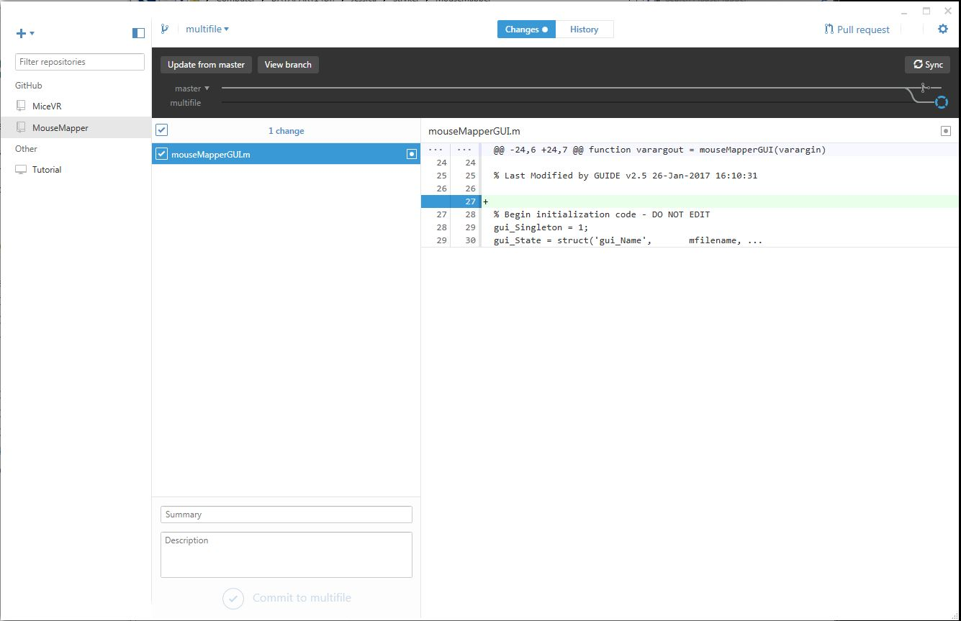

**G**

**E**

**D**