Interpretable Sparse Modeling of Longitudinal Signals
via Critical-Range Rectification and Anytime Rule Compression

Dissertation Prospectus (Written Proposal)

Jason Orender
Department of Computer Science
Old Dominion University

Advisor: Dr. Jiangwen Sun
Committee: Dr. Mohammed Zubair; Dr. Yaohang Li; Dr. Yet Nguyen

February 2026

Abstract
High-dimensional longitudinal data are common in clinical monitoring, industrial control systems, and other sensor-driven domains. When outcomes are governed by go/no-go thresholds and delayed effects, standard sparse models such as L1-regularized logistic regression often become unstable after lag expansion because multicollinearity undermines consistent support recovery. At the same time, many stakeholders require models that are interpretable as simple rules and that can be trained and evaluated under constrained compute.
This prospectus proposes an end-to-end framework that addresses these constraints using three stages: (i) critical-range rectification, which converts each lagged continuous measurement into a {−1,+1} indicator denoting whether it lies within a data-driven range observed during events; (ii) sparse model fitting using an L1-regularized logistic baseline on the rectified design; and (iii) anytime rule compression (“logic polishing”), which collapses small-magnitude coefficients to produce a compact m-of-K rule model tuned to maximize Youden’s J at a chosen operating point. Preliminary studies on synthetic data with known ground-truth rules and on real-world datasets (including the HAI industrial control system) suggest that rectification improves feature-and-lag attribution, reduces false positives, and can decrease end-to-end training time.
A tractable proof-of-concept theoretical analysis uses the zero-threshold arcsin relation under joint normality to show how sign binarization contracts pairwise correlations, improves conditioning of the Gram matrix, and increases the likelihood of satisfying the LASSO irrepresentable condition. The proposed dissertation work will (a) strengthen theoretical generalization beyond the proof-of-concept assumptions, (b) quantify the contribution of each pipeline stage via ablations and stability studies, and (c) expand evaluation to additional longitudinal domains and baselines.

Table of Contents

Abstract 1
Table of Contents 2
1. Introduction 3
2. Background and Related Work 4
3. Proposed Framework 5
4. Research Questions Overview 10
5. Preliminary Studies and Evidence to-date (RQ1) 10
6. Theoretical Analysis (RQ2) 14
7. Anytime Rule Compression 15
8. Proposed Future work and Evaluation Plan 16
9. Timeline and Milestones 17
10. Expected Contributions 18
11. References 19

1. Introduction
Longitudinal data consist of repeated measurements of the same variables over time, coupled with outcomes of interest. In many real-world settings, outcomes are triggered when one or more variables enter specific ranges, often after a delay. Such threshold-and-lag behavior arises in physical systems and in complex socio-technical contexts where actionable decision support is required.
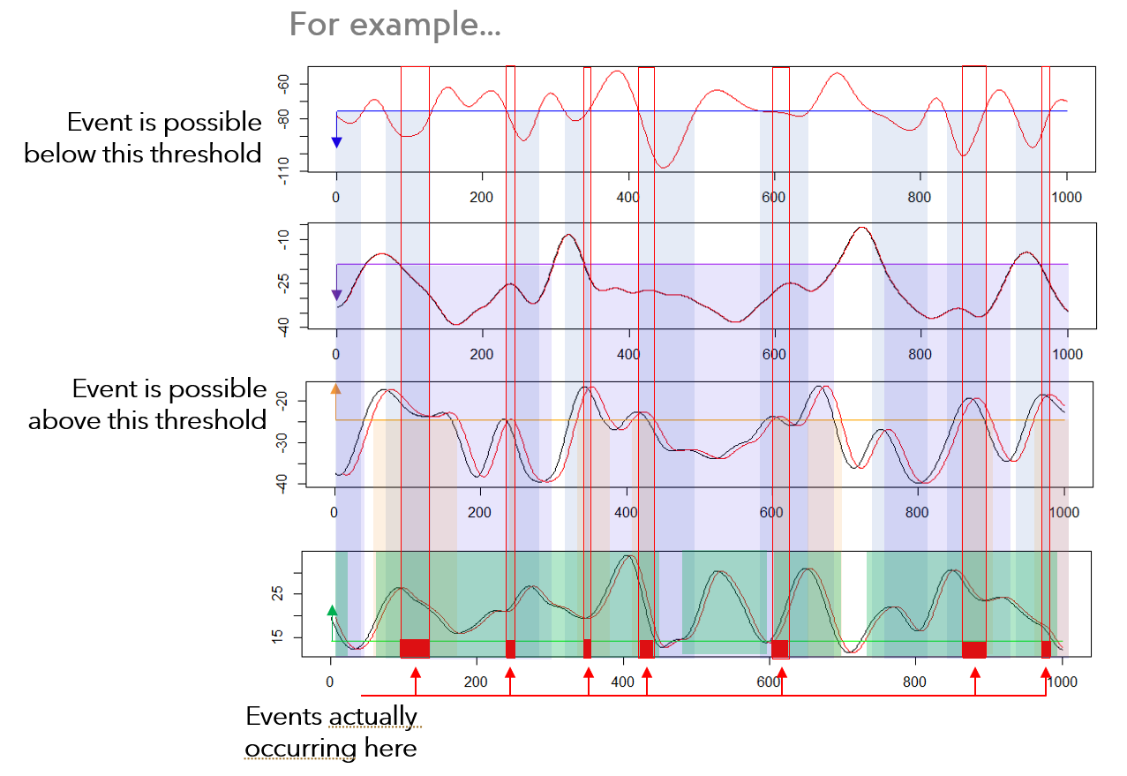
Figure 1. Illustrative threshold-and-lag behavior in longitudinal signals.

A common modeling strategy is to expand the design matrix with lagged versions of each signal and then apply a sparse learner. However, lag expansion induces strong multicollinearity among adjacent lags and across correlated sensors, which can lead to dense fits, arbitrary feature selection, and unclear feature attribution. In constrained compute environments, complex black-box models may be impractical; and even when accurate, they often fail to provide transparent, actionable explanations.

1.1 Problem statement
This work targets two tensions that arise together in longitudinal feature learning:
- Correlation + high dimension → unstable sparse selection.
- Interpretability demands rules, not hundreds of coefficients.
The overarching goal is to develop a pipeline that is accurate enough for operational use, produces directly interpretable rules, and remains computationally efficient.

1.2 Thesis and scope
Thesis: critical-range rectification makes sparse longitudinal modeling more reliable and interpretable; anytime rule compression makes it usable. The scope of this prospectus emphasizes inherently interpretable sparse models with explicit feature attribution under constrained compute. Deep learning is out of scope except as contextual baselines where appropriate.

1.3 Prior publications and dissertation position
The prospectus builds on prior work by the author and collaborators, including a rectification-first feature selection pipeline and a proof-of-concept theoretical analysis for correlation contraction and irrepresentable-condition (IC) satisfaction [1,3], as well as an anytime rule compression method for distilling rectified sparse models into compact m-of-K rule forms [2]. The dissertation will unify and extend these contributions into a coherent framework with broader evaluation, strengthened theory, and a reproducible implementation.

2. Background and Related Work
Sparse modeling with L1 penalties is a standard approach for feature selection and interpretability. However, consistent recovery of the true support depends on conditions that can be violated by strong predictor correlations. This section summarizes relevant ideas in sparse learning, longitudinal lag expansion, and competing approaches for feature selection and rule learning.

2.1 L1-regularized models and feature selection
The LASSO and L1-regularized logistic regression encourage sparse coefficient vectors by shrinking many coefficients to exactly zero [4,5]. Sparsity can serve as feature selection, and in longitudinal designs selected coefficients can localize time lags, enabling causal hypotheses about delayed effects.

2.2 Support recovery and the irrepresentable condition
Zhao and Yu introduced the irrepresentable condition (IC) as a characterization of when LASSO can recover the true support in correlated designs [6]. In lag-expanded longitudinal data, strong collinearity among predictors often violates the IC, yielding dense or unstable selections. This prospectus uses the IC as the central theoretical lens for explaining why rectification improves feature selection behavior.

2.3 Interpretability as a design requirement
In high-stakes settings, interpretability is not an afterthought: end-users must understand why a prediction was made and be able to validate it against domain knowledge. Interpretable models are often preferred over post hoc explanations of black boxes in many decision contexts [7,8]. This motivates explicit logical structures (rules) rather than large sets of small-magnitude coefficients.

2.4 Competing approaches
Relevant competing families include:
- Group and structured sparsity methods impose structure on coefficients (e.g., grouped penalties or monotone lag decay). They can stabilize estimation but do not directly transform the correlation structure of the inputs [10–12].
- Correlation-aware or rank-based LASSO variants can improve robustness but may not address IC satisfaction directly [14,15].
- Wrapper/importance methods (e.g., recursive elimination, tree-based importance) are pragmatic but can be heuristic and less transparent [16].
- Quadratic-programming and logic-rule approaches (including Logical Analysis of Data) capture thresholding but can be computationally intensive due to pairwise testing and combinatorial rule search [9,17,18].

3. Proposed Framework
The proposed solution is an end-to-end pipeline consisting of rectification, sparse model fitting, and rule compression. Each stage contributes a distinct capability: rectification emphasizes threshold-relevant signal structure, sparse fitting performs selection and attribution, and compression produces a compact logical rule that is easy to apply.
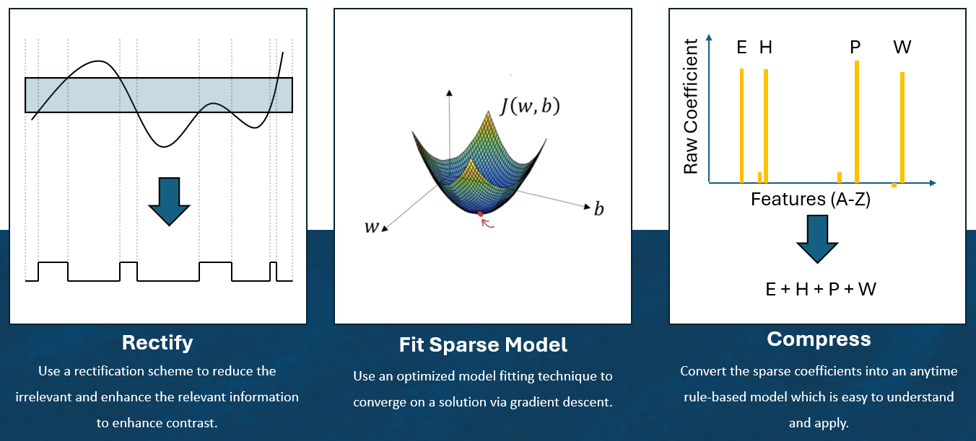
Figure 2. End-to-end pipeline: critical-range rectification → sparse model fitting → anytime rule compression.

3.1 Critical-range rectification
Critical-range rectification converts continuous measurements into logical indicators. For each feature (including each lagged column), a critical range is estimated from positive (event) examples in the training data only. A transformed matrix A of identical dimensions is produced with entries in {−1,+1} indicating whether each measurement lies inside or outside the learned range. Learning ranges on training folds only prevents information leakage.
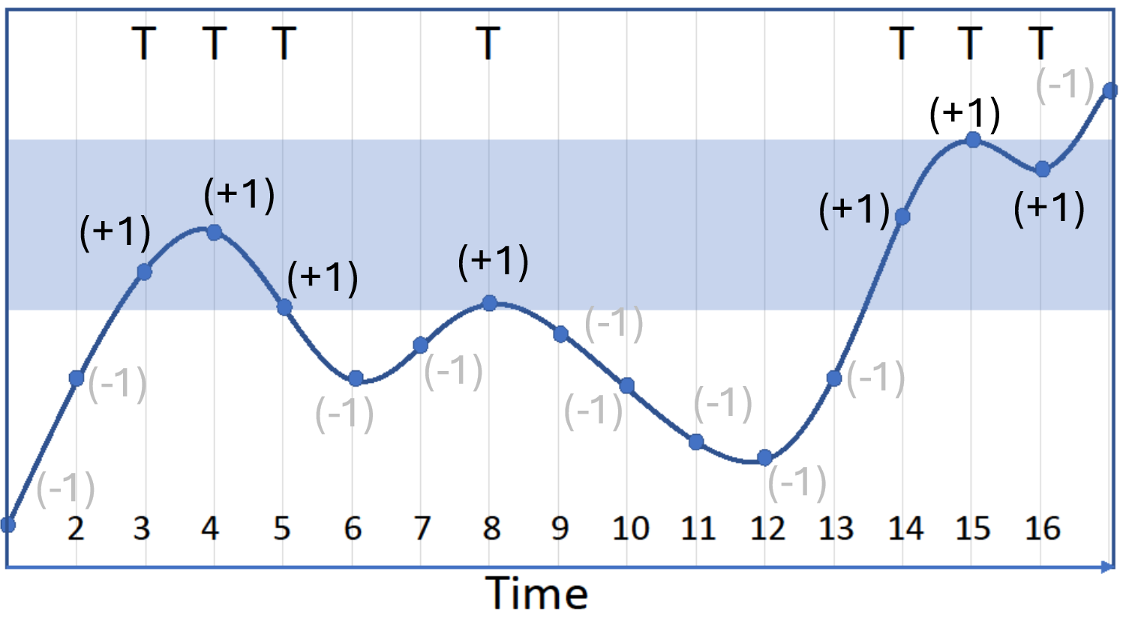
Figure 3. Critical-range definition and {−1,+1} rectification of a longitudinal signal.

3.1.1 Algorithm and practical guardrails
Algorithm 1 summarizes critical-range rectification. In practice, robust quantiles can replace min/max to reduce sensitivity to outliers, and complement indicators can be added for strongly negatively associated features (outside-range activation).
Algorithm 1 Binarization (from [1])
Require: X, y (training set only)
Output: A, r_{j}[b, c]
1: | Let r_{j}[b, c] be the critical range for feature vector X_{j}, where b is the minimum and c is maximum defining that range.
2: | procedure BINARIZATION(X, y)
3: | Let Z be the rows of X where y=1.  Z ⊆ X, where Z = {X | y = TRUE}
4: | Compute r_{j=1..d} = [min(Z_{j}), max(Z_{j})] .  Note: If the min / max calculations induce brittleness in the solution (e.g. if there are outliers in the data set), using a robust quantile can provide a remedy.
5: | Compute A, the set of transformed features, such that:
 | a_{ij} = +1 when x_{ij} ≥ r_{j}[b] and x_{ij} ≤ r_{j}[c]
 | a_{ij} = −1 when x_{ij} < r_{j}[b] or x_{ij} > r_{j}[c]
6: | end procedure

Algorithm 1. Critical-range rectification (pseudocode) from [1].

3.2 Sparse baseline model fitting
After rectification, an L1-regularized logistic model is fit to the transformed design using cross-validation to select the regularization strength [5]. Each nonzero coefficient corresponds to a specific sensor-and-lag indicator and its associated critical range, yielding explicit attribution artifacts: (i) the selected sensor, (ii) the selected lag, and (iii) the actionable range.

3.3 Anytime rule compression (“logic polishing”)
Although L1 regularization often yields relative sparsity, practical models can still contain many small-magnitude coefficients that obscure underlying logic. Logic polishing collapses small coefficients to zero and forces remaining coefficients to a fixed magnitude K, producing a compact m-of-K rule model tuned to maximize Youden’s J. The method is anytime: scanning k from 1 to the number of active coefficients yields a monotone sequence of candidate rule models, and users may stop once a desired simplicity/accuracy tradeoff is reached.
Algorithm 2 Logical Polish (from [1])
Require: $X∈{\{-1,+1\}}^{n×d}$, y $∈{\{0,1\}}^{n}$,
$w∈R^{d}$, $b_{0}∈R$ (from LASSO fit),
J₀: Youden’s J for baseline model,
K: Vote magnitude,
rt: Relative tolerance to J required
Output: Rule Model (w*, b*)
1: | Collect active features and sort by importance.  - Let $J=\left\{j:w_{j}≠0\right\}, l=\left|J\right|$  - Sort $J$ by descending $\left|w_{j}\right|$ to get an index  order $π=\left(π_{1}, …, π_{l}\right)$  - Define signs $s_{j}=sign\left(w_{j}\right)∈\left\{-1,+1\right\}$  for $j∈J$.
2: | Precompute per-feature signed contributions.  - Build: $M∈{\{-1,+1\}}^{n×l}$  where $M_{i,k}=s_{π_{k}}X_{i,π_{k}}$  - Compute cumulative votes $V∈Z^{n×l}$ with  $V_{i,k}=\sum_{t=1}^{k}{M_{i,k}}$ for $k=1, …, l$  - So, $V_{i,k}=\#\left(agreements\right)-\#(disagreements)$ among the top-k.
3: | Initialize incumbent (anytime state).  - Set $(w^{*}, b^{*}, k^{*}, J^{*})←(w, b_{0}, 0, -∞)$  - $T←(1-rt)∙J_{0}$
4: | Main scan over rule size k.  FOR k = 1 to $l$  - Construct the rule weight vector for top-k.  $${\tilde{w}}_{j}^{(k)}=\left\{\begin{matrix}K∙s_{j}, \\ 0, \end{matrix}\right. \begin{matrix} j∈\left\{π_{1}, …, π_{k}\right\} \\ otherwise\end{matrix}$$  - Choose intercept $b^{(k)}$ per policy.  $$b^{(k)}=log\left(\frac{p}{1-p}\right)-\sum_{t=1}^{k}{K_{s_{π_{t}}μ_{π_{t}}}}$$where:  $μ_{j}=\frac{1}{n}\sum_{i}{X_{i,j}}$ and $p=\frac{1}{n}\sum_{i}{y_{i}}$  - Update incumbent (for anytime).  if $J_{k}>J^{*}$:  update $(w^{*}, b^{*}, k^{*}, J^{*})←({\tilde{w}}_{}^{\left(k\right)}, b^{\left(k\right)}, k, J_{k})$
5: | Adoption decision.  if $J^{*}>T$, adopt new coefficient set, otherwise  $(w^{*}, b^{*}, k^{*})←(w, b_{0}, l)$.
6: | Finalize outputs.  Return Rule Model $\left(w^{*}, b^{*}\right)$ with $k^{*}$ non-zeros,  each $±K$ if the new coefficient set was adopted.
7: | end procedure

Algorithm 2. Anytime logic polishing (pseudocode).

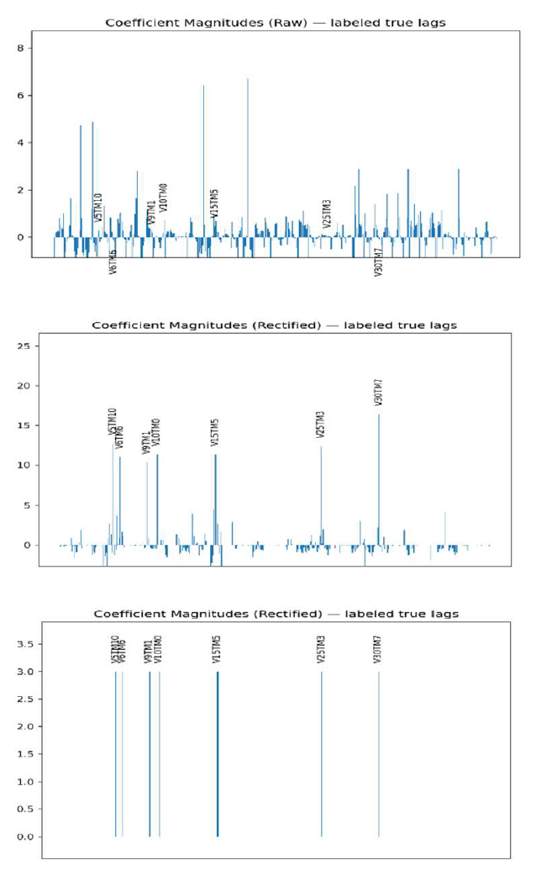
Figure 4. Logic polishing: coefficient magnitudes before (top), after rectification (middle), and then after compression (bottom), resulting in a compact rule representation.

4. Research Questions Overview
This dissertation is organized around three research questions (RQs):
RQ1: Can critical-range binarization produce a stable sparse baseline with reliable feature attribution?
RQ2: Why does binarization work, and can the backbone be generalized?
RQ3: Can the solution be compressed into a set of logical rules?

4.1 Evaluation criteria
Across RQs, success will be evaluated using:
- Predictive performance: AUC and Youden’s J at an operational threshold.
- Interpretability: number of active features, number/length of rules, and clarity of lag attribution.
- Efficiency: end-to-end training and inference time; memory footprint when applicable.
- Stability: support stability across folds/bootstraps (e.g., Jaccard similarity).

5. Preliminary Studies and Evidence to Date (RQ1)
Preliminary studies evaluate whether critical-range rectification improves feature-and-lag attribution and model behavior in longitudinal settings. Experiments include synthetic datasets with known ground truth, real-world datasets, and a comparison to a quadratic-programming selector.

5.1 Synthetic data with known ground-truth rules
Synthetic longitudinal data are constructed so that events occur when a small set of variables are simultaneously within their critical ranges at specific lags. This stresses support recovery under severe multicollinearity intentionally created via lag expansion. Rectification is applied prior to fitting and compared against untransformed baselines. Table 1 summarizes representative test-set performance on the synthetic case.

Method | Transform Status | Rel. Time | Youden’s J | F1
LASSO | Transformed | 1.00 | 0.975 | 0.988
LASSO | Untransformed | 1.83 | 0.753 | 0.804
Random Forest | Transformed | 12.5 | 0.980 | 0.990
Random Forest | Untransformed | 43.0 | 0.913 | 0.947
Group LASSO | Transformed | 24.5 | 0.689 | 0.558
Group LASSO | Untransformed | 53.5 | 0.624 | 0.459
Table 1. Synthetic case: transformed vs untransformed comparisons (values from preliminary experiments).

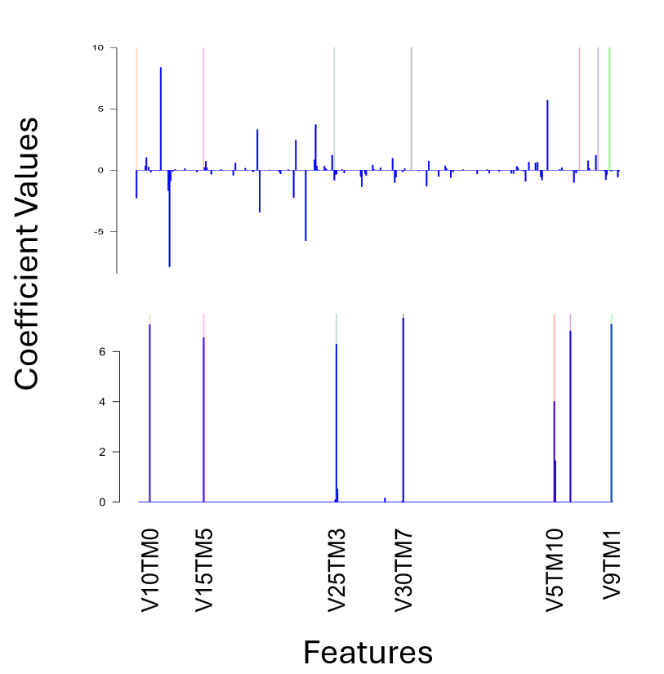
Figure 5. Coefficient profiles on synthetic data: transformed vs untransformed (ground-truth lag locations highlighted).

Across these synthetic settings, rectification improves the alignment of nonzero coefficients with ground-truth variables and lags, increases Youden’s J and F1, and reduces end-to-end fitting time relative to modeling the raw lag-expanded design.

5.2 Comparison to quadratic programming feature selection
A quadratic-programming method due to Katrutsa and Strijov is a close parallel in spirit: it aims to maximize relevance while minimizing redundancy using pairwise similarity measures [9]. In preliminary comparisons, the method often identifies related variables but can miss the correct lag and incurs a large computational cost due to pairwise evaluation.
Figure 6. Quadratic programming importance magnitudes on the identical synthetic dataset used in Section 5.1.

In these experiments the quadratic-programming approach was approximately 100–200× slower than the combined time for rectification plus LASSO fitting. A key advantage of the proposed pipeline is that it retains polynomial-time components and produces explicit lag attribution artifacts.

5.3 Real-world datasets
Real-world evaluation focuses on interpretability and subsystem-faithful attribution in addition to predictive metrics. The HAI industrial control system dataset provides a longitudinal sensor setting with known attack scenarios; UNICEF longitudinal data illustrates a regime where raw metrics can favor untransformed models but at the cost of interpretability.

Statistic | HAI (Transformed) | HAI  (Un-Trans) | UNICEF (Transformed) | UNICEF  (Un-Trans)
ACC | 0.987 | 0.939 | 0.902 | 0.963
AUC | 0.982 | 0.943 | 0.865 | 0.989
F1 | 0.987 | 0.942 | 0.894 | 0.958
Youden’s J-Index | 0.974 | 0.878 | 0.815 | 0.925
Table 2.HAI and UNICEF data set performance on transformed vs. untransformed data.

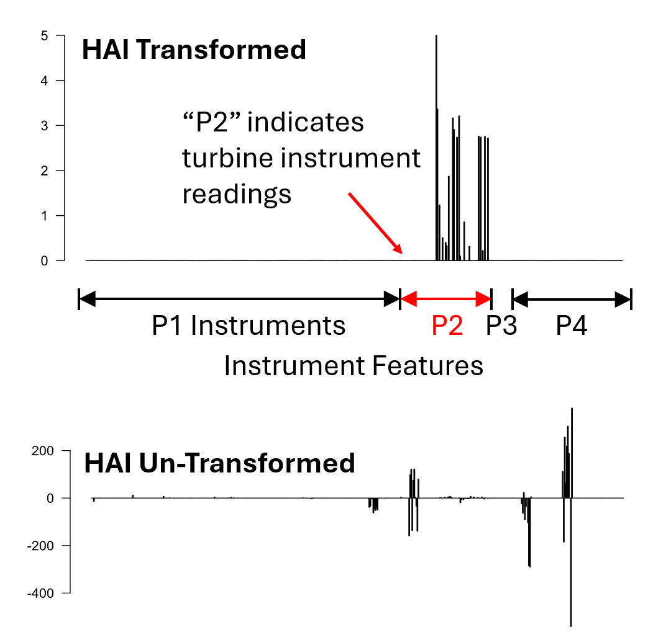
Figure 7. Real-world coefficient concentration and performance: HAI turbine loop selection vs untransformed spread.

On HAI, the transformed model concentrates coefficients on turbine-related sensors and reduces false positives, aligning with the known attacked subsystem. On UNICEF, untransformed metrics can be higher while yielding a more complex and less interpretable solution; transformed models remain much sparser and retain actionable ranges.

6. Theoretical Analysis (RQ2)
RQ2 asks why rectification helps and how broadly the backbone generalizes. To avoid overstating generality, this prospectus presents a tractable proof-of-concept analysis for zero-threshold sign binarization under joint normality. This setting yields a closed-form arcsin mapping for correlations and supports an IC-based explanation for improved support recovery [1,6].

6.1 Irrepresentable condition (IC) overview
The IC provides a condition (eq. 1) under which LASSO can recover the true support in correlated designs [6]:
$${∥X_{S^{c}}^{⊤}X_{S} {\left(X_{S}^{⊤}X_{S}\right)}^{-1}sign\left(β_{S}\right)∥}_{∞}<1$$ | (1)
- Based on the work of Zhao and Yu in 2006, which proved that if we can satisfy the IC relationship, there is a substantially improved probability of recovering the true support for a dataset.
- We will use the arcsin relation as a tractable proof-of-concept (PoC) to show that in the case of zero-based thresholds binarization increases the probability of satisfying the IC.
- High collinearity among raw, lag-expanded features often violates the IC, yielding dense or unstable selections, hence the focus in this work on longitudinal data.

6.2 Correlation contraction via arcsin relation (PoC)
Under joint normality and zero-threshold sign binarization, the correlation between binarized variables obeys an arcsin relation, resulting in the post-binarization correlation as a contraction of the original correlation. The bivariate normal orthant probability identity, 𝑃(𝑋 > 0, 𝑌 > 0) = 1⁄4 + 1⁄2𝜋 arcsin(𝜌) implies the following closed-form mapping, resulting in the significant relationship (|ρ̃| ≤ |ρ|):
$$\tilde{ρ} = \frac{2}{π}arcsin\left(ρ\right), \left|\tilde{ρ}\right|≤\left|ρ\right|\text{ for }ρ∈\left(-1,1\right)$$ | (2)
- For standardized, jointly normal (𝑋, 𝑌) with correlation 𝜌 and binarized 𝑋.
- The tilde (“~”) is used to distinguish binarized data from its original continuous counterpart, where in this case all feature values greater than 0 are coded as +1 and all feature values that are less than or equal to zero are coded as -1.
- Under joint normality and zero-threshold sign binarization, this result shows that when binarized, all pairwise correlations must be less than or equal to their original, never greater.
- In fact, equality occurs only at 𝜌∈{−1,0,1}, due to the arcsin relation being strictly convex on (0,1) and strictly concave on (-1,0).

6.3 Conditioning and IC tightening
Correlation contraction has matrix-level consequences. In stylized equicorrelated regimes, contracting off-diagonal correlations improves conditioning of the Gram matrix and reduces the infinity norm of its inverse. Together with contraction of off-support covariances, this shrinks a standard upper bound on the IC term for non-relevant features, which increases the likelihood that the IC is satisfied in the proof-of-concept setting.
Since:
$$\left|θ_{j}\right|≤{\left\|C_{jS}\right\|}_{∞}{\left\|G_{SS}^{-1}\right\|}_{∞}{\left\|sign\left(β_{S}\right)\right\|}_{∞}$$ | (3)
and:
${\left\|{\tilde{C}}_{js}\right\|}_{∞}≤{\left\|C_{js}\right\|}_{∞}$, ${\left\|{\tilde{G}}_{ss}^{-1}\right\|}_{∞}≤{\left\|G_{ss}^{-1}\right\|}_{∞}$ | (4, 5)
we define:
${B_{j} ≔ \left\|C_{js}\right\|}_{∞}{\left\|G_{ss}^{-1}\right\|}_{∞}$, ${{\tilde{B}}_{j} ≔ \left\|{\tilde{C}}_{js}\right\|}_{∞}{\left\|{\tilde{G}}_{ss}^{-1}\right\|}_{∞}$ | (6, 7)
$B^{*} ≔\max_{jϵS^{c}}(B_{j})$, ${\tilde{B}}^{*} ≔\max_{jϵS^{c}}({\tilde{B}}_{j})$ | (8, 9)
Thus, under the stated assumptions:
$$\operatorname{Pr}\left({\tilde{B}}^{*}<1\right) ≥ \operatorname{Pr}\left(B^{*}<1\right)$$ | (10)

The lemmas isolate why binarization helps:
- pairwise contraction keeps off-diagonals from saturating
- better conditioning bounds inverse norms
- Smaller off-support covariances reduce the IC term.
Together these raise the chance of correct support recovery and promote sparse, stable selections.

6.4 Scope, caveats
The proof-of-concept analysis uses zero thresholds and joint normality to isolate the mechanism (correlation contraction → improved conditioning → smaller IC bound).

7. Anytime Rule Compression (RQ3)
RQ3 focuses on converting sparse rectified models into compact logical rules without materially degrading operating performance. Logic polishing forces coefficient magnitudes to {0, ±K}, reduces small-magnitude noise, and yields an m-of-K rule model tuned to maximize Youden’s J. The key empirical claim is that the compressed rule model preserves AUC (within a practical equivalence tolerance) while greatly reducing complexity.
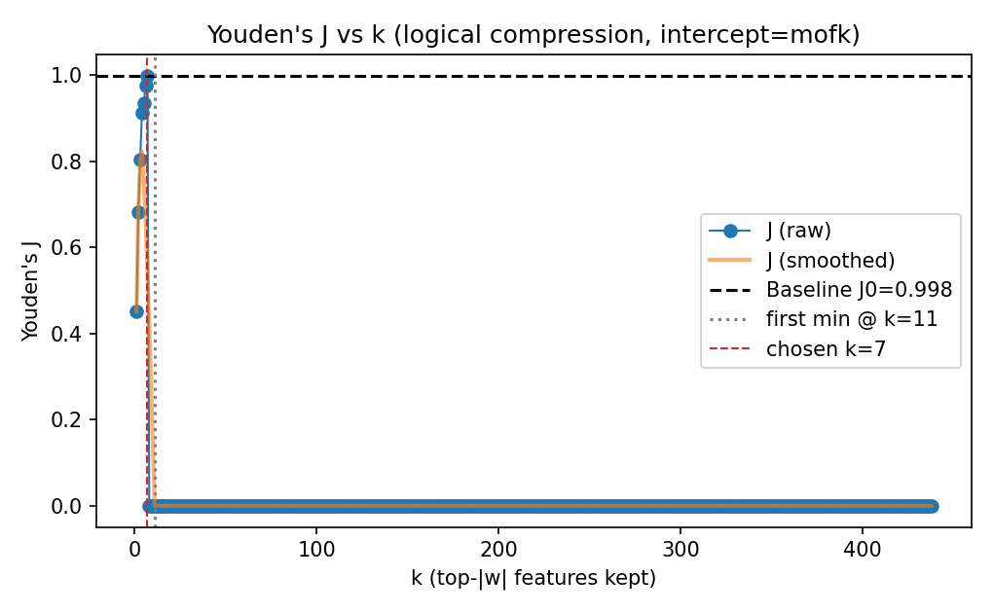
Figure 11. RQ3 results: Youden’s J vs k curve.

8. Proposed Future Work and Evaluation Plan
The prospectus plan emphasizes experiments and analyses that the committee can shape prior to the dissertation defense. Planned work is organized into must-do items needed to complete the dissertation, high-leverage studies that strengthen claims, and stretch goals.

8.1 Must-do items
- RQ1 expansion: quantify selection stability across folds/bootstraps; report stability alongside AUC/J, sparsity, and runtime.
- RQ2 strengthening: extend beyond the zero-threshold proof-of-concept toward non-zero/critical-range thresholds (scope-limited), and clarify assumptions and failure modes.
- RQ3 validation: produce anytime tradeoff curves on at least one real dataset; assess sensitivity to vote magnitude K, intercept policy, and adoption tolerance.

8.2 High-leverage experiments (committee-guided)
These studies are designed to isolate causal contributions and clarify generalization. Committee input is requested to prioritize them.
- Ablation study: isolate the contribution of each stage—raw+L1, rectified+L1, rectified+L1+polish, and (optional) raw+L1+polish—across metrics, complexity, and stability.
- Baseline pack: elastic net [13], stability selection, and at least one scalable rule learner (e.g., rule lists) for interpretability comparison [19].
- Distribution shift test: learn critical ranges on one period/site and evaluate on another to assess robustness.
- Non-independence extension: demonstrate a multivariate or interaction-aware critical region on a focused case study; compare to independent-feature ranges.
- AUC/J operating-point analysis: show how rule models trade sensitivity/specificity across thresholds and how this maps to domain requirements.

8.3 Limitations and risk mitigation
Several limitations are anticipated, along with mitigations that will be incorporated into the dissertation evaluation:
- Outliers and brittle ranges: use robust quantiles or trimmed ranges; evaluate sensitivity to range estimation.
- Multiple triggers (OR structure): expand the feature set with contracted range variants and evaluate when this is necessary; use compression to restore interpretability.
- Negative-correlation edge cases: include complement indicators where appropriate; report behavior on synthetic negative-correlation regimes.
- Non-threshold regimes: quantify when binarization loses information (e.g., UNICEF-like settings) and characterize the interpretability–accuracy trade-off.

8.4 Reproducibility plan
All experiments will be implemented with a reproducible workflow including fixed random seeds, versioned datasets/partitions, and automated reporting of metrics, plots, and selected features/ranges. The intent is to package the rectification, fitting, and polishing steps into a reusable library with an experiment harness to enable repeatability and facilitate committee review.

9. Timeline and Milestones
The target schedule aligns with program milestones leading to the dissertation defense and graduation. Dates will be updated based on committee feedback.
Milestone | Target Date | Deliverable
Prospectus defense | 23 Feb 2026 | Committee feedback and approval to proceed
D3 submission | 06 Mar 2026 | Official prospectus paperwork
RQ1 stability + ablations | Mar–Apr 2026 | Stability/ablation report; updated experiments
RQ2 theory extensions | Apr–May 2026 | Non-zero threshold analysis and writeup
RQ3 real-data anytime curves | May–Jun 2026 | Rule-compression evaluation on real dataset(s)
Dissertation draft to committee | 03 Jul 2026 | Full dissertation draft
Dissertation defense | 17 Jul 2026 | Final defense
Graduation | 28 Aug 2026 | Degree conferral
Table 2. Proposed timeline to graduation (subject to committee guidance).

10. Expected Contributions
If completed as proposed, the dissertation will contribute:
- A critical-range rectification framework for longitudinal feature selection with explicit lag attribution and actionable ranges.
- A proof-of-concept theoretical explanation linking binarization to correlation contraction, improved conditioning, and increased likelihood of satisfying the LASSO IC.
- An anytime rule compression method that converts sparse rectified models into compact logical rules while preserving operating performance (AUC/J) within practical tolerance.
- A reproducible implementation and evaluation harness supporting deployment under constrained compute and enabling repeatable scientific comparisons.
- A python package which implements these algorithms and provides a straightforward means of validation and extension of these results.

References
[1] J. Orender, J. Sun, and M. Zubair, “Efficient Longitudinal Feature Selection via Binarized Transformation: Theory and Case Studies,” IEEE Big Data, 2025.
[2] J. Orender, J. Sun, and M. Zubair, “Anytime Rule Compression and Rectified Logistic Modeling for Longitudinal Signals,” 1st International Conference on Big Data Analytics and Applications (BDAA), 2025.
[3] J. Orender, M. Zubair, and J. Sun, “LASSO Logic Engine: harnessing the logic parsing capabilities of the LASSO algorithm for longitudinal feature learning,” IEEE International Conference on Big Data, 2022, pp. 309–318.
[4] R. Tibshirani, “Regression shrinkage and selection via the lasso,” Journal of the Royal Statistical Society: Series B, vol. 58, no. 1, pp. 267–288, 1996.
[5] J. Friedman, T. Hastie, and R. Tibshirani, “Regularization paths for generalized linear models via coordinate descent,” Journal of Statistical Software, vol. 33, no. 1, pp. 1–22, 2010.
[6] P. Zhao and B. Yu, “On model selection consistency of lasso,” Journal of Machine Learning Research, vol. 7, pp. 2541–2563, 2006.
[7] C. Rudin, “Stop explaining black box machine learning models for high stakes decisions and use interpretable models instead,” Nature Machine Intelligence, vol. 1, no. 5, pp. 206–215, 2019.
[8] W. J. Murdoch, C. Singh, K. Kumbier, R. Abbasi-Asl, and B. Yu, “Definitions, methods, and applications in interpretable machine learning,” Proceedings of the National Academy of Sciences, vol. 116, no. 44, pp. 22071–22080, 2019.
[9] A. Katrutsa and V. Strijov, “Comprehensive study of feature selection methods to solve multicollinearity problem according to evaluation criteria,” Expert Systems with Applications, vol. 76, pp. 1–11, 2017.
[10] M. Yuan and Y. Lin, “Model selection and estimation in regression with grouped variables,” Journal of the Royal Statistical Society: Series B, vol. 68, no. 1, pp. 49–67, 2006.
[11] L. Meier, S. van de Geer, and P. Bühlmann, “The group lasso for logistic regression,” Journal of the Royal Statistical Society: Series B, vol. 70, no. 1, pp. 53–71, 2008.
[12] R. Tibshirani and X. Suo, “An ordered lasso and sparse time-lagged regression,” Technometrics, vol. 58, no. 4, pp. 415–423, 2016.
[13] H. Zou and T. Hastie, “Regularization and variable selection via the elastic net,” Journal of the Royal Statistical Society: Series B, vol. 67, no. 2, pp. 301–320, 2005.
[14] H. Zou, “The adaptive lasso and its oracle properties,” Journal of the American Statistical Association, vol. 101, no. 476, pp. 1418–1429, 2006.
[15] M. Rejchel and M. Bogdan, “Rank-based lasso: Efficient methods for high-dimensional robust model selection,” Journal of Machine Learning Research, vol. 21, no. 244, pp. 1–47, 2020.
[16] H. Zhu, W. Xu, Z. Zhang, Y. Xu, and J. Fan, “A variable selection approach for highly correlated predictors in high-dimensional genomic data,” Bioinformatics, vol. 37, no. 16, pp. 2238–2244, 2021.
[17] L. Freijeiro-González, M. Febrero-Bande, and W. González-Manteiga, “A critical review of lasso and its derivatives for variable selection under dependence among covariates,” International Statistical Review, vol. 90, no. 1, pp. 118–145, 2022.
[18] L. Ladha and T. Deepa, “Feature selection methods and algorithms,” International Journal on Computer Science and Engineering, vol. 3, no. 5, pp. 1787–1797, 2011.
[19] E. Angelino, N. Larus-Stone, D. Alabi, M. Seltzer, and C. Rudin, “Learning certifiably optimal rule lists for categorical data,” Journal of Machine Learning Research, vol. 18, no. 234, pp. 1–78, 2018.
[20] H. Shin, W. Lee, J. Yun, and H. Kim, “HAI 1.0: HIL-based augmented ICS security dataset,” USENIX Workshop on Cyber Security Experimentation and Test (CSET), 2020.
[21] D. J. Schuirmann, “A comparison of the two one-sided tests procedure and the power approach for assessing the equivalence of average bioavailability,” Journal of Pharmacokinetics and Biopharmaceutics, vol. 15, no. 6, pp. 657–680, 1987.
[22] R. Student, “The probable error of a mean,” Biometrika, vol. 6, no. 1, pp. 1–25, 1908.
[23] R. A. Horn and C. R. Johnson, Matrix Analysis, 2nd ed. Cambridge University Press, 2012.
[24] W. Feller, An Introduction to Probability Theory and Its Applications, vol. 2. Wiley, 1991.
[25] H. Hotelling, “Relations between two sets of variates,” in Breakthroughs in Statistics: Methodology and Distribution, Springer, 2012 (original work published 1936).
[26] E. Boros, P. L. Hammer, T. Ibaraki, A. Kogan, E. Mayoraz, and I. Muchnik, “An implementation of logical analysis of data,” IEEE Transactions on Knowledge and Data Engineering, vol. 12, no. 2, pp. 292–306, 2000.
[27] E. Boros, P. L. Hammer, T. Ibaraki, and A. Kogan, “Logical analysis of numerical data,” Mathematical Programming, vol. 79, no. 1–3, pp. 163–190, 1997.
[28] A. Y. Ng, “Feature selection, L1 vs. L2 regularization, and rotational invariance,” in Proc. ICML, 2004.

