Multiple Linear Regression

Je’Kolby Worthy

2/1/2021

# Module 2, Assignment 2

## Je’Kolby Worthy

### Multiple Linear Regression

library(tidyverse)

## ── Attaching packages ─────────────────────────────────────── tidyverse 1.3.0 ──

## ✓ ggplot2 3.3.3 ✓ purrr 0.3.4  
## ✓ tibble 3.0.5 ✓ dplyr 1.0.3  
## ✓ tidyr 1.1.2 ✓ stringr 1.4.0  
## ✓ readr 1.4.0 ✓ forcats 0.5.0

## ── Conflicts ────────────────────────────────────────── tidyverse_conflicts() ──  
## x dplyr::filter() masks stats::filter()  
## x dplyr::lag() masks stats::lag()

library(tidymodels)

## ── Attaching packages ────────────────────────────────────── tidymodels 0.1.2 ──

## ✓ broom 0.7.3 ✓ recipes 0.1.15  
## ✓ dials 0.0.9 ✓ rsample 0.0.8   
## ✓ infer 0.5.4 ✓ tune 0.1.2   
## ✓ modeldata 0.1.0 ✓ workflows 0.2.1   
## ✓ parsnip 0.1.5 ✓ yardstick 0.0.7

## ── Conflicts ───────────────────────────────────────── tidymodels_conflicts() ──  
## x scales::discard() masks purrr::discard()  
## x dplyr::filter() masks stats::filter()  
## x recipes::fixed() masks stringr::fixed()  
## x dplyr::lag() masks stats::lag()  
## x yardstick::spec() masks readr::spec()  
## x recipes::step() masks stats::step()

library(glmnet)

## Loading required package: Matrix

##   
## Attaching package: 'Matrix'

## The following objects are masked from 'package:tidyr':  
##   
## expand, pack, unpack

## Loaded glmnet 4.1

library(GGally)

## Registered S3 method overwritten by 'GGally':  
## method from   
## +.gg ggplot2

library(ggcorrplot)   
library(MASS)

##   
## Attaching package: 'MASS'

## The following object is masked from 'package:dplyr':  
##   
## select

library(car)

## Loading required package: carData

##   
## Attaching package: 'car'

## The following object is masked from 'package:dplyr':  
##   
## recode

## The following object is masked from 'package:purrr':  
##   
## some

library(lubridate)

##   
## Attaching package: 'lubridate'

## The following objects are masked from 'package:base':  
##   
## date, intersect, setdiff, union

library(lmtest)

## Loading required package: zoo

##   
## Attaching package: 'zoo'

## The following objects are masked from 'package:base':  
##   
## as.Date, as.Date.numeric

**# Task 1**

bike = bike_cleaned <- read_csv("bike_cleaned.csv")

##   
## ── Column specification ────────────────────────────────────────────────────────  
## cols(  
## instant = col_double(),  
## dteday = col_character(),  
## season = col_character(),  
## mnth = col_character(),  
## hr = col_double(),  
## holiday = col_character(),  
## weekday = col_character(),  
## workingday = col_character(),  
## weathersit = col_character(),  
## temp = col_double(),  
## atemp = col_double(),  
## hum = col_double(),  
## windspeed = col_double(),  
## casual = col_double(),  
## registered = col_double(),  
## count = col_double()  
## )

bike = bike %>% mutate(dteday = mdy(dteday))   
str(bike)

## tibble [17,379 × 16] (S3: spec_tbl_df/tbl_df/tbl/data.frame)  
## $ instant : num [1:17379] 1 2 3 4 5 6 7 8 9 10 ...  
## $ dteday : Date[1:17379], format: "2011-01-01" "2011-01-01" ...  
## $ season : chr [1:17379] "Winter" "Winter" "Winter" "Winter" ...  
## $ mnth : chr [1:17379] "Jan" "Jan" "Jan" "Jan" ...  
## $ hr : num [1:17379] 0 1 2 3 4 5 6 7 8 9 ...  
## $ holiday : chr [1:17379] "NotHoliday" "NotHoliday" "NotHoliday" "NotHoliday" ...  
## $ weekday : chr [1:17379] "Saturday" "Saturday" "Saturday" "Saturday" ...  
## $ workingday: chr [1:17379] "NotWorkingDay" "NotWorkingDay" "NotWorkingDay" "NotWorkingDay" ...  
## $ weathersit: chr [1:17379] "NoPrecip" "NoPrecip" "NoPrecip" "NoPrecip" ...  
## $ temp : num [1:17379] 0.24 0.22 0.22 0.24 0.24 0.24 0.22 0.2 0.24 0.32 ...  
## $ atemp : num [1:17379] 0.288 0.273 0.273 0.288 0.288 ...  
## $ hum : num [1:17379] 0.81 0.8 0.8 0.75 0.75 0.75 0.8 0.86 0.75 0.76 ...  
## $ windspeed : num [1:17379] 0 0 0 0 0 0.0896 0 0 0 0 ...  
## $ casual : num [1:17379] 3 8 5 3 0 0 2 1 1 8 ...  
## $ registered: num [1:17379] 13 32 27 10 1 1 0 2 7 6 ...  
## $ count : num [1:17379] 16 40 32 13 1 1 2 3 8 14 ...  
## - attr(*, "spec")=  
## .. cols(  
## .. instant = col_double(),  
## .. dteday = col_character(),  
## .. season = col_character(),  
## .. mnth = col_character(),  
## .. hr = col_double(),  
## .. holiday = col_character(),  
## .. weekday = col_character(),  
## .. workingday = col_character(),  
## .. weathersit = col_character(),  
## .. temp = col_double(),  
## .. atemp = col_double(),  
## .. hum = col_double(),  
## .. windspeed = col_double(),  
## .. casual = col_double(),  
## .. registered = col_double(),  
## .. count = col_double()  
## .. )

bike = bike %>% mutate_if(is.character,as_factor)  
bike = bike %>% mutate(hr = as_factor(hr))  
str(bike)

## tibble [17,379 × 16] (S3: spec_tbl_df/tbl_df/tbl/data.frame)  
## $ instant : num [1:17379] 1 2 3 4 5 6 7 8 9 10 ...  
## $ dteday : Date[1:17379], format: "2011-01-01" "2011-01-01" ...  
## $ season : Factor w/ 4 levels "Winter","Spring",..: 1 1 1 1 1 1 1 1 1 1 ...  
## $ mnth : Factor w/ 12 levels "Jan","Feb","Mar",..: 1 1 1 1 1 1 1 1 1 1 ...  
## $ hr : Factor w/ 24 levels "0","1","2","3",..: 1 2 3 4 5 6 7 8 9 10 ...  
## $ holiday : Factor w/ 2 levels "NotHoliday","Holiday": 1 1 1 1 1 1 1 1 1 1 ...  
## $ weekday : Factor w/ 7 levels "Saturday","Sunday",..: 1 1 1 1 1 1 1 1 1 1 ...  
## $ workingday: Factor w/ 2 levels "NotWorkingDay",..: 1 1 1 1 1 1 1 1 1 1 ...  
## $ weathersit: Factor w/ 4 levels "NoPrecip","Misty",..: 1 1 1 1 1 2 1 1 1 1 ...  
## $ temp : num [1:17379] 0.24 0.22 0.22 0.24 0.24 0.24 0.22 0.2 0.24 0.32 ...  
## $ atemp : num [1:17379] 0.288 0.273 0.273 0.288 0.288 ...  
## $ hum : num [1:17379] 0.81 0.8 0.8 0.75 0.75 0.75 0.8 0.86 0.75 0.76 ...  
## $ windspeed : num [1:17379] 0 0 0 0 0 0.0896 0 0 0 0 ...  
## $ casual : num [1:17379] 3 8 5 3 0 0 2 1 1 8 ...  
## $ registered: num [1:17379] 13 32 27 10 1 1 0 2 7 6 ...  
## $ count : num [1:17379] 16 40 32 13 1 1 2 3 8 14 ...  
## - attr(*, "spec")=  
## .. cols(  
## .. instant = col_double(),  
## .. dteday = col_character(),  
## .. season = col_character(),  
## .. mnth = col_character(),  
## .. hr = col_double(),  
## .. holiday = col_character(),  
## .. weekday = col_character(),  
## .. workingday = col_character(),  
## .. weathersit = col_character(),  
## .. temp = col_double(),  
## .. atemp = col_double(),  
## .. hum = col_double(),  
## .. windspeed = col_double(),  
## .. casual = col_double(),  
## .. registered = col_double(),  
## .. count = col_double()  
## .. )

Why do we convert the “hr” variable into factor? Why not just leave as numbers? **We convert the “hr” variable into factor, because it is a categorical variable and not a numeric variable.**

ggpairs(bike, columns = c(1,10,11,12,13,16))

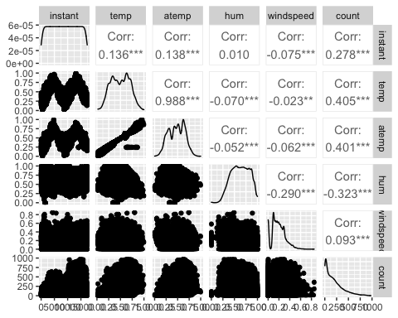

**# Task 2**

Which of the quantitative variables appears to be best correlated with “count” (ignore the “registered” and “casual” variable as the sum of these two variables equals “count”)? **The temperature variable appears to be the best correlated with count.**

**# Task 3**

ggplot(bike,aes(x=hr,y=count)) + geom_boxplot() + theme_bw()

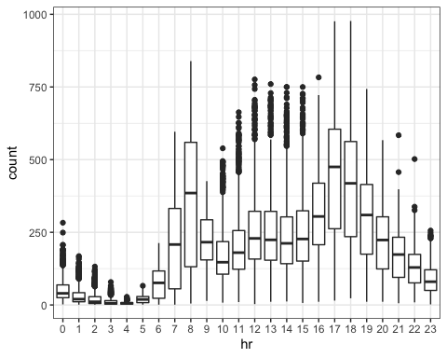

ggplot(bike,aes(x=season,y=count)) + geom_boxplot() + theme_bw()

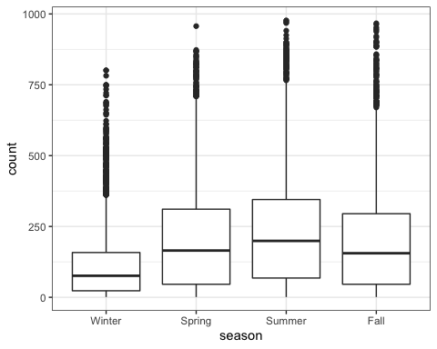

ggplot(bike,aes(x=mnth,y=count)) + geom_boxplot() + theme_bw()

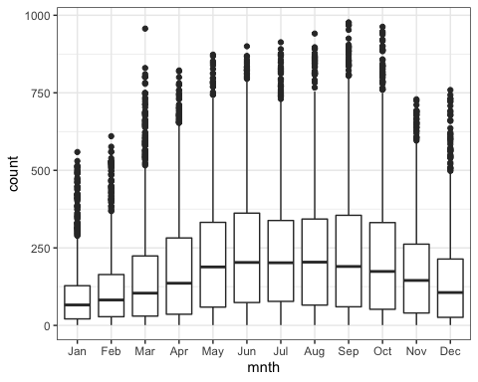

ggplot(bike,aes(x=holiday,y=count)) + geom_boxplot() + theme_bw()

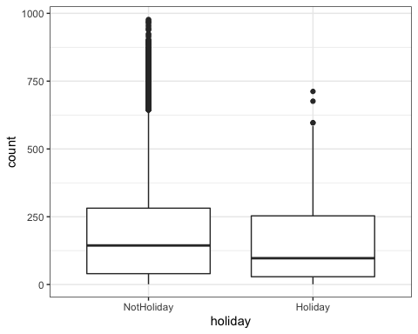

ggplot(bike,aes(x=weekday,y=count)) + geom_boxplot() + theme_bw()

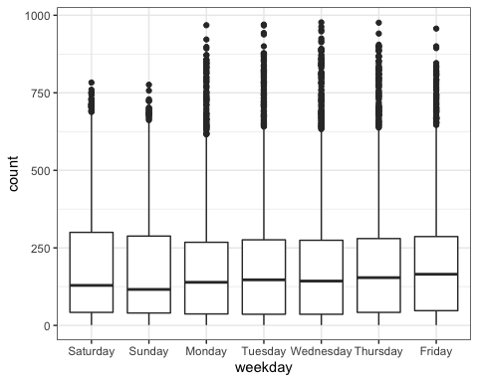

ggplot(bike,aes(x=workingday,y=count)) + geom_boxplot() + theme_bw()

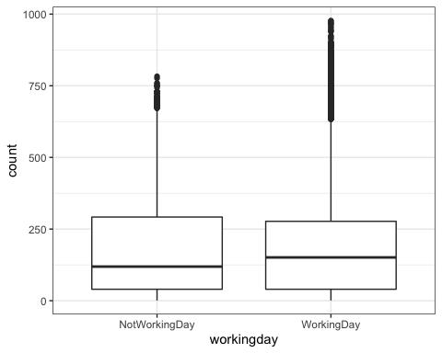

ggplot(bike,aes(x=weathersit,y=count)) + geom_boxplot() + theme_bw()

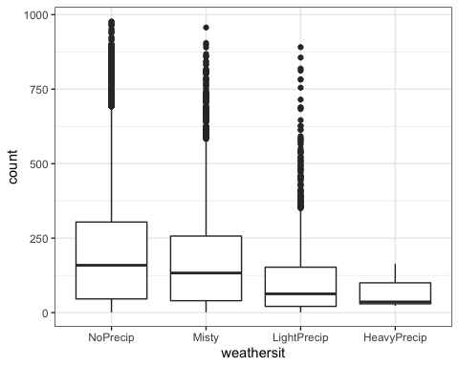 Which variables appear to affect “count”? Provide a brief explanation as to why you believe that each variable does or does not affect “count”. **The count is clearly affected by month, season, weathersit and workday variables. A strong correlation between temp and count is formed by looking at our quantitative variables. The variables of season, weathersit, and months all are factors that tie in together as they are all weather-related.**

# Task 4

bike_count_recipe = recipe(count ~ hr, bike)   
  
lm_model =  
 linear_reg() %>%  
 set_engine("lm")  
  
 lm_wflow =  
 workflow()%>%  
 add_model(lm_model)%>%  
 add_recipe(bike_count_recipe)  
   
 lm_fit = fit(lm_wflow, bike)

summary(lm_fit$fit$fit$fit)

##   
## Call:  
## stats::lm(formula = ..y ~ ., data = data)  
##   
## Residuals:  
## Min 1Q Median 3Q Max   
## -446.45 -60.99 -6.01 50.10 551.49   
##   
## Coefficients:  
## Estimate Std. Error t value Pr(>|t|)   
## (Intercept) 53.898 4.756 11.332 < 2e-16 ***  
## hr1 -20.522 6.731 -3.049 0.002300 **   
## hr2 -31.028 6.752 -4.595 4.35e-06 ***  
## hr3 -42.171 6.796 -6.205 5.58e-10 ***  
## hr4 -47.545 6.796 -6.996 2.73e-12 ***  
## hr5 -34.008 6.747 -5.040 4.70e-07 ***  
## hr6 22.146 6.729 3.291 0.000999 ***  
## hr7 158.167 6.724 23.523 < 2e-16 ***  
## hr8 305.113 6.724 45.377 < 2e-16 ***  
## hr9 165.411 6.724 24.600 < 2e-16 ***  
## hr10 119.770 6.724 17.812 < 2e-16 ***  
## hr11 154.245 6.724 22.939 < 2e-16 ***  
## hr12 199.418 6.722 29.668 < 2e-16 ***  
## hr13 199.763 6.719 29.729 < 2e-16 ***  
## hr14 187.051 6.719 27.838 < 2e-16 ***  
## hr15 197.335 6.719 29.368 < 2e-16 ***  
## hr16 258.085 6.717 38.422 < 2e-16 ***  
## hr17 407.554 6.717 60.674 < 2e-16 ***  
## hr18 371.613 6.722 55.286 < 2e-16 ***  
## hr19 257.625 6.722 38.327 < 2e-16 ***  
## hr20 172.132 6.722 25.608 < 2e-16 ***  
## hr21 118.416 6.722 17.617 < 2e-16 ***  
## hr22 77.437 6.722 11.520 < 2e-16 ***  
## hr23 33.933 6.722 5.048 4.50e-07 ***  
## ---  
## Signif. codes: 0 '***' 0.001 '**' 0.01 '*' 0.05 '.' 0.1 ' ' 1  
##   
## Residual standard error: 128.2 on 17355 degrees of freedom  
## Multiple R-squared: 0.5015, Adjusted R-squared: 0.5008   
## F-statistic: 759.1 on 23 and 17355 DF, p-value: < 2.2e-16

**Suggesting that this is a successful model. R-squared values that are less than 0.5 were shown when I plugged into the model month, season, and working day.**

#Task 5

bike2 = bike %>% dplyr::select("season", "mnth", "hr", "holiday", "weekday","workingday", "weathersit", "temp", "atemp", "hum", "windspeed", "count")  
summary(bike2)

## season mnth hr holiday   
## Winter:4242 May :1488 16 : 730 NotHoliday:16879   
## Spring:4409 Jul :1488 17 : 730 Holiday : 500   
## Summer:4496 Dec :1483 13 : 729   
## Fall :4232 Aug :1475 14 : 729   
## Mar :1473 15 : 729   
## Oct :1451 12 : 728   
## (Other):8521 (Other):13004   
## weekday workingday weathersit temp   
## Saturday :2512 NotWorkingDay: 5514 NoPrecip :11413 Min. :0.020   
## Sunday :2502 WorkingDay :11865 Misty : 4544 1st Qu.:0.340   
## Monday :2479 LightPrecip: 1419 Median :0.500   
## Tuesday :2453 HeavyPrecip: 3 Mean :0.497   
## Wednesday:2475 3rd Qu.:0.660   
## Thursday :2471 Max. :1.000   
## Friday :2487   
## atemp hum windspeed count   
## Min. :0.0000 Min. :0.0000 Min. :0.0000 Min. : 1.0   
## 1st Qu.:0.3333 1st Qu.:0.4800 1st Qu.:0.1045 1st Qu.: 40.0   
## Median :0.4848 Median :0.6300 Median :0.1940 Median :142.0   
## Mean :0.4758 Mean :0.6272 Mean :0.1901 Mean :189.5   
## 3rd Qu.:0.6212 3rd Qu.:0.7800 3rd Qu.:0.2537 3rd Qu.:281.0   
## Max. :1.0000 Max. :1.0000 Max. :0.8507 Max. :977.0   
##

glimpse(bike2)

## Rows: 17,379  
## Columns: 12  
## $ season <fct> Winter, Winter, Winter, Winter, Winter, Winter, Winter, Wi…  
## $ mnth <fct> Jan, Jan, Jan, Jan, Jan, Jan, Jan, Jan, Jan, Jan, Jan, Jan…  
## $ hr <fct> 0, 1, 2, 3, 4, 5, 6, 7, 8, 9, 10, 11, 12, 13, 14, 15, 16, …  
## $ holiday <fct> NotHoliday, NotHoliday, NotHoliday, NotHoliday, NotHoliday…  
## $ weekday <fct> Saturday, Saturday, Saturday, Saturday, Saturday, Saturday…  
## $ workingday <fct> NotWorkingDay, NotWorkingDay, NotWorkingDay, NotWorkingDay…  
## $ weathersit <fct> NoPrecip, NoPrecip, NoPrecip, NoPrecip, NoPrecip, Misty, N…  
## $ temp <dbl> 0.24, 0.22, 0.22, 0.24, 0.24, 0.24, 0.22, 0.20, 0.24, 0.32…  
## $ atemp <dbl> 0.2879, 0.2727, 0.2727, 0.2879, 0.2879, 0.2576, 0.2727, 0.…  
## $ hum <dbl> 0.81, 0.80, 0.80, 0.75, 0.75, 0.75, 0.80, 0.86, 0.75, 0.76…  
## $ windspeed <dbl> 0.0000, 0.0000, 0.0000, 0.0000, 0.0000, 0.0896, 0.0000, 0.…  
## $ count <dbl> 16, 40, 32, 13, 1, 1, 2, 3, 8, 14, 36, 56, 84, 94, 106, 11…

bike2_recipe= recipe(count ~ season +mnth + hr + holiday + weekday + workingday + weathersit + temp + atemp + hum + windspeed, bike2) %>%   
 step_other(hr, season, mnth, holiday, weekday, threshold = 0.01) %>%  
 step_dummy(all_nominal())%>%  
 step_center(all_predictors())%>%  
 step_scale(all_predictors())  
  
ridge_model =   
 linear_reg(mixture = 0)%>%  
 set_engine("glmnet")  
  
ridge_wflow =   
 workflow()%>%  
 add_model(ridge_model)%>%  
 add_recipe(bike2_recipe)  
  
ridge_fit = fit(ridge_wflow, bike2)  
  
ridge_fit

## ══ Workflow [trained] ══════════════════════════════════════════════════════════  
## Preprocessor: Recipe  
## Model: linear_reg()  
##   
## ── Preprocessor ────────────────────────────────────────────────────────────────  
## 4 Recipe Steps  
##   
## ● step_other()  
## ● step_dummy()  
## ● step_center()  
## ● step_scale()  
##   
## ── Model ───────────────────────────────────────────────────────────────────────  
##   
## Call: glmnet::glmnet(x = maybe_matrix(x), y = y, family = "gaussian", alpha = ~0)   
##   
## Df %Dev Lambda  
## 1 52 0.00 73420  
## 2 52 0.56 66900  
## 3 52 0.61 60950  
## 4 52 0.67 55540  
## 5 52 0.74 50600  
## 6 52 0.81 46110  
## 7 52 0.89 42010  
## 8 52 0.97 38280  
## 9 52 1.07 34880  
## 10 52 1.17 31780  
## 11 52 1.28 28960  
## 12 52 1.40 26390  
## 13 52 1.54 24040  
## 14 52 1.68 21910  
## 15 52 1.84 19960  
## 16 52 2.01 18190  
## 17 52 2.20 16570  
## 18 52 2.41 15100  
## 19 52 2.64 13760  
## 20 52 2.88 12540  
## 21 52 3.15 11420  
## 22 52 3.44 10410  
## 23 52 3.75 9482  
## 24 52 4.10 8640  
## 25 52 4.47 7872  
## 26 52 4.87 7173  
## 27 52 5.31 6536  
## 28 52 5.78 5955  
## 29 52 6.29 5426  
## 30 52 6.83 4944  
## 31 52 7.42 4505  
## 32 52 8.06 4105  
## 33 52 8.73 3740  
## 34 52 9.46 3408  
## 35 52 10.24 3105  
## 36 52 11.07 2829  
## 37 52 11.95 2578  
## 38 52 12.88 2349  
## 39 52 13.88 2140  
## 40 52 14.92 1950  
## 41 52 16.02 1777  
## 42 52 17.18 1619  
## 43 52 18.39 1475  
## 44 52 19.65 1344  
## 45 52 20.96 1225  
## 46 52 22.32 1116  
##   
## ...  
## and 54 more lines.

plot(ridge_fit$fit$fit$fit$lambda,ridge_fit$fit$fit$fit$dev.ratio)

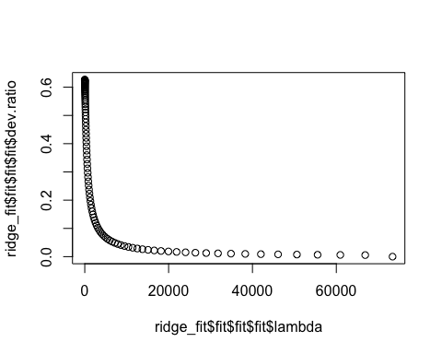

ridge_fit%>%  
 pull_workflow_fit()%>%  
 pluck("fit") %>%  
 coef(s=13)

## 53 x 1 sparse Matrix of class "dgCMatrix"  
## 1  
## (Intercept) 189.4630876  
## temp 28.4366729  
## atemp 26.6537839  
## hum -24.4557593  
## windspeed -3.2276179  
## season_Spring 10.0892335  
## season_Summer 3.5388436  
## season_Fall 19.4971495  
## mnth_Feb -1.1205294  
## mnth_Mar 1.6701576  
## mnth_Apr 0.7531169  
## mnth_May 3.9377605  
## mnth_Jun -1.2860739  
## mnth_Jul -5.6065875  
## mnth_Aug 1.1769839  
## mnth_Sep 9.1250536  
## mnth_Oct 5.8072456  
## mnth_Nov 0.5414665  
## mnth_Dec 0.3570480  
## hr_X1 -17.2361977  
## hr_X2 -18.5649284  
## hr_X3 -20.1161969  
## hr_X4 -20.4280957  
## hr_X5 -17.6649021  
## hr_X6 -6.8380221  
## hr_X7 18.2005321  
## hr_X8 44.1092996  
## hr_X9 15.8610480  
## hr_X10 5.0301781  
## hr_X11 9.2069250  
## hr_X12 16.0731648  
## hr_X13 14.8202446  
## hr_X14 11.6307273  
## hr_X15 13.3428717  
## hr_X16 25.0999101  
## hr_X17 54.2019963  
## hr_X18 48.4809099  
## hr_X19 28.6256311  
## hr_X20 14.1045184  
## hr_X21 5.2283682  
## hr_X22 -1.4023523  
## hr_X23 -8.4521997  
## holiday_Holiday -4.3729416  
## weekday_Sunday -4.3754849  
## weekday_Monday -1.5823982  
## weekday_Tuesday -1.0944100  
## weekday_Wednesday -0.1016868  
## weekday_Thursday -0.5675788  
## weekday_Friday 0.9182103  
## workingday_WorkingDay -0.2130578  
## weathersit_Misty -1.6741479  
## weathersit_LightPrecip -14.3539746  
## weathersit_HeavyPrecip -0.2935185

**Only the resulting model, the ridge method gave us a .6224 R-Squared value.**

# Task 6

bike2_recipe= recipe(count ~ season +mnth + hr + holiday + weekday + workingday + weathersit + temp + atemp + hum + windspeed, bike2) %>%   
 step_other(hr, season, mnth, holiday, weekday, threshold = 0.01) %>%  
 step_dummy(all_nominal())%>%  
 step_center(all_predictors())%>%  
 step_scale(all_predictors())  
  
lasso_model =   
 linear_reg(mixture = 0)%>%  
 set_engine("glmnet")  
  
lasso_wflow =   
 workflow()%>%  
 add_model(lasso_model)%>%  
 add_recipe(bike2_recipe)  
  
lasso_fit = fit(lasso_wflow, bike2)  
  
lasso_fit

## ══ Workflow [trained] ══════════════════════════════════════════════════════════  
## Preprocessor: Recipe  
## Model: linear_reg()  
##   
## ── Preprocessor ────────────────────────────────────────────────────────────────  
## 4 Recipe Steps  
##   
## ● step_other()  
## ● step_dummy()  
## ● step_center()  
## ● step_scale()  
##   
## ── Model ───────────────────────────────────────────────────────────────────────  
##   
## Call: glmnet::glmnet(x = maybe_matrix(x), y = y, family = "gaussian", alpha = ~0)   
##   
## Df %Dev Lambda  
## 1 52 0.00 73420  
## 2 52 0.56 66900  
## 3 52 0.61 60950  
## 4 52 0.67 55540  
## 5 52 0.74 50600  
## 6 52 0.81 46110  
## 7 52 0.89 42010  
## 8 52 0.97 38280  
## 9 52 1.07 34880  
## 10 52 1.17 31780  
## 11 52 1.28 28960  
## 12 52 1.40 26390  
## 13 52 1.54 24040  
## 14 52 1.68 21910  
## 15 52 1.84 19960  
## 16 52 2.01 18190  
## 17 52 2.20 16570  
## 18 52 2.41 15100  
## 19 52 2.64 13760  
## 20 52 2.88 12540  
## 21 52 3.15 11420  
## 22 52 3.44 10410  
## 23 52 3.75 9482  
## 24 52 4.10 8640  
## 25 52 4.47 7872  
## 26 52 4.87 7173  
## 27 52 5.31 6536  
## 28 52 5.78 5955  
## 29 52 6.29 5426  
## 30 52 6.83 4944  
## 31 52 7.42 4505  
## 32 52 8.06 4105  
## 33 52 8.73 3740  
## 34 52 9.46 3408  
## 35 52 10.24 3105  
## 36 52 11.07 2829  
## 37 52 11.95 2578  
## 38 52 12.88 2349  
## 39 52 13.88 2140  
## 40 52 14.92 1950  
## 41 52 16.02 1777  
## 42 52 17.18 1619  
## 43 52 18.39 1475  
## 44 52 19.65 1344  
## 45 52 20.96 1225  
## 46 52 22.32 1116  
##   
## ...  
## and 54 more lines.

plot(lasso_fit$fit$fit$fit$lambda,lasso_fit$fit$fit$fit$dev.ratio)

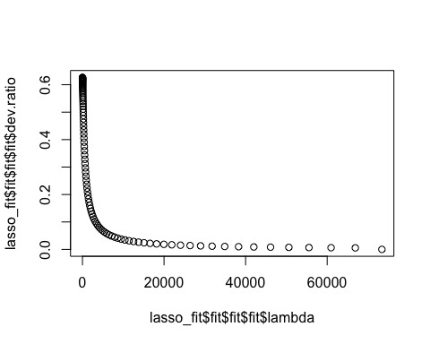

lasso_fit%>%  
 pull_workflow_fit()%>%  
 pluck("fit") %>%  
 coef(s=0.099)

## 53 x 1 sparse Matrix of class "dgCMatrix"  
## 1  
## (Intercept) 189.46308763  
## temp 29.20245544  
## atemp 26.06293119  
## hum -24.02411573  
## windspeed -3.87800912  
## season_Spring 11.56385553  
## season_Summer 5.12303457  
## season_Fall 21.61079740  
## mnth_Feb -0.57273322  
## mnth_Mar 1.97730315  
## mnth_Apr 0.46717771  
## mnth_May 3.57295564  
## mnth_Jun -1.81689943  
## mnth_Jul -6.36382735  
## mnth_Aug 0.60292714  
## mnth_Sep 8.70666364  
## mnth_Oct 5.11081740  
## mnth_Nov -0.24118447  
## mnth_Dec 0.01848549  
## hr_X1 -14.57690878  
## hr_X2 -15.97150761  
## hr_X3 -17.61948790  
## hr_X4 -17.93387085  
## hr_X5 -15.05325064  
## hr_X6 -3.88515083  
## hr_X7 21.89879890  
## hr_X8 48.57031881  
## hr_X9 19.53757041  
## hr_X10 8.41751199  
## hr_X11 12.73165203  
## hr_X12 19.82325747  
## hr_X13 18.54847484  
## hr_X14 15.28215972  
## hr_X15 17.04796419  
## hr_X16 29.14436319  
## hr_X17 59.07733194  
## hr_X18 53.16976131  
## hr_X19 32.71033430  
## hr_X20 17.75013607  
## hr_X21 8.58992286  
## hr_X22 1.75417076  
## hr_X23 -5.50691463  
## holiday_Holiday -4.50101821  
## weekday_Sunday -4.68225822  
## weekday_Monday -1.66004834  
## weekday_Tuesday -1.18595324  
## weekday_Wednesday -0.16007998  
## weekday_Thursday -0.64232222  
## weekday_Friday 0.89945579  
## workingday_WorkingDay -0.40003129  
## weathersit_Misty -1.94474327  
## weathersit_LightPrecip -15.02430431  
## weathersit_HeavyPrecip -0.31734519

What are the implications of the model results from the ridge and lasso methods? **Wednesday was dropped off the lasso model, and we now have an R-Squared value of 0.6321, which is higher than my previous ridge model which was an R-Squared value of 0.62244.**