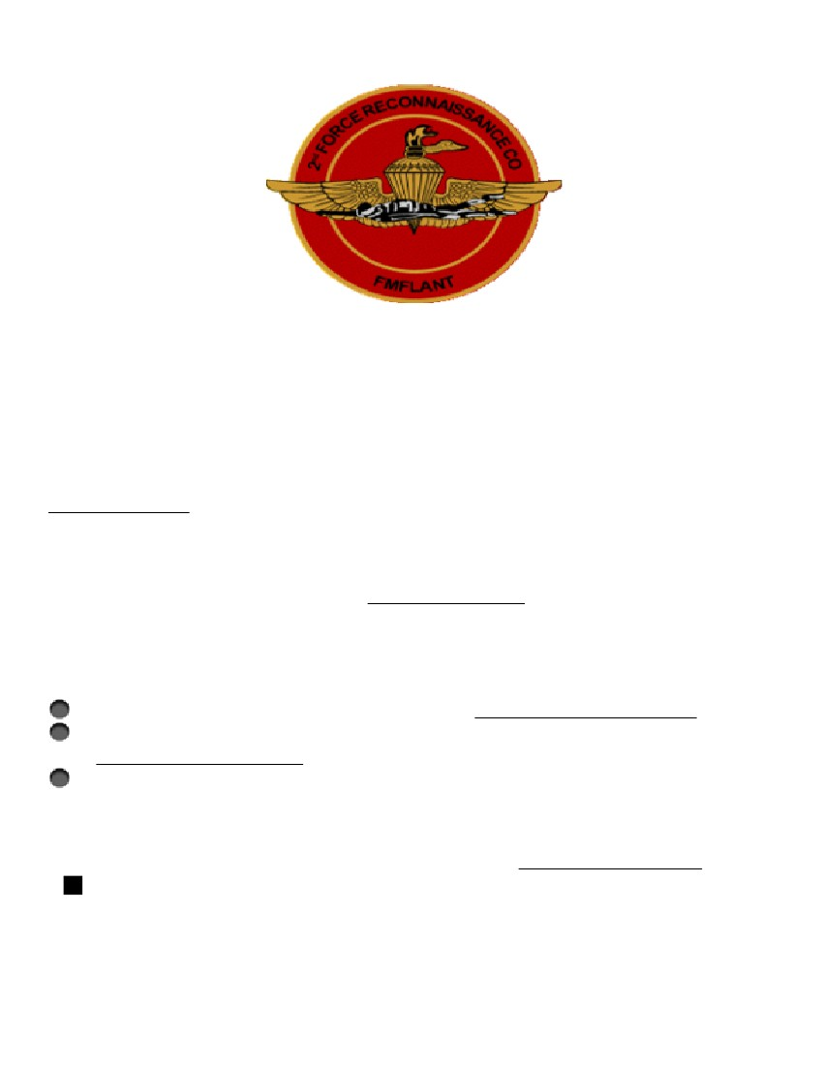
RSVP

90 Day Warning Order
2d Force Recon Marines & Guests
6th Annual Reunion
18-20 May 2017
Concept of ops
18th. Thur. 0800-1300 Pistol, Rifle Shoot @ Flatwoods range.
18th. Thur. 1300 6th Annual ForRecCo Golf Classic, @Northshore.
19th. Fri. 0900-1400 Deep Sea Fishing $70 each, (10 pax min,50 max)
view trip @ Queen Jean.com
19th Fri. 0900-1300 2d Force Recon Company tour @ 2d Recon Bn.
20th Sat. 1300 Reunion Picnic and Memoriam @FOB CAPERS.
All activities in the vicinity of Jacksonville, NC
Golf, call Alan Classon at (239) 980-3486 classon.sgt@gmail.com
Fishing, RSVP NLT 1 Apr w/ Phil Smith at (540)-498-0733
jarhed73@yahoo.com. RSVP A MUST TO FISH.
Rooms, (70’s) RSVP NLT 15 Mar w/Tom Chepurko.
tomchepurko@gmail.com or (443) 994-6656. If you desire to stay
in
condo with specific friends, have a single POC/condo inform Tom.
(80’s) RSVP w/Scott Nyman (910) 938-2529 snyman@ec.rr.com
RSVP for Reunion and events, Fishing trip by 1 Apr!
More details and directions at 30 dayWO
Don't miss link—up!

