3D Modeling and Camera Manipulation

Jacob Regan

For this project, we designed a 3D model of a small solar system using OpenGL. For my implementation, I built the system shown, consisting of 2 spherical planets, each with their own orbiting moon, one pentagonal prism planet textured with my face, and a sun at the center around which all the planets orbit.

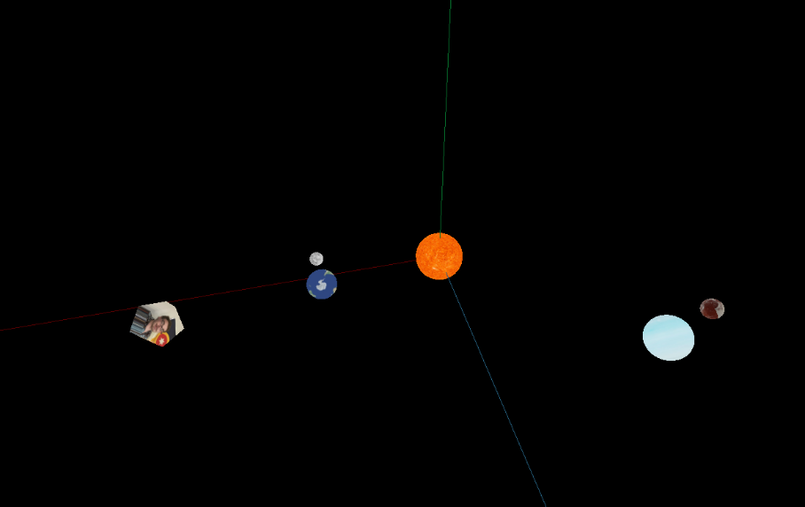As we can see, the closest planet has an earth texture, and its moon has a standard texture map for the moon. The middle planet has a map for Neptune, with a moon that has a texture map for Pluto. The sun has a standard texture map and the prism shows a map of my face.

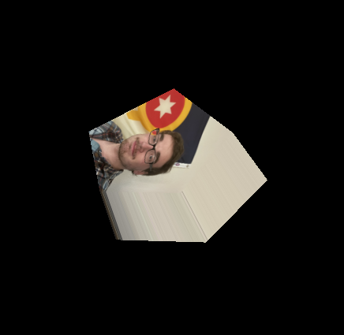Each orbiting body has its own orbital speed, rotational speed, rotational direction, and orbital distance. For the spheres, the shape.Sphere class from graphicslib3d was used. For the pentagonal prism planet, I wrote a class extending the shape class for the pentagonal shape, which can be seen in the outer orbiting body, as shown to the right.

As far as the approach, the controls navigation were implemented using the KeyListener, which spoke to a custom Camera class that updates the camera’s position based on the keyboard input. The matrix updates are handled using a matrix stack for the celestial objects, and the unique properties for each object are updated by popping off the stack.

