Lights, Materials, Textures, and Skyboxes

Jacob Regan

For this project, we created a scene with multiple objects lit with scene lighting and containing a skybox in the background. I used project 2 as a basis and modified it so it contains two planets with different textures and the imported space shuttle object from the example project. The lit scene is shown below:

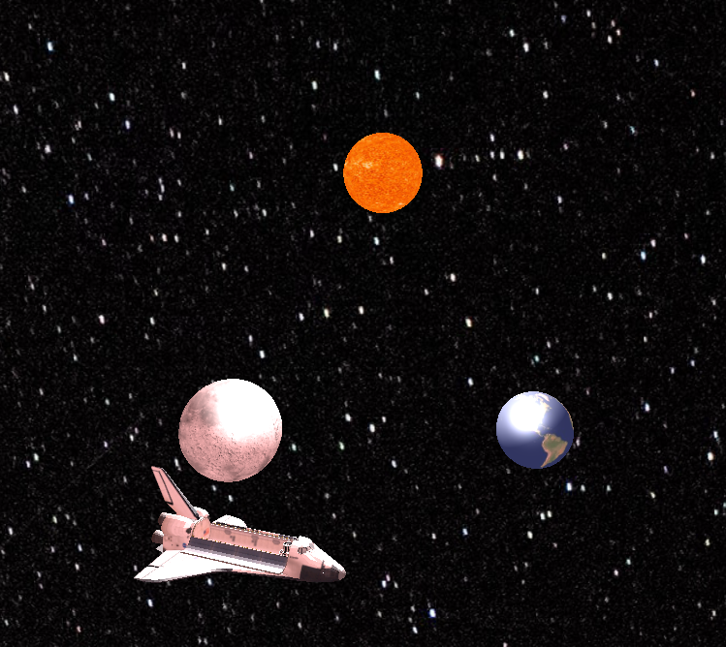

As we can see, there is a shading effect cast on the ship and planets by the sun above, which is set as the source for the positional light. We can toggle it in the scene using spacebar, resulting in the following:

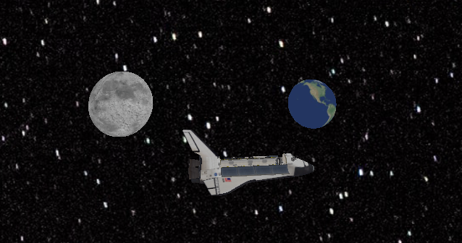

When the positional light it toggled off, only the lower objects remain, and they are only lit by a slight ambient light. The skybox just shows space. I had a bit of issue adjusting the shading, as initially it was not casting correctly on the objects, but I fixed this by adjusting the fragment and vertex shaders.

I also had an interesting issue with the skybox where it was not attached to the camera, but for some reason would change with the ship. I fixed this issue by adjusting the identity functions for the material, view, and material-view matrices. The world can be navigated using the control schema for the previous project, with WSAD controlling directional movement and the arrow pad controlling rotational movement. Spacebar toggles the positional light.