CS 601.471/671 NLP: Self-supervised Models
Homework 4: Neural Language Modeling + Fixed-Window LMs
For homework deadline and collaboration policy, check the calendar on the course website
Name: John Riedl
Collaborators, if any: None
Sources used for your homework, if any:
Course materials. I searched APIs, tokenizer, math symbols, and other info on the internet, including Gemini.
This assignment focuses on language modeling, while continuing to build up on our prior knowledge of neural networks. We will review several aspects about training neural nets and also extend it to modeling sequences in language.
Homework goals: After completing this homework, you should be comfortable with:
- thinking more deeply about training neural networks; debugging your neural network
- getting more engaged in using PyTorch for training NNs
- training your first neural LM

Concepts, intuitions and big picture

Multiple-choice questions.
- Select the sentence that best describes the terms “model”, “architecture”, and “weights”.
$▫$ Model and weights are the same; they form a succession of mathematical functions to build an architecture.
$XX$ An architecture is a succession of mathematical functions to build a model and its weights are those functions parameters.
- During forward propagation, in the forward function for a layer $l$ you need to know what is the activation function in a layer (Sigmoid, tanh, ReLU, etc.). During Backpropagation, the corresponding backward function does not need to know the activation function for layer $l$ since the gradient does not depends on it.
$▫$ True
$XX$ False
- You have built a network using the tanh activation for all the hidden units. You initialize the weights to relative large values, using randn(..,..)*1000. What will happen?
$▫$ It doesn’t matter. So long as you initialize the weights randomly gradient descent is not affected by whether the weights are large or small.
$▫$ This will cause the inputs of the tanh to also be very large, thus causing gradients to also become large. You therefore have to set the learning rate to be very small to prevent divergence; this will slow down learning.
$▫$ This will cause the inputs of the tanh to also be very large, causing the units to be “highly activated” and thus speed up learning compared to if the weights had to start from small values.
$XX$ This will cause the inputs of the tanh to also be very large, thus causing gradients to be close to zero. The optimization algorithm will thus become slow.
- What is the “cache" used for in our implementation of forward propagation and backward propagation?
$▫$ It is used to cache the intermediate values of the cost function during training.
$XX$ We use it to pass variables computed during forward propagation to the corresponding backward propagation step. It contains useful values for backward propagation to compute derivatives.
$▫$ It is used to keep track of the hyperparameters that we are searching over, to speed up computation.
$▫$ We use it to pass variables computed during backward propagation to the corresponding forward propagation step. It contains useful values for forward propagation to compute activations.
- Among the following, which ones are "hyperparameters"? (Check all that apply.)
$X$ size of the hidden layers.
$X$ learning rate
$X$ number of iterations
$X$ number of layers in the neural network
- True/False? Vectorization allows you to compute forward propagation in an $L$-layer neural network without an explicit for-loop (or any other explicit iterative loop) over the layers $l=1,2,…,L$. $▫$ True $XX$ False
- True or false? A language model usually does not need labels annotated by humans for its pretraining. $XX$ True $▫$ False
- What is the order of the language modeling pipeline?
$▫$ First, the model, which handles text and returns raw predictions. The tokenizer then makes sense of these predictions and converts them back to text when needed.
$▫$ First, the tokenizer, which handles text and returns IDs. The model handles these IDs and outputs a prediction, which can be some text.
$XX$ The tokenizer handles text and returns IDs. The model handles these IDs and outputs a prediction. The tokenizer can then be used once again to convert these predictions back to some text.

Short answer questions
- Look at the definition of [Stochastic] Gradient Descent in PyTorch: https://pytorch.org/docs/stable/generated/torch.optim.SGD.html. You will see that this is a bit more complex than what we have seen in the class. Let’s understand a few nuances here.
  - Notice the maximize parameter which controls whether we are running a maximization or minimization. In the algorithm the effect of this parameter is shown as essentially a change in the sign of the gradients:
  - 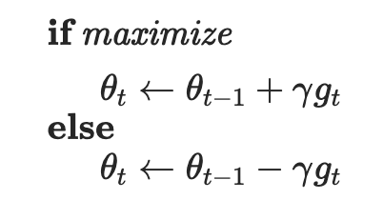
  - How do you think this change leads to the desired outcome (maximization vs minimization)?
  - From calculus we know that functions can have maximums and minimums. By moving in the direction of greatest increase, the function searches for a maximum, which depending on the learning rate could be a local maximum or the overall maximum. In essence, this parameter changes the function to gradient ascent.
  - The next set of parameters momentum, dampening, weight_decay. What do you think the impact of these parameters are? Read the documentations and interpret their roles.
momentum
When momentum is used in gradient descent, velocity ($ν_{t}=μν_{t-1}+(1-τ)g_{i})$ is the weighted average of the gradient and the prior value of the velocity. In the equation, the momentum $μ$ serves as the weight for the previous value of the velocity $ν_{t-1}.$ Thus, a weighted average of past velocities is added to the gradient ($g_{i}$), which in turn is dampened by $\left(1-τ\right)$, where $τ$ is the dampening. The net effect of momentum is that if the gradient is consistently in the same direction, it accelerates descent in this direction. This speeds up optimization, dampens oscillations, and reduces the risk of getting caught in a local minimum.
dampening
Dampening (τ) is a parameter that is subtracted from 1. This value is used to regulate the amount of the gradient used to determine the current momentum, which is in turn used to calculate the new weights. By setting dampening, we can regulate the weighted average of the momentum and current gradient and make the momentum less sensitive to abrupt changes.
weight_decay – adds a L2-type penalty to the gradient. This penalty works to keep the weights small and improves generalization. Smaller weights will also reduce the risk of exploding gradients.
- What are few benefits to using Fixed-Window-LM over $n$-grams language models? (limit your answer to less then 5 sentences).
Fixed window language models have several major benefits with respect to n-grams. First, they do not have to learn counts for each combination of words and, in this manner, solve the sparsity problem. Second, the fixed window allows for more context than the smallest n, and the embeddings allow for parameter sharing and similar words can be handled similarly, even if the context hasn’t been seen before. Finally, as follows from the first and second benefits, the size of the model is smaller than for n-grams, which is o(exp(n)).
- When searching over hyperparameters, a typical recommendation is to do random search rather than a systematic grid search. Why do you think that is the case? (less than 2 sentences).
Neural networks can have high computational costs. A random search is more cost effective, because it can show a wider variety of hyperparameter combinations in the same time that a systematic grid search explores a narrower range of combinations.
- Remember the normalization layer that we saw during the class. Here is the corresponding PyTorch page: https://pytorch.org/docs/stable/generated/torch.nn.LayerNorm.html. In the normalization formula, why do we use epsilon $ϵ$ in the denominator?
The writeup says that epsilon is added for numerical stability, but I would say it a little differently. It is there to prevent division by zero in case the variance is zero, or explosion of the gradient if it is very low.

Softmax Smackdown: Squishing the Competition

Softmax gradient
You might remember in the midterm exam that we saw a neural network with a Softmax and a cross-entropy loss:
$$\hat{\text{y}}=\text{Softmax}\left(\text{h}\right), J=\text{CE}\left(y,\hat{y}\right), \text{h},y,\hat{y}∈R^{d}.$$
Basically here $\hat{y}$ is a $d$-dimensional probability distribution over $d$ possible options (i.e. i​yi=1 and $∀i:y_{i}∈\left[0,1\right]$). $y$ is a $d$-dimensional one-hot vector, i.e., all of these values are zeros except one that corresponds to the correct label.
Here we want to prove the hint that was provided in the exam, which was:
$$∇_{h}J=\hat{y}-y.$$
Prove the above statement. In your proof, use the statement that you proved in HW3 about gradient of Softmax function: $\frac{d{\hat{\text{y}}}_{i}}{d{\text{h}}_{j}}={\hat{\text{y}}}_{i}\left(δ_{ij}-{\hat{\text{y}}}_{j}\right),$ where $δ_{ij}$ is the Kronecker delta function and ${\hat{\text{y}}}_{i}$ is the value in the $i$-th index of $\hat{\text{y}}$.
$$J= -\sum{y_{i}\log\left({\hat{\text{y}}}_{i}\right)}$$
using the chain rule
$\frac{∂J}{∂{\hat{\text{y}}}_{i}}\frac{∂{\hat{\text{y}}}_{i}}{∂{\text{h}}_{j}}$ =$\sum{\left(-\frac{y_{i}}{{\hat{y}}_{i}}\right)*{\hat{y}}_{i}\left(δ_{ij}-{\hat{y}}_{j}\right) =\sum{-y_{i}\left(δ_{ij}-{\hat{y}}_{j}\right)}}$
$\frac{∂J}{∂{\text{h}}_{j}}$= $\sum{ -y_{i}\left(δ_{ij}-{\hat{y}}_{j}\right)= \sum{-y_{i}δ_{ij}}+ \sum{y_{i}}{\hat{y}}_{j} }$
Since $δ_{ij }$is non-zero when i = j, $δ_{ij}$ and in the second term, $\sum{y_{i}}=1$,
$\frac{∂J}{∂{\text{h}}_{j}}$ = $-y_{j}+{\hat{y}}_{j}$

Softmax temperature
Remember the softmax function, $σ\left(z\right)$? Here we will add a temperature parameter $τ∈R^{+}$ to this function:
$$\text{Softmax: }σ{\left(z;τ\right)}_{i}=\frac{e^{z_{i}/τ}}{\sum_{j=1}^{K}{e^{z_{j}/τ}}} \text{ for }i=1,…,K$$
Show the following:
- In the limit as temperature goes to zero $τ→0$, softmax becomes the same as greedy action selection, argmax.
As $τ→0$, there are two cases.
max $z_{i}$: in this case, $e^{z_{i}/τ}$ will increase toward infinity much faster than for smaller values of $z_{i}$.
In the limit, since$\frac{ \sum_{j=1 j≠i}^{K}{e^{z_{j}/τ}}}{e^{\max{z_{i}/τ}}}$ $≈0$, $\frac{e^{\max{z_{i}/τ}}}{e^{\max{z_{i}/τ}}+ \sum_{j=1 j≠i}^{K}{e^{z_{j}/τ}}}≈ \frac{e^{\max{\frac{z_{i}}{τ}}}}{e^{\max{\frac{z_{i}}{τ}}} }=1$
In other words, dividing top and bottom by $e^{\max{\frac{z_{i}}{τ}}}$ ,
$$\frac{e^{\max{z_{i}/τ}}}{e^{\max{z_{i}/τ}}+ \sum_{j=1 j≠i}^{K}{e^{z_{j}/τ}}}= \frac{1}{1+ \sum_{j=1 j≠i}^{K}{e^{\frac{z_{j}-\max{z_{i}}}{τ}}}}$$
since all terms in $\sum_{j=1 j≠i}^{K}{\frac{z_{j}-\max{z_{i}}}{τ}}$ go to $-∞$,
$\frac{1}{1+ \sum_{j=1 j≠i}^{K}{e^{\frac{z_{j}-\max{z_{i}}}{τ}}}}$ $≈$ 1
and for all other $z_{i}$, $\frac{e^{z_{i}/τ}}{e^{\max{z_{i}/τ}}+ \sum_{j=1 j≠i}^{K}{e^{z_{j}/τ}}}≈ \frac{e^{z_{i}/τ}}{e^{\max{\frac{z_{i}}{τ}}} }$ $≈0$
Therefore, the Softmax will always choose the value with highest probability, just like argmax.

- In the limit as temperature goes to infinity $τ→+∞$, softmax gives equiprobable selection among all actions.
In the limit as $τ→+∞$, $e^{z_{i}/τ} and e^{z_{j}/τ}$ go to 1 since $\frac{1}{τ} goes to 0, and e^{0}$ = 1, resulting in $\sum_{j=1}^{K}{1}=k and$ $\frac{e^{z_{i}/τ}}{\sum_{j=1}^{K}{e^{z_{j}/τ}}} =\frac{1}{K}$ , which means each i is equally probable.

Backprop Through Residual Connections
As you know, When neural networks become very deep (i.e. have many layers), they become difficult to train due to the vanishing gradient problem – as the gradient is back-propagated through many layers, repeated multiplication can make the gradient extremely small, so that performance plateaus or even degrades. An effective approach is to add skip connections that skip one or more layers. See the provided network.
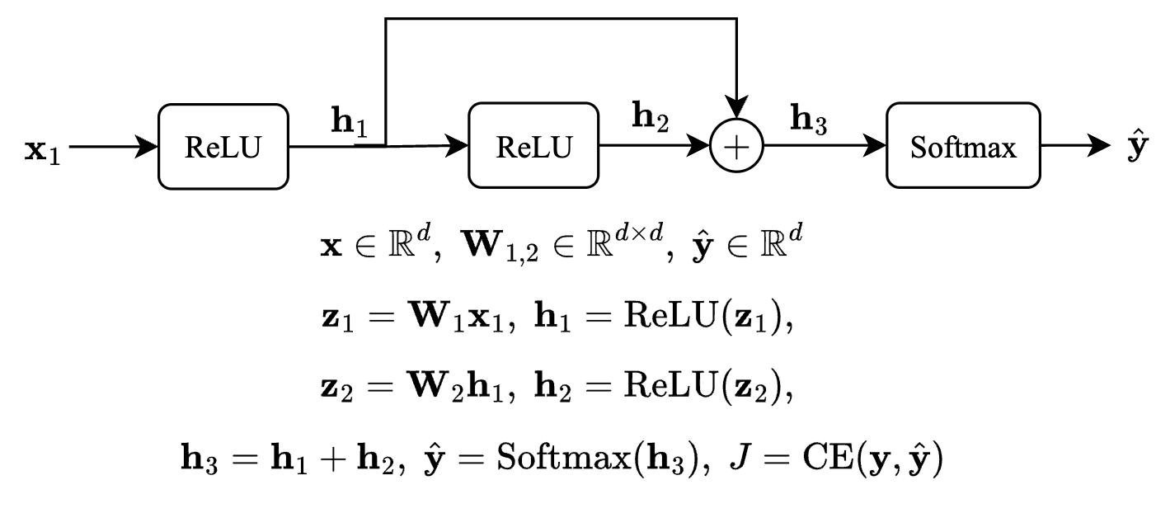
- You have seen this in the quiz, but lets try again. Prove that: $\frac{∂}{∂{\text{z}}_{i}}\text{ReLU}\left(\text{z}\right)=1\{{\text{z}}_{i}>0\}$ where $1\{x>0\}=\left\{\begin{matrix}1 & \text{if} x>0 \\ 0 & \text{if} x≤0 \\ & \end{matrix}\right.$. More generally, $∇_{\text{z}}\text{ReLU}\left(\text{z}\right)=\text{diag}\left(1\{\text{z}>0\}\right)$ where $1\{.\}$ is applied per each dimension and $\text{diag}\left(.\right)$ turns a vector into a diagonal matrix.
$RelU= \left\{\begin{matrix}x if x>0 \\ 0 if x ≤0\end{matrix}\right.$
since ReLU is an elementwise operation, for input vector z = [$z_{1}, …, z_{n}]$
$$RelU(z_{i})= \left\{\begin{matrix}z_{i} if z_{i}>0 \\ 0 if z_{i} ≤0\end{matrix}\right.$$
$\frac{dRelU(z_{i})}{dz_{i}}= \left\{\begin{matrix}1 if z_{i}>0 \\ 0 if z_{i} ≤0\end{matrix}\right.$
Creating the Jacobian out of the $z_{i}$, which is applied elementwise, resulting in $f_{i}$($z_{i}$)
$\left[\begin{matrix}\frac{{∂f}_{1}, }{∂z_{1}} & ⋯ & \frac{{∂f}_{1}, }{∂z_{n}} \\ ⋮ & ⋱ & ⋮ \\ \frac{{∂f}_{n}, }{∂z_{1}} & ⋯ & \frac{{∂f}_{n}, }{∂z_{n}}\end{matrix}\right]$
because ReLU is element-wise,$f_{i}\left(z_{i}\right)$and off-diagonal values are therefore 0.
Since given the above definition for Relu, $\frac{∂RelU(z_{i})}{∂z_{i}}= \left\{\begin{matrix}1 if z_{i}>0 \\ 0 if z_{i} ≤0\end{matrix}\right.$, we can substitute.
= $\left[\begin{matrix}11\{\text{z}>0\} & ⋯ & 0 \\ ⋮ & ⋱ & ⋮ \\ 0 & ⋯ & 1\{\text{z}>0\}\end{matrix}\right]=\text{diag}\left(1\{\text{z}>0\}\right)$

- As you see, a single variable ($h_{2}$ in the example) feeds into two different layers of the network. Here we want to show that the two upstream signals stemming from this node are merged as summation during Backprop. Specifically prove that:
$$\frac{∂h_{3}}{∂h_{1}}=\text{I}+\frac{∂h_{2}}{∂z_{2}}\frac{∂z_{2}}{∂h_{1}}$$

$h_{3}=h_{1}+h_{2}$, note $h_{2}$ is a function of $h_{1}$
$$\frac{{∂h}_{3}}{{∂h}_{1}}=\frac{{∂h}_{1}}{{∂h}_{1}}+ \frac{{∂h}_{3}}{{∂h}_{2}}\frac{{∂h}_{2}}{{∂h}_{1}}$$
$\frac{{∂h}_{3}}{{∂h}_{2}}=I$
$\frac{{∂h}_{3}}{{∂h}_{1}}=I+ \frac{{∂h}_{2}}{{∂h}_{1}}$
By the chain rule
$h_{2}=ReLU(z_{2}$), $z_{2}={W_{`}}_{2}h_{1}$
$\frac{{∂h}_{2}}{{∂h}_{1}}= \frac{{∂h}_{2}}{{dz}_{2}}\frac{z_{2}}{{∂h}_{1}}$
Substituting back in
$\frac{{∂h}_{3}}{{∂h}_{1}}=I+ \frac{{∂h}_{2}}{{∂z}_{2}}\frac{∂z_{2}}{{∂h}_{1}}$
- In the given neural network your task is to compute the gradient $\frac{∂J}{∂x}.$ You are allowed (and highly encouraged) to use variables to represent intermediate gradients.
- Hint 1: Compute these gradients in order to build up your answer: $\frac{∂J}{∂{\text{h}}_{3}}$, $\frac{∂J}{∂{\text{h}}_{2}}$, $\frac{∂J}{∂{\text{z}}_{2}}$, $\frac{∂J}{∂{\text{h}}_{1}}$, $\frac{∂J}{∂{\text{z}}_{1}}$, $\frac{∂J}{∂\text{x}}$. Show your work so we are able to give partial credit!
- Hint 2: Recall that downstream = upstream * local.
- $∇_{h3}J=\hat{y}-y.$

- from 2,
- $\frac{{∂h}_{3}}{{∂h}_{1}}=I+ \frac{{∂h}_{2}}{{∂h}_{1}}$ = I + $\frac{{∂h}_{2}}{{∂z}_{2}}\frac{{∂z}_{2}}{{∂h}_{1}}$ = I + $\frac{{∂h}_{2}}{{∂z}_{2}}W_{2}$,

- $\frac{{∂h}_{2}}{{∂z}_{2}}= \left\{\begin{matrix}I & \text{if} z_{2}>0 \\ 0 & \text{if} z_{2}≤0 \\ & \end{matrix}\right.$
- $\frac{{∂h}_{1}}{{∂z}_{1}}= \left\{\begin{matrix}I & \text{if} z_{1}>0 \\ 0 & \text{if} z_{1}≤0 \\ & \end{matrix}\right.$
$\frac{{∂z}_{2}}{{∂h}_{1}}= W_{2}$, $\frac{{∂z}_{1}}{{∂x}_{1}}= W_{1}$
$∇_{h3}J\frac{{∂h}_{3}}{{∂h}_{1}}\frac{{∂h}_{1}}{{∂z}_{1}}\frac{{∂z}_{1}}{{∂x}_{1}}=$($\hat{y}-y)(I + \frac{{∂h}_{2}}{{∂z}_{2}}W_{2}) \frac{{∂h}_{1}}{{∂z}_{1}}W_{1}$
rewriting the two ReLU derivatives in terms of $x_{1}$. This occurs because there are no bias terms.
- $\frac{{∂h}_{2}}{{∂z}_{2}}W_{2}= \left\{\begin{matrix}W_{2} & \text{if} z_{2}>0 \\ 0 & \text{if} z_{2}≤0 \\ & \end{matrix}\right.$
- $\frac{{∂h}_{1}}{{∂z}_{1}}W_{1}= \left\{\begin{matrix}W_{1} & \text{if} z_{1}>0 \\ 0 & \text{if} z_{1}≤0 \\ & \end{matrix}\right.$
Cases
$1.\text{if} z_{1}>0$, $z_{2}>0, \frac{∂J}{{∂x}_{1}}=$($\hat{y}-y)(W_{1} + W_{2}W_{1} )$

- $\text{2. }\text{if} z_{1} >0$, $z_{2}≤0 \frac{∂J}{{∂x}_{1}}=$($\hat{y}-y)W_{1}$

- $3.if z_{1}≤0, \frac{∂J}{{∂x}_{1}}=$0

- Based on your derivations, explain why residual connections help mitigate vanishing gradients.
In the derivations above, we show that the residual path adds an identity matrix to the Jacobian. This can mitigate the effect of small gradients by keeping the Jacobian near the identity.

Programming
In this programming homework, we will
- implement your own subword tokenizer.
- implement fixed-window MLP language models

Skeleton Code and Structure:
The code base for this homework can be found at this GitHub repo under the hw3 directory. Your task is to fill in the missing parts in the skeleton code, following the requirements, guidance, and tips provided in this pdf and the comments in the corresponding .py files. The code base has the following structure:
- tokenization.py implements the Byte-Pair Encoding algorithm for subword tokenization.
- mlp_lm.py implements a fixed-window MLP-based language model on a subset of Wikipedia.
- main.py provides the entry point to run your implementations in both tokenizatiton.py and mlp_lm.py.
- hw4.md provides instructions on how to setup the environment and run each part of the homework in main.py
TODOs — Your tasks include 1) generate plots and/or write short answers based on the results of running the code; 2) fill in the blanks in the skeleton to complete the code. We will explicitly mark these plotting, written answer, and filling-in-the-blank tasks as TODOs in the following descriptions, as well as a # TODO at the corresponding blank in the code.

Submission:
Your submission should contain two parts: 1) plots and short answers under the corresponding questions below; and 2) your completion of the skeleton code base, in a .zip file

Tokenization Algorithms
All NLP systems have at least three main components that help machines understand natural language:
- Tokenization
- Embedding
- Model architectures
Models like BERT, GPT-2 or GPT-3 all share the same components but with different architectures that distinguish one model from another. We are going to focus on the first component of an NLP pipeline which is tokenization. An often overlooked concept but it is a field of research in itself. Though we have SOTA algorithms for tokenization it’s always a good practice to understand the evolution trail.
Here’s what we’ll cover:
- What is tokenization?
- Why do we need a tokenizer?
- Types of tokenization - Word, Character and Subword.
- Byte Pair Encoding Algorithm
- Other tokenization algorithms:
  - Unigram Algorithm
  - WordPiece - BERT transformer
  - SentencePiece - End-to-End tokenizer system

What is Tokenization?
Tokenization is the process of representing raw text in smaller units called tokens. These tokens can then be mapped with numbers to further feed to an NLP model.
Read and run the full_word_tokenization_demo in tokenization.py for an overly simplified example of what a tokenizer does.
This is a very simple example where we just split a text string in to “whole words” on white spaces, and we have not considered grammar, punctuation, or compound words (like “test”, “test-ify”, “test-ing”, etc.).

Problems with word tokenization:

- Missing words in the training data: With word tokens, your model won’t recognize the variants of words that were not part of the data on which the model was trained. So, if your model has seen ‘foot‘ and ‘ball‘ in the training data but the final text has “football”, the model won’t be able to recognize the word and it will be treated with a “<UNK>” token. Similarly, punctuations pose another problem, “let” or “let’s” will need individual tokens and it is an inefficient solution. This will require a huge vocabulary to make sure you’ve every variant of the word. Even if you add a lemmatizer to solve this problem, you’re adding an extra step in your processing pipeline.
- Not all languages use space for separating words: For a language like Chinese, which doesn’t use spaces for word separation, this tokenizer will fail.

Character-based tokenization
To resolve the problems associated with word-based tokenization, an alternative approach of character-by-character tokenization was tried. This solves the problem of missing words as now we are dealing with characters that can be encoded using ASCII or Unicode and it could generate embedding for any word now.
Every character, be it space, apostrophes, or colons, can now be assigned a symbol to generate a sequence of vectors. But this approach had its cons. Character-based models will treat each character and will lead to longer sequences. For a 5-word long sentence, you may need to process 30 tokens instead of 5 word-tokens.

Subword Tokenizaiton
To address the earlier issues, we could think of breaking down the words based on a set of prefixes and suffixes. For example, we can build a system that can identify subwords like “##s”, “##ing”, “##ify”, “un##” etc., where the position of double hash “##” denotes prefix and suffixes. So, a word like “unhappily” is tokenized using subwords like “un##”, “happ”, and “##ily”.
BPE (Byte-Pair Encoding) was originally a data compression algorithm that is used to find the best way to represent data by identifying the common byte pairs. It is now used in NLP to find the best representation of text using the least number of tokens.
Here’s how it works:
- Add a “</w>” at the end of each word to identify the end of a word and then calculate the word frequency in the text.
- Split the word into characters and then calculate the character frequency.
- For a predefined number of iterations (set by you), count the frequency of the consecutive tokens and merge the most frequently occurring pairings.
- Keep iterating until you have reached the iteration limit or if you have reached the token limit.
We will now go through this algorithm step by step.
Read the get_word_freq function in tokenization.py that implements the step 1 above to preprocess each word and count its frequency.
TODOs: Read and complete the missing lines in the get_pairs function in tokenization.py to implement the step 2 above. This function takes the word frequency record returned from get_word_freq as input, split the words into tokens (characters at this initial step), and counts token-pairs frequency.
Hint: follow the comments in the code for specific requirements.
Read the get_most_frequent_pair and merge_byte_pairs functions in tokenization.py that implements the step 3 above, merge the top-1 frequent token-pairs in all the words.
In practise, after iterating over the input text for a desired number of times, we extract the resulting tokenization as our subword dictionary. For this purpose, we provide get_subword_tokens function in tokenization.py
With all these functions, we can now run one step of the BPE algorithm!
Read and run the test_one_step_bpe.py in main.py to test the BPE algorithm for one step. A correct implementation of get_pairs should pass all the tests.

Complete the BPE Algorithm
With the above implementations, we can complete all the steps of the BPE algorithm that iterates over the input corpus.
TODOs: Read and complete the missing lines in the exract_bpe_subwords function in tokenization.py that implements the full BPE algorithm. Once you finished, run the test_bpe function in main.py, a correct implementation of exract_bpe_subwords should pass all the tests.
Hint: follow the comments in the code and you can reuse the helper functions provided/you implemented above.
So as we iterate with each best pair, we merge (concatenating) the pair and you can see as we recalculate the frequency, the original character token frequency is reduced and the new paired token frequency pops up in the token dictionary.

Running BPE on a subset of Wikipedia
Now, let’s run this algorithm on a larger scale. In particular, we will run on many Wikipedia paragraphs. As usual, let’s use the Huggingface library to download the data (the load_bpe_data function).
TODOs: Read and run the bpe_on_wikitext in main.py that iterates the BPE algorithm on a subset of Wikipedia, and interprets the final subwords extracted from the Wikipedia documents. In particular, identify examples of subwords that correspond to
- complete words
West, however</w>, German</w>, became</w>, does</w>, as, as</w>
- part of a word:
fore</w>, before</w>, ship</w>, ward</w>, ian</w>, attemp
- non-English words(including other languages or common sequence special characters)
ich</w>, и, 60</w>, %</w>, δ
Explain why these subwords have come about. (no more than 10 sentences)
1. From the printouts, “West<w>” builds up from “est<w>”, which builds up from “t<w>” and “st<w>”. Because “West<w>” is capitalized, it indicates that the token is from a first word, a proper noun and/or the name of a particular region. The other words are common English words, but “as” and as</w> are both on the list, indicating the frequent use of these letters in the middle and at the end of words.
2. Of the parts of words mentioned, “ship</w>” and ward</w>, are relatively common suffixes, but “fore</w>” is listed as a suffix and not as a prefix, even though it is used fairly often (“foretell,” “forearm,” “forewarn”). Perhaps, since “re<w>” is an important part of many common words (“are</w>”, “here</w>”, “were</w>”, and especially “before</w>”), this subword (“fore<w>”) was quickly formed. “ian</w>” is interesting because of the standard English method of forming nationalities (“Canadian”, “Australian”, “Romanian”, etc.) I included “attemp,” because this might be the example of the algorithm stopping before a subword could become inflected forms of the word, “attempt.”
3. Of the four non-English words mentioned above, one could be from German text (ich</w>) or is at the end of English words, one is probably just a Cyrillic character from citations (“и”) since there is no “</w>” token indicating is the Russian word meaning “and”, and two are math symbol (“%<w>”, “δ”); furthermore, “ich” can stand along as a German pronoun or common German suffix, but it likely resulted during the formation of “which<w>.” Since there is no “hich<w>,” the subwords “wh” and “ich<w>” were likely combined to form this common word. Besides citations and names, other sources of non-English characters could be quotations, number values such as prices, or equations.

Additonal Readings: Other Tokenization Algorithms

WordPiece
WordPiece is the subword tokenization algorithm used for BERT, DistilBERT, and Electra. The algorithm was outlined in and is very similar to BPE. WordPiece first initializes the vocabulary to include every character present in the training data and progressively learns a given number of merge rules. In contrast to BPE, WordPiece does not choose the most frequent symbol pair, but the one that maximizes the likelihood of the training data once added to the vocabulary.
So what does this mean exactly? Referring to the previous example, maximizing the likelihood of the training data is equivalent to finding the symbol pair, whose probability is divided by the probabilities of its first symbol followed by its second symbol is the greatest among all symbol pairs. E.g. “u”, followed by “g” would have only been merged if the probability of “ug” divided by “u”, “g” would have been greater than for any other symbol pair. Intuitively, WordPiece is slightly different from BPE in that it evaluates what it loses by merging two symbols to ensure it’s worth it.

Unigram
Unigram is a subword tokenization algorithm introduced in . In contrast to BPE or WordPiece, Unigram initializes its base vocabulary to a large number of symbols and progressively trims down each symbol to obtain a smaller vocabulary. The base vocabulary could for instance correspond to all pre-tokenized words and the most common substrings. Unigram is not used directly for any of the models in the transformers, but it’s used in conjunction with SentencePiece([paragraph:sentetncepiece]).
At each training step, the Unigram algorithm defines a loss (often defined as the log-likelihood) over the training data given the current vocabulary and a unigram language model. Then, for each symbol in the vocabulary, the algorithm computes how much the overall loss would increase if the symbol was to be removed from the vocabulary. Unigram then removes p (with p usually being 10% or 20%) percent of the symbols whose loss increase is the lowest, i.e. those symbols that least affect the overall loss over the training data. This process is repeated until the vocabulary has reached the desired size. The Unigram algorithm always keeps the base characters so that any word can be tokenized.
Because Unigram is not based on merge rules (in contrast to BPE and WordPiece), the algorithm has several ways of tokenizing new text after training. As an example, if a trained Unigram tokenizer exhibits the vocabulary:
[“b”, “g”, “h”, “n”, “p”, “s”, “u”, “ug”, “un”, “hug”],
“hugs” could be tokenized both as [“hug”, “s”], [“h”, “ug”, “s”] or [“h”, “u”, “g”, “s”]. So which one to choose? Unigram saves the probability of each token in the training corpus on top of saving the vocabulary so that the probability of each possible tokenization can be computed after training. The algorithm simply picks the most likely tokenization in practice but also offers the possibility to sample a possible tokenization according to their probabilities.
Those probabilities are defined by the loss the tokenizer is trained on. Assuming that the training data consists of the words $x_{1},…,x_{N}$ and that the set of all possible tokenizations for a word $x_{i}$ is defined as $S\left(x_{i}\right)$, then the overall loss is defined as
L=-i=1Nlogx∈Sxi​px

SentencePiece
All tokenization algorithms described so far have the same problem: It is assumed that the input text uses spaces to separate words. However, not all languages use spaces to separate words. One possible solution is to use language-specific pre-tokenizers, e.g. XLM uses a specific Chinese, Japanese, and Thai pre-tokenizer). To solve this problem more generally, treats the input as a raw input stream, thus including the space in the set of characters to use. It then uses the BPE or unigram algorithm to construct the appropriate vocabulary.
The XLNetTokenizer uses SentencePiece for example, which is also why in the example earlier the “” character was included in the vocabulary. Decoding with SentencePiece is very easy since all tokens can just be concatenated and “” is replaced by a space.
All transformer models in the library that use SentencePiece use it in combination with unigram. Examples of models using SentencePiece are ALBERT XLNet,Marian, and T5.

Fixed-Window MLP Language Models
In the second part of the homework, we will build, train, and evaluate fixed-window MLP language models as we learned in class: given the context words in the fixed-size window on the left hand side, predict the next word continuation.
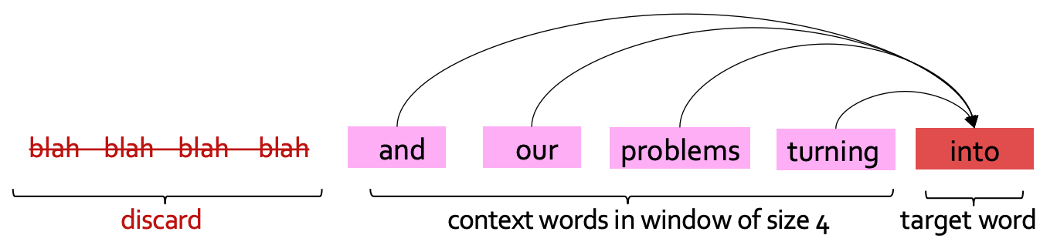
Fixed-window LM

Data Loading and Preprocessing
We will be using the same WikiText dataset we used for building n-gram LM in homework 2. We follow similar preprocessing steps to split paragraphs into sentences followed by tokenization (Now we have learned more about subword tokenization in class and the previous question!).
TODOs read the preprocess_data function in ngram_lm.py and complete the missing lines to prepare input-output pairs for training fixed-window LMs.
Hint: follow the requirements in the code comments.

Build our LM
Let’s now turn to building our model. Here, we are following the footsteps of the neural probabilistic language model (NPLM) , which is extending earlier studies such as .
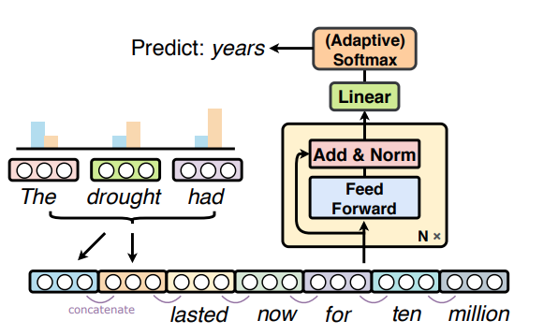
NPLM Architecture
We will follow a modular design for our implementation to make it more interpretable. In particular, will implement 3 layers:
- The input layer which loops up word embeddings, concatenates them, and transforms them into a hidden representation.
- The middle layer transforms the representation with a non-linearity.
- The output layer which transforms a hidden vector to a probability distribution over the words
Let’s get to work!
TODOs: read and complete the forward functions for the following classes
- NPLM_first_block: input layer that embeds the input token ids into embedding vectors, concatenates the embeddings, applies linear transformation, layer normalization, and dropout
- NPLM_block: middle layers with linear transformation, tanh activation, residual connection, layer normalization, and dropout.
- NPLM_final_block: output layer that transforms hidden representation to log probability over the vocabulary with log softmax.
Hint: check out nn.LayerNorm and nn.Dropout, torch.tanh and nn.functional.log_softmax for more details on these layers and operations. For embedding concatenation, you may find torch.Tensor.view useful. Also, follow the step-by-step comments in the code for the requirements of the implementation.
TODOs: read and complete the __init__ and forward functions for the NPLM class, which is the final model that stacks all the above layers.
Hint: remember to apply ReLU non-linear activation after each middle layer, details at nn.functional.relu.

Train and Evaluate the LM
Now it’s time to train and evaluate it! Like the previous homework, we will use cross-entropy loss between the predictions of our language model and actual words that appeared in our training data. Note that we applied log softmax to the final output of the LM, as described in homework to, we will use negative log-likelihood loss as the training criterion to calculate the cross-entropy loss.
- As introduced in the class, we will use Perplexity to evaluate our LM, as a measure of predictive quality of a language model.
TODOs Read and complete the missing lines in train and evaluate functions in mlp_lm.py to calculate the perplexity.
Hint: remember in the class we discussed the connection between perplexity and cross-entropy loss, and note that in our implementation we took natural logarithm instead of the base of 2.
Note we are using Adam (Adaptive Moment Estimation) , which is a popular optimization algorithm used in deep learning and machine learning. It is a stochastic gradient descent (SGD) optimization algorithm that is well suited for training deep neural networks. The algorithm has some internal estimates to dynamically adjust the learning rates for each parameter based on its past gradients, which can result in faster convergence and improved performance compared to traditional SGD.
TODOs Once you finished all the implementations, run load_data_mlp_lm and single_run_mlp_lm in main.py to train and evaluate the model and paste the plots of loss and Perplexity here.
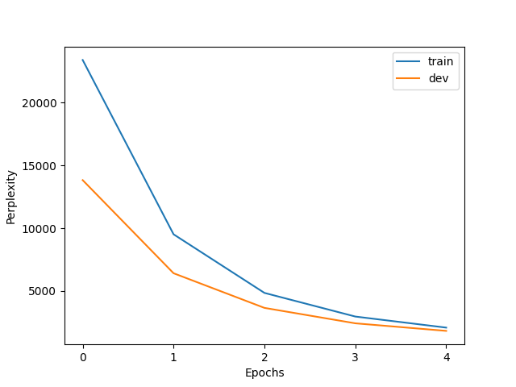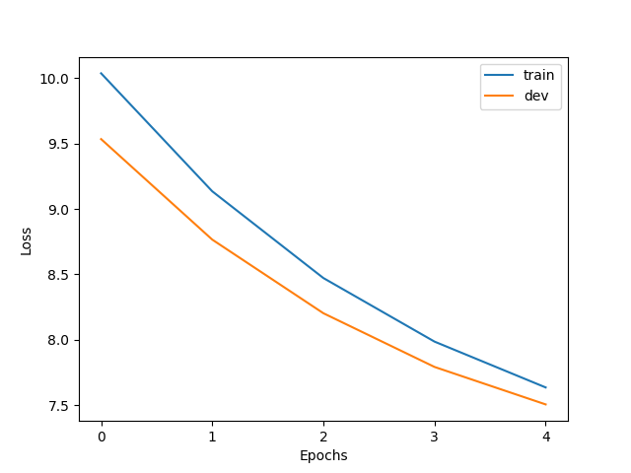
***************Comments
It looks like the loss needs another epoch or a higher learning rate to converge.
Just for fun, I increased the learning rate to 2e-5 and got the following, which shows that the loss still hasn’t converged.
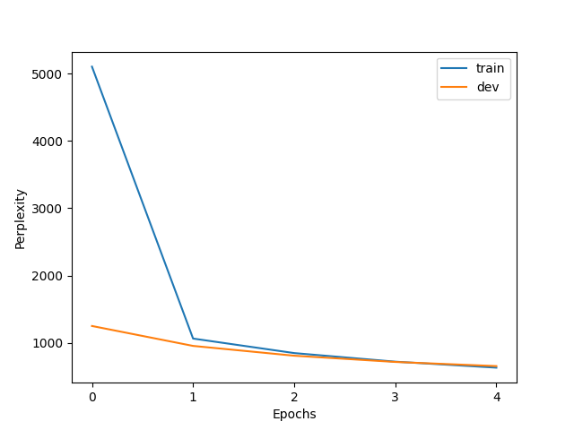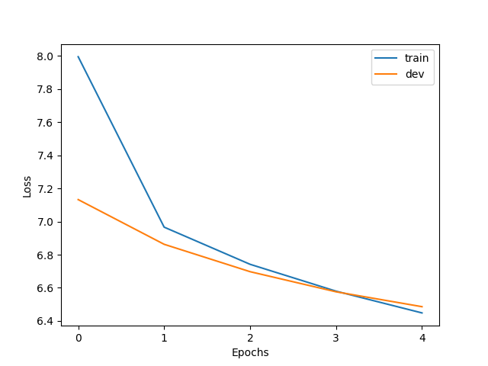
***
I also ran the prompt from the next part. Here the higher top-p help avoid the repitition problem.
Dev Perplexity: 1816.9989013671875; Dev Loss: 7.504941240270087
---------- Sample From the Model ----------
---------- greedy ----------
Generated text: The best perks of living on the east......, the the.. the the... the the... the the... the the..
---------- sampling with p=0.0 ----------
Generated text: The best perks of living on the east......, the the.. the the... the the... the the... the the..
---------- sampling with p=0.3 ----------
Generated text: The best perks of living on the east of many are of third as,er by re been, ) until. his = included 8 @ based @ and the s are the with the due
---------- sampling with p=0.5 ----------
Generated text: The best perks of living on the east, a point works those9th to won shown Melbourne century to cm the R failed of album positive child g the 1914 than 1934dis Kent arrestll
---------- sampling with p=0.8 ----------
Generated text: The best perks of living on the east Smart telephone different took Ham R for target, Homer DC representations 153 1983 Miles others obtained youthful hear fact absence Statesff NO 1852 can parts Bluesn,
---------- sampling with p=1.0 ----------
Generated text: The best perks of living on the east Dead geographic curve v rich waotype construction nearby documentsdina leaderjamo that compilationdized ' determine public automobilerkin principles IAAF use it roles Syracuse arguably %

Sample From a Pre-trained LM
Note that compared with the original NPLM implementation, we reduce the model size by shrinking both the width and depth of our model, and we only use a small subset of the data. It is expected to take an hour or so to train the model on the CPU of your PC. Training the above LM with full size model and data might take hours to days. To save you time, we have trained a language model for you to play with. All you have to do is to download its weight parameters. Download the pre-trained weights and copy it to your local directory under /hw4/.
Now that we have the model weight downloaded, we can instantiate a model with these parameters. This will work in two steps.
- First we will need to create a new model (with potentially random weights).
- Then, we will copy the parameter values to the model using load_state_dict function.
We then evaluate the loaded model on the dev set. Now that we have loaded a pre-trained LM, how can we sample from it? We will implement two strategies, greedy decoding and top-p sampling that we briefly discussed in homework 2.
For greedy, we select the most probable words (argmax).
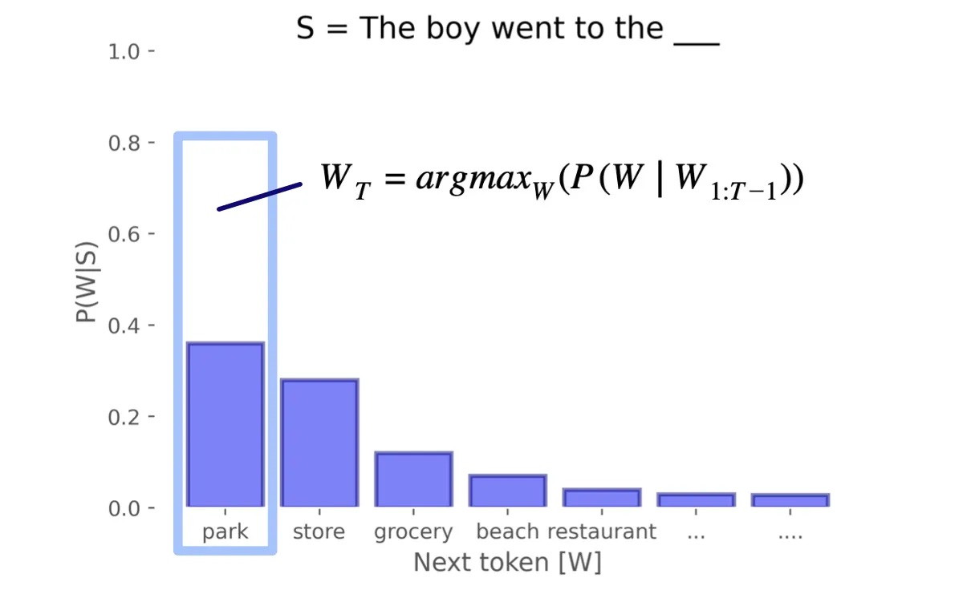
Greedy Decoding
For top-p, we sample from the distribution proportional to word probabilities. Words with higher probabilities will be more likely to be sampled. However, we also have an option of filtering the low-probability tokens, and instead retaining tokens that constitute top_p probability.
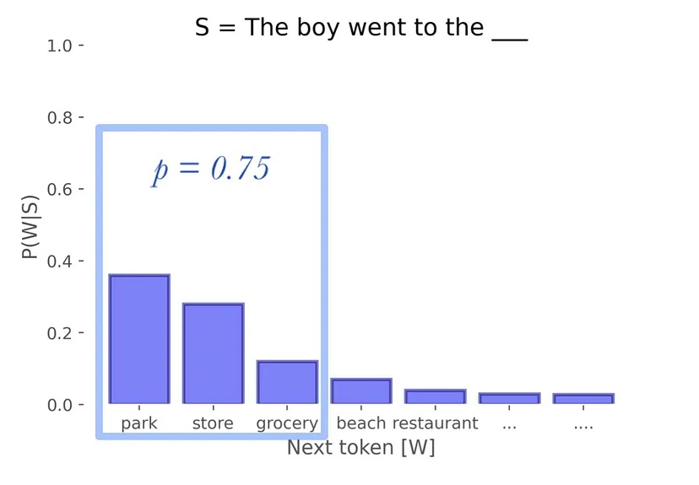
Greedy Decoding
Read generate_text and sample_from_mlp_lm in mlp_lm.py for more details about how to load the pre-trained model, evaluate on dev set and perform greedy/top-p sampling. You can learn more about top-p sampling implementation at TopPLogitsWarper.
TODOs Run the sample_from_trained_mlp_lm in main.py to sample from the pre-trained LM, paste the completion to the prefix under different sampling strategies here, and describe in 2-3 sentences your findings.
Hint: compare the output of the above generations, which one is your favorite? Explain why this choice of sampling leads to better text generation.
Dev Perplexity: 250.67147827148438; Dev Loss: 5.524143046521126
---------- Sample From the Model ----------
---------- greedy ----------
Generated text: The best perks of living on the east side of the city. ". "... ".... ". "... ".... ". "
---------- sampling with p=0.0 ----------
Generated text: The best perks of living on the east side of the city. ". "... ".... ". "... ".... ". "
---------- sampling with p=0.3 ----------
Generated text: The best perks of living on the east of the U. S. government had a year. ". ", the episode ' s very much of the most common age. "..
---------- sampling with p=0.5 ----------
Generated text: The best perks of living on the east. ". ", and was the first part of the season, and has a second night for his way. ", and the album is not
---------- sampling with p=0.8 ----------
Generated text: The best perks of living on the east side of the period, the Games ' s father are by any science fiction things. ". ". was a sweet ", but with the modern
---------- sampling with p=1.0 ----------
Generated text: The best perks of living on the east stuff with a. 95. and steamed – 28 Ediar, the TV lost he had made the film, and Frank cancel had a dress first
The perplexity and loss for this model are significantly better than for our model (ppl = 250 vs. ppl = 1816). Although despite sampling risk, p = .8 produces some reasonable text, for this prompt, greedy actually works best, probably because the prompt includes “living,” which is strongly connected with the collocation “east side.” The downside here is that the generation does not terminate until the max_len is reached, thereby causing the repeating pattern (.". "... "...), which repeats twice and starts a third time.
Note: I modified the code to fix the input shape on line 303 of mlp_lm.py. In addition, I had to change to CPU mode.

Optional Feedback
Have feedback for this assignment? Found something confusing? We’d love to hear from you!

https://self-supervised.cs.jhu.edu/sp2024/

