Product Review Site

Overview: The idea behind this product is designed to be a one stop review site. User will be able to look up a product and see reviews from members of site. User will be able to view reviews as a guest user but will only be able to add or modify review by logging in or registering for the site. The advantages of this site are that reviews are for the product not the seller of the product. Most reviews on the web at this time are done on specific company site, i.e. amazon,target, Walmart. The goal of this project is to give a user a unbiased review of the product that does not pertain to who sold it.

Roles:

Adam Drag: Authentication, Webpack implementation, and CSS cleanup

Jaime Gonzalez: Product API, Product display pages and search

Mattew Swinford: Travis integration, Product display pages

Jesse Salmon: Project manager, User login/registration pages

Team: QA and Unit testing

Flow diagram: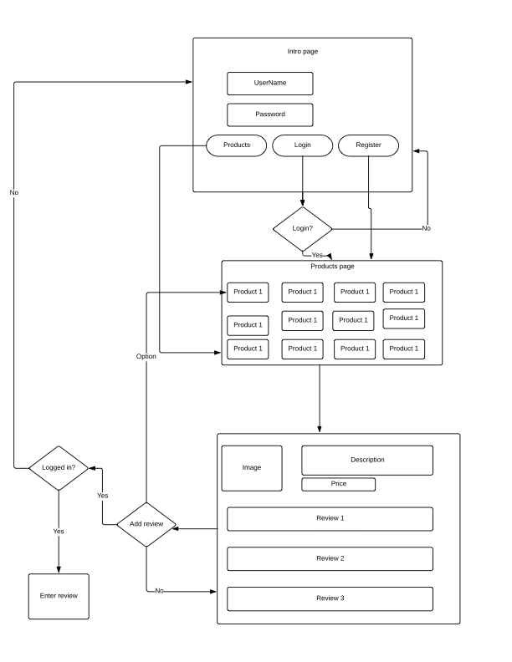

WireFrame: https://wireframe.cc/pro/pp/e0adc49a6215358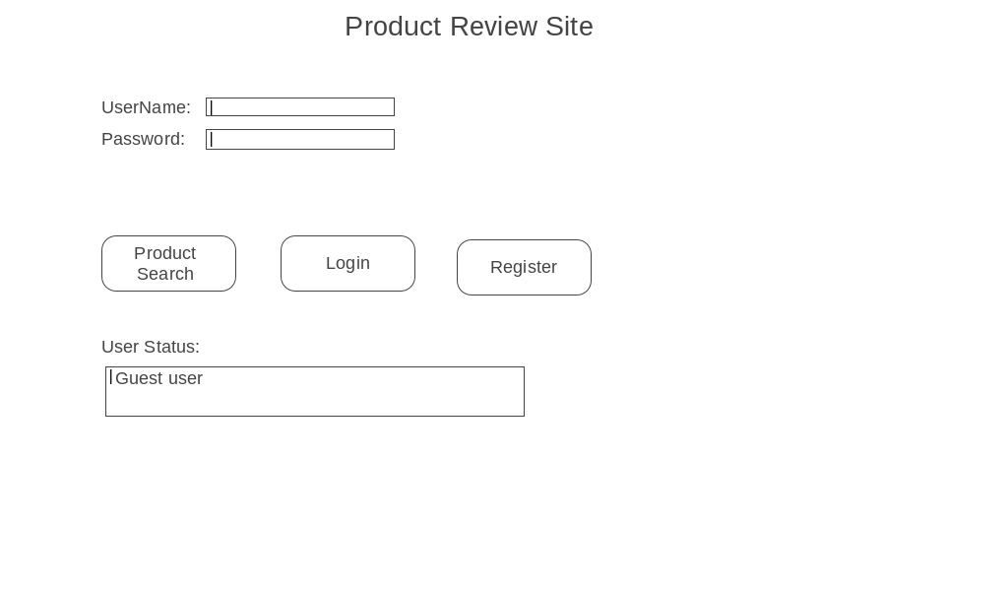

Fig 1: intro page:

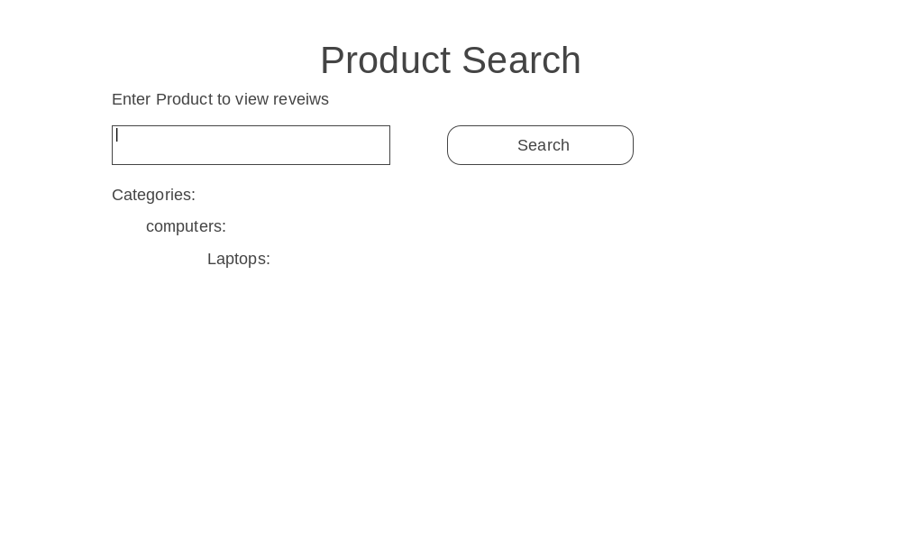

Fig 2: Search Page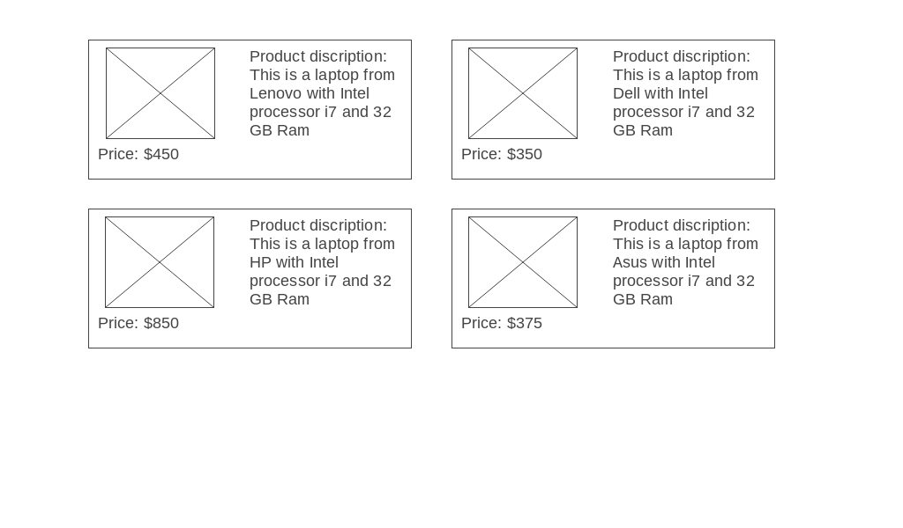

Fig 3: Product List page

Fig 4: Product Details page

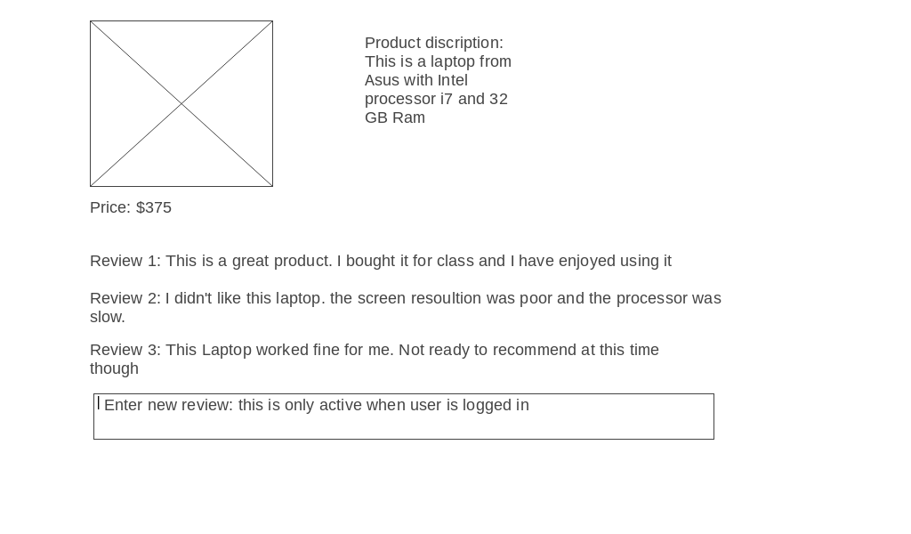

KonBan: <https://github.com/orgs/ProductReviewTeam/projects/1>