Will Spaeth

2-7-20

Homework 1

**-----------------------**

**./hw1_script.py**

**-----------------------**

#!/usr/bin/env python3

import pickle

import os

import matplotlib.pyplot as plt

from tensorflow.keras.models import Model

from tensorflow.keras.layers import Input, Dense

import numpy as np

def main():

# Load data

# Ins: (256, 8), float64

# Outs: (256, 1), float64

with open("hw1_dataset.pkl", "rb") as fp:

hw1_dataset = pickle.load(fp)

# Create & train 10 different models

prediction_errors = []

for i in range(10):

# Build & compile model

model = dnn(hidden_sizes=[8, 4, 4], hidden_act="elu", output_act="linear")

model.compile(optimizer="adam", loss="mse")

model.summary()

# Train model

model.fit(

x=hw1_dataset["ins"],

y=hw1_dataset["outs"],

epochs=3000,

batch_size=32

)

# Predict and calculate absolute error

predictions = model.predict(hw1_dataset["ins"])

prediction_errors.append( np.squeeze(np.abs(hw1_dataset["outs"] - predictions)) )

# Plot learning curve for this model

plot_learning_curve(i, model.history)

# Compute the absolute prediction errors for all runs, combine the data and generate a histogram of the absolute errors

prediction_errors = np.concatenate(prediction_errors, axis=0)

create_histogram(prediction_errors)

def dnn(hidden_sizes, hidden_act="sigmoid", output_act="tanh"):

"""Construct a simple deep neural network"""

inputs = Input(shape=(8,))

hidden_stack_out = hidden_stack(hidden_sizes, hidden_act)(inputs)

outputs = Dense(1, activation=output_act)(hidden_stack_out)

return Model(inputs=inputs, outputs=outputs)

def hidden_stack(hidden_sizes, hidden_act="sigmoid"):

"""Represents a stack of neural layers"""

layers = []

for size in hidden_sizes:

layers.append(Dense(size, activation=hidden_act))

def hidden_stack_layer(inputs):

"""Layer hook for stack"""

for i in range(len(layers)):

if i == 0:

carry_out = layers[i](inputs)

else:

carry_out = layers[i](carry_out)

return carry_out

return hidden_stack_layer

def create_histogram(prediction_errors):

fig = plt.figure()

ax = fig.add_subplot(1, 1, 1)

ax.hist(prediction_errors, 50)

plt.ylabel("Count")

plt.xlabel("Error")

fig.savefig("error_histogram.png", dpi=fig.dpi)

def plot_learning_curve(experiment_num, history):

save_path = "learning_curves/"

if not os.path.exists(save_path):

os.mkdir(save_path)

fig = plt.figure()

ax = fig.add_subplot(1, 1, 1)

ax.plot(history.history["loss"])

plt.ylabel("MSE")

plt.xlabel("Epochs")

fig.savefig(save_path + f"experiment_{experiment_num}.png", dpi=fig.dpi)

if __name__ == "__main__":

main()

**------------------------------------------**

**Resulting 10 Learning Curves**

**-----------------------------------**

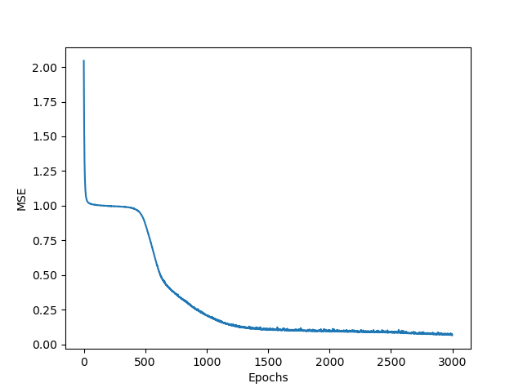**

**------------------------------------------**

**Resulting Error Histogram**

**-----------------------------------**

