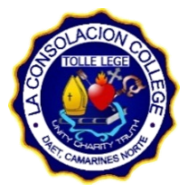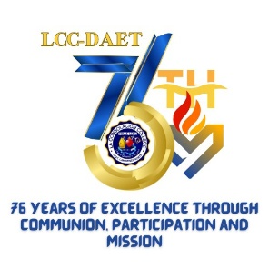

La Consolacion College of Daet, Inc.

Froilan Pimentel Avenue Daet, Camarines Norte 4600

**BASIC EDUCATION DEPARTMENT**

Academic Year 2024 - 2025

**GENERAL BIOLOGY 1 Joseph Christian D. Pioquinto**

**September 5, 2024 Grade 11 – St. Liberatus of Gafsa**

1. Research on the different diseases associated with meiosis including but not limited to the following:

a. Turner Syndrome

b. Down Syndrome

c. Klinefelter Syndrome

d. Trisomy X

e. Cystic Fibrosis

f. Thalassemia

a. Turner Syndrome

Turner syndrome, a condition that affects only females, results when one of the X chromosomes (sex chromosomes) is missing or partially missing.

b. Down Syndrome

Down syndrome is a genetic disorder caused when abnormal cell division results in an extra full or partial copy of chromosome 21.

c. Klinefelter Syndrome

Klinefelter syndrome is a genetic condition that results when a boy is born with an extra copy of the X chromosome.

d. Trisomy X

Triple X syndrome, also called trisomy X or 47,XXX, is a genetic disorder that affects about 1 in 1,000 females. Females normally have two X chromosomes in all cells — one X chromosome from each parent

e. Cystic Fibrosis

Cystic fibrosis (CF) is an inherited disorder that causes severe damage to the lungs, digestive system and other organs in the body

f. Thalassemia

Thalassemia is an inherited blood disorder, which means that it is passed from parents to children through genes.

2. Read and study the process of cell division.

What is Cell Division?

Cell division happens when a parent cell divides into two or more cells called daughter cells.

How does it occur?

Cell division usually occurs as part of a larger cell cycle. All cells reproduce by splitting into two, where each parental cell gives rise to two daughter cells.

Sources:

<https://www.mayoclinic.org/>

https://byjus.com/