Question 1:

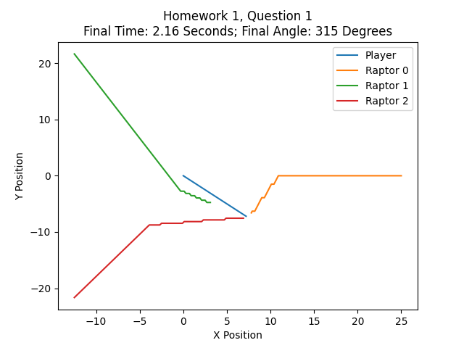When put in this situation, the optimal final time is approximately 2.16 seconds, with an initial angle of 315 degrees. The following plot shows the motion of each of the raptors over time, along with the player’s movement, which is shown in blue.

The equations for the raptors can be derived from the following:

$$\frac{dx}{dt}=v \\ {Δx}_{raptor}=cos\left(θ_{raptor-to-human}\right)*v_{raptor}* dt \\ Δy_{raptor}=sin\left(θ_{\text{raptor-to-human}}\right)*v_{raptor}*dt$$

When taken at a small enough dt time interval, the equations therefore derive into the motion presented on the graph. The equations for the player can be derived from the following.

$$Δx_{\text{player}}=cos\left(θ_{initial-angle}\right)*v_{\text{player}}*Δt \\ Δy_{\text{player}}=sin\left(θ_{\text{initial-angle}}\right)*v_{\text{player}}*Δt$$

One should note that the player’s movement is entirely dependent upon the initial angle that they are placed at. This is used to show that the player cannot change angles throughout this first simulation.

Question 2:

The equations for question 2 are much similar to the equations for question 1. The only change is that the player can now move in a different direction for every time step. This means that the new equation that governs the movement of the player is as follows:

$$Δx_{\text{player}}=cos\left(θ_{\text{farthest-angle-player-to-raptor}}\right)*v_{\text{player}}*Δt \\ Δy_{\text{player}}= sin\left(θ_{\text{farthest-angle-player-to-raptor}}\right) * v_{\text{player}} * Δt$$

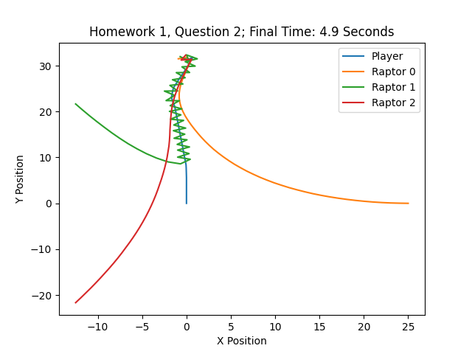One should note the addition of the angular component for the new movement equations. This denotes the player being able to change angles. The following graph shows the new movement of the player when given these conditions.

Question 3)

Under the conditions of a DT of 0.1s and a death distance of 0.1m, one will run for 7.2s to a maximum of 98.15m. At this time, the raptor comes within the death distance and catches the runner.

Question 4a)

After one step, the drunk’s possible positions could be step 2 or step 4. Either of these steps has a probability of 0.5, as at this point the ending square of step 2 and step 4 are mutually exclusive and purely chance based (with a probability of 0.5 for each corresponding action). For two steps, the question gets slightly more complicated. Now the drunk can be on steps 1, 3, or 5. The following table shows the probability and path to end up at each of these steps.

|  |  |
| --- | --- |
| Step | Probability |
| Step 1 | ¼ (Left, Left) |
| Step 3 | ½ (Left, Right; Right, Left) |
| Step 5 | ¼ (Right, Right) |

**Question 4b)**

One would expect the drunk to land in the bar when given an initial position of 0 to 2. This is because these positions are closer to the bar than they are the drunkard’s home, which logically implies that the drunkard will be more likely than not to end up at the bar. This is inversely true for initial positions 3 to 5. If the drunkard begins in positions 3 to 5, they will be more likely than not to end up at home.

This is because each step taken is an independent action (given by the equation p(x) = 0.5p(x-1) + 0.5p(x+1)). Due to this reality, we can infer that the drunkard will be more likely to end up at the place that they are closer to in their initial placement, whether that be 0 to 2 in the case of the bar, or 3 to 5 in the case of home.