# Whitewater rafting vacation | Dry Oar Boating | Home

## Dry Oar LogoDry Oar

* Home
* Rivers
* FAQ
* Rates/Dates
* Contact Us

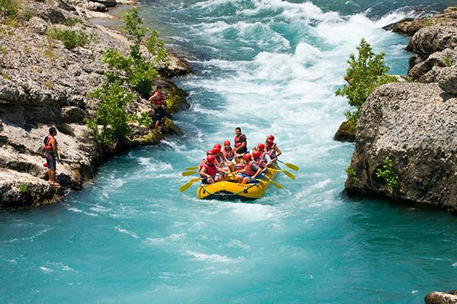

## We run Rivers to relax.

We believe that there is nothing like a river trip for *relaxing*. That is why we subscribe to the dry oar philosophy of boating. Keeping your oars dry for us means taking time to look around and notice the **beauty** that surrounds the rivers we love.

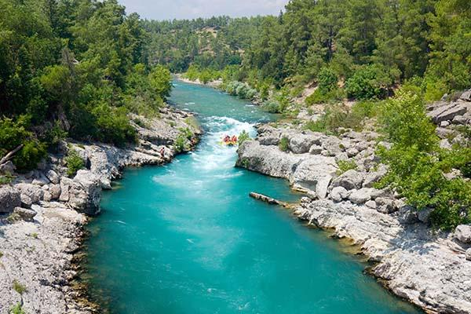

© 2017 Dry Oar Bro Thompson