Chapter 4

2019-09-27

# contrail Network Policy (ch3)

## network policy introduction

if you remember in chapter 4, we’ve introduced the "flat network" requirement in kubernetes network, and in there you already learned that a flat network assumes a "allow-any-any" model - basically a kubernetes pod can reach any other pods **by default**. this surely makes the design and implementation of kubernetes networking significantly simplified and much more scalable. on the other hand, with companies large and small rapidly adopting the platform, security has emerged as an important concern. In reality, in many cases certain level of network segmentation methods are required to ensure that only certain pods can talk to each other. that is when kubernetes network policy comes into the picture. a Kubernetes "network policy" defines the access permissions for groups of pods in a way pretty much like a security group in the cloud is used to control access to VM instances. kubernetes supports network policy via the NetworkPolicy object, which is a Kubernetes resource just like pod, service, ingress, etc. the role of it is to define how groups of pods are allowed to communicate with each other. now let’s explain the way kubernetes network policy works:

1. initially, in a kubernetes cluster, all pods are non-isolated by default. they works in "allow-any-any" model so anyone can talk to any others.
2. now you apply a network policy named policy1 to pod A to allow A to talk to pod B. from this moment on, pod A will talk to **pod B only**, because B is the only pod in the "whitelist".
3. for pod A only, any connections that are not explicitly allowed by this network policy policy1 will be rejected. you don’t need to explicitly define this in policy policy1 or any other policies, it will be enforced by the nature of kubernetes network policy. we can call this implicit policy as "deny all" policy
4. for other pods, for example, pod B, which are applied with network policy policy1, and not any other network policies either, will continue to follow the "allow-any-any" model so it can communicate to all other pods in the cluster. we can call this implicit policy as "allow all" policy
5. assuming you want pod A to also be able to communicate to pod C, you need to update the network policy policy1 to **explicit** allow it. in another word, you need to keep updating the "whitelist" to allow more traffic types.
6. multiple network-polices can be applied to a pod. for example, you can add a second policy policy2 which also select pod A to apply its forwarding rules.

as you see, whenever you define a policy, essentially you will apply at least three policies in the cluster:

* policy1: the network policy you defined, with the whitelist rules of allowed traffic for the selected pod
* a "deny all" network policy: deny all other traffic that is not in the whitelist for the selected pod
* a "allow all" network policy: allow all other traffic for other pods that are not selected by the policy1 network policy

**Note**

Network polices are implemented by the network component, so you must be using a network solution which supports network policy. Simply creating the resource without a controller to implement it will have no effect. in chapter X, you will see how these network policies looks like in contrail.

## network policy definition

like all other objects in kubernetes, network policy can be defined in a yaml file. here is an example that we’re going to test later in this chapter:

#policy-do.yaml  
apiVersion: networking.k8s.io/v1  
kind: NetworkPolicy  
metadata:  
 name: policy-do  
 namespace: dev  
spec:  
 podSelector:  
 matchLabels:  
 app: server-dev  
 policyTypes:  
 - Ingress  
 - Egress  
 ingress:  
 - from:  
 - ipBlock:  
 cidr: 10.169.25.20/32  
 - namespaceSelector:  
 matchLabels:  
 project: qa  
 - podSelector:  
 matchLabels:  
 app: client1-dev  
 ports:  
 - protocol: TCP  
 port: 80  
 egress:  
 - to:  
 - ipBlock:  
 cidr: 10.169.25.21/32  
 ports:  
 - protocol: TCP  
 port: 8080

look at the spec part of this yaml file, it has the following structures:

spec:  
 podSelector:  
 ......  
 policyTypes:  
 - Ingress  
 - Egress  
 ingress:  
 - from:  
 ......  
 egress:  
 - to:  
 ......

Network policy definition can logically be divided into four sections:

1. podSelector: this defines the pods selection identifing pods where the Network policy would be applied
2. policyTypes: specify type of policy rules, Ingress, Egress or both.
3. ingress: define the ingress policy rules for the selected pods
4. egress: define the egress policy rules for the selected pods

next we’ll look at each sections.

### podSelector

when you define a network policy, kubernetes needs to know which pods you want this policy to act on. Similar to how the service select its backend pods, the network policy select which pods it will be applied to based on labels:

podSelector:  
 matchLabels:  
 app: server-dev

here the network policy would be applied to all pods which has the label app:  
server-dev. all of the following contents in spec will apply to the selected pods only.

### policyTypes

The second section defines the policyTypes for the selected pods. it can be either ingress, egress, or both. both types define specific traffic types in the form of one or more rules, which we’ll discuss next.

policyTypes:  
 - Ingress  
 - Egress

### ingress and egress

ingress and egress section defines the direction of traffic initiator, from the selected pods perspective. for example considering the following simplified example:

ingress:  
 - from:  
 - podSelector:  
 matchLabels:  
 app: client1-dev  
 ports:  
 - protocol: TCP  
 port: 80  
 egress:  
 - to:  
 - podSelector:  
 matchLabels:  
 app: client2-dev  
 ports:  
 - protocol: TCP  
 port: 8080

assuming selected pod is server-dev pod, and there is only one pod client1-dev in the cluster having a matching label client1-dev. two things will happen:

* ingress direction: pod server-dev can accept a TCP session with a destination pod 80, coming from pod client1-dev
* egress direction: pod server-dev can initiate a TCP session with a destination pod 8080, towards pod client1-dev.

#### network policy rule

each from or to statement defines a rule in the network policy:

* a from statement defines an ingress policy rule
* a to statement defines an egress policy rule

so you can define multiple rules to allow complex traffic mode for each direction:

ingress:  
INGRESS RULE1  
INGRESS RULE2  
egress:  
EGRESS RULE1  
EGRESS RULE2

each rule identifies the network endpoints where the selected pods can communicate. Network endpoint can be identified by different methods:

* ipBlock: select pods based on ip address block
* namespaceSelector: select pods based on label of namespace (NS)
* podSelector: select pods based on label of pod

so the yaml structure for a rule can look like this:

ingress:  
 - from:  
 - ipBlock:  
 .....  
 - namespaceSelector:  
 .....  
 - podSelector:  
 .....  
 ports:  
 ......

for example:

policyTypes:  
 - Ingress  
 - Egress  
 ingress:  
 - from:  
 - ipBlock:  
 cidr: 10.169.25.0/24  
 except:  
 - 10.169.25.21/32  
 - namespaceSelector:  
 matchLabels:  
 project: qa  
 - podSelector:  
 matchLabels:  
 app: client1-dev  
 egress:  
 - to:  
 - ipBlock:  
 cidr: 10.169.25.20/32

here:

* The ingress network points are
  + subnet 10.169.25.0/24 except 10.169.25.21/32, **or**
  + all pods in namespaces which has the label project: qa, **or**
  + pods which has the label app: client1-dev
* The egress network point is 10.169.25.20/32

#### AND vs OR

It is also possible to select only a few pods from namespaces instead of all pods. podSelector can be specified along with namespaceSelector. in that case, network endpoint would be only those pods with matching labels in the selected namespaces, instead of all pods in the namespace. for example:

ingress:  
- from:  
 - namespaceSelector:  
 matchLabels:  
 project: qa  
 podSelector:  
 matchLabels:  
 app: client-qa

here, the selected pod can only communicate with those pods:

* in namespaces with label project: qa, **AND** (not **OR**) -
* pods with label app: client-qa

Please be careful it is totally different than the below definition, which allow the selected pod to talk to those pods:

* in namespaces with label project: qa, **OR** (not **AND**) -
* pods with label app: client-qa, regardless of which namespace they belongs to

ingress:  
- from:  
 - namespaceSelector:  
 matchLabels:  
 project: qa  
 - podSelector:  
 matchLabels:  
 app: client-qa

#### ports

it is also possible to specify ports for an ingress and egress rule.

Ports in ingress says that selected pods can allow incoming traffic for the specified ports. Ports in egress says that selected pods can send traffic to specified ports. If it is not mentioned it applies to all ports.

here is an example of policyTypes with ports specified:

policyTypes:  
 - Ingress  
 - Egress  
 ingress:  
 - from:  
 - ipBlock:  
 cidr: 10.169.25.20/32  
 - namespaceSelector:  
 matchLabels:  
 project: qa  
 - podSelector:  
 matchLabels:  
 app: client1-dev  
 ports:  
 - protocol: TCP  
 port: 80  
 egress:  
 - to:  
 - ipBlock:  
 cidr: 10.169.25.21/32  
 ports:  
 - protocol: TCP  
 port: 8080

The above network policy says that all ingress network endpoint can reach selected pods at tcp port 80, selected pods can reach all egress network endpoint’s tcp port 8080. all other traffic would be blocked.

## create network policy

you can create and verify the network policy same way as you create other kubernetes objects:

$ kubectl apply -f policy-do.yaml  
networkpolicy.networking.k8s.io/policy-do created  
  
$ kubectl get netpol -n dev  
NAME POD-SELECTOR AGE  
network-policy-do app=server-dev 6s  
  
$ kubectl describe netpol policy-do -n dev  
Name: policy-do  
Namespace: dev  
Created on: 2019-09-25 23:16:31 -0400 EDT  
Labels: <none>  
Annotations: kubectl.kubernetes.io/last-applied-configuration:  
 {"apiVersion":"networking.k8s.io/v1","kind":"NetworkPolicy",  
 "metadata":{"annotations":{},"name":"policy-do",  
 "namespace":"dev"},"spec":{"eg...  
Spec:  
 PodSelector: app=server-dev  
 Allowing ingress traffic:  
 To Port: 80/TCP  
 From:  
 IPBlock:  
 CIDR: 10.169.25.20/32  
 Except:  
 From:  
 NamespaceSelector: project=qa  
 From:  
 PodSelector: app=client1-dev  
 Allowing egress traffic:  
 To Port: 8080/TCP  
 To:  
 IPBlock:  
 CIDR: 10.169.25.21/32  
 Except:  
 Policy Types: Ingress, Egress

# Contrail – k8s Network Policy

In chapter 3 we introduced kubernetes network policy. we’ve mentioned that simply creating network policy object won’t have any effect unless the kubernetes networking implementation support it. In this chapter we are going to focus on contrail’s solution for kubernetes network policy. we’ll demonstrate how things work with examples.

**Contrail Firewall.**

Contrail has various security features to define policies between workloads. e.g.: "security groups", "network policy" and "firewall". Each has its own capabilities and a different design goal. in this chapter we’ll focus on "contrail firewall" only.

Contrail Firewall, often referred as "Contrail Security", is one of the feature that identifies the workloads based on the tags(labels). as you can see, this is similar to k8s network policy, so it is natural for contrail to use its firewall to implement k8s network policy.

the implementation has the following advanatages:

1. Workloads can be represented and grouped by tags.
2. Combinational tags can be used in policies.
3. Untagged workloads can be specified in policies.
4. Policies can be applied in various layers.

**Contrail k8s Network Policy test.**

Before getting into deeper into contrail firewall, lets test and see how does the k8s network policy works in contrail.

in our test we need:

* 3 namespaces,
* 5 pods
  + 1 server pod,
  + 2 client pods in the same namespace,
  + 2 clients from two different namespaces)
* 2 CIDRs to show allow and deny traffic within, across namespaces and CIDRs

Lets create the required k8s NS and pods resources.

the dev, qa and build namespaces all-in-one yaml file:

#policy-ns-do.yaml  
kind: Namespace  
apiVersion: v1  
metadata:  
 name: dev  
 labels:  
 project: dev  
---  
kind: Namespace  
apiVersion: v1  
metadata:  
 name: qa  
 labels:  
 project: qa  
---  
kind: Namespace  
apiVersion: v1  
metadata:  
 name: build  
 labels:  
 project: build  
---

create the 3 namespaces:

$kubectl create -f network-policy-ns-do.yaml  
namespace/dev created  
namespace/qa created  
namespace/build created

create following pods in the three NS:

|  |  |
| --- | --- |
| NS | pod |
| dev | server-dev |
| dev | client1-dev |
| dev | client2-dev |
| qa | client-qa |
| build | client-build |

here is the all-in-one yaml file:

# policy-pod-do.yaml  
apiVersion: v1  
kind: Pod  
metadata:  
 name: server-dev  
 labels:  
 app: server-dev  
 do: policy  
 namespace: dev  
spec:  
 containers:  
 - name: webserver  
 image: contrailk8sdayone/contrail-webserver  
 securityContext:  
 privileged: true  
 ports:  
 - containerPort: 80  
---  
apiVersion: v1  
kind: Pod  
metadata:  
 name: client1-dev  
 labels:  
 app: client1-dev  
 do: policy  
 namespace: dev  
spec:  
 containers:  
 - name: ubuntu  
 image: contrailk8sdayone/ubuntu  
---  
apiVersion: v1  
kind: Pod  
metadata:  
 name: client2-dev  
 labels:  
 app: client2-dev  
 do: policy  
 namespace: dev  
spec:  
 containers:  
 - name: ubuntu  
 image: contrailk8sdayone/ubuntu  
---  
apiVersion: v1  
kind: Pod  
metadata:  
 name: client-qa  
 labels:  
 app: client-qa  
 do: policy  
 namespace: qa  
spec:  
 containers:  
 - name: ubuntu  
 image: contrailk8sdayone/ubuntu  
---  
apiVersion: v1  
kind: Pod  
metadata:  
 name: client-build  
 labels:  
 app: client-build  
 do: policy  
 namespace: build  
spec:  
 containers:  
 - name: ubuntu  
 image: contrailk8sdayone/ubuntu  
---

**Tip**

we use the contrail-webserver and ubuntu image that we’ve been using throughout the book, for server and clients repectively. also, we add a label do: policy in all pods so that displaying all pods used in this test is easier.

create and verify all pods:

$kubectl create -f policy-pod-do.yaml  
pod/server-dev created  
pod/client1-dev created  
pod/client2-dev created  
pod/client-qa created  
pod/client-build created  
  
$ kubectl get pod -l 'do=policy' -o wide --all-namespaces  
NAMESPACE NAME READY STATUS RESTARTS AGE IP NODE NOMINATED NODE  
build client-build 1/1 Running 0 42s 10.47.255.230 cent333 <none>  
dev client1-dev 1/1 Running 0 42s 10.47.255.233 cent333 <none>  
dev client2-dev 1/1 Running 0 42s 10.47.255.232 cent333 <none>  
dev server-dev 1/1 Running 0 42s 10.47.255.234 cent333 <none>  
qa client-qa 1/1 Running 0 42s 10.47.255.231 cent222 <none>

Before creating the k8s network policy, lets try to access the server pod from all the clients (client1-dev, client2-dev, client-qa and client-build) pods and from host of the two nodes.

check the httpserver is running at port 80 in server-dev pod:

$kubectl exec -it server-dev -n dev -- netstat -antp| grep 80  
tcp 0 0 0.0.0.0:80 0.0.0.0:* LISTEN 1/python

accessing httpserver of server-dev from client1-dev:

$ kubectl exec -it client1-dev -n dev -- curl http://10.47.255.234  
<html>  
<style>  
 h1 {color:green}  
 h2 {color:red}  
</style>  
 <div align="center">  
 <head>  
 <title>Contrail Pod</title>  
 </head>  
 <body>  
 <h1>Hello</h1><br><h2>This page is served by a <b>Contrail</b>  
 pod</h2><br><h3>IP address = 10.47.255.234<br>Hostname = server-dev</h3>  
 </body>  
 </div>  
</html>

we can repeat the same command, except replace the the client pod’s name and namespaces:

$ kubectl exec -it client2-dev -n dev -- curl http://10.47.255.234  
$ kubectl exec -it client-qa -n qa -- curl http://10.47.255.234  
$ kubectl exec -it client-build -n build -- curl http://10.47.255.234

same curl command can be sent from the host of two nodes in the cluster:

$ curl http://10.47.255.234  
$ curl http://10.47.255.234

in all tests, we’ll see exactly the same test result .

now lets create the k8s network-policy and see what is happening and any differences in test result.

here is the same exact policy yaml file we’ve showed in chapter 3:

# policy-do.yaml  
apiVersion: networking.k8s.io/v1  
kind: NetworkPolicy  
metadata:  
 name: network-policy-do  
 namespace: dev  
spec:  
 podSelector:  
 matchLabels:  
 app: server-dev  
 policyTypes:  
 - Ingress  
 - Egress  
 ingress:  
 - from:  
 - ipBlock:  
 cidr: 10.169.25.20/32  
 - namespaceSelector:  
 matchLabels:  
 project: qa  
 - podSelector:  
 matchLabels:  
 app: client1-dev  
 ports:  
 - protocol: TCP  
 port: 80  
 egress:  
 - to:  
 - ipBlock:  
 cidr: 10.169.25.21/32  
 ports:  
 - protocol: TCP  
 port: 8080

from the network-policy definition, we can see what the policy is trying to enforce:

* the following clients can reach the server-dev server pod located in dev namespace
  + client1-dev from dev namespace
  + client-qa from qa namespace
  + any pod in node 10.169.25.20 (cent222 in our setup)
* all other accesses are denied.

let’s create the policy and verify its effect.

$ kubectl apply -f policy-do.yaml  
networkpolicy.networking.k8s.io/network-policy-do created  
$ kubectl get networkpolicies --all-namespaces  
NAMESPACE NAME POD-SELECTOR AGE  
dev network-policy-do app=server-dev 17s

accessing httpserver of server-dev pod from pod client1-dev, client-qa and node cent222 host:

$ kubectl exec -it client1-dev -n dev -- curl http://10.47.255.234  
<html>  
<style>  
 h1 {color:green}  
 h2 {color:red}  
</style>  
 <div align="center">  
 <head>  
 <title>Contrail Pod</title>  
 </head>  
 <body>  
 <h1>Hello</h1><br><h2>This page is served by a <b>Contrail</b>  
 pod</h2><br><h3>IP address = 10.47.255.234<br>Hostname = server-dev</h3>  
 </body>  
 </div>  
</html>

repeat the same test from from pod client2-dev, client-build and another node cent333 now get timed out:

$ kubectl exec -it client2-dev -n dev -- curl http://10.47.255.234 -m 10  
curl: (28) Connection timed out after 10000 milliseconds  
command terminated with exit code 28  
  
$ kubectl exec -it client-build -n build -- curl http://10.47.255.234:80 -m 30  
curl: (28) Connection timed out after 10001 milliseconds  
command terminated with exit code 28  
  
$ curl http://10.47.255.234:80 -m 30  
curl: (28) Connection timed out after 10001 milliseconds

From the above exercise, we can conclude that k8s network policy works as expected in contrail.

## Deeper view

Contrail Firewall is designed with a hierarchical structure:

* the top level object is named “Application Policy Set(APS)”.
* APS has Firewall Policies;
* Firewall Policy has Firewall Rules;
* Firewall rules has the endpoints;
* Endpoints can be identified via tags or address groups(CIDRs).

Below table would represent network policy construtcs in k8s and mapping constructs in contrail and the mapping is done by the kube-manager.

|  |  |
| --- | --- |
| K8s Network Policy Construct | Contrail Firewall Construct |
| Cluster Name | APS (one per k8s cluster) |
| Network Policy | Firewall Policy (one per k8s network policy) |
| Ingress and Egress policy | Firewall Rule (one per k8s ingress/egress policy) |
| CIDR | Address Group(one per k8s network policy CIDR ) |
| Label | Tag (one for each k8s label) |

contrail-kube-manager will do the following things for k8s network policy:

1. It will create a APS with Kubernetes cluster name during the initialization.
2. It registers to k8s api server to watch network policies CRUD events.
3. Whenever namespace is created, it will associate the k8s APS to the virtual-networks belonging to the namespace.
4. Whenever pod or namespace is created, tag will be created for the k8s labels in contrail.
5. Whenever network policy is created, firewall policy will be created with matching firewall rules and network endpoints.

**Note**

APS can be associated to different contrail objects, e.g.

* VMI(virtual-machine-interface)
* VM(virtual-machine)
* virtual-network
* project

In contrail-k8s cluster, it is associated to virtual network. Whenever traffic goes on those networks, firewall policies associated on the APS would be evaluated and respective action would be taken for the traffic.

Lets focus on the contrail objects which are created for k8s network policy.

1. As mentioned in the above section, APS with k8s cluster name will be created by contrail-kube-manager during the initialization. Since the cluster name is k8s by default, we can see the APS k8s in the below contrail ui. There is one more APS default-application-policy-set which is created by default. By default firewall policy k8s-denyall and k8s-allowall will be created. Since k8s by default "allows all" and contrail firewall by default "denies all", contrail has to have rules to match k8s default bahaviour. So by default firewalls rules are added in k8s-allowall firewall policy. Below contrail ui snapshots shows it.

* 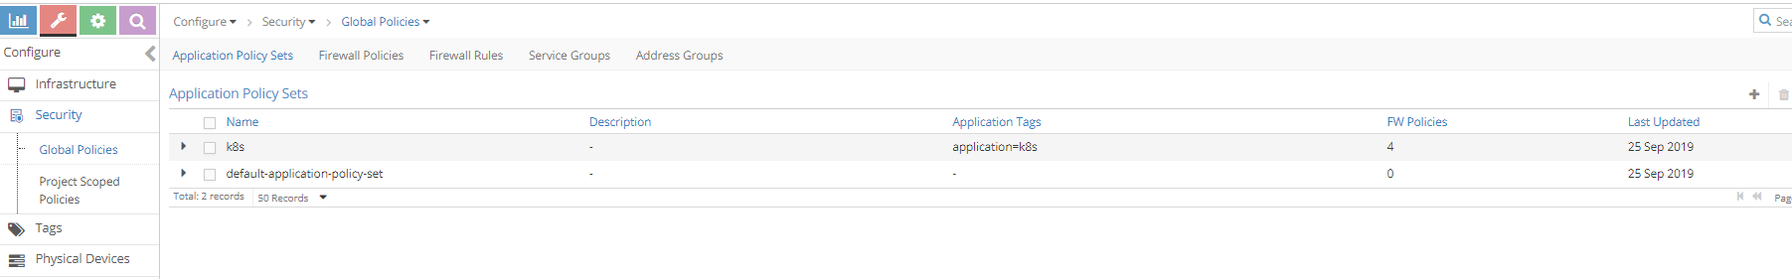
* 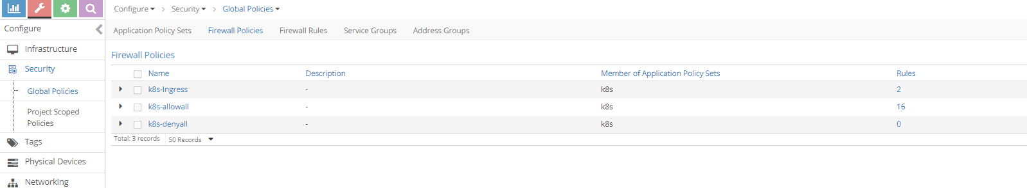
* **Note**
* When firewall polices are evaluated for the APS, it is evaluated in a sequence. When there is a matching policy, it will be executed. So all firewall polices and allfirewall rules has a sequence number. contrail-Kube-manager allocates the right sequence number for firewall policies and firewall rules to keep the k8s network-policy intact in contrail. K8s-ingress firewall policy is created for the ingress loadbalancer which is out of the scope of this book.

1. After the network policy creation, k8s APS will have the new firewall policy for the k8s netwok policy.

* 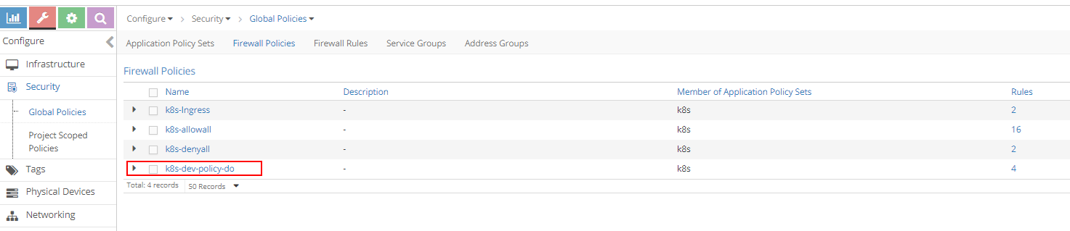

1. K8s-dev-policy-do is the new firewall policy created by contrail-kube-manager for k8s network policy policy-do. As explained in earlier chapters, cluster and namespace name are prepended to the network policy name. If we closely watch, we can see four firewall rules in K8s-dev-policy-do firewall policy and two new firewall rules for the k8s-denyall firewall policy are added. clicking at the firewall policy k8s-dev-policy-do, Firewall rules of k8s-dev-policy-do is matching to k8s network policy which can be seen:

* 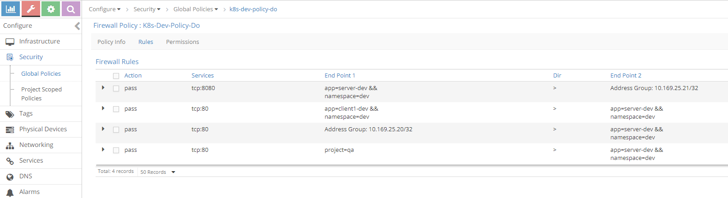

1. Newly added firewall rules for firewall policy k8s-denyall can also be seen below. These rules are needed to deny other traffic to the server-dev pod.

* 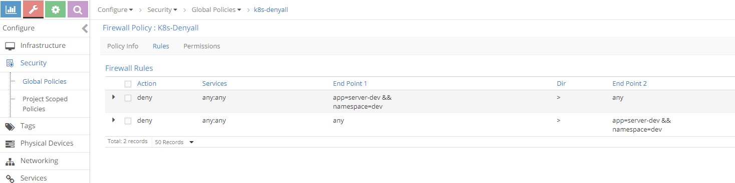

1. Lets see the sequence number of the firewall policies. Since firewall policy k8s-dev-policy-do has high priority (indicated by a lower sequence number) than k8s-denyall and k8s-allowall, all matching traffic for the endpoints are allowed. similarly, k8s-denyall has high priority than k8s-allowall, so all other traffic will be dropped.

* 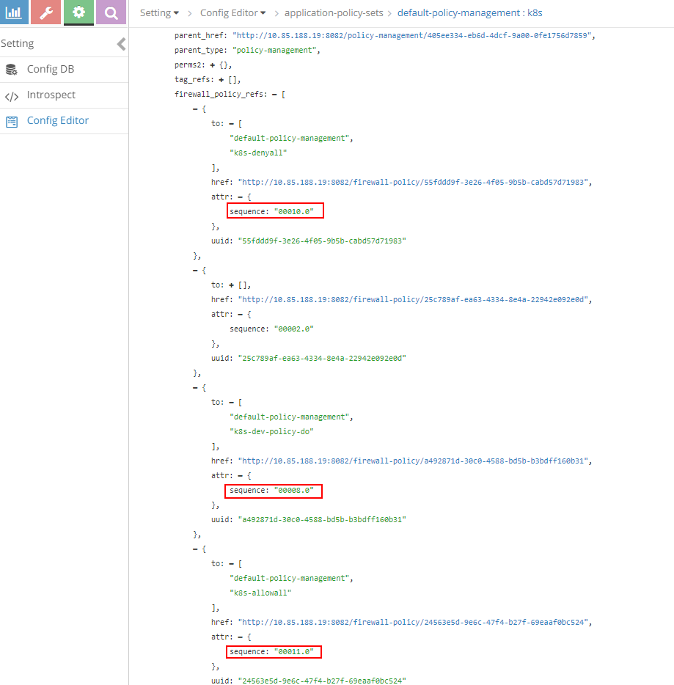

1. Also look at the tags and associated ports(vmi). For each pod label, tag can be seen and it is attached to the respective pod port which is done by the kube-manager.

* 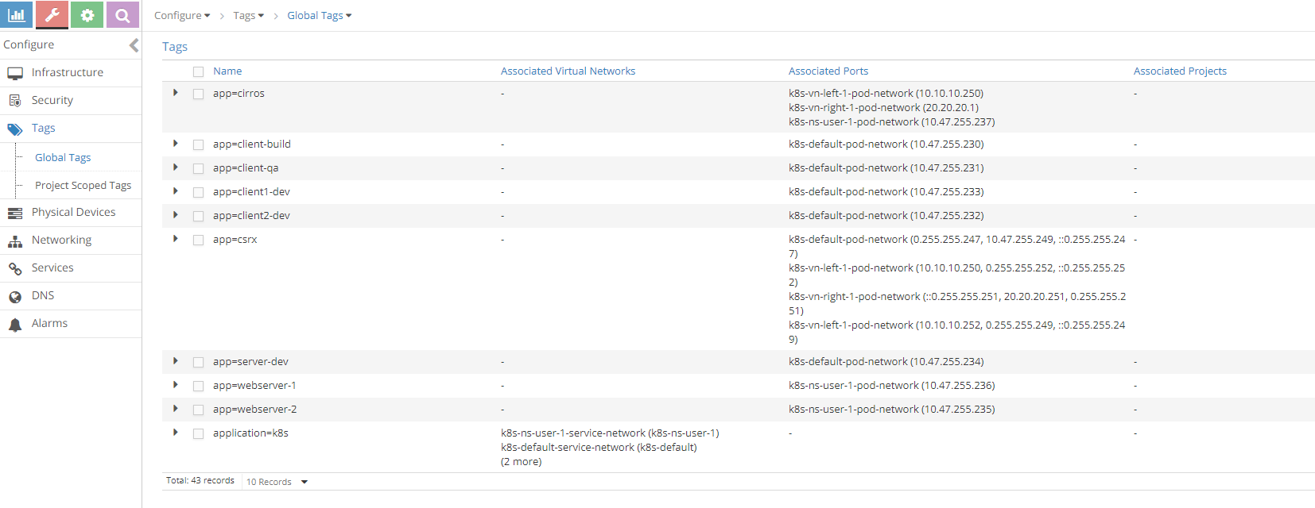

1. Since action for the whitelisted case is FORWARD and flow for FORWARD is explained in the previous sections with service and ingress, lets focus on the flow for the non-whitelisted case.

* $ kubectl exec -it client-build -n build -- curl -v 10.47.255.234  
  * Rebuilt URL to: 10.47.255.234/  
  * Hostname was NOT found in DNS cache  
  * Trying 10.47.255.234...  
  * connect to 10.47.255.234 port 80 failed: Connection timed out  
  * Failed to connect to 10.47.255.234 port 80: Connection timed out  
  * Closing connection 0  
  curl: (7) Failed to connect to 10.47.255.234 port 80: Connection timed out  
  command terminated with exit code 7
* login to contrail-vrouter-agent and see the flow
* $ docker exec -it vrouter_vrouter-agent_1 flow --match 10.47.255.234:80  
  Flow table(size 80609280, entries 629760)  
    
  Entries: Created 340 Added 336 Deleted 280 Changed 331Processed 340 Used Overflow entries 0  
  (Created Flows/CPU: 91 84 65 100)(oflows 0)  
    
  Action:F=Forward, D=Drop N=NAT(S=SNAT, D=DNAT, Ps=SPAT, Pd=DPAT, L=Link Local Port)  
   Other:K(nh)=Key_Nexthop, S(nh)=RPF_Nexthop  
   Flags:E=Evicted, Ec=Evict Candidate, N=New Flow, M=Modified Dm=Delete Marked  
  TCP(r=reverse):S=SYN, F=FIN, R=RST, C=HalfClose, E=Established, D=Dead  
    
  Listing flows matching ([10.47.255.234]:80)  
    
   Index Source:Port/Destination:Port Proto(V)  
   ----------------------------------------------------------------------------------  
   11148<=>242676 10.47.255.234:80 6 (4)  
   10.47.255.230:35778  
  (Gen: 1, K(nh):52, Action:D(Unknown), Flags:, TCP:Sr, QOS:-1, S(nh):52,  
   Stats:0/0, SPort 62120, TTL 0, Sinfo 0.0.0.0)  
    
   242676<=>11148 10.47.255.230:35778 6 (4)  
   10.47.255.234:80  
  (Gen: 1, K(nh):65, Action:D(FwPolicy), Flags:, TCP:S, QOS:-1, S(nh):65,  
   Stats:6/444, SPort 61489, TTL 0, Sinfo 12.0.0.0)
* Since client-build is not part of the white-list for the server-dev pod, the action is set to D(FwPolicy) which means DROP due to Firewall Policy.

1. So far we have discussed the ingress policy type. There is no change for egress policy type. So whatever we discussed it can be applied to egress policy type.
2. Contrail ui provides nice visualization for security. It is self explanatory if you know how contrail security works.

* 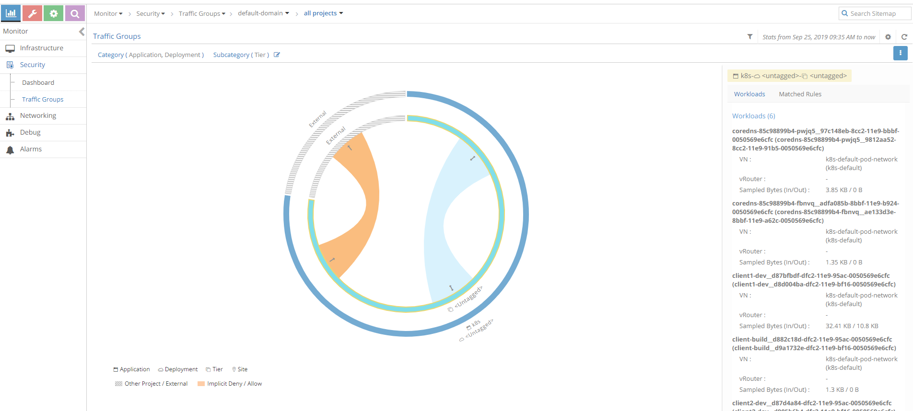
* Sample traffic visualization for the above policy with workload
* 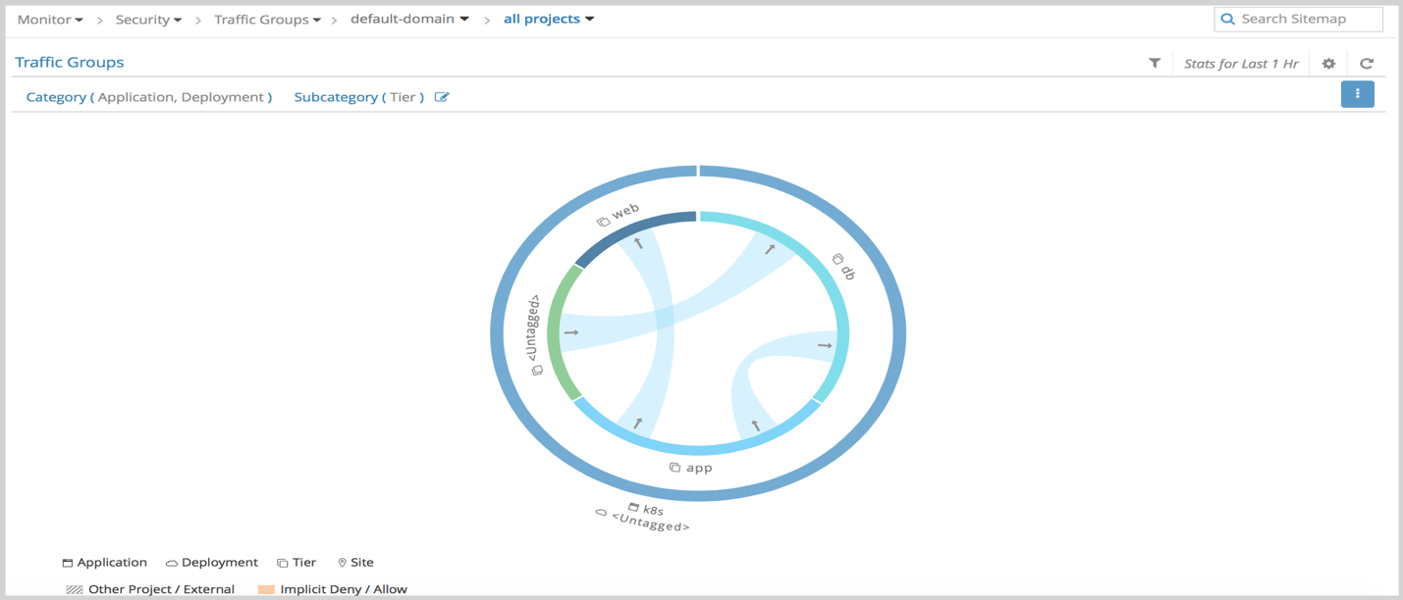
* Sample traffic visualization with more network policies