appendix

2019-08-26

# contrail kubernetes setup installation

## HW/SW prerequisites

* centos 7.6
* 32G mem
* 50G HD

$ cat /etc/centos-release  
CentOS Linux release 7.6.1810 (Core)  
  
$ free -h  
 total used free shared buff/cache available  
Mem: 31G 20G 7.0G 72M 3.8G 10G  
Swap: 0B 0B 0B  
  
$ df -h | head  
Filesystem Size Used Avail Use% Mounted on  
/dev/mapper/centos-root 47G 40G 7.3G 85% /

## 3 nodes cluster only setup

### topology

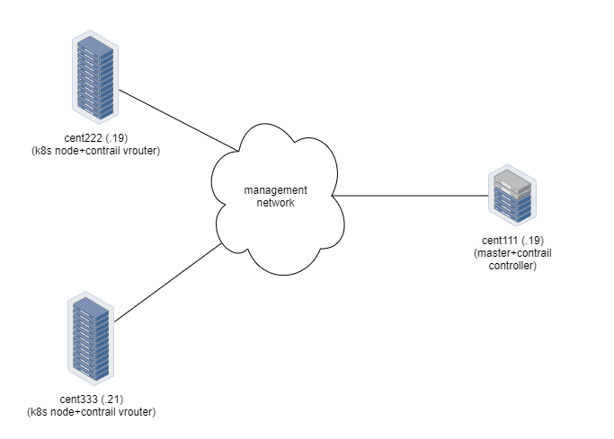

3 nodes cluster-only setup (no external connections)

### yaml template

global_configuration:  
 CONTAINER_REGISTRY: ci-repo.englab.juniper.net:5000  
 REGISTRY_PRIVATE_INSECURE: true  
provider_config:  
 bms:  
 ssh_pwd: Juniper  
 ssh_user: root  
 ntpserver: ntp.juniper.net  
 domainsuffix: local  
instances:  
 bms1:  
 provider: bms  
 ip: 10.85.111.26  
 roles:  
 analytics:  
 analytics_alarm:  
 analytics_database:  
 analytics_snmp:  
 config:  
 config_database:  
 control:  
 k8s_master:  
 kubemanager:  
 webui:  
 bms2:  
 provider: bms  
 ip: 10.85.111.27  
 roles:  
 k8s_node:  
 vrouter:  
 bms3:  
 provider: bms  
 ip: 10.85.111.28  
 roles:  
 k8s_node:  
 vrouter:  
contrail_configuration:  
 CLOUD_ORCHESTRATOR: kubernetes  
 CONTRAIL_VERSION: master-latest  
 RABBITMQ_NODE_PORT: 5673

only the following parameters needs to be changed:

ssh_pwd: Juniper  
ssh_user: root  
ntpserver: ntp.juniper.net  
ip: 10.85.111.26 ~ 28

## deploy setup based on yaml file

yum -y install epel-release git ansible net-tools  
yum -y install python-pip python-urllib3 python-requests  
  
git clone https://github.com/Juniper/contrail-ansible-deployer.git  
cp instances.yaml contrail-ansible-deployer/config/instances.yaml  
cd contrail-ansible-deployer  
  
ansible-playbook -i inventory/ playbooks/configure_instances.yml  
  
#if it is openstack  
ansible-playbook -i inventory/ playbooks/install_openstack.yml  
#if it is k8s  
ansible-playbook -i inventory/ playbooks/install_k8s.yml  
  
ansible-playbook -i inventory/ playbooks/install_contrail.yml

## verification

[root@cent1 ~]# contrail-status  
Pod Service Original Name State Id Status  
 redis contrail-external-redis running ac7ccf200841 Up 12 hours  
analytics api contrail-analytics-api running 4d5df940f2c9 Up 12 hours  
analytics collector contrail-analytics-collector running eede6985b56b Up 12 hours  
analytics nodemgr contrail-nodemgr running 9a695d3ad116 Up 12 hours  
analytics-alarm alarm-gen contrail-analytics-alarm-gen running a9a2b63a13e7 Up 12 hours  
analytics-alarm kafka contrail-external-kafka running f2b8b87e7891 Up 12 hours  
analytics-alarm nodemgr contrail-nodemgr running 539d41216ec0 Up 12 hours  
analytics-snmp nodemgr contrail-nodemgr running 3a15390a119f Up 12 hours  
analytics-snmp snmp-collector contrail-analytics-snmp-collector running 894c8695c8a5 Up 12 hours  
analytics-snmp topology contrail-analytics-snmp-topology running 1325d917c62b Up 12 hours  
config api contrail-controller-config-api running 6bdf6530afd5 Up 12 hours  
config device-manager contrail-controller-config-devicemgr running 2eb24b537089 Up 12 hours  
config nodemgr contrail-nodemgr running 13c3a8a63597 Up 12 hours  
config schema contrail-controller-config-schema running 2b571e48b2c1 Up 12 hours  
config svc-monitor contrail-controller-config-svcmonitor running 79ccd1a6975a Up 12 hours  
config-database cassandra contrail-external-cassandra running f0fc9e49fab2 Up 12 hours  
config-database nodemgr contrail-nodemgr running 73fc28f9325e Up 12 hours  
config-database rabbitmq contrail-external-rabbitmq running d5bb7e78331a Up 12 hours  
config-database zookeeper contrail-external-zookeeper running cedb14f696d3 Up 12 hours  
control control contrail-controller-control-control running 7a25b10adb13 Up 12 hours  
control dns contrail-controller-control-dns running 3b660a355a44 Up 12 hours  
control named contrail-controller-control-named running eb2eb603cb2d Up 12 hours  
control nodemgr contrail-nodemgr running 7bb60c059042 Up 12 hours  
database cassandra contrail-external-cassandra running fcb268d42098 Up 12 hours  
database nodemgr contrail-nodemgr running 7d44a2334ef3 Up 12 hours  
database query-engine contrail-analytics-query-engine running 3f4c5a64e7db Up 12 hours  
device-manager dnsmasq contrail-external-dnsmasq running 3be66d74f44e Up 12 hours  
kubernetes kube-manager contrail-kubernetes-kube-manager running 804a9badb60a Up 12 hours  
webui job contrail-controller-webui-job running 786aad4792be Up 12 hours  
webui web contrail-controller-webui-web running 715ebaa06bb9 Up 12 hours  
  
== Contrail control ==  
control: active  
nodemgr: active  
named: active  
dns: active  
  
== Contrail analytics-alarm ==  
nodemgr: active  
kafka: active  
alarm-gen: active  
  
== Contrail kubernetes ==  
kube-manager: active  
  
== Contrail database ==  
nodemgr: initializing (Disk for DB is too low. )  
query-engine: active  
cassandra: active  
  
== Contrail analytics ==  
nodemgr: active  
api: active  
collector: active  
  
== Contrail config-database ==  
nodemgr: initializing (Disk for DB is too low. )  
zookeeper: active  
rabbitmq: active  
cassandra: active  
  
== Contrail webui ==  
web: active  
job: active  
  
== Contrail analytics-snmp ==  
snmp-collector: active  
nodemgr: active  
topology: active  
  
== Contrail device-manager ==  
  
== Contrail config ==  
svc-monitor: active  
nodemgr: active  
device-manager: active  
api: active  
schema: active