A Bayesian Varying Coefficient Multiple Index
Model for Longitudinal Analysis of Environmental Chemical Mixtures
Wei Jia
Department of Biostatistics, Health Informatics and Data Science
University of Cincinnati College of Medicine jiawi@mail.uc.edu
Kimberly Yolton
Division of General and Community Pediatrics
Cincinnati Children’s Hospital Medical Center Kimberly.Yolton@cchmc.org
Xu, Yingying
Division of General and Community Pediatrics
Cincinnati Children’s Hospital Medical Center Yingying.Xu@cchmc.org
Lili, He
Imaging Research Center
Cincinnati Children’s Hospital Medical Center lili.he@cchmc.org
M.B. Rao
Department of Biostatistics, Health Informatics and Data Science
University of Cincinnati College of Medicine raomb@ucmail.uc.edu
Roman A. Jandarov
Department of Biostatistics, Health Informatics and Data Science
University of Cincinnati College of Medicine jandarrn@ucmail.uc.edu
April 2024

Abstract
This paper introduces the Bayesian Varying Coefficient Multiple Index Model (BVCMIM), a novel statistical approach designed to estimate the longitudinal effects of environmental chemical exposure mixtures on human health outcomes. Traditional methods in environmental health often focus on single chemical exposures or rely on linear models that may not capture the complex, non-linear, and non-additive relationships inherent in chemical mixtures. BVCMIM overcomes these limitations by allowing for the estimation of non-linear relationships between exposure indices and health outcomes, while also accounting for interactions among different chemical exposures over time. The model incorporates the use of continuous shrinkage priors for sparsity, ensuring that only the most relevant exposures are included in the analysis, and applies Hamiltonian Monte Carlo for uncertainty quantification. Through a series of simulations, we demonstrate that BVCMIM provides robust and interpretable estimates of both baseline and longitudinal health effects, even in scenarios with intricate chemical interactions. BVCMIM offers a flexible and powerful tool for environmental health researchers aiming to understand the impact of complex chemical mixtures on health trajectories.

Introduction
Exposure to chemical stressors can have diverse effects on human health [20, 17, 9]. Historically, research has primarily focused on modeling the impact of exposure to individual chemicals [10, 8]. However, in reality, environmental exposures typically consist of complex mixtures of chemicals, making it critical to understand their combined effects. This is a key research priority for the National Institute of Environmental Health Sciences (NIEHS) [5, 18]. When analyzing mixture effects, researchers often aim to assess how exposures influence health outcomes across different ages, necessitating a longitudinal approach [4].
Several statistical approaches have been proposed to analyze mixture effects, including exposure-response surface methods and exposure-index methods. Exposure-response surface approaches, like Bayesian kernel machine regression (BKMR) [2], estimate multi-dimensional relationships between exposures and outcomes in a non-parametric way, capturing linear and non-linear effects, and non-additive interactions effects. For BKMR, interpretation relies mostly on examining the posterior analysis of the high-dimensional exposure-response surface, heavily utilizing visualization. When dealing with a moderate to large number of components in the mixture, rigorous interpretation becomes challenging due to the vast number of main effects and interactions involved. For instance, in the analysis of 18 exposures discussed in this study, BKMR necessitates visually inspecting 18 main effect exposure-response functions and 306 pairwise interaction surface plots. Furthermore, BKMR struggles with highdimensional data, a phenomenon known as the “curse of dimensionality” [19].
On the other hand, exposure-index methods assess the association between
an outcome and a composite index formed from multiple exposures. Two widely used approaches in environmental health are Weighted Quantile Sum (WQS) regression [6] and Quantile G-computation (QGC) [13]. Both methods begin by transforming the exposure variables into quantiles and then fitting a linear model to estimate the effect of the combined exposures. In WQS regression, the exposure index is a weighted sum of quantile transformed exposures, where the weights are estimated from the data and constrained to be non-negative and sum to one. These weights reflect the relative contribution of each exposure to the overall mixture effect. The model then estimates a single coefficient—the overall index effect—that quantifies the association between the composite exposure and the outcome. Quantile G-computation generalizes this idea by relaxing the constraint on weights and allowing them to be negative or positive, thereby enabling estimation of both harmful and protective components within the mixture. A key advantage of these methods is interpretability: they provide a single parameter representing the mixture’s overall effect, along with component-specific weights that indicate the relative influence of each exposure. This simplification leads to clearer communication of results. Additionally, their compact structure enables efficient inference when model assumptions are valid. However, because these methods rely on linear modeling frameworks, they may lack the flexibility needed to capture complex, nonlinear, or interactive exposure–response relationships. While it is possible to modify these methods to include higher-order terms or interactions, doing so parametrically often complicates the interpretability of the weights and can lead to inaccurate inference.
Recently, the Bayesian Multiple Index Model (BMIM) was introduced [16] as a flexible framework that combines features of both exposure–response surface methods and exposure-index models for non-longitudinal data. BMIM assumes that chemicals can be grouped naturally based on shared characteristics or similar modes of action, and it constructs a separate index for each group. This multiple-index approach reduces the dimensionality of the exposure space while allowing for non-linear relationships between each index and the outcome, as well as non-additive interactions among exposures. As a result, BMIM offers improved flexibility for modeling complex mixture effects.
In longitudinal settings—where exposures are measured once but health outcomes are recorded at multiple time points—it becomes important to evaluate not only the effect of the exposure mixture on a single outcome, but also on the trajectory of the outcome over time. To address this, previous approaches have integrated exposure–response or exposure-index models with mixed-effects frameworks to capture both baseline levels and changes in health outcomes. For instance, Bayesian Varying Coefficient Kernel Machine Regression (BVCKMR) [15] combines Bayesian kernel machine regression with mixed-effects modeling to allow for nonlinear exposure effects that vary over time. Similarly, Jia (2024) [12] extends quantile regression to a mixed-effects setting, relaxing the directional constraint used in WQS to allow more flexibility in estimating mixture effects. These methods enable estimation of mixture effects on both the baseline outcome and its trajectory across time. However, they also inherit the limitations of the underlying exposure–response frameworks on which they are built.
In summary, despite recent advancements in statistical methods for analyzing chemical mixtures, substantial challenges remain—particularly in longitudinal settings. Many existing models, such as Bayesian Kernel Machine Regression (BKMR), offer flexible surface estimation but suffer from scalability issues and limited interpretability when applied to high-dimensional exposures. Indexbased approaches like Weighted Quantile Sum (WQS) regression improve interpretability by summarizing mixtures, but are typically linear, cross-sectional, and rely on restrictive assumptions (e.g., directional constraints, quantile transformation). Moreover, these models often cannot capture the evolution of exposure effects over time. In longitudinal studies of child health, understanding how mixture effects change with age is crucial for identifying sensitive windows of development.
To address these limitations, we propose a Bayesian Varying Coefficient Multiple Index Model (BVCMIM) that (i) incorporates group-wise exposure indices to enhance interpretability, (ii) flexibly models nonlinear effects, (iii) allows for exposure group interactions using kernel functions, and (iv) integrates subject-specific time-varying random effects for repeated outcome measurements. Therefore, BVCMIM bridges the gap between interpretability, flexibility, and scalability—providing a practical framework for analyzing complex environmental mixtures in longitudinal cohort studies.

Data Overview and Preparation
To illustrate the applicability of the proposed method described in later sections, we analyze data from the Health Outcomes and Measures of the Environment (HOME) Study—a prospective birth cohort conducted in the Greater Cincinnati, Ohio metropolitan area. The HOME Study enrolled pregnant women from three local hospitals and collected extensive environmental, behavioral, and developmental data on their children.
For this study, we focus on assessing the relationship between prenatal chemical exposures and children’s neurodevelopment, as measured by the Bayley Mental Development Index (MDI). MDI scores were assessed at child ages 12, 24, and 36 months. Chemical exposures data were collected during pregnancy from maternal biological samples. Our analytic subset includes 149 children with complete data on relevant exposures and neurodevelopmental outcomes, consistent with previous work [12]. The demographics information for all participants are provided in table 1.
Following the preprocessing steps outlined in Braun et al. [3], we excluded chemicals with detection frequencies below 20%, yielding 36 continuous chemical exposure variables that can be grouped naturally into five sets of pollutants hypothesized to act similarly: Phthalates and Bisphenol A (Pth & BPA), Polychlorinated Biphenyls (PCB), Organochlorines (OC), Polybrominated Diphenyl Ethers (PBDE) and Perfluorinated Compounds (PFC). For measurements below the limit of detection (LOD), we imputed values using the standard substitution √ method: LOD/ 2 [11]. The geometric means and standard deviations for 36 chemical exposure variables are provided in table 2. To mitigate the influence of skewed distributions and potential outliers, all chemical concentrations were log-transformed using log₁₀.
This prepared dataset provides a rich platform to evaluate the proposed model in the context of high-dimensional, longitudinal environmental health data.
Table 1: Demographic Profile of Participants
Category | Subgroup | N | Percentage (%)
 | 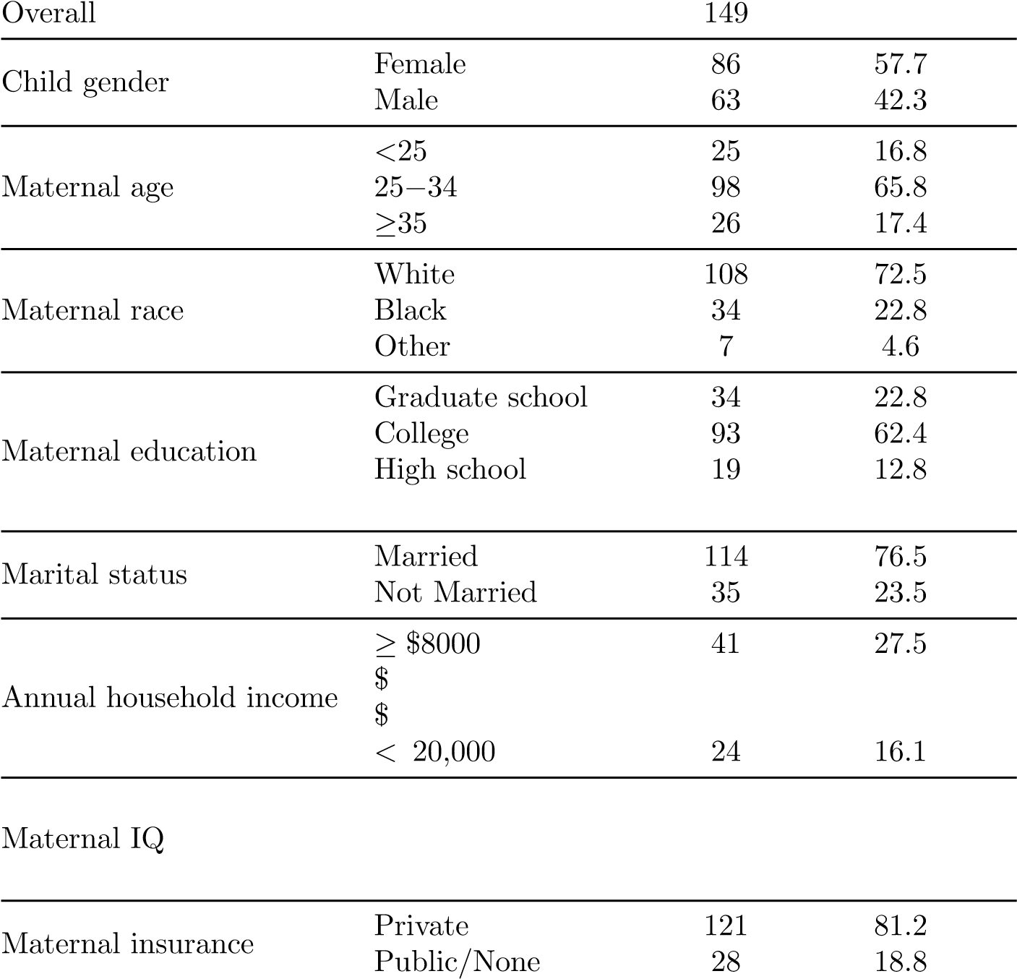< High school | 6 | 4.0
 | 40,000 to <$80,000 | 63 | 42.3
 | 20,000 to <$40,000 | 21 | 14.1
 | $  1st tertilt (58-101) | 40 | 26.8
 | 2nd tertile (>101-114) | 59 | 39.6
3rd tertile (115-134) 40 26.8
Table 2: Geometric means and standard deviations of maternal biological samples chemicals concentrations during pregnancy for all 149 participants
Category | Chemical | GM (GSD)
Pth & BPA | MBP  MIBP  MEP2  MBZP2  MCPP | 22.6 (1.3) 5.7 (1.0)  95.6 (1.5)  9.4 (1.2)  3.0 (0.7)
 | MEHHP | 24.65 (1.35)
 | MECPP | 35.28 (1.33)
 | BPA | 3.13 (0.87)
PCB | PCB28  PCB74  PCB99  PCB105  PCB118  PCB138 158  PCB146  PCB153  PCB156 | 8.17 (0.54)  18.46 (0.52)  18.28 (0.56) 8.25 (0.58)  30.77 (0.62)  50.01 (0.63) 8.20 (0.59)  69.50 (0.64)  11.78 (0.64)
 | PCB170 | 18.88 (0.70)
 | PCB183 | 7.19 (0.58)
 | PCB187 | 14.49 (0.64)
 | PCB194 | 9.83 (0.64)
 | PCB196 203 | 11.64 (0.61)
 | PCB199 | 9.82 (0.65)
 | PCB206 | 6.59 (0.50)
OC | PP DDE  T NONA | 452.74 (0.61)  48.40 (0.62)
PBDE | BB153  PBDE28  PBDE99  PBDE100 | 8.33 (0.69)  8.15 (0.77)  29.93 (1.07)  26.10 (0.98)
 | PBDE153 | 34.43 (1.01)
PFC | PFOA  PFOS  PFNA | 6.80 (0.45)  14.28 (0.45)  2.03 (0.20)
 | PFHXS | 2.73 (0.43)

Methodological Background

Bayesian Multiple Index Model (BMIM)
Suppose there are P chemical exposures denoted by z_{i1},...,z_{iP} for subject i = 1,...,n, which can be naturally partitioned into M mutually exclusive groups. Let z_{im} = (z_{im1},...,z_{imLm})^{T} represent the vector of exposures in group m = 1,...,M, where L_{m} is the number of chemicals in group m. The Bayesian Multiple Index Model (BMIM) models the outcome y_{i} as:
(1)
Here, θ_{m} is a vector of index weights for chemicals in group m, and the function h(·) is a flexible surface (e.g., via kernel regression) that maps the M group-specific indices to the response. x_{i} is a vector of additional covariates with associated coefficients β, and ϵ_{i} ∼ N(0,σ²) is the residual error term.

Mixed-Effects Modeling for Longitudinal Data
A mixed-effects model is an extension of the standard linear regression model that is effective for analyzing and modeling data generated from multiple sources of variation. It establishes a relationship between a response variable (outcome) and several explanatory variables. What distinguishes the mixed-effects model is its incorporation of both fixed and random factors. Fixed effects estimate average responses across groups, similar to a standard regression model, while random effects (such as individual-specific effects) account for natural variability in responses among different entities, facilitating response estimation for each entity in the analysis. It is essential to consider the correlation among measurements within the same entity during modeling, as these measurements are often correlated. The correlation among repeated responses can vary, resulting in different covariance or correlation structures. Under a longitudinal study, each subject has the same outcome measured at different time points, or more specifically, ages. Measures for the same subject are correlated, so, random effects can be add for each subject to account for inter-subject variations. The model accommodates various covariance structures and enables the estimation of effects and variance parameters. The dataset’s structure can vary from balanced (equal observations per entity) to unbalanced (unequal observations per entity), and the model can handle such variations effectively.

Proposed Method: Bayesian Varying Coefficient Multiple Index Model (BVCMIM)

Model Specification
Let y_{ij} denote the health outcome for subject i at age age_{ij}. Let z_{i1},...,z_{iP} be the P chemical exposures for subject i, which can be partitioned into M mutually exclusive groups. Define z_{im} = (z_{im1},...,z_{imLm})^{T} as the vector of exposures in group m = 1,...,M, where L_{m} is the number of chemicals in group m. Fowlling the mixed effect model specification [15], the proposed Bayesian Varying Coefficient Multiple Index Model (BVCMIM) is formulated as:
yij =hM1 (ziT1θ11,...,ziMT θ1M) + hM2 (ziT1θ21,...,ziMT θ2M) · ageij
(2)
+ xTi β + uTijbi + γ1 + γ2 · ageij + ϵij
Here, h^{M}_{q} (·), for q = 1,2, are flexible functions—parametric or nonparametric—that model the combined effects of M exposure indices. The vector θ_{qm} contains weights of length L_{m} that quantify the contribution of each chemical in group m to the q-th index. Specifically,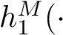) estimates the mixture effects on the outcome at baseline age (age_{ij} = 0), while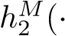) captures how these effects evolve over time. The terms γ₁ and γ₂ represent fixed intercept and slope, respectively. x_{i} denotes additional covariates with coefficients β, u^{T}_{ij}b_{i} accounts for subject-specific random effects, and ϵ_{ij} ∼ N(0,σ²) is the residual error. This model can be further written in matrix form as
Y_{i} = X_{i}β + W_{i}h_{i} + U_{i}b_{i} + ϵ_{i} (3)
for i = 1,...,n and repeated measures j = 1,...,J_{i} and b_{i} ∼ N₂(0,σ²D) and ϵ_{i} ∼ (0,σ²I_{Ji}). h_{i} is the vector of mixture effects and b_{i} is the vector of random effects for subject i. U and W are matrices constructed by ages of different individuals. X_{i} is the matrix of covariates for subject i with coefficients β. Y_{i} = (Y_{i1},...,Y_{iJi})^{T} is the outcome for subject i. The fixed effects γ₁ and γ₂ can be included by adding column of intercept and age into X_{i} Specifically, we write the model as following:
Please refer to the pdf file for equations

Prior Distributions and Posterior Inference
Following the Bayesian parameterization of the mixed effects model and inspired by [15], we can express our proposed model as a hierarchical model:
y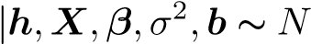(Xβ + Wh + Ub,σ²I) (4)
h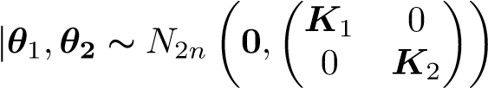 (5)
where K_{q} denotes the kernel matrix with i, j element K_{q}(z_{qi}∗ ,z_{qj}∗ ). Depending on the problem, several different kernel functions K_{q} can be employed. To capture non-linear relationships between the exposure indices and the outcome, we model the index-response functions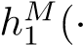) and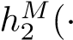) using Gaussian kernel functions. Specifically, for each function h^{M}_{q} (·), where q = 1,2, we define a kernel matrix K_{q} ∈ R^{n×n} with elements:
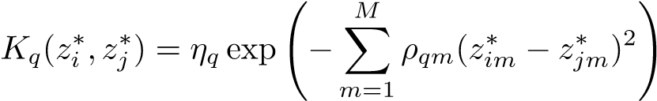,
where is the vector of group-specific exposure indices for subject i, and similarly for z_{j}∗. The parameter η_{q} controls the overall variance (amplitude) of the kernel, while ρ_{qm} governs the relevance (smoothness) of the m-th index within kernel q. Larger values of ρ_{qm} result in stronger penalization for differences in index m, making the function more sensitive to variation along that dimension. This formulation allows the model to flexibly learn smooth, non-linear surfaces over the M-dimensional index space without requiring pre-specification of interactions or functional forms. The use of separate kernel matrices K₁ and K₂ enables independent modeling of baseline and trajectory effects, further increasing flexibility.
To induce sparsity and identify influential chemical exposures within each index, we assign continuous shrinkage priors to the index weights θ₁ and θ₂ [7]:
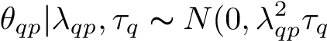) (6)
where τ_{q} is global parameter which shrinks all θ_{qp} toward zero; λ_{qp} is local parameter which allow some θ_{qp} to to be included in the model. The level of shrinkage is controlled by τ_{q} as large value of τ_{q} will reflect little shrinkage and value close to zero will shrink all θ_{qp} to zero. We also use hyperparameters as follows:
λ_{qp} ∼ Cauchy(0,1) (7) τ_{q} ∼ Cauchy(0,1) (8)
We note therefore that the horseshoe prior is a global–local shrinkage prior that allows for aggressive shrinkage of irrelevant coefficients while preserving large signals. Specifically, it combines a global shrinkage parameter that controls overall sparsity with local parameters that allow certain coefficients to “escape” shrinkage if supported by the data. This property makes it particularly wellsuited for high-dimensional mixture settings, where most exposures may have negligible effects. Compared to alternatives like the spike-and-slab prior, which requires binary inclusion indicators, the continuous prior offers a computationally efficient and continuous approach to regularization that adapts to varying signal strengths. This results in more stable and interpretable estimation of index weights, facilitating identification of key chemicals within each exposure group.
When prior knowledge about the direction of effects for one or more groups is available, directional constraints can be imposed on θ_{qm} to improve estimation.
b|σ²,D∼ N_{2n}(0,σ²(I_{n} ^{O}D))  where covariance matrix D follows: | (9)
D⁻¹ ∼ Wishart_{q}(v₀,C₀) | (10)
σ² ∼ gamma⁻¹(α,γ) | (11)
β∝ 1 | (12)
The posterior distributions were estimated using the Hamiltonian Monte Carlo (HMC) algorithm, a gradient-based Markov chain Monte Carlo method that uses simulated Hamiltonian dynamics to explore the posterior distribution more efficiently. HMC improves sampling efficiency by reducing random walk behavior and autocorrelation between samples, leading to faster convergence and more stable parameter estimates [1].

Simulation Study
To assess the performance of BVCMIM under various mixture effect scenarios, we designed two simulation settings that reflect common challenges in environmental health studies. Scenario A assumes all exposures with effects have positive contributions, whereas Scenario B includes both protective and harmful chemicals, introducing mixed (bidirectional) effects. In each scenario, a subset of exposure groups was assigned true effects on the baseline outcome and/or the outcome trajectory. We also introduced known interactions between groups to evaluate BVCMIM’s ability to recover non-additive relationships. Table 3 summarizes the configuration of each simulation scenario.
Table 3: Simulation scenario design summary for evaluating BVCMIM.
Scenario A: Positive Effects Only
Effect direction | All effects are positive
Groups with baseline effects | Group 1, Group 5
Groups with trajectory effects | Group 2, Group 4
Interaction structure | Group 1 × Group 5 (baseline) Group 2 × Group 4 (trajectory)
Scenario B: Mixed Positive and Negative Effects
Effect direction | Mixed: both positive and negative effects
Groups with baseline effects | Group 1 (positive), Group 3 (negative),  Group 5 (positive)
Groups with trajectory effects | Group 2 (positive), Group 3 (negative),  Group 4 (positive)
Interaction structure | Group 1 × Group 5 (baseline) Group 2 × Group 4 (trajectory)
More specifically, in our simulated examples, we first wanted to mimic the empirical correlation structure of real exposures from the HOME dataset. In order to do that, we calculated the empirical covariance matrix Σ derived from 36 chemical exposures grouped into M = 5 mutually exclusive categories. For each simulated subject i, we then generated a P = 36-dimensional exposure vector from a multivariate normal distribution:
z_{i} ∼ MVN₃₆(0,Σ).
We assigned group-specific index weights θ_{qm} that differ for baseline (q = 1) and trajectory (q = 2) effects. The exposure indices for each subject were then computed as:
z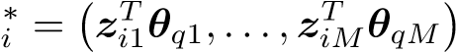,
which are passed through index-response functions h_{q}(·), where q = 1,2. We simulated two distinct scenarios:
- Scenario A (Positive Effects Only): In this setting, all non-zero weights are positive. The assigned weights are:
θ₁₁ = (0.5,0.6,0.5,0,0,0,0,0)^{T}, θ₁₅ = (0,0,0.5,0.5)^{T}, θ₂₂ = (0.6,0.4,0.5,0,0,0,...,0)^{T}, θ₂₄ = (0,0,0,0,0.4,0.2)^{T}. All other weights are set to zero. The index-response functions are:
,
where f_{A}(·) is an S-shaped (sigmoidal) function representing non-linear effects.
- Scenario B (Mixed Positive and Negative Effects): This scenario includes both protective and harmful exposures. The assigned weights are: θ₁₁ = (0.5,0.6,0.5,0,0,0,0,0)^{T}, θ₁₃ = (−0.8,−0.8)^{T}, θ₁₅ = (0,0,0.5,0.5)^{T}, θ₂₂ = (0.6,0.4,0.5,0,0,0,...,0)^{T}, θ₂₃ = (−0.8,−0.8)^{T}, θ₂₄ = (0,0,0,0,0.4,0.2)^{T}. All other weights are zero. The index-response functions are:
,
where f_{B}(·) is again an S-shaped function capturing non-linearity.
Table 1 presents the results of simulations. In each scenario, we generated 10 datasets of 100 observations. We assessed the performance of estimating effects h by regressing the predicted h^{ˆ} on grand truth h for h₁ and h₂. We present the intercept, slope, R² and root mean squared error (RMSE) of the regressions over 10 datasets. Good performance on estimation can be indicated when the intercept is close to zero, and the slope and R² are both close to 1. We see that the performance is consistent across all simulations; for all simulations, the intercept ranging from -0.05 to 0.176, the slope ranges from 0.950 to 1.001, and the R² ranges from 0.972 to 0.990. The result shows adding directional constrains from prior knowledge doesn’t improve the performance on estimating h. Lastly, the RMSE is higher for h₁ than h₂.
Scenario | Constrain | h | Intercept | Slope | R2 | RMSE
A | No | 1 | 0.045 | 0.952 | 0.972 | 0.476
 |  | 2 | 0.064 | 1.000 | 0.989 | 0.329
A | Yes | 1 | 0.062 | 0.971 | 0.974 | 0.466
 |  | 2 | 0.028 | 1.001 | 0.982 | 0.417
B | No | 1 | 0.084 | 0.946 | 0.972 | 0.533
 |  | 2 | 0.012 | 0.995 | 0.990 | 0.280
B | Yes | 1 | 0.176 | 0.950 | 0.979 | 0.491
 |  | 2 | -0.050 | 0.978 | 0.968 | 0.479
Table 4: Simulation results evaluating the estimation accuracy of BVCMIM under Scenarios A and B. Each row summarizes the regression of predicted h^{ˆ} on true h across 10 simulated datasets. Metrics include intercept, slope, R², and root mean squared error (RMSE).
We further identify the indices of the mixtures most associated with health outcomes. Drawing inspiration from relative importance, which has been defined in previous literature to quantify the impact of each chemical on health outcomes [15], we propose an index-wise relative importance metric to quantify the impact of each chemical index on both the baseline health outcome and the outcome trajectory. This metric is based on predicting the baseline outcome (h₁) and the outcome trajectory (h₂) using index-response functions at two new exposure profiles: one where all chemicals in an index group are at high exposure (75th percentile) and another where they are at low exposure (25th percentile).For example, to estimate the relative importance of chemical index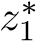, we predict the index-response functions h₁ and h₂ for high and low
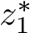, while holding chemicals in other indices of the mixture at their median exposure to isolate the effect of 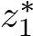. The difference in the estimated h₁ for high versus low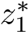 corresponds to the relative importance of index 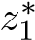 on the baseline outcome. Similarly, the difference in the estimated h₂ for high versus low 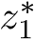 corresponds to the relative importance of index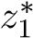on the outcome trajectory.
The relative importance for scenario A and B are given in figure 1 and 2, in which we plot the BVCMIM predicted versus true relative importance for each simulation. The result for each simulation scenario were averaged across 10 datasets. For each simulation, the relative importance was estimated on the dataset for that simulation, whereas the true known relative importance remains the same across datasets. 95% confidence interval are given as the predicted relative importance ± 1.96 times the square root of the predicted corresponding variance. We see that, in both scenarios, the most 95% intervals capture the true index-response effect. For a few intervals which did not capture the index-response effect exactly, they are very close to the true effects. Relative importance plots show that chemical indices which are most associated with health baseline outcome and outcome trajectory are welly estimated by BVCMIM.
A feature of BVCMIM is that it is simple and straightforward to interpret interaction as we only need to investigate M×(M−1) index wise interactions. We present two-way index wise interactions for both baseline outcome and outcome trajectory for scenario A and scenario B in figure 3 and 4 . The interaction between index i and index j are visualized as the index-response curves of index i while fix index j at low (25th percentile) and high (75th percentile) and all other indices at their median. Parallel lines indicates no interaction between indices while deviation indicates interactions. We can see from figure 3 and figure 4 that, at baseline outcome, there is a strong interaction between index 1 and index 5, and at outcome trajectory, there is a strong interaction between index 2 and index 4. They are consistent with simulation generating processes.
BVCMIM also provides estimation of weights for each chemical exposure which can be interpreted as contributions to the indices which they belong to. Table 5 shows the estimated weights from simulation scenario A. At baseline, z₁, z₂ and z₃ are significant in index 1, z35 and z36 are significant in index
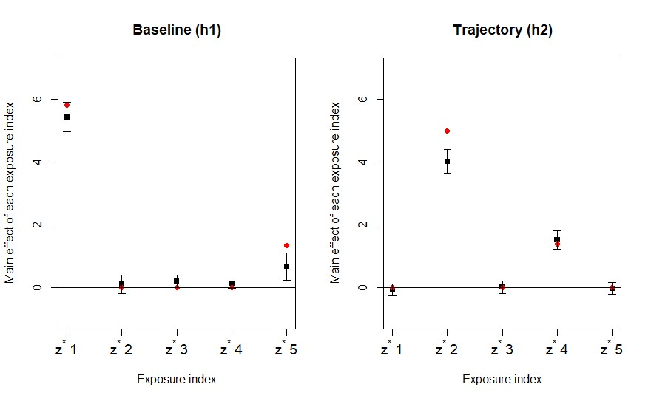
  - Without directional constrain
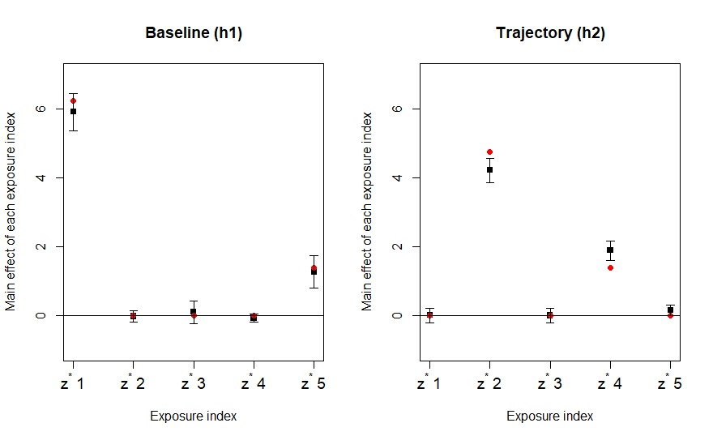
  - With directional constrain
Figure 1: Comparison of BVCMIM-predicted versus true relative importance for chemical indices in Simulation Scenario A (unidirectional effects). (a) Without directional constraints; (b) With directional constraints.
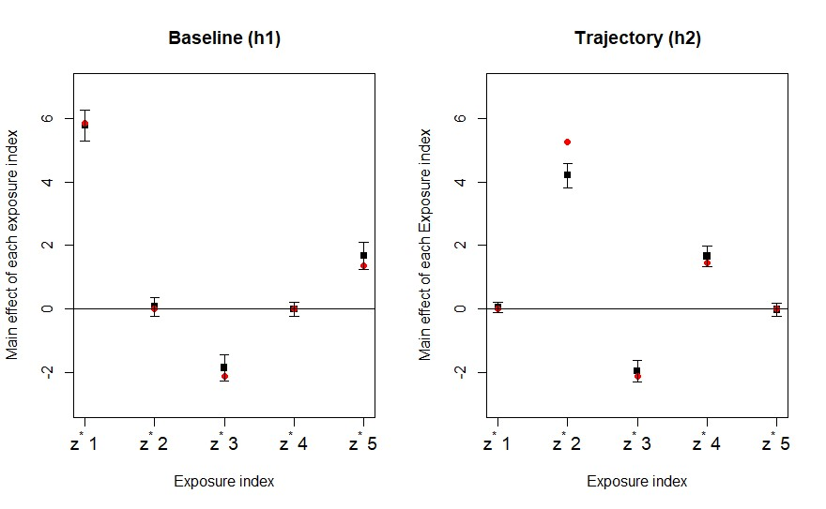
  - Without directional constrain
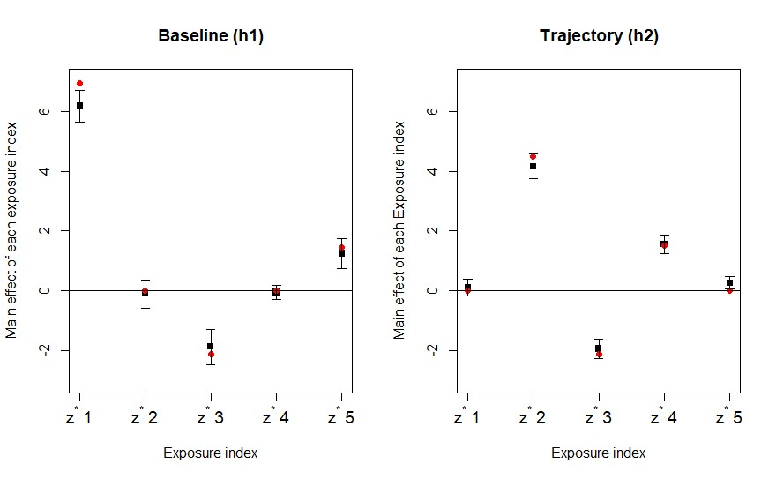
  - With directional constrain
Figure 2: Comparison of BVCMIM-predicted versus true relative importance for chemical indices in Simulation Scenario B (bidirectional effects). (a) Without directional constraints; (b) With directional constraints.
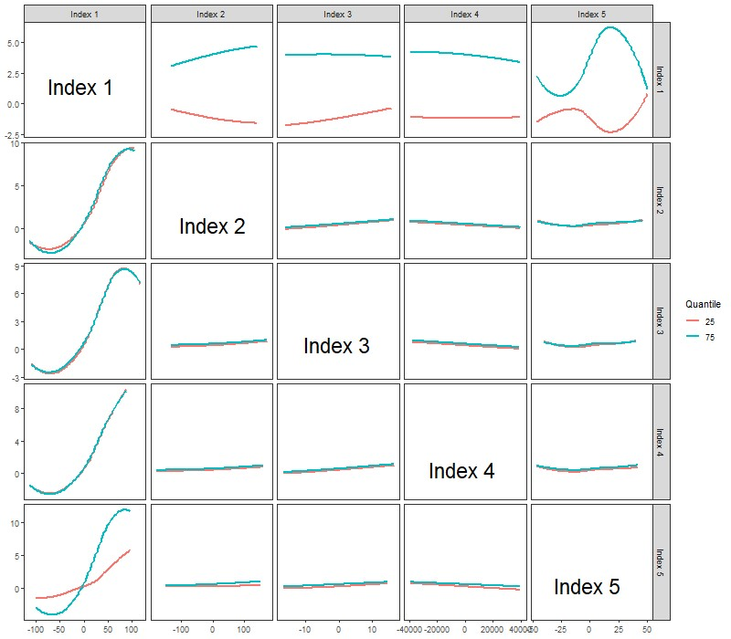
- Interaction plot at baseline (h₁)
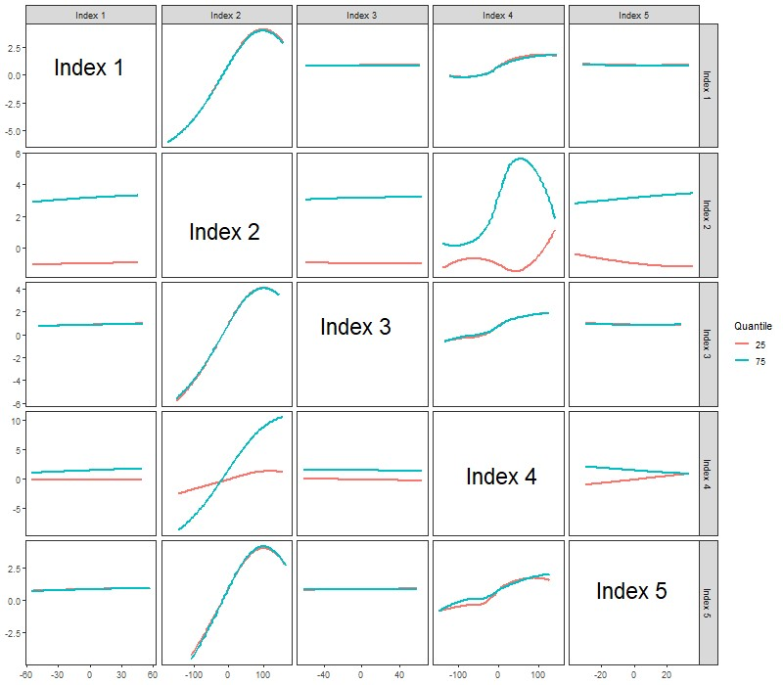
- Interaction plot at Tragectory (h₂)
Figure 3: Visualizing two-way interaction of scenario A with BVCMIM. Each panel shows the index-response relation for one index with all other indices fixed at a given percentile. Panel (a) is for h₁ and panel (b) is for h₂
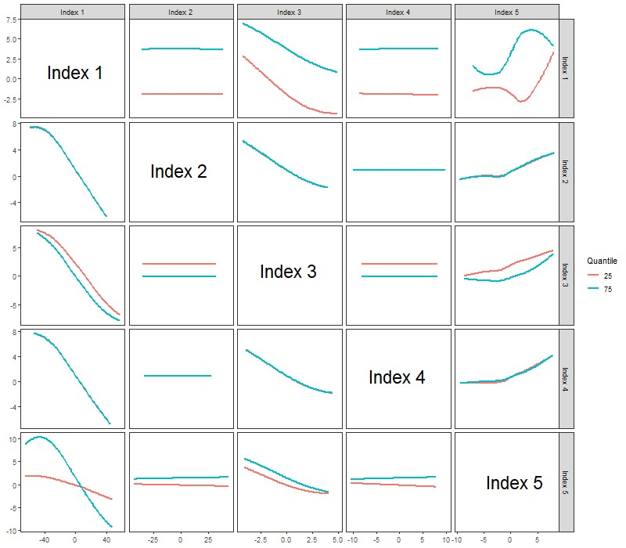
- Interaction plot at Baseline (h₁)
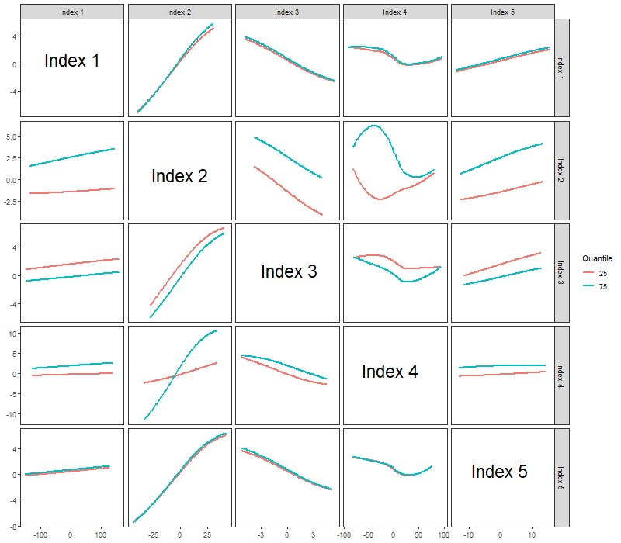
- Interaction plot at Tragectory (h₂)
Figure 4: Visualizing two-way interaction of scenario B with BVCMIM. Each panel shows the index-response relation for one index with all other indices fixed at a given percentile. Panel (a) is for h₁ and panel (b) is for h₂

5; at the outcome trajectory, z₉, z₁₀ and z₁₁ are significant in index 2, z₃₁ and z₃₂ are significant in index 4. These estimations match with the setting in simulation scenario A. Similarly, table 6 shows the estimated weights from simulation scenario B. At baseline, z₁, z₂ and z₃ are significant in index 1, z₂₅ and z₂₆ are significant in index 3 and z₃₅ and z₃₆ are significant in index 5. At the outcome trajectory, z₉, z₁₀ and z₁₁ are significant in index 2, z₂₅ and z₂₆ are significant in index 3 and z₃₁ and z₃₂ are significant in index 4. These estimations match with the setting in simulation scenario B.

Application to the HOME Study
To illustrate the practical utility of BVCMIM, we applied the model to data from the Health Outcomes and Measures of the Environment (HOME) Study—a prospective birth cohort designed to investigate environmental influences on child development. This study provides rich longitudinal outcome data and detailed prenatal chemical exposure measurements, making it an ideal setting for evaluating the temporal dynamics of exposure-response relationships.
Prior research using HOME data has shown that several environmental chemicals, particularly endocrine-disrupting compounds such as phthalates, bisphenol A (BPA), and perfluorinated compounds (PFCs), are associated with altered neurodevelopmental outcomes in early childhood [3, 12]. However, most existing analyses have relied on single-chemical models or linear mixture approaches, which may fail to capture the complex, non-linear, and time-varying effects of chemical mixtures. Moreover, the presence of correlated exposures and potential interactions between chemical groups presents an additional layer of analytical complexity.
BVCMIM addresses these challenges by enabling simultaneous estimation of baseline effects and outcome trajectories, while also accounting for non-linearity, interactions between exposure groups, and individual chemical contributions. In our analysis, Age was treated as a discrete time variable, with 12 months coded as baseline (0), 24 months as 1, and 36 months as 2. A Gaussian kernel was used to flexibly model the index-response surface. The Markov Chain Monte Carlo (MCMC) sampler was run for 2,000 iterations, discarding the first 1,000 as burn-in.
Each exposure index corresponds to a distinct chemical group. Figure 5 shows the estimated relative importance of each index at baseline and over the outcome trajectory. At baseline, indices corresponding to phthalates & BPA and perfluorinated compounds (PFCs) were negatively and positively associated with MDI scores, respectively.
To examine potential synergistic effects, we visualized the interaction between the phthalates & BPA group and the PFC group in Figure 6. A modest interaction effect was observed, suggesting potential modification of one group’s effect depending on the level of the other.
Table 7 reports the estimated weights for individual chemicals within each group. Among phthalates & BPA, mono-(3-carboxypropyl) phthalate (MCPP)
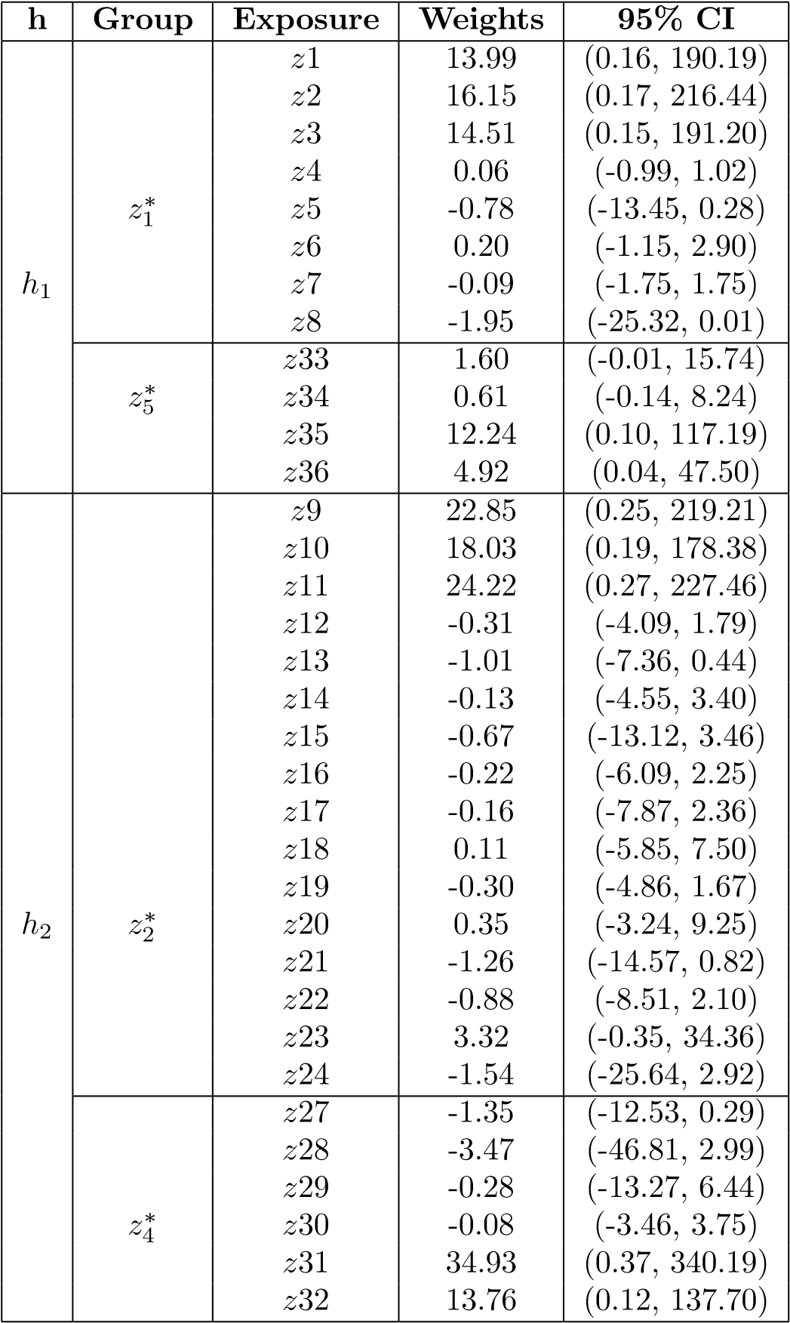
Table 5: Estimated posterior weights and 95% credible intervals for each chemical in Simulation Scenario A.
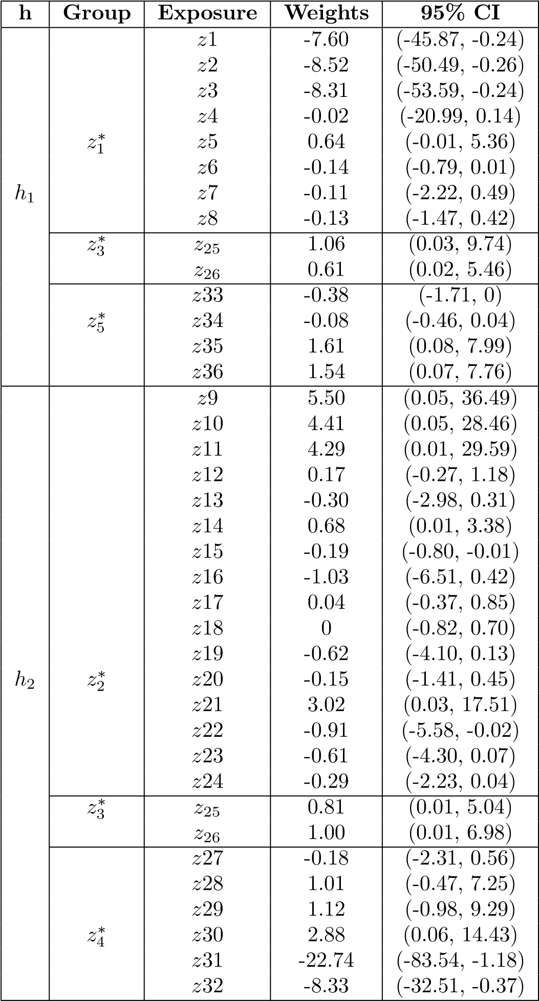
Table 6: Estimated posterior weights and 95% credible intervals for each chemical in Simulation Scenario B.
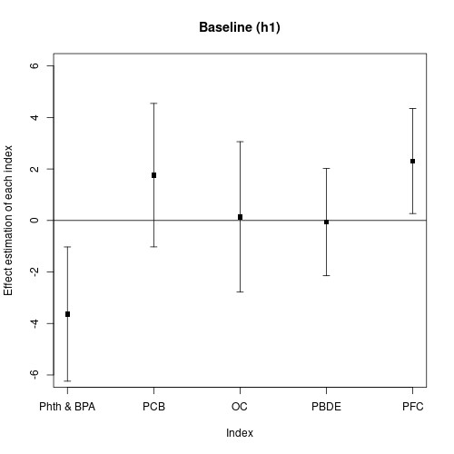
- Relative importance at baseline
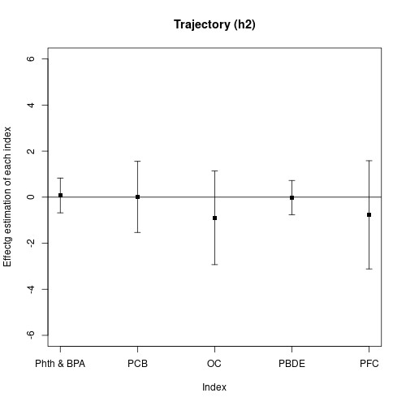
- Relative importance at trajectory
Figure 5: Estimated relative importance of chemical indices in the HOME cohort. (a) Baseline importance at 12 months; (b) Importance over the outcome trajectory from 12 to 36 months.
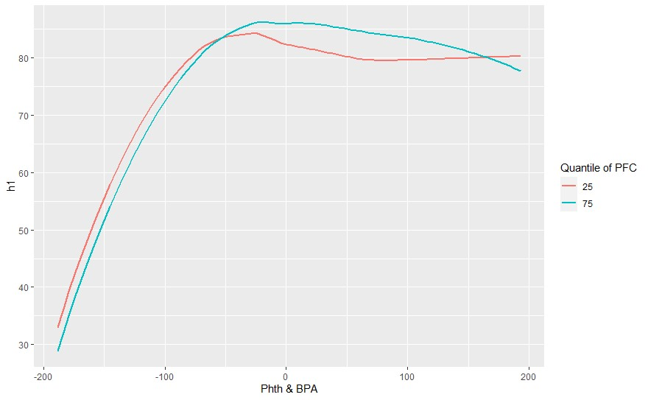
Figure 6: Estimated interaction effect between the Phthalates & BPA group and the PFC group on children’s neurodevelopment.
had the strongest influence on neurodevelopmental outcomes. Within the PFC group, perfluorononanoic acid (PFNA) was identified as a key contributor, showing a significant association with MDI scores.

Discussion
We introduced the Bayesian Varying Coefficient Multiple Index Model (BVCMIM), a novel hierarchical modeling framework that integrates mixed-effects and multipleindex modeling to evaluate the longitudinal effects of environmental chemical mixtures on health outcomes. BVCMIM is specifically designed to estimate both baseline effects and outcome trajectories, addressing the complexity and high dimensionality of chemical exposure data.
A key feature of BVCMIM is the construction of group-based exposure indices, which reduce dimensionality while allowing for flexible, non-linear indexresponse relationships. By applying the horseshoe prior, the model enables automatic shrinkage and selection of influential chemicals within each group. Furthermore, by incorporating interaction terms between indices, BVCMIM allows for the exploration of synergistic or antagonistic effects across chemical groups.
Posterior inference was performed using Hamiltonian Monte Carlo (HMC), which offers efficient sampling in high-dimensional parameter spaces. Our simulation studies demonstrated that BVCMIM accurately estimates both main
Group | Exposure | Weights | 95% CI
 | MBP | 1.01 | (-2.52, 10.92)
 | MIBP | 0.68 | (-4.10, 9.64)
 | MEP2 | 1.09 | (-3.20, 10.90)
 | MBZP2 | 2.62 | (-3.52, 10.86)
Pth & BPA | MCPP | 60.90 | (0.60, 323.18)
 | MEHHP | 1.45 | (-1.78, 13.80)
 | MECPP | -1.06 | (-13.82, 3.88)
 | BPA | 10.86 | (-2.10, 78.42)
 | PCB28 | -1.30 | (-12.94, 6.45)
 | PCB74 | 2.02 | (-7.76, 25.79)
 | PCB99 | 2.51 | (-16.26, 14.25)
 | PCB105 | 5.18 | (-4.51, 34.60)
 | PCB118 | 2.91 | (-8.28, 26.47)
 | PCB138 158 | 4.09 | (-7.14, 51.30)
 | PCB146 | 1.84 | (-8.33, 13.55)
 | PCB153 | 1.70 | (-18.58, 18.35)
PCB | PCB156 | 64.05 | (-0.37, 603.37)
 | PCB170 | 46.90 | (-16.90, 339.75)
 | PCB183 | 33.56 | (-4.55, 177.45)
 | PCB187 | 27.00 | (-3.79, 55.98)
 | PCB194 | 0.85 | (-8.04, 11.80)
 | PCB196 203 | 10.10 | (-28.86, 77.21)
 | PCB199 | 4.38 | (-5.55, 16.58)
 | PCB206 | 10.24 | (-19.98, 87.44)
OC | PP DDE | -0.41 | (-8.40, 1.99)
 | T NONA | -43.25 | (-449.76, -0.13)
 | BB153 | 34.83 | (-1.68, 133.41)
 | PBDE28 | 0.15 | (-2.62, 15.80)
PBDE | PBDE47 | 0.40 | (-6.04, 12.53)
 | PBDE99 | 11.42 | (-4.37, 75.44)
 | PBDE100 | 4.66 | (-3.86, 13.61)
 | PBDE153 | 0.12 | (-4.94, 4.10)
 | PFOA | -1.15 | (-7.66, 2.38)
PFC | PFOS | -3.07 | (-14.78, 2.83)
 | PFNA | -12.21 | (-92.54, -0.02)
 | PFHXS | 1.59 | (-3.51, 15.02)
Table 7: Posterior estimates of chemical-specific weights at baseline, with 95% credible intervals
effects and interactions under various exposure scenarios, including those with unidirectional and bidirectional effects. Notably, adding directional constraints based on prior knowledge did not substantially improve performance, suggesting that the horseshoe prior sufficiently manages sparsity in most settings.
When applied to the HOME Study cohort, BVCMIM identified meaningful associations between prenatal exposure indices and neurodevelopmental outcomes. At baseline, Phthalates & BPA were negatively associated with children’s neurodevelopment, whereas PFCs showed a positive association. Similar findings can be found in previous publications for the inverse association between Phthalates & BPA with children’s neurodevelopment [14]. The model also detected a modest interaction effect between these two groups. Chemicalspecific weights highlighted MCPP and PFNA as key contributors within their respective indices, aligning with existing toxicological literature.
While BVCMIM provides a powerful and interpretable framework, it has several limitations. First, chemical exposures were measured only once during pregnancy, and the model does not currently accommodate time-varying or postnatal exposures, which may influence developmental outcomes. Second, exposure groupings were predefined based on chemical class or structure, and any misclassification in these groupings could affect interpretability and estimation. Future extensions could incorporate data-driven or hierarchical grouping strategies. Third, the Gaussian kernel was used to model non-linear index-response surfaces, but performance may vary depending on kernel choice and tuning parameters; sensitivity analyses were not conducted in this work. Additionally, while the horseshoe prior performs well for sparsity, sensitivity to hyperparameter choices was not fully explored in this study. More genarally, we also note that the HOME dataset includes a relatively modest sample size (n = 149), which may limit power to detect small or complex interaction effects. Finally, as with any observational study, unmeasured confounding cannot be ruled out, and causal interpretations should be made cautiously.
In summary, BVCMIM offers a flexible and scalable approach for analyzing complex chemical mixtures in longitudinal studies. It balances interpretability, modeling flexibility, and computational efficiency—allowing researchers to uncover both main effects and interactions among chemical groups. By identifying key contributors within mixtures and capturing how their effects evolve over time, BVCMIM provides valuable insights for environmental health research and risk assessment. Future extensions incorporating time-varying exposures and alternative grouping structures will further broaden its utility.

References
- Michael Betancourt. A conceptual introduction to hamiltonian monte carlo. arXiv preprint arXiv:1701.02434, 2017.
- Jennifer F Bobb, Linda Valeri, Birgit Claus Henn, David C Christiani, Robert O Wright, Maitreyi Mazumdar, John J Godleski, and Brent A Coull. Bayesian kernel machine regression for estimating the health effects of multi-pollutant mixtures. Biostatistics, 16(3):493–508, 2015.
- Joseph M Braun, Amy E Kalkbrenner, Allan C Just, Kimberly Yolton, Antonia M Calafat, Andreas Sj¨odin, Russ Hauser, Glenys M Webster, Aimin Chen, and Bruce P Lanphear. Gestational exposure to endocrine-disrupting chemicals and reciprocal social, repetitive, and stereotypic behaviors in 4and 5-year-old children: the home study. Environmental health perspectives, 122(5):513–520, 2014.
- Joseph M Braun, Kimberly Yolton, Shaina L Stacy, Bahar Erar, George D Papandonatos, David C Bellinger, Bruce P Lanphear, and Aimin Chen. Prenatal environmental chemical exposures and longitudinal patterns of child neurobehavior. Neurotoxicology, 62:192–199, 2017.
- Danielle J Carlin, Cynthia V Rider, Rick Woychik, and Linda S Birnbaum. Unraveling the health effects of environmental mixtures: an niehs priority, 2013.
- Caroline Carrico, Chris Gennings, David C Wheeler, and Pam FactorLitvak. Characterization of weighted quantile sum regression for highly correlated data in a risk analysis setting. Journal of agricultural, biological, and environmental statistics, 20:100–120, 2015.
- Carlos M Carvalho, Nicholas G Polson, and James G Scott. Handling sparsity via the horseshoe. In Artificial intelligence and statistics, pages 73–80. PMLR, 2009.
- Eva Govarts, Sylvie Remy, Liesbeth Bruckers, Elly Den Hond, Isabelle Sioen, Vera Nelen, Willy Baeyens, Tim S Nawrot, Ilse Loots, Nick Van Larebeke, et al. Combined effects of prenatal exposures to environmental chemicals on birth weight. International journal of environmental research and public health, 13(5):495, 2016.
- Philippe Grandjean and Philip J Landrigan. Neurobehavioural effects of developmental toxicity. The lancet neurology, 13(3):330–338, 2014.
- Yun-Chul Hong, Eun-Young Park, Min-Seon Park, Jeong Ah Ko, Se-Young Oh, Ho Kim, Kwan-Hee Lee, Jong-Han Leem, and Eun-Hee Ha. Community level exposure to chemicals and oxidative stress in adult population. Toxicology letters, 184(2):139–144, 2009.
- Richard W Hornung and Laurence D Reed. Estimation of average concentration in the presence of nondetectable values. Applied occupational and environmental hygiene, 5(1):46–51, 1990.
- Wei Jia and Roman Jandarov. Assessing the longitudinal impact of environmental chemical mixtures on children’s neurodevelopment: A bayesian approach. arXiv preprint arXiv:2404.12553, 2024.
- Alexander P Keil, Jessie P Buckley, Katie M O’Brien, Kelly K Ferguson, Shanshan Zhao, and Alexandra J White. A quantile-based g-computation approach to addressing the effects of exposure mixtures. Environmental health perspectives, 128(4):047004, 2020.
- Nan Li, George D Papandonatos, Antonia M Calafat, Kimberly Yolton, Bruce P Lanphear, Aimin Chen, and Joseph M Braun. Identifying periods of susceptibility to the impact of phthalates on children’s cognitive abilities. Environmental research, 172:604–614, 2019.
- Shelley H Liu, Jennifer F Bobb, Birgit Claus Henn, Chris Gennings, Lourdes Schnaas, Martha Tellez-Rojo, David Bellinger, Manish Arora, Robert O Wright, and Brent A Coull. Bayesian varying coefficient kernel machine regression to assess neurodevelopmental trajectories associated with exposure to complex mixtures. Statistics in medicine, 37(30):4680–4694, 2018.
- Glen McGee, Ander Wilson, Thomas F Webster, and Brent A Coull. Bayesian multiple index models for environmental mixtures. Biometrics, 79(1):462–474, 2023.
- Deborah Rice and Stan Barone Jr. Critical periods of vulnerability for the developing nervous system: evidence from humans and animal models. Environmental health perspectives, 108(suppl 3):511–533, 2000.
- Kyla W Taylor, Bonnie R Joubert, Joe M Braun, Caroline Dilworth, Chris Gennings, Russ Hauser, Jerry J Heindel, Cynthia V Rider, Thomas F Webster, and Danielle J Carlin. Statistical approaches for assessing health effects of environmental chemical mixtures in epidemiology: lessons from an innovative workshop. Environmental health perspectives, 124(12):A227– A229, 2016.
- Rohit Tripathy, Ilias Bilionis, and Marcial Gonzalez. Gaussian processes with built-in dimensionality reduction: Applications to high-dimensional uncertainty propagation. Journal of Computational Physics, 321:191–223, 2016.
- Ann M Vuong, Kimberly Yolton, Joseph M Braun, Bruce P Lanphear, and Aimin Chen. Chemical mixtures and neurobehavior: a review of epidemiologic findings and future directions. Reviews on environmental health, 35(3):245–256, 2020.

