SYRIA | 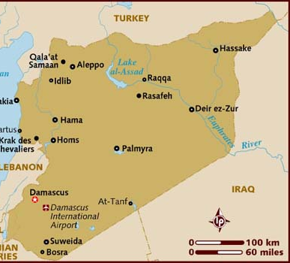  Taken from Lonely Planet
Population: 18,3 mil
Religion: Muslims 90%; Christians 5,9%
Official Language: Arabic
Head of State – Bashar al-Assad
Syria’s 6 year old violent civil war & battle with ISIS continues to inflict a heavy toll on the population. The conflict has claimed more than half a million lives & displaced half the pre-war population of 22 mil from their home, creating 6 mil refugees as well as internally displaced persons. Destroyed homes & inadequate food has exacerbated the problem, pushing millions into unemployment & poverty. Much of Syrian society has been radicalized, especially in areas controlled by radical Islamic groups. Consequently, half of Syria’s Christians have fled the country. The war has led to a lack of sustained access to health care & continual education. (WIN10/40)
Please pray :  - That the education of children will move away from any form of Islamic terrorism & the hatred of other people & nations.  - That the war & violence in Syria will cause many, who support Islam, to question it.  - That many Syrians will turn to Jesus.  Blessed is he whose help is the God of Jacob, whose hope is in the LORD his God, (Ps 146:5 ESV) |   SAAWE  Tel (011) 396-1225

MONGOLIA | 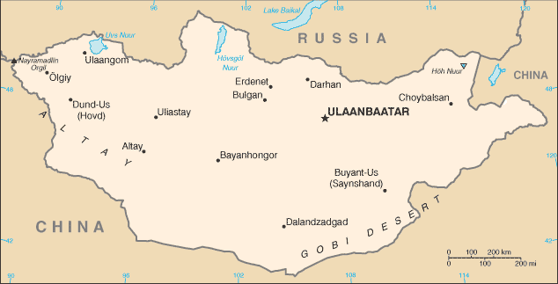  Taken from World Fact Book
Population: 3,1 mil
Religion: Buddhists 35,3%; Christians 1,7%
Official language: Mongolian
Head of State: Pres Khaltmaagin Battulga
A third of Mongolia’s population lives in the capital, Ulaanbataar, while nearly half of the country’s workforce is nomadic. In 1989 less than a handful of Christian Mongols lived in the country. Now 100 000 Christian believers are thought to exist. In Ulaanbataar alone, there are approximately 200 churches. In addition, there are small gatherings of Christian believers in every province. Several severe winters & dry summers have devastated grain & cattle farmers & caused terrible smog problems impacting human health. A new government was elected on the promise of bringing economic reforms. (WIN10/40)
Please pray :  - Praise the Lord for the marvelous work He is doing in Mongolia & pray that He will draw many people to repentance & faith in Him.  - That the Lord will give the new government great wisdom to bring about changes necessary to bring blessing to the people.  “Salvation is to be found through him alone; “ (Act 4:12 GNB) | SAAWE  Tel (011) 396-1225

SOMALIA | 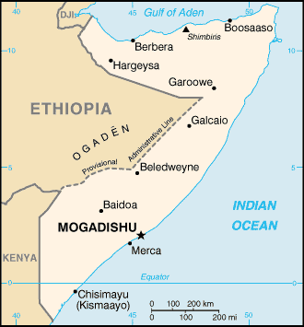  Taken from World Fact Book
Population: 14,7 mil
Religion: Muslims 99,7%; Christians 0,30%
Official language: Somali & Arabic
Head of State: Pres Mohamed Abdullahi Mohamed
For decades, Somalia has been a failed state. Clashes between Somali warlords have resulted in half a million people dying between 2010 & 2012 in what was then Africa’s worst humanitarian disaster. With no rain for two years, Somalia’s drought is the most severe in living memory. At least six million Somalis need assistance: half face famine. Cholera & other diseases are endemic & spread faster & further than ever before. The volatile situation in Yemen has led to a continued influx of people to Somalia. The Somali militant Islamist group, Al Shabaab, operates there & targets Christians & local communities. Christian Believers are killed. Besides war, drought & famine, the women of Somalia are facing even greater violence. (WIN10/40)
Please pray :  - For those suffering so much in Somalia.  - That women will be protected from sexual predators.  - That the Islamic Al Shabaab will be transformed, from a radical militant group, into workers approved by God.  “Salvation is to be found through him alone; “ (Act 4:12 GNB) | SAAWE  Tel (011) 396-1225

PAKISTAN | 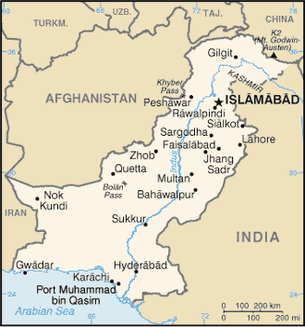  Taken from World Fact Book
Population: 197 mil
Religion: Muslims 95,8%; Christians 0,7%
Official language: Urdu & English
Head of State: Pres Mammoon Hussain

With the world’s third largest Muslim population, Pakistan is the only country created in the name of Islam. Pakistan is one of the world’s most corrupt countries. Its political & economic systems are crippled by the interference of refugees & radical Islamists. Pakistan hosts over 2 mil refugees – the second most refugees in the world. At least 48 terrorist & extremist groups – including the Taliban, Al Qaeda, & ISIS – operate in Pakistan. The country’s culture of Islamization with its notorious blasphemy laws has led to devastating consequences for Christian Believers, who experience more violence than almost anywhere else. There are, however, signs that the blasphemy laws may be reviewed due to their mis-use by Muslims with vendettas against others.

(WIN 10/40)

Please pray:  - Praise the Lord that the blasphemy laws might be changed  - That Christians will experience a renewal in their faith & a vision to reach the lost in Pakistan.  - For a transparent government that will lead with integrity & righteousness & will seek peace instead of violence.  Salvation comes from our God, who sits on the throne, and from the Lamb!" (Rev 7:10 GNB) | SAAWE  Tel (011) 396-1225

