FIJI | 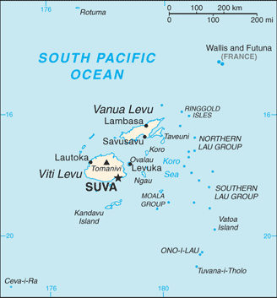  Taken from World Fact Book
Population: 915 885
Religion: Christians 65% (Ev 25,2%)
Official Language: English; Head of State: Pres Jioji Konrote
It was under British rule from 1874 – 1970. Post-independence calm is consistently disrupted by military coups. In 1987 & 2000, Fijian ethnic interests were at the heart of the coups. The coup In 2006 occurred on the pretext of stopping corruption & endemic racism, but was more likely retribution for the clemency extended to previous coup plotters as well as prevention of ethnic Fijian interests from establishing themselves again. In every case the coups have been universally condemned by the global community & resulted in expulsion/suspension from the Commonwealth as well as sanctions. Sadly such actions seem not to prevent further coups, & the ones suffering most from such actions are the poor of all races. Its economy is largely based on tourism & sugar. The Indian community dominates nearly all commercial activities but lacks long-term security, with almost all land rights denied them.
Please pray :  - For political stability & that democratically elected governments will be accepted & respected.  - For Fijians to be set free from alcoholism & that broken homes be restored.  - Praise the Lord that Fiji has been a hotbed of mission-sending & that this legacy is being revived.  Blessed is he whose help is the God of Jacob, .. (Ps 146:5 ESV) |   SAAWE  Tel (011) 396-1225

TONGA | 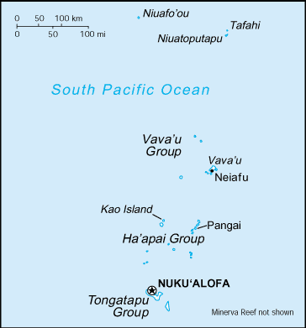  Taken from World Fact Book
Population: 109 591
Religion: Christians 95,8%; Baha’i 3,5%
Official language: Tongan
Head of State: Prime Minister ‘Akilisi Põhiva
It was a British protected State from 1900 – 1970. It is a constitutional monarchy with the king & nobles having predominant influence. A growing movement toward democracy since 1990 & with the death of the king in 2006, but political demonstrations indicate that the pace is too slow for many pre-reformers. The first elected Prime Minister assumed office in 2006. There is religious freedom but the Free Wesleyan Church enjoys a privileged position, with the king as titular head. Tonga has the world’s highest national percentage of Mormons & the country’s largest employers are Mormons; many financial perks are on offer for those considering the switch .
Please pray :  - Praise the Lord for a strong Christian presence & influence in daily life & that Tonga sends significant numbers of missionaries despite its relative poverty & isolation  - That Tongan Christians will seek ways to contribute to the Kingdom of God rather than seeking the church that benefits them the most.  - For the error of the Mormon sect to be exposed & for many to find freedom in Christ.  “Salvation is to be found through him alone; “ (Act 4:12 GNB) | SAAWE  Tel (011) 396-1225

SAMOA | 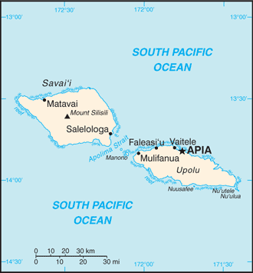  Taken from World Fact Book
Population: 198 381
Religion: Christians 96,6% (Ev 18%); Baha’i 1,9%
Official language: Samoan
Head of State: Chieftain Va’aletoa Sualauvi II
Samoa was under German rule from 1900 – 1914 & then thereafter under New Zealand UN Trusteeship until independence in 1962. It was the 1st Pacific Island nation to win post-colonial independence. The growing population, limited & decreasing resources & the communal land system strains the economy. The country is moving away from agriculture toward a service economy focused on tourism. The 2009 earthquake damaged much infrastructure, causing significant economic setback. Samoans have been Christian for more than a century, but much of the church suffers from nominalism & rivalry between denominations. Mormonism is a concern. It is growing quickly. Mormons send & receive more missionaries from Samoa than any other denominations,. However the growth of evangelicals is encouraging.
Please pray :  - For wisdom in how to grow & expand their economy.  - That Mormons will turn to the Lord Jesus & that Christians will be enlightened to the errors in Mormonism.  - Harmony between the newer & the more traditional branches of the Church.  “Salvation is to be found through him alone; “ (Act 4:12 GNB) | SAAWE  Tel (011) 396-1225

JAPAN | 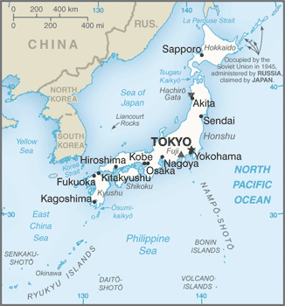  Taken from World Fact Book
Population: 126,9 mil
Religion: Buddhists 69,6%; other 23,7%; Christians 2,2%
(Ev 0,5 %)
Official language: Japanese; Head of State: Emperor Akihito

An archipelago of 6852 islands, Japan has the world’s 3rd largest economy & is a major donor for world crises. Last year, Japan remained on high alert, concerned that North Korea (both a neighbor & an enemy) might be provoked into action. A strong traditional core has been flanked by a progressive younger generation valuing Western culture & ideas. Japan suffers from a high suicide rate, the leading cause of death for those under 30. It is still one of the world’s most secular nations. 70% of Japanese identify with no personal religion, although most adhere to Shinto & Buddhist customs. The announcement that Emperor Akihito will abdicate in April 2019 has shaken traditional values.
Please pray:  - Praise the Lord that urban churches are experiencing growth due to university students coming to faith in Jesus.  - For a renewal of faith in the Church as 90% of Japanese Christians backslide due to work pressures.  - That urban churches will reach out to the surrounding rural areas, where there are no churches.  Salvation comes from our God, who sits on the throne, and from the Lamb!" (Rev 7:10 GNB) | SAAWE  Tel (011) 396-1225

