PAKISTAN | 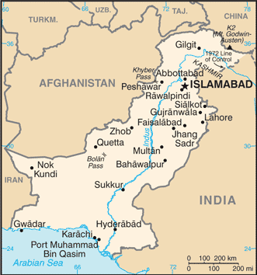  Taken from World Fact Book
Population 209,9 mil – Literacy 57,9%
Religion: Muslims 96,4%; Christians 2,5%; Hindus 1,1%
Official language: Urdu & English; Head of State: Pres Arif Alvi
Established in 1947 when the Indian sub-continent was partitioned. Conflict with India has continues, with both countries claiming their right to the disputed Kashmir region. It has the world’s second-largest Muslim population & Sunni-Shia conflict accounts for much of the violence in the country. After 9/11 Pakistan became a frontline for the war against terrorism, with the US fighting the Taliban on the border between Pakistan & Afghanistan. In 2011, al Qaeda leader, Osama bin Laden, was found & killed in a hideout in Abbottabad. Besides al Qaeda other extremist groups are also active in Pakistan. It faces increased pressure to curb Islamic terrorist influences within its borders. It has implemented drastic counter-terrorism measures since the Peshawar military school massacre. Persecution against Christians involves the notorious blasphemy laws that are regularly used against innocent Christians. (INcontext)
Please pray :  - That God might open new doors for the Gospel among the least reached in this country.  - For Pakistani Muslims to encounter the visible image of Christ in local believers.  - For wisdom for government leaders as they attempt to repress the activities & influence of extremist groups.  “Blessed are those whose help is the God of Jacob, whose hope is in the Lord their God.“ (Ps 146:5) |   SAAWE  Tel (011) 396-1225

QATAR | 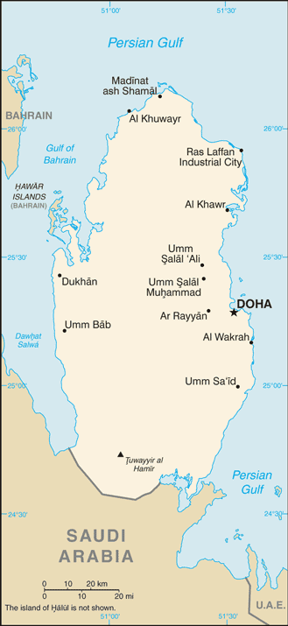  Taken from World Fact Book
Population 2,3 mil – Literacy 97,3%
Religion: Muslims 78%; Christian 9%; Other 13%;
Official Language: Arabic
Head of State: Sheikh Tamim bin Hamad Al Thani
This small country was once characterized by fishing villages & Bedouin nomads, but has now risen to a position of significance in the region & globally. Received independence in 1971 but refused to join the United Arab Emirates. The Altani family has ruled for more than 150 yrs & this has been the reason for it being the most stable in the Middle East. Since the discovery of oil the number of foreign labourers has grown to more than the native population. Once the poorest Gulf State, it is now the richest in the world on the GDP-per capita ranking. Qatar’s direct sponsoring of terrorism has been well-documented & its wealth seems to play a crucial role in it..(INcontext)
Please pray :  - Pray for Godly intervention in the conflict between Qatar & other Arab countries.  - That the divisions within Islam would prompt Muslims to seek the truth & that Jesus will reveal Himself to them.  - That the vast wealth of Qatar will be use for good & not for sponsoring of Islamic extremist movements.  “It is He …. Who brings princes to nothing, and makes the rulers of the earth as emptiness” (Is 40:23) | SAAWE  Tel (011) 396-1225

USA | 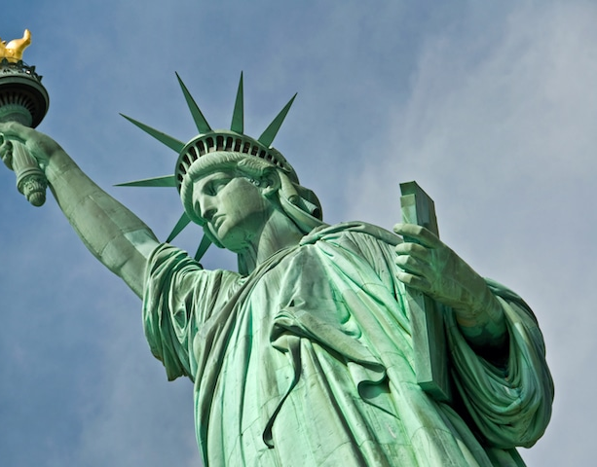
Population 326,6 mil – Literacy 99%
Religion: Christians 68,2%; Unaffiliated 22,8%; Other 6,2%;
Official language: English; Head of State: Pres Donald Trump
The US is still the world’s leading superpower. Its recent history is dominated by the ‘War on Terror’ that followed the 9/11. Under Barack Obama’s administration, troops began withdrawing from Afghanistan, but Pres Trump has recommitted more troops to Afghanistan & Iraq during his first year in office. Pres Trump’s “America first” policy saw the US resigning from several partnerships & agreements which could result in a declining US presence around the world. This could prompt Russia & China to take more of a lead in global geopolitics. Pres Trump, however, has made ‘big’ geopolitical moves by meeting with his North Korean counterpart & moving the US embassy to Jerusalem. The church still plays an active role in American society, but is being challenged by rapidly rising atheism & secularism. Hollywood continues to export a very negative image of Christianity among the non-Western world, that sees it as a representation of the ‘Christian’ West’s values & morals.
Please pray :  - For Godly US leadership & administration & that God will use Mr Trump for the benefit of His Kingdom.  - That God will use this nation throughout the world as a beacon of hope & as a positive influence.  - Praise God for the many missionaries that continue to come from the US & pray for their protection.  “You need to be patient, in order to do the will of God and receive what he promises.” (Heb 10:36) | SAAWE  Tel (011) 396-1225

SOUTH AFRICA | 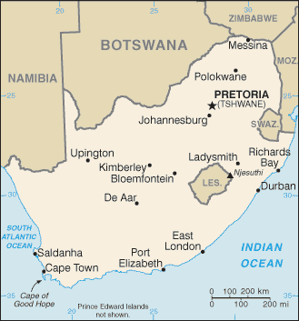  Taken from World Fact Book
Population 54,8 mil – Literacy 94,4%
Religion: Christians 75%; Muslims 2%; Ethno-religious 13,5%
Official Language: 11 local languages
Head of State: Pres Cyril Ramaposa
South Africa is characterized by diversity in terms of its cultures, influences, languages, religions & socioeconomic status levels, & the country is home to the largest communities of European, Asian & racially-mixed ancestry in Africa. Its ‘apartheid’ policy caused it to be ‘internationally isolated’ for a number of decades. In the late 1980s & early 1990s many ANC activists were freed & the ANC unbanned. In 1994 the ANC won the first non-racial elections. The government continues to face widespread problems of poverty, corruption, high crime rates, unemployment as well as an HIV/AIDS endemic (SA has the second highest infection rate in the world). It has one of the continent’s largest economies & it is part of the BRICS club of emerging world economic powerhouses. (INcontext)
Please pray :  - For strong Christian leaders in government who are unwilling to compromise.  - That indigenous African believers will recognize the falsehood of ancestral worship & turn fully to Christ.  - For the salvation of all Muslims in SA.  “Declare His glory among the nations, His marvellous deeds among all peoples.” (Ps 96:3) | SAAWE  Tel (011) 396-1225

