INDIA | 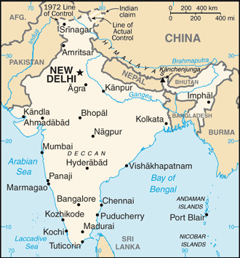  Taken from World Fact Book
Population 1,200 mil – Literacy 71,2%
Religion: Hindus 79,8%; Muslims 14,2%; Christians 2,3%;
Official language: Hindi & English
Head of State: Prime Minister Narendra Modi
India is, politically, the world’s largest democracy & its population is the second largest in the world. With a strong military, nuclear capabilities & a rapidly growing economy, it is fast becoming a key player on the global stage. It is also one of the world’s most ancient civilisations & is the most ethnically diverse country in the world. After the 2014 elections Narendra Modi was appointed Prime Minister. His party is openly ‘Hindu nationalist’ in its agenda. There are reports of Muslims & Christians being forced to convert to Hinduism in spite of freedom of religion in its constitution. India is home to the largest number of ‘unreached’ people groups. ±87% of the population can be categorised as ‘unreached’ which comprises of more than 2300 people groups. (INcontext)
Please pray :  - That the thousands of unreached people groups will be reached by local Indian missionaries.  - That the nationalist movement trying to enforce Hinduism will fail, & that the Church will stand out as the answer for those seeking truth.  - That Christians will be bold & remain faithful despite hardships & discrimination.  “… blessed is the one who trusts in the Lord,…. . They will be like a tree planted by the water….“ (Jer 17:7) |   SAAWE  Tel (011) 396-1225

RUSSIA | 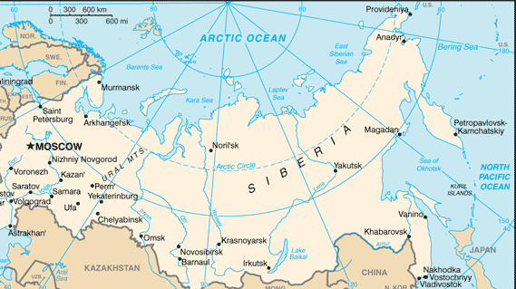  Taken from World Fact Book
Population 142,2 mil – Literacy 99,7%
Religion: Christian 66,9%; Atheists 19,1%; Muslims 12,5%;
Official Language: Russian; Head of State: Pres Vladimir Putin
Russia has the largest surface area in the world. The Russian Empire of 18th century grew to become the largest empire in history. Communist Rule followed the overthrow of the Tsar & the Russian Empire in 1917, & religious & political dissent was crushed. The USSR was established in 1922 with Moscow as iits capital. Stalin ruled from mid 1920s until his death in 1953. Russia played a key role in defeating Nazi forces during World War II, but its post-war expansions brought it in conflict with the West, resulting in the decades-long “Cold War’ characterized by intense political & military tension but no direct fighting. The USSR was dissolved in 1991, In recent years, Russia has adopted a more aggressive nationalist stance & foreign policy. It is also in dispute with the West due to its support for Iran & its nuclear programme. It also supports the embattled Assad Regime in Syria.(INcontext)
Please pray :  - That Russia’s ambitions of enlarging the Russian homeland will come to nothing.  - For Godly wisdom for all role players in international diplomacy.  - That the Orthodox Church will use its influence to avert confrontation with Europe & the West.  In Your hand are power and might, so that none is able to withstand You. (2 Chron 20:6) | SAAWE  Tel (011) 396-1225

NIGERIA | 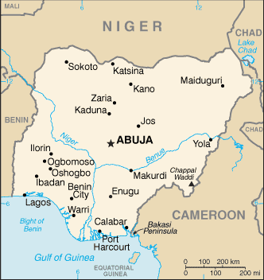  Taken from World Fact Book
Population 190,6 mil – Literacy 59,6%
Religion: Muslims 50%; Christians 40%; Indigenous10%;
Official language: English
Head of State: Pres Muhammadu Buhari
Africa’s most populous country is also the continent’s leading oil producer, but Nigeria continues to struggle with a multitude of challenges. After a history of slave trade, Muslim expansion & British colonialism, Nigeria gained its independence in 1960. In 2009 Boko Haram launched a violent campaign to create an Islamic state & to have Sharia imposed throughout the country. Their name meaning “Western Education is forbidden” & its membership is estimated to be between 4 000 & 20 000. The Nigerian Church has, for many years, enjoyed a growing & thriving existence. The ongoing attacks by Boko Haram, however, have brought fear & anger & Christian leaders find it difficult to preach forgiveness when people are suffering. Islam is moving further southwards into the country & is growing at a rapid rate. (INcontext)
Please pray :  - For wisdom & guidance for the leaders of the country to make good decisions concerning national defence against radical Islamists.  - That the Church will respond with wisdom, forgiveness, grace & love.  - For the Nigerian Church to stand as a visible, God-glorifying witness & believers not to be routed in fear.  “…for Christ’s sake, I delight in weakness, in insult, in hardship, in persecution,… For when I am weak, then I am strong.” (2Cor 12::10) | SAAWE  Tel (011) 396-1225

CHINA | 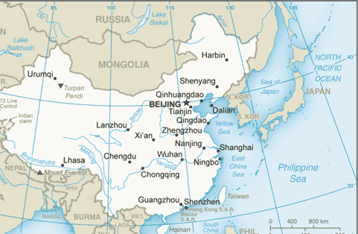  Taken from World Fact Book  (INcontext)
Population 1 380 mil – Literacy 96,4%
Religion: Atheists 74,9%; Buddhists 18,2%; Christians 5,1%; Official Language: Mandarin; Head of State: Pres Xi Jingping
China, the world’s largest population, has a history & culture of nearly 4 000 years. The Peoples Republic of China was founded in 1949 along Communist lines under Mao Zedong. Mao’s government attempted to rid the country of all ‘anti-Communist’ elements – including all religions. The ‘Cultural Revolution’ (1966-1976) purged all remaining capitalist & traditional influences. Millions died during this time. Since 1989 China has opened more to the rest of the world. It has also once again risen as a global superpower, & in 2014, China surpassed the US as the fastest growing economy in the world. Despite extreme opposition & persecution, the Chinese Church has grown in a miraculous way over the last four decades – from an estimated 2,7 mil in 1975 to more than 75 mil in 2010 & an estimated 130 mil in 2017. The new generation has relatively little experience of persecution & is exposed influences like the ‘prosperity gospel’.
Please pray :  - That China’s leadership will seek the best for the country instead of building their own ‘thrones’.  - That the Church in China will not be confused by different theologies coming from the West.  - For the many Chinese missionaries who are reaching other nations with the Gospel.  “You will be secure, because there is hope;… !”(Job 11:18) | SAAWE  Tel (011) 396-1225

