BURUNDI – President: Pierre Nkurunziza | 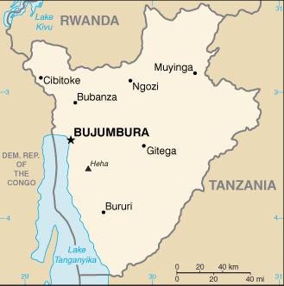  Taken from CIA World Fact Book
Population: 10,4 mil
Religion:
Christians 90,4% - Evangelical 27%
Indigenous 3,8%
Muslims 5,5%
Official languages: French & Kirundi
Literacy 58%
It separated from Rwanda in 1959 & received independence from Belgium in 1962. The country was dominated by Tutsis for 400 yrs. An estimated 250 000 people died from the combined conflicts between Hutus & Tutsis in 1962 & 1993. It is one of the world’s poorest countries – 70 – 80% live below the poverty line.
Please pray :  - For true peace, reconciliation & forgiveness between Hutus & Tutsis.  - For wisdom for the church & government on how to handle the returning refugees – most have nothing & lack initiative.  - For peaceful elections on 26 June 2015.  “In that day the Root of Jesse shall stand as a banner for the peoples; the nations will rally to Him, and his place of rest will be glorious.” (Is 11:10) |   SAAWE  Tel (011) 396-1225

NIGER – President: Mahamadou Buhari | 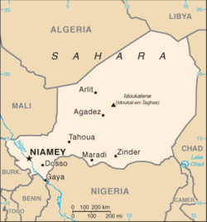  Taken from CIA World Fact Book
Population: 15,9 mil
Religion:
Muslims 97,1%
Ethno Religionists 2,5%
Christians 0,33%: Evangelical 0,1%
Official language: French
Literacy 28,7%
Since independence from France in 1958 they’ve had 4 military coups and are now in their 7th republic. It is one of the world’s poorest countries & most barely survive on subsistence agriculture & livestock. The country is handicapped by its landlocked position, poor education, poverty, lack of infrastructure, poor health care & environmental degradation, yet it possesses some of the world’s largest uranium deposits which should bring investments should the uranium market improve.
Please pray :  - Praise the Lord that this Muslim country is open to the Gospel & that the church is growing.  - For focused efforts to evangelize those under the age of 15 – half of the population.  - That the least evangelized will soon be reached: Tuareg, Zarma, Kanuri, Fulbe, Songhai, Tubu & Arabs.  “Declare his glory among the nations, his marvelous deeds among all peoples.” (Ps 96:3) | SAAWE  Tel (011) 396-1225

LIBERIA – President: George Weah | 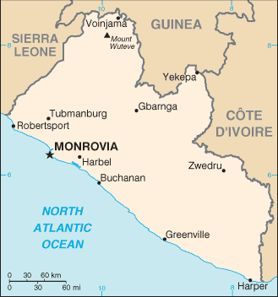  Taken from CIA World Fact Book
Population: 4,4 mil
Religion:
Ethno religions 45,3%
Christians 46,5% - Evangelical 9,7%
Muslims 12,2%
Official language: English
Literacy 51,9%
Liberia was established in 1822 as an American colony where they could send former slaves. 2 civil wars took place & resulted in the deaths of between 250 000 & 500 000 people & devastated the economy. 85% of the population lives below the poverty line. Its economy & political stability has recently been threatened by a deadly Ebola virus epidemic. It has Africa’s first female president.
Please pray :  - Praise the Lord that with Liberia’s first female president came prosperity.  - For healing of the terrible physical, psychological & spiritual wounds of war.  - For spiritual mature leaders in churches to preach the Bible with integrity.  “Many nations will be joined with the Lord in that day and will become my people.”(Zech 2:11) | SAAWE  Tel (011) 396-1225

CONGO REPUBLIC/BRAZZAVILLE – President: Denis Sassou Nguesso | 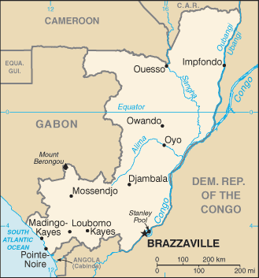  Taken from CIA World Fact Book
Population: 4,7 mil
Religion:
Christians 57,5% - Evangelical 15,9%
Muslims 1,6%
Kimbanguists 1,5%
Official language: French
Literacy 84,7%
It is the home of Beatriz Kimpa Cita who created a movement called Antonianism which taught that Jesus & other early Christians were from the “Congo Kingdom”. She incorporated Christian views with traditional beliefs to build a Congolese identity among the fighting tribes. Congo Rep received independence in 1960. It has experienced 3 coups but is currently stabilizing, with China becoming a major source of financial support.
Please pray:  - For a pure Gospel, that is devoid of syncretism & heresy, to be proclaimed.  - For the less reached in central & northern areas to hear the Gospel.  - For the expansion of ministries that equip the youth.  “ ..ten men from all languages … (will) say ’Let us go with you, because we have heard that God is with you.’”(Zech 8:23) | SAAWE  Tel (011) 396-1225

