BENIN – President: Patrice Talon | 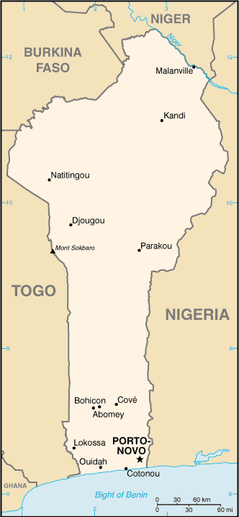  Taken from CIA World Fact Book
Population: 9,9 mil
Religion:
Muslims 24,4%
Vodoun 17,3%
Christians 42,8% - Evangelical 8,3%
Other 15,5%
Official Language: French
Literacy 33,6%
Instability marked the first years of Benin, after independence from France in the 1960’s, but as time went by Benin grew economically & has become one of Africa’s leading suppliers of cotton. There is conflict in the north due to colonizers drawing up borders without proper research. Most in the north are Sunni Muslim, but in the south the majority are Christian. Many of both religions also practice Voodoo or other traditional religions.
Please pray :  - For the people of Benin to be released from the stronghold & fear of Voodoo.  - For righteous leaders to be good stewards of the country.  - For peace in the north in the conflict areas.  “In that day the Root of Jesse shall stand as a banner for the peoples; the nations will rally to Him, and his place of rest will be glorious.” (Is 11:10) |   SAAWE  Tel (011) 396-1225

DJIBOUTI – President: Ismaïl Omar Guelleh | 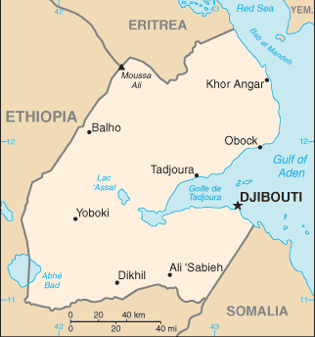  Taken from CIA World Fact Book
Population: 879 053
Religion:
Muslims 97,0%
Christians 1,75% - Evangelical 0,1%
Non Religious 1,2%
Official language: French & Arabic
Literacy 72,2%
A civil war destabilized the country from 1991-1994, they have since held several successful elections. With the conflict in Somalia many sought refuge in Djibouti. This created a problem as the national unemployment rate is more than 30%. The aridity of the land, coupled with dire climatic conditions does not allow people to engage in agricultural activities. This makes it difficult for refugees to earn a living, which creates tension between refugees & locals.
Please pray :  - That God will reveal Himself to the Afar people.  - For peace between the refugees & locals.  - For the government to find creative ways of creating jobs for all.  “Declare his glory among the nations, his marvelous deeds among all peoples.” (Ps 96:3) | SAAWE  Tel (011) 396-1225

GAMBIA – President: Adama Barrow | 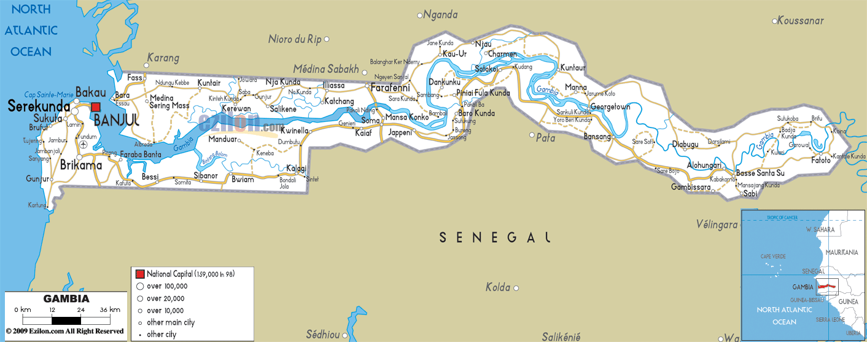
Population: 1,8 mil
Religion:
Muslims 89,5%
Christians 4,5% - Evangelical 0,8%
Ethno religionists 5,6%
Official language: English
Literacy 38%
It was a colony of Portugal & then of Britten. Since gaining independence in 1965 Gambia has enjoyed relative stability. Its an agriculturally rich country & its economy is dominated by farming, fishing & tourism. 1/3 of the population lives below the international poverty line of US$1,25 per day. Many people from both Muslim & Christian background mix their faith with indigenous beliefs.
Please pray :  - For revival, peace & stability.  - For the unreached Muslim majority to discover a genuine life in Jesus.  - For missionaries who will be willing to travel upriver to bring the Gospel to the unreached tribes.  “Many nations will be joined with the Lord in that day and will become my people.”(Zech 2:11) | SAAWE  Tel (011) 396-1225

Somalia – President: Mohamed Abdullahi Tarmajo | 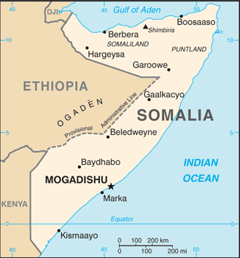  Taken from CIA World Fact Book
Population: 10 mil
Religion:
Muslims 99,67%
Christians ,33%
Official language: Somali & Arabic
Literacy 19,2%

It is one of the most closed countries. Agriculture & camel herding is practiced in the south & north-west. It gained independence in 1960, but conflicts brought the country to a state of destitution. Civil war in 1991 toppled the dictatorship, but no viable leadership emerged. In 2006 the Union of Islamic Courts took control of the capital, Mogadishu, along with significant areas of the country. Militants were expelled, but 10 000 civilians were killed & ± 1mil displaced. In recent years, terrorist group Al-Shabaab has rapidly gained power & blocks foreign aid meant for refugees & the starving Somali population.
Please pray:  - For order & stability in Somalia.  - For God’s intervention in this needy country.  - For the many women who have been raped, divorced & left by their husbands.  - The many children who have been smuggled out of Somalia.  “ ..ten men from all languages … (will) say ’Let us go with you, because we have heard that God is with you.’”(Zech 8:23) | SAAWE  Tel (011) 396-1225

