MALI – President: Ibrahim Boubacar Keïta | 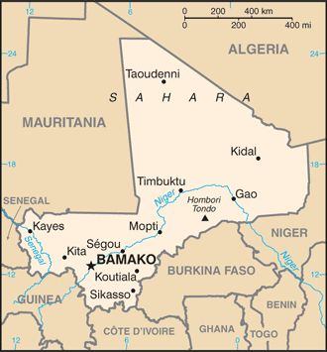  Taken from CIA World Fact Book
Population: 20,3 mil
Religion:
Muslims 94,8%
Ethno Religionists 9,8%
Christians 2,4% - Evangelical 0,7%
Official language: French
Literacy 19%
It’s a landlocked state – dry southern grasslands merge into the Sahara desert. The Niger river runs through the southern part of the country. It’s one of the world’s poorest countries. Subsistence farming & fishing occupies 80% of the population. It’s a secular state with freedom of religion. Islam practiced here incorporates elements of African traditional religions & superstitious folk practices.
Please pray :  - For Muslims to hear, read about & experience the love of Jesus.  - For a new wave of evangelism such as happened in the 1980’s.  - For Mali’s leaders for wisdom on how to provide health care, education, employment & stability for their people.  “In that day the Root of Jesse shall stand as a banner for the peoples; the nations will rally to Him, and his place of rest will be glorious.” (Is 11:10) |   SAAWE  Tel (011) 396-1225

CHAD – President: Idriss Déby | 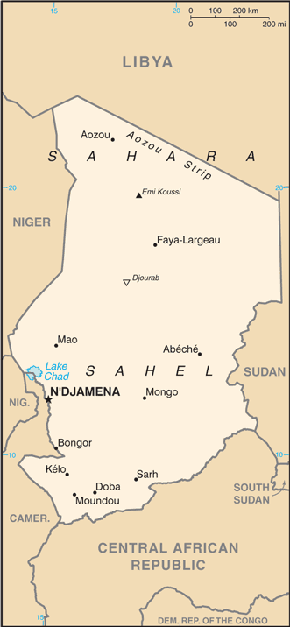  Taken from CIA World Fact Book
Population: 16,4 mil
Religion:
Muslims 52,8%
Ethno Religionists 2,5%
Christians 38,5% - Evangelical 10,1%
Official language: French & Arabic
Literacy 53,7%
Chad as part of France’s African holdings until 1960, endured 3 decades of civil war before peace was restored in 1990. It has been plagued by rebel attacks in the north & east & in the capital. It is a secular state. Religious leaders are involved in managing the country’s wealth. They sit on the body that oversees use of oil reserves & the seat rotates between Muslim & Christian leaders every 4 yrs.
Please pray :  - For integrity & honesty to rule the nation & displace government corruption.  - For medical care & services for the people of Chad.  - For the church to be both burdened & equipped for evangelism.  “Declare his glory among the nations, his marvelous deeds among all peoples.” (Ps 96:3) | SAAWE  Tel (011) 396-1225

MAURITANIA – President: Mohamed Ould Ghazouani | 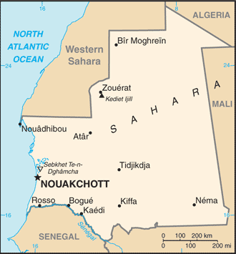  Taken from CIA World Fact Book
Population: 4,6 mil
Religion:
Muslims 99,8%
Christians 0,25% - Evangelical 0,1%
Official language: Arabic
Literacy 51,2%
One of the world’s poorest countries. Most practice subsistence farming & animal herding as there is only 1% arable land. 1/3 of children are chronically malnourished. 10 – 20% of the Mauritanian population still lives in bondage of slavery. Barriers to change are: laws, social resistance, low literacy, minimal exposure to the Gospel & Christians, reluctance to engage with the outside world.
Please pray:  - For the Word of God to be preached among Mauritanians in their heart language.  - For God’s mercy in the wake of severe drought & a poor economy.  - That Mauritanians in other countries will be evangelized.  “Many nations will be joined with the Lord in that day and will become my people.”(Zech 2:11) | SAAWE  Tel (011) 396-1225

MADAGASCAR – President: Andry Rajoelina  (The world’s 4th largest island) | 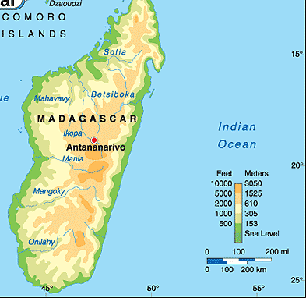
Population: 27,7 mil Religion:
Christians 53,5% - Evangelical 11,5%
Ethno Religionists 37,7%
Muslims 8%
Official language: Malagasy, French & English
Literacy 70,6%
In 1896 it became a French colony but gained independence in 1960. What followed were 17 yrs of single party rule & 3 coups. This crippled the economy. Their economy is based on agriculture, fishing & forestry & these employ 80% of the population. The island was hit by a hurricane in Jan 2015, which affected over 50 000 people. Another concern for this nation is drought induced famine & an outbreak of plague which has affected 1000’s & left many dead. Old beliefs, veneration of ancestral spirits & witchcraft are widespread among those who claim to be Christian.
Please pray:  - Praise the Lord for church growth since 1990, but also pray for revival.  - For honest government leaders.  - For well-trained Christian workers willing to serve in isolated areas.  “ ..ten men from all languages … (will) say ’Let us go with you, because we have heard that God is with you.’”(Zech 8:23) | SAAWE  Tel (011) 396-1225

