GUINEA – President: Alpha Condé | 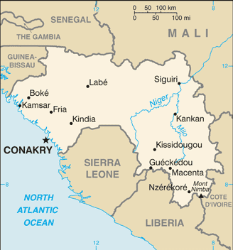  Taken from CIA World Fact Book
Population: 13,1 mil
Religion:
Muslims 88,3%
Ethno Religionists 6,9%
Christians 4,5% - Evangelical 0,7%
Official Language: French
Literacy 41%
Guinea is another country in Africa that has been troubled by violence, power hungry leadership & coups. They had their first democratic elections in 1993. Much of the population incorporates some indigenous rituals into their religious practices. They have freedom of religion although there is still some hostility between faiths. The church has been in decline since the late 1990’s. In Sept 2013 Christians, churches as well as pastor’s homes were savagely attacked by Muslim mobs.
Please pray :  - That God will meet the needs of the spiritually & physically poor people in a holistic way.  - For pioneer missionaries who serve among difficult-to- reach Muslims.  - For the unreached Guineans living in remote areas to hear a clear Gospel presentation.  “The LORD, the Most High, is to be feared; he is a great king, ruling over all the world “(Ps 47:2) |   SAAWE  Tel (011) 396-1225

GUINEA-BISSAU – President: Umaro Sissoco Embaló | 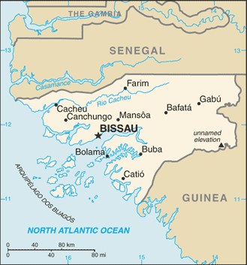  Taken from CIA World Fact Book
Population: 2 mil
Religion:
Muslims 52,0%
Indigenous 35,1%
Christians 10,9% - Evangelical 1,6%
Official language: Portuguese Creole; Literacy 39,6%
Since independence from Portugal in 1974 Guinea-Bissau has experienced political & military upheaval, all in all 4 coups. The constitution provides for freedom of religion. One of the world’s poorest countries, it relies mainly on cash crops of cashew nuts, fish, hardwood & other agricultural products. It is a major transshipment point of cocaine from Colombia to Europe.
Please pray :  - For spiritually mature trained national workers to move outside urban areas to minister to less-reached people.  - For distribution of oral Christian materials for the poor & illiterate.  - For more people of Guinea-Bissau to become literate.  “The LORD is great and is to be highly praised; he is to be honored more than all the gods. “(Ps 96:4) | SAAWE  Tel (011) 396-1225

EQUATORIAL–GUINEA - President: Teodoro Obiang Nguema Mbasogo | 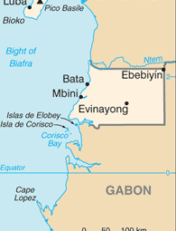  Taken from CIA World Fact Book
Population: 1,4 mil
Religion:
Christians 90% - Evangelical 4,4%
Muslims 3,9%
Ethno religionists 3,1%
Official language: Spanish & French; Literacy 84,2%
This former Spanish colony is one of Africa’s smallest countries, but the 3rd largest oil exporter south of the Sahara. The discovery of oil has given this country a massive boost in economic growth, but living standards are yet to catch up. 50% of the population doesn’t have clean drinking water & 20% of children die before the age of 5. It is in the top 12 of the most corrupt states. Many pagan practices, such as animism is still a problem in this country. The result is a diluted form of Christianity.
Please pray :  - For the government to seek a godly plan for developing society.  - That nominalism & animistic traditions will die out as Christ is revealed to the people.  - For Christian immigrant oil workers to boldly share their faith.  “Say to all the nations, "The LORD is king!" (Ps 96:10a) | SAAWE  Tel (011) 396-1225

NAMIBIA – President: Hage Geingol | 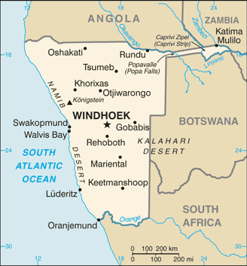  Taken from CIA World Fact Book
Population: 2,5 mil
Religion:
Christians 91,4% - Evangelicals 12,2%
Indigenous 4,5%
Non-Religious 4%
Official language: English; Literacy 85%

Namibia is currently one of the more stable countries in Africa, but that wasn’t always the case. Since the early 1800’s German settlers started infiltrating the area. After Britain took over “The Cape Colony” the amount of people moving north, grew significantly. This movement reached its peak after diamonds were discovered in the early 1900’s. After World War 1, SA administered the territory. In fear of Communism spreading from Angola to SA, SA mobilized troops into Namibia. This became known as the Bush War which lasted 25yrs. Namibia received its independence in 1990. Most of its income comes from diamonds, tourism & livestock.
Please pray:  - For revival among Christians clinging to unbiblical beliefs.  - For wisdom & discernment to reach the unreached people groups.  - For life-sustaining jobs for the 27% who are unemployed.  “The LORD is king, and the people tremble.” (Ps 99:1) | SAAWE  Tel (011) 396-1225

