BURKINA FASO – President: Roch Mark Christian Kaboré | 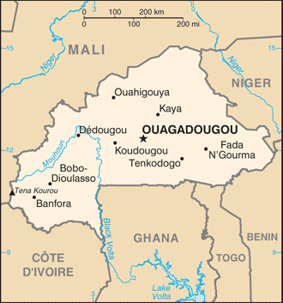  Taken from CIA World Fact Book
Population: 20,9 mil
Religion:
Muslims 52,2%; Christians 20,7% - Evangelical 8,9%
Ethno religionists 26,4%
Official Language: French; Literacy 23,6%
It is a former French colony & received its independence in 1960. It’s rich in natural resources like gold, phosphate, marble & the biggest export is cotton. In spite of the above it is one of the poorest countries in Africa. 80% of the population lives below the poverty line. Droughts & desertification have severe effects on agriculture. The name means “land of honest men”, but sadly corruption levels remain high & it was one of the reasons that Blaise Compaore was ousted in 2014. Some Muslim groups are responding to the Gospel but idolatry, fetishism & secret societies continue to dominate daily life.
Please pray :  - For believers to deal biblically with extreme poverty issues.  - For occult power to be broken.  - For the hearts of both Muslims & fetishists to be open to God’s Word.  “All nations will remember the LORD. From every part of the world they will turn to him;”(Ps 22:27) |   SAAWE  Tel (011) 396-1225

GABON – President: Ali Bongo Ondimba | 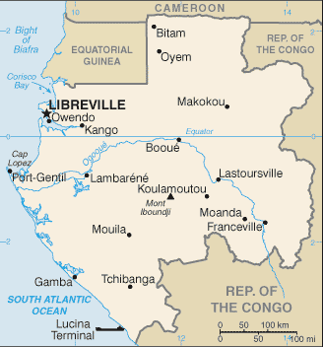  Taken from CIA World Fact Book
Population: 2,2 mil
Religion:
Christians 79,4% - Evangelical 12,7%; Muslims 10,4%
Ethno Religionists 7,8%
Official language: French; Literacy 84%
It received independence from France in 1967. El Hadj Bongo Ondimba took over & became one of the longest serving heads of state in the world – 1967 – 2009 when he passed away. His son succeeded him. Gabon’s prosperity is mainly attributed to their rich oil reserves. 70% of their export income comes from crude oil. Their diminishing reserves has caused the government to focus on the development of tourism as well. Although most of Gabon’s people are considered poor, they enjoy more wealth per person than many of its neighbours.
Please pray :  - Praise God for political peace in Gabon.  - For the church to be witnesses to their Muslim neighbours.  - For the church to discern between true & false teachings.  “Declare his glory among the nations, his marvelous deeds among all peoples.” (Ps 96:3) | SAAWE  Tel (011) 396-1225

MAURITIUS – President: Prithvirajsing Roopun | 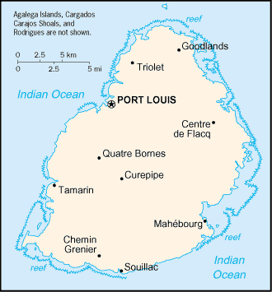  Taken from CIA World Fact Book
Population: 1,3 mil
Religion:
Hindus 48,6%
Christians 32,7% - Evangelical 10,1%
Muslims 17,02%
Official language: English; Literacy 85,1%
It was an uninhabited island until the Dutch took possession of it in 1598. They abandoned it in 1710 because of harsh living circumstances. The French then took it as theirs in 1715, using it as base during the Napoleonic wars. In 1810 the British seized it from France. During this time slaves were sold on the island to work the sugar cane fields. On the 1st of Feb 1835 slavery was abolished which led to rapid economic changes. Today Mauritius is a stable democracy.
Please pray :  - For a surge in national Christian workers.  - For more Christian resources in the languages of the highly connected population.  - For more teachers of the Word who are well-trained models of godliness.  “May the peoples praise you, O God; may all the peoples praise you!“(Ps 67:5) | SAAWE  Tel (011) 396-1225

RWANDA – President: Paul Kagame | 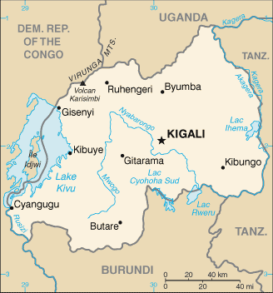  Taken from CIA World Fact Book
Population: 13 mil
Religion:
Christians 89,1% - Evangelicals 26,9%
Muslims 5,2%
Ethno Religionists 5,2%
Official language: French, English & Kinyarwanda
Literacy 64%

Rwanda became infamous in 1994 when the genocide broke out. According to the UN 800 000 – 1mil Tutsis & moderate Hutus were slaughtered (6 people murdered every min for 3 months) & 250 000 – 500 000 women were raped during this time. The reason for these atrocities was the result of years of suppression by the Tutsi minority of the Hutu majority. Today Rwanda is more stable & building its economy. Tea & coffee production is the main sources of income. There are between 300 000 – 400 000 survivors of the genocide of which 50 000 are widows & 75 000 orphans. There is a strong Islamisation movement taking place.
Please pray:  - For healing & reconciliation especially in the younger generation.  - For those who have fled the country to be able to return.  - For leaders to be trained to be witnesses of God’s love.  “From the east to the west praise the name of the LORD!”  (Ps 113:3) | SAAWE  Tel (011) 396-1225

