ZAMBIA – President: Edgar Lungu | 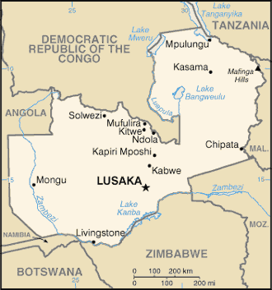  Taken from CIA World Fact Book
Population: 18,4 mil
Religion:
Christians 87% - Evangelicals 25,7%
Ethno Religionists 10,8%
Muslims 1,4%
Official Language: English
Literacy 67,9%
Originally inhabited by the Khoisan people. Became the British Protectorate of Northern Rhodesia towards the end of the 19th century. In 1964 Zambia became independent & Prime Minister Kenneth Kaunda became the president. In 2010 the World Bank named Zambia one of the world’s fastest economically reformed countries. 68% of Zambians live below the recognized national poverty line. Zambia fell into poverty after international copper prices declined in the 1970s. Agriculture plays a very important part in Zambia’s economy. Its HIV rate is estimated to be 13,5% among adults. In has declined by 25% from 2001 to 2010.
Please pray :  - That the dedication of Zambia to Christ will be reflected by the dedication of its leaders & Christians to Christ.  - That skilled professionals will return to Zambia to serve their own people.  - Praise the Lord for the drop in the HIV/AIDS rate.  “The LORD, the Most High, is to be feared; he is a great king, ruling over all the world “(Ps 47:2) |   SAAWE  Tel (011) 396-1225

ESWATINI (SWAZILAND) – King Mswati III | 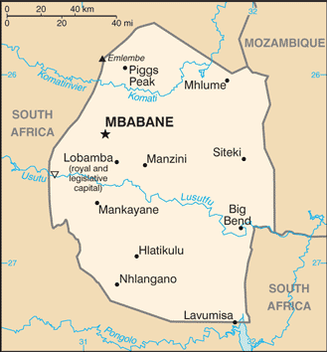  Taken from CIA World Fact Book
Population: 1,13 mil
Religion:
Zionists 40%
Roman Catholics 20% - Evangelicals 25,1%
Muslims 10%
Other 30%
Official language: siSwati & English
Literacy 79,2%
Annually a Reed Dance is held where 20 000 – 30 000 maidens gather & the King chooses a bride. All political parties have been banned. Many Christians live no differently from their unbelieving compatriots & the church has stagnated. Much witchcraft, ancestral worship, polygamy & immorality takes place. Life expectancy has dropped to 32,3yr for women & 31,7yr for men. 38,8% are infected with AIDS. 60% of the youth are under 20yrs. Muslims & mosques are increasing.
Please pray :  - For spiritual revival.  - For holy living & a clear Evangelical message to be proclaimed.  - That men will be drawn into the church.  “The LORD is great and is to be highly praised; he is to be honored more than all the gods. “(Ps 96:4) | SAAWE  Tel (011) 396-1225

LESOTHO – Prime Min: Moeketsi Majoroi | 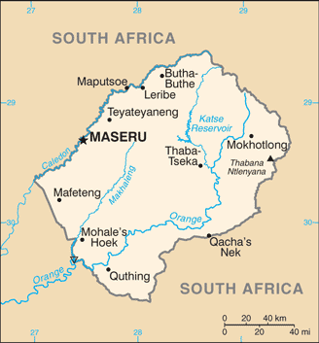  Taken from CIA World Fact Book
Population: 2,1 mil
Religion:
Christians 80% - Evangelicals 12,1%
Indigenous 20%
Official language: Sesotho & English
Literacy 81,4%
Lesotho was founded in the 1800s by chieftain Moshoeshoe. It later became a buffer zone between the “Voortrekker” republics & the British ruled Cape Colony. In 1868 Britain annexed Lesotho: Lesotho was an important vantage point to get back important trade routes & the King of Lesotho wanted protection from the “Voortrekkers”. Lesotho gained independence in 1970. Has since experienced 4 coups. It has one of the world’s highest HIV/AIDS infection rates. 50% of this nation lives below the poverty line.
Please pray :  - For believers working in HIV/AIDS ministries to spread hope through Christ.  - For the mighty hand of God to banish animistic traditions from the church.  - For fruitful & sustained ministry that yields thriving churches.  “Say to all the nations, "The LORD is king!" (Ps 96:10a) | SAAWE  Tel (011) 396-1225

BOTSWANA – President: Mokgweetsi Masisi | 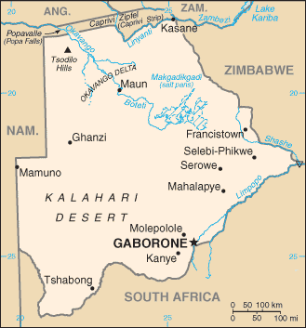  Taken from CIA World Fact Book
Population: 2,4 mil
Religion:
Christians 71,6% - Evangelicals 8,1%
Badimo 6%
Atheists 20,6%
Official language: English & Setswana
Literacy 78,9%

In the 1800s it became the Bechuanaland Protectorate. In 1966 it received its independence & became the Republic of Botswana. There are 38 luxury lodges in Botswana. In contrast to this the average income per household in Gaborone is $2 per day. 2/3 of the city spends ± ½ of their income on food. 63% of the city doesn’t have food security. 21% of the rural areas often go without food. Yet the economic growth is steady, corruption rare & a multiparty democracy the norm. Unfortunately one in three people are infected with AIDS. It has created a situation so dire that a recent president stated “We are threatened with extinction”.
Please pray:  - For true faith among Christians – free from tribal or animistic thinking.  - That young people will live holy lives.  - For Bible based training for local church leaders.  - For the 100 000 AIDS orphans.  - For the unreached peoples – Kalanga, Yeyi, San, Herero, Nambya & Mbukshu.  “The LORD is king, and the people tremble.” (Ps 99:1) | SAAWE  Tel (011) 396-1225

