CHINA - 10 Previous Olympics  2016 – 416 participants in 26 sports categories | 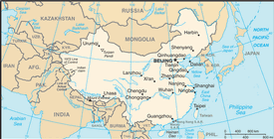  Taken from CIA World Fact Book
Population: 1.4 billion – Literacy 96,8%
Religion: Non-Religious 44,4%; Chinese 28,5 %;
Buddhist 12,5%; Christian 7,9% - Evangelicals 5,7%
China is the largest Country in Asia & 3rd in the world. For centuries China was a leading civilization, but in the 19th & 20th centuries it was beset by civil unrest, major famines, military defeats & foreign occupation. After World War ll, the Communists under Mao Zedong established an autocratic socialist system that imposed strict controls over everyday life & cost the lives of tens of millions of people. The staggering recent growth of the Chinese Church has no parallel in history – from 2,7mil evangelicals in 1975 to over 75 mil in 2010.
Please pray :  - That atheism promoted for so long, will finally be revealed as hollow & deceptive lies.  - For family stability & well-being. Pray that many Christians will get involved in drug rehabilitation, marriage counseling & suicide prevention.  - That the Refiner’s fire might keep burning & that the Church’s spiritual cutting edge might not be blunted.  “All who worship images are put to shame, …. Worship Him, all you gods!”(Ps 97:7) |   SAAWE  Tel (011) 396-1225

INDIA - 24 Previous Olympics  2016 – 117 participants in 15 sports categories | 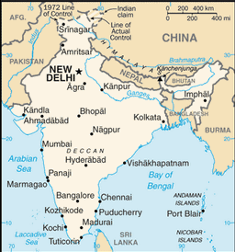Taken from CIA World Fact Book
Population: 1,4 billion – Literacy 74% (65% Female; 82% Male)
Religion: Hindu 74,3%; Muslim 14,3%; Christianity 5,8% -Evangelicals 2,2%; Sikh 1,9%
The Mughal Dynasty ruled India for more than 3 centuries. By the 19th century, Great Britain had become the dominant political power on the subcontinent. The British India Army played a vital role in both World Wars. Nonviolent resistance to
British rule led to independence in 1947. Communal violence led to the creation of two separate states, India & Pakistan. Despite pressing problems - significant overpopulation, environmental degradation, poverty & corruption - rapid economic development is fueling India’s rise on the world stage.
Please pray :  - That India will find ways to tackle the serious ills of society: malnutrition (40% of population), child labour, bonded labour, female infanticide, rapid spread of AIDS etc.  - For children in crisis: 35 mil orphans, 11 mil abandoned, 3 mil live on the street, 20 – 50 mil in child labour, 264 mil suffer physical abuse, 1,2 mil involved in prostitution.  - That athletes participating in the Olympics, will come in contact with Christian believers willing to share their faith.  “Do not stop crying out to the Lord ..” (1 Sam 7:8) | SAAWE  Tel (011) 396-1225

THAILAND - 17 Previous Olympics  2016 - 54 Participants in 15 sports categories | 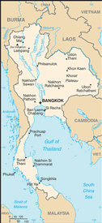  Taken from CIA World Fact Book
Population: 66,6 mil – Literacy 95,2%
Religion: Buddhist 85,3%; Muslim 7,9%; Non-Religious 2,4%;
Christian 1,1% - Evangelicals 0,5%
Thailand was formally known as Siam. It’s a constitutional monarchy headed by King Maha Vajiralongkorn who succeeded his father King Bumibol, the world’s longest reigning head of state. After World War ll, Thailand went through decades of political instability, characterized by coups. In 2008 the courts dissolved the coalition & formed a new coalition. In 2010 the Red Shirts, loyal to the People’s Power Party (which was deposed in 2008), initiated sustained protests that paralyzed much of Bangkok. The Thai political scene is deeply divided. Thailand means “Land of the Free”, but it is held captive in a complex web of Buddhism, traditional culture, spirit appeasement & occult practices.
Please pray :  - For a spiritual breakthrough so that, in the Lord Jesus, the Thai may be free indeed.  - For the 2,8 mil who are caught up in the sex trade to be set free.  - For a mighty work of the Spirit in Thailand.  “The Lord has made His salvation known and revealed His righteousness to the nations.” (Ps 98:2) | SAAWE  Tel (011) 396-1225

IRAN - 17 Previous Olympics  2016 – 63 participants in 15 sports categories | 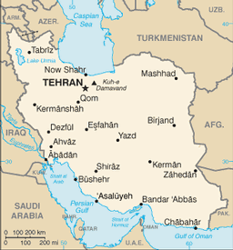Taken from CIA World Fact Book
Population: 84 mil – Literacy 90.3%
Religion: Muslim 98,6%; Christian 0,51% - Evangelicals 0,2%;
Baha’i 0,4%; Non-Religious 0,3%
Known as Persia until 1935, Iran became an Islamic republic in 1979 after the ruling monarchy was overthrown & the Shah forced into exile. It now has a theocratic system of government with ultimate political authority vested in the Supreme leader, a learned religious scholar. During 1980 – 1988 Iran fought a bloody war with Iraq which expanded into the Persian Gulf & lead to clashes with the US. Iran has the 2nd largest natural gas reserves & the 4th largest petroleum reserves.
Please pray:  - That those facing pressure and hopelessness might find release and hope in Christ: 5 mil drug addicts,  200 000 street children, & a very large number of prostitutes.  - For the persecuted minorities: Baha’i, Sufi Muslims & Christians.  - That athletes participating in the Olympics, will come in contact with Christian believers willing to share their faith.  “.. I will beckon to the Gentiles, I will lift up my banner to the peoples.” (Is 49:22) | SAAWE  Tel (011) 396-1225

