UKRAINE - 6 Previous Olympics (1952 – 1985 USSR & 1992 unified team)  2016 – 206 Participants in 22 sports categories | 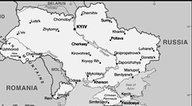  Taken from CIA World Fact Book
Population 43,7 mil – Literacy 99,4%
Religion: Christian 79% (Orthodox) - Evangelicals 3,8%;
Non-Religions 19,5%; Muslim 1,1%
78 people groups – 28 unreached
Following the collapse of czarist Russia in 1917, Ukraine was able to achieve a short-lived period of independence. It was reconquered & forced to endure a brutal Soviet rule that engineered 2 forced famines in which 8 mil died. During World
War ll, Germany & Soviet armies were responsible for some 7-8 mil more deaths. Although independence was achieved in 1991 with the dissolution of the USSR, democracy & prosperity remained elusive. A peaceful mass protest “Orange Revolution” in 2004 overturned a rigged election.
Please pray :  - For physical & emotional healing of the past.  - For corruption to be eradicated & that prosperity, righteousness & compassion will surface in this country.  - That athletes participating in the Olympics, will come in contact with Christian believers willing to share their faith.  “You created each nation, and they will all bow down to worship and honor you. “(Ps 86:9) |   SAAWE  Tel (011) 396-1225

JAMAICA - 17 Previous Olympics  2016 – 58 participants in 4 sports categories. | 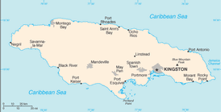  Taken from CIA World Fact Book
Population: 3 mil – Literacy 87,6%
Religion: Christian 82,9 - Evangelicals 28%;
Ethno Religion 10,2%; Non Religious 4,65%
9 people groups – 0 unreached
Jamaica is an island situated in the Caribbean Sea. It was under Spanish rule & known as Santiago, but became an English colony in 1655 & known as Jamaica. It became independent in 1962. The Tiano Indians who inhabited Jamaica were gradually exterminated & replaced by African slaves. The slaves were set free with the abolition of slavery in 1834. Violent crime, drug trafficking & poverty pose significant challenges to the government today. This puts Jamaica fourth globally for murders per capita.
Please pray :  - For courage, moral integrity & determination to turn the country back to God.  - That “Christians” will truly find Jesus as their Saviour, or recommit themselves to Him, & have a positive influence on their families & their communities.  - That athletes participating in the Olympics, will come in contact with Christian believers willing to share their faith.  “Declare his glory among the nations, …” (Ps 96:3) | SAAWE  Tel (011) 396-1225

IRELAND – 21 Previous Olympics  2016 – 77 participants in 14 sports categories. | 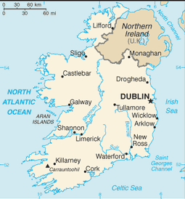  Taken from CIA World Fact Book
Population: 4,9 mil – Literacy 99%
Religion: Christian 91,7%(Catholic) – Evangelicals 1,5%;
Non-Religious 7,2%; Muslims 0,9%
45 people groups – 5 unreached
It is an Island west of Great Britain. Politically, Ireland is divided between the Republic of Ireland, which covers just under 5/6 of the island, & Northern Ireland, part of the UK. Over 60 yrs of intermittent warfare in the 1500’s led to English dominance after 1603. In the 1690’s, a system of Protestant English rule was designed to materially disadvantage the Catholic majority & Protestant dissenters & was extended during the 18th century. In 1801, Ireland became part of the UK. A war of independence in the early 20th century led to the partition of the island.
Please pray :  - For healing, reconciliation & forgiveness for the many years of suffering, oppression, violence & bloodshed at the hands of the Vikings & the British.  - For the Irish nation to rediscover its ancient heritage of deep & profound faith in Christ.  - That athletes participating in the Olympics, will come in contact with Christian believers willing to share their faith.  Tell everyone of every nation, "Praise the glorious power of the LORD. “(Ps 96:7) | SAAWE  Tel (011) 396-1225

HUNGARY - 26 previous Olympics  2016 – 160 participants in 21 sports categories | 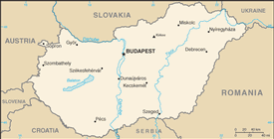  Taken from CIA World Fact Book
Population: 9,7 mil – Literacy 99%
Religion: Christian 88% (Catholic 59,6%) – Evangelicals 2,8%; Non-religious 10,9%; Jewish 0,9%
25 people groups – 4 unreached

Hungary is situated in Central Europe and was a great power until the end of World War l. Hungary has lost almost 70% of its territory, along with 65% of its ethnic population & all its sea ports under the Treaty of Trianon. The Kingdom was succeeded by an authoritarian regime & then a Communist era (1947 – 1989) during which time Hungary gained widespread international attention because of the Revolution of 1956. Hungary dismantled its 150 mile long fence border with Austria in 1989, accelerating the collapse of the Eastern Bloc. It is the 3rd most popular tourist destination in the world.
Please pray:  - That Hungarians will see the truth of the Gospel and the freedom it brings through Jesus.  - For revival in the Church that will give birth to a new spirit of witness & activism.  - That athletes participating in the Olympics, will come in contact with Christian believers willing to share their faith.  “ …and through your descendants, all the nations of the earth will be blessed …”.(Gen 22:18) | SAAWE  Tel (011) 396-1225

