HONG KONG - 16 Previous Olympics  2016 – 37 participants in 9 sports categories | 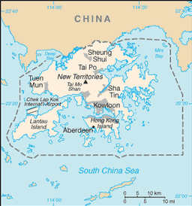  Taken from CIA World Fact Book
Population 7,4 mil – Literacy 93,5%
Religion: Chinese 59,6%; Non-Religious 21,9%;
Christian 12,4% - Evangelicals 6,1%; Other 3,8 %;
24 people groups – 10 unreached
Hong Kong became a colony of the British Empire in 1839. It was occupied by Japan during the Pacific War after which the British resumed control until 1997 when China resumed sovereignty. Hong Kong is one of the two special administrative regions of China. It is a city-state situated on China’s south coast and is renowned for its expansive skyline and deep natural harbour. It is one of the most densely populated areas in the world. Its population is 95% ethnic Chinese and 5% other groups. Hong Kong is one of the world’s richest cities & largest economies.
Please pray :  - That the Church will continue to be salt & light through social support organizations  - For renewal of & revival in the church.  - That athletes participating in the Olympics, will come in contact with Christian believers willing to share their faith.  “May the nations praise you, O God. Yes, may all the nations praise you.”(Ps 67:3) |   SAAWE  Tel (011) 396-1225

ESTONIA - 12 Previous Olympics (1952 – 1988 USSR) 2016 – 45 participants in 13 sports categories | 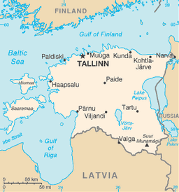  Taken from CIA World Fact Book
Population 1,3 mil – Literacy 99%
Religion: Non-Religious 54%; Christian 45,3% -
Evangelicals 4,9%; Ethno-Religions 0,2%;
18 people groups – 3 unreached
Estonia is a state in the Baltic Region of Northern Europe. Estonians are a Finnic People and the official language, Estonian is closely related to Finnish. It is a democratic parliamentary republic. It is one of the least populous members of the EU, Eurozone & NATO. It was forcibly incorporated into the USSR in 1940 and regained independence in 1991 with the collapse of the Soviet Union. It is listed as a “High-Income Economy” and as an “advanced economy” with a human development index of “Very High”. Many marginal Christian sects are increasing in number & influence.
Please pray :  - For the truth and light of Christ to be established in this new marketplace of religious options.  - Most of the population need to be re-evangelized. Pray for a new vision for evangelism and revival to reawaken the nominal majority.  - That athletes participating in the Olympics, will come in contact with Christian believers willing to share their faith.  “Let the whole world bless our God and sing aloud his raises.”  (Ps 66:8) | SAAWE  Tel (011) 396-1225

ANGOLA - 9 Previous Olympics  2016 – 25 Participants in 7 sports categories | 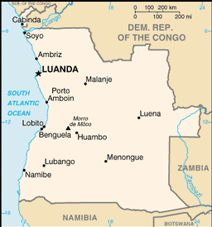  Taken from CIA World Fact Book
Population 32,8 mil – Literacy 66,8%
Religion: Christian 94,1% (Catholic) - Evangelicals 22,5%; Ethno-Religions 4%; Muslim 1,1%; 63 people groups – 1 unreached
Angola, as a Portuguese colony, was only established by the 1920’s. Independence was achieved in 1975, after a protracted liberation war. After independence, Angola was the scene of an intense civil war from 1975 – 2002. The country has vast mineral and petroleum reserves, and its economy has on average grown at a two-digit pace since the 1990’s, especially since the end of the civil war. In spite of this, living standards remain low, and life expectancy & infant mortality rates are among the worst-rated in the World.
Please pray :  - For the healing of visible & invisible wounds & that the church will play a huge roll in this process.  - For Christ-like, holy living by followers of the Lord Jesus that will commend the gospel to unbelievers.  - That athletes participating in the Olympics, will come in contact with Christian believers willing to share their faith.  “Sing to God, you kingdoms of the earth. Sing praises to the Lord.” (Ps 68:32) | SAAWE  Tel (011) 396-1225

CROATIA – (1920 – 1985 Yugoslavia) 7 Previous Olympics - 2016 – 87 participants in 18 sports categories | 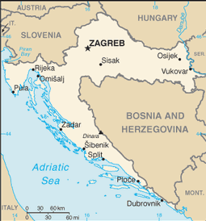  Taken from CIA World Fact Book
Population 4,4 mil – Literacy 98,1%
Religion: Christian 92% (Catholics) - Evangelicals 0,4%;
Non-Religious 6,01%; Muslim 1,9%;
25 people groups – 2 unreached
Croatia is a parliamentary republic in Europe. Croatia’s Adriatic Sea coast contains more than a thousand islands. After World War l, Croatia was included in the short-lived State of Slovenes, Croats and Serbs that declared independence and co-founded the Kingdom of Yugoslavia. A Croatian state briefly existed during World War ll. After the war it became a founding member of the 2nd Yugoslavia, a socialist state. In 1991 Croatia declared independence & the 4-year war of independence followed. Croatia has a comparatively high life expectancy, literacy, education, standard of living & income.
Please pray:  - For true reconciliation between Croat, Serb & Bosnian and for the religious & ethnic bondages to be broken through the power of Christ.  - Pray that all Croatians would move beyond empty rituals of the Catholic church to a living relationship with Jesus.  - That athletes participating in the Olympics, will come in contact with Christian believers willing to share their faith.  “Let the whole world bless our God and sing aloud his raises.”(Ps 66:8) | SAAWE  Tel (011) 396-1225

