Turks of Turkey (59,7mil) 0,01% CHRISTIANS  (6th largest Unreached People Group in the world)  DID YOU KNOW? Since the 1920s modern Turkey has become a secular, developed nation that sits, literally & symbolically, between the Christian West & Muslim World. Turkey is the only secular republic with a majority of the population being Muslim. Though traditional ways continue to exist in some areas, the typical Turk lives a secularized, modern urban life, with all the materialistic advantages & temptations that go with it. Cultural sexism remains as women are often viewed through traditional Islamic beliefs. 60% of Turks live in major cities. 40% are employed in the agricultural sector living in villages & using natural resources to earn a living. They are predominantly nominally Sunni Muslim. They also believe that men can curse one another by giving them the ‘evil eye’ & one is protected against such a curse by wearing blue beads also called ‘the evil eye’.(Taken from Ethné to Ethné) | 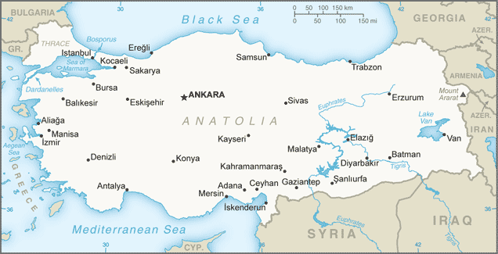  Taken from "Operation World CD" by Patrick Johnstone
Please pray :  - That the Holy Spirit will soften the hearts of the Turks so that they will be receptive to the Gospel.  - That the many seeds that have been sown in Turkey, over many years & by many Christian missionaries, will start sprouting & that many Turks will start accepting Jesus as their saviour.  - That many Turks living abroad will be reached with the Gospel & will take it back to Turkey.  “All nations will remember the LORD. From every part of the world they will turn to him;…” (Ps 22:27) |   SAAWE  Tel (011) 396-1225

Chamar of India (47,7mil) 1,22% CHRISTIANS  (7th largest Unreached People Group in the world)  DID YOU KNOW? The Chamar live primarily in India’s western states & are considered untouchables or Dalits. To be untouchable in the Hindu tradition, is to be undesirable or unworthy. This translates into frequent joblessness, lack of education & lifelong poverty. Their main occupation is manufacturing of shoes & sandals from finished leather. They are also engaged in daily-wage labour & petty business. They practice monogamy in marriage. Dowry is largely prevalent & is paid in cash & kind. Remarriage is allowed for widowers but not for widows. The dead are cremated & their mortal remains immersed in sacred water. Rice balls are offered to the dead on the 10th day after death. The Chamar are Hindu.(Taken from Ethné to Ethné) | 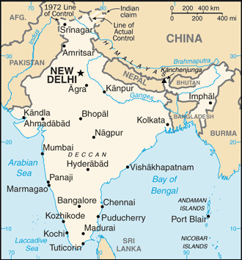  Taken from "Operation World CD" by Patrick Johnstone
Please pray :  - For the salvation of the Chamar people & that God may send several Christian workers among them to meet their spiritual & physical needs.  - For the Chamar people to break through the caste barrier; be accepted & accept other communities.  - That Chamar believers will be salt & light to others.  “Declare his glory among the nations, his marvelous deeds among all peoples.” (Ps 96:3) | SAAWE  Tel (011) 396-1225

Rajputs of India (45,6 mil) 0,02% CHRISTIANS  (8th largest Unreached People Group in the world)  DID YOU KNOW? The Rajputs are a proud people whose name is derived from the word Rajputra which means King’s son.  Generally the Rajputs are materially well off. They are established leader of society & influential in politics. They are a landowning community engaged in farming. Many are in the Indian army. Literacy is higher in comparison to other castes & Brahmins serve them as priests. They live in extended families. In urban areas, however the nuclear family is now the norm. All sons inherit equal shares of the property while the eldest succeeds as the head of the family. Women avoid contact with all male members except their husbands who are held in high esteem. The practice of dowry is very common, but is so burdensome that female infanticide is a consequence. Most of the Rajputs are Hindu. (Teken from People Groups of India) | Taken from "Operation World CD" by Patrick Johnstone
Please pray :  - That the Holy Spirit will prepare the hearts of the Rajputs so that they will be receptive to the Gospel.  - That the Lord will give them a hunger to know Him.  - That the Rajputs will increasingly grow in awareness of Jesus, his life & his sacrifice for them.  “Many nations will be joined with the Lord in that day and will become my people.”(Zech 2:11) | SAAWE  Tel (011) 396-1225

Java Pesisir Lor of Indonesia (37,6mil) 2,8% CHRISTIANS (9th Largest Unreached People Group)  DID YOU KNOW? They inhabit the villages, small towns & cities which stretch south from the North Java Sea to the hills & mountains that span two-thirds of the length of the island of Java. They are less emotionally reserved & in personal communication they can be direct & aggressive. Although the majority of these people are farmers, fishermen, or both, the trend is to seek training for an increasing variety of urban & rural occupations. One-story bamboo-framed homes & modern brick homes are built side by side. Nearly all of them profess to be Sunni Muslim, Sufi mystic beliefs are widely practiced. Year round groups of Javanese Pesisir Lor people travel to the graves of Islamic missionaries beseeching the ancient spirits for health, salvation & sustenance. (Taken from Ethné to Ehtné) | 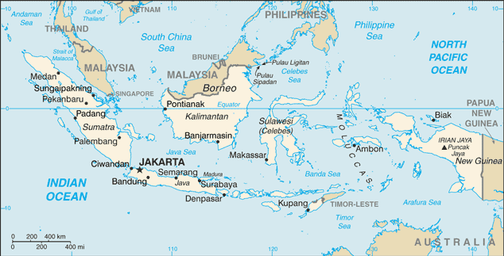  Taken from "Operation World CD" by Patrick Johnstone
Please pray:  - That the Lord will call Christian engineers to go to Indonesia to help build better dams & irrigation.  - That these Christians will also show them friendship, love & Jesus.  - That the Holy Spirit will soften the hearts of these people towards Christians so that they will be receptive to the Gospel.  “….so that the whole world may know your will; so that all nations may know your salvation.” (Ps 67:2) | SAAWE  Tel (011) 396-1225

