Shaikh of Bangladesh (125,8 mil) & India (85,9 mil) 0% CHRISTIANS; (Bangladesh largest & India 3rd largest Unreached People Group in the world.)  DID YOU KNOW? Islam arrived in the area now known as Pakistan in 711 AD. Muslims & Arabs flocked to this area & settled permanently. The descendants of these Arabs usually go by the title of Shaikh. After the advent of Islam, some high castes converted to Islam & adopted this title & are known as Punjabi Shaikh. Their main professions are business & public service. Bangladesh is one of the poorest & most densely populated nation on earth. There are few natural resources, and wages are terribly low for those that work. Floods & mudslides are an annual occurrence during monsoon season. With so many people so close together, these natural disasters have a magnified impact on the people.(Taken from Ethné to Ethné) | 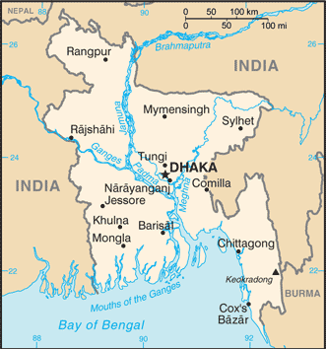  Taken from CIA World Factbook
Please pray :  - That the power of Islam in their lives will be broken & that they will be set free.  - That Christian NGOs will have long-term impact on poverty & lead many Shaikh to Jesus..  - That the Holy Spirit will prepare their hearts to receive Jesus Christ as Saviour & Lord.  “All kings will bow down before Him; all nations will serve Him!”(Ps72:11) |   SAAWE  Tel (011) 396-1225

Japanese of Japan (120,5 mil) 1,2% CHRISTIANS  (2nd largest Unreached People Group in the world)  DID YOU KNOW? Racially, culturally & ethnically, the Japanese are one of the most homogenous people groups in the world. They identify themselves in terms of biological heritage, birth in Japan, a shared culture, & a common language (Japanese). 60% of Japanese live in nuclear families. Their economy is based on a competitive market/private enterprise system. Many families farm as a secondary occupation. They all enjoy wearing Western clothing for their daily activities; however, traditional costumes are worn during special religious ceremonies or festivals. Shintoism is the native religion of Japan & is rooted in animism. Buddhism was introduced to Japan in the sixth century. Today, most Japanese claim to be both Shintoist & Buddhist. On the outside, they seem to have few needs. However many of them have become obsessed with materialistic pleasures, careers & possessions. (Ethné to Ethné) | 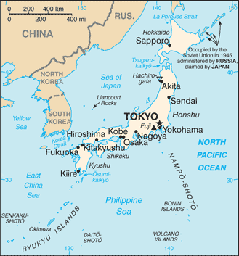  Taken from CIA World Factbook
Please pray :  - That the Lord will bless the missions organizations working in Japan & give them a huge harvest.  - That the Japanese will become discontented with their materialistic pleasures & possessions & will find the Lord Jesus.  - That the Holy Spirit will soften the hearts of the Japanese so that they will be receptive to the Gospel.  “All nations … will come and bow down to You” (Ps 86:9) | SAAWE  Tel (011) 396-1225

Brahmins of India (59,1mil) 0% CHRISTIANS  (4th largest Unreached People Group in the world)  DID YOU KNOW? Brahman refers to the “Supreme Self” in Hinduism or the first of the gods. Over time, Brahmins became a powerful & influential group in India & many discriminated against lower castes. They are located throughout India but mainly in the Northern states. The Brahmins are members of the highest priestly caste in Hinduism & perform priestly services. They may also work in jobs associated with lower castes. Such work precludes the Brahmin from carrying out priestly duties & such a person may even be barred from the priesthood. Brahmins are vegetarian, in keeping with Hindu beliefs in reincarnation. However some do consume milk products or fish. Brahmins study the religious texts & teach members of other castes. Traditionally they serve as the spiritual guides & teachers of the princes & warriors.(Taken from Ethné to Ethné & Wikipedia ) | 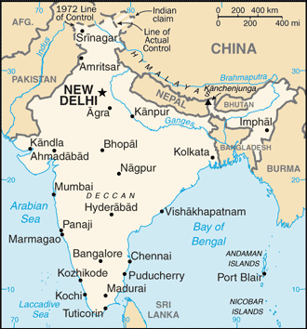  Taken from CIA World Factbook
Please pray :  - That the Lord will call missionaries to witness to these people in a way that will speak to their specific needs.  - That the light of the gospel will break through the satanic veil that blinds this community  - That God will reveal Himself to this community & use Brahmins to preach & teach about Jesus Christ.  “The Lord has made His salvation known and revealed His righteousness to the nations.” (Ps 98:2) | SAAWE  Tel (011) 396-1225

Yadav of India (58,6 mil) 0,01% CHRISTIANS  (5th largest Unreached People Group in the world)  DID YOU KNOW? The Yadav are a caste comprising of milkmen, herdsmen, cattle breeders & labourers. Their traditional occupation is animal husbandry & selling of its products. Some Yadav are businessmen & other professionals. They have become politically powerful in the states of Bihar & Uttar Pradesh in last 3 decades. They are very influential and are a major challenge to the political supremacy of the Brahmans. They have expertise in oral traditions & group singing in praise of the god Vishnu, Krishna or one of the many other gods they worship. They are known to have more faith in astrology & talismans than in the services of a doctor. They lack good education. Every year Bihar experiences major floods, killing hundreds of people & leaving millions homeless. (Taken from Ethné to Ethné) | Taken from CIA World Factbook
Please pray:  - That the Lord will reveal Himself to them as the one & only true God.  - That the Lord will call Christian teachers to go & work among the Yadav.  - For Christian relieve workers who will give more than food, clothes & medicines – who will give them Jesus.  “.. I will beckon to the Gentiles, I will lift up my banner to the peoples.” (Is 49:22) | SAAWE  Tel (011) 396-1225

