Central Thai of Thailand (22,6 mil)  (23r^{d} Largest Unreached People Group of the world)  DID YOU KNOW? The Central Thai, or Khon Thai, meaning the “the free people”, live on the country’s rich central plain. Centuries ago they lived in China, but relentless pressure from the Chinese gradually forced them southwards. The Central Thai are unusually polite, respectful & hospitable. Children are brought up to respect certain people eg those of a higher rank & age, etc. Families are the core of Thai society & in rural areas, the immediate family usually lives, eats, & farms together. Both men & women plow, till, fish, cook, tend babies, clean house, & wash clothes. Theravada Buddhism is the central unifying force in Thai society, although they also attempt to incorporate their folk animistic beliefs by worshipping of spirits & objects. Prostitution is a pressing social problem with ±200,000 to 500,000 prostitutes from poor rural areas who help their families survive by selling their bodies. |   Taken from Joshua Project
Please pray :  - That the Lord will send Christian teachers to educate, especially the women & medical teams to help curb the public health problems like hepatitis, malaria & HIV.  - That they will be set free from Buddhism &, animism.  - That the Holy Spirit will prepare their hearts for the Gospel.  “Proclaim his glory to the nations, his mighty deeds to all peoples”. (Ps 96:3) |   SAAWE  Tel 083 973 4011  Patrys

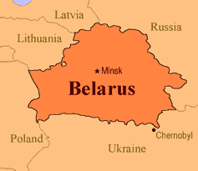  Northeastern Isan Thai of Thailand (18,5 mil)  (28th Largest Unreached People Group in the world)  DID YOU KNOW? The Northeastern Thai, also known as the Lao Isan, live on a flat arid plain known for its infrequent rainfall & few natural resources. It is noted for its archeological relics & monuments dating back to Khmer influence. These people were forcibly relocated to this region from Laos. Most of the Isan Thai are farmers dependent on rain-fed agriculture. Although agriculture & industry is hindered by the shortage of water & infrastructure they still produce their world famous mud-mee silk. They are friendly & open & family & community oriented. Because of frequent draught these people are thought of as poverty stricken, yet they have become an urban, industrial labour force in larger cities & overseas. More than half are Theravada Buddhist. but also worship spirits & venerated objects. | 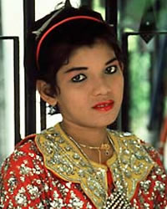  Taken from Joshua Project
Please pray :  - For workers that will contribute to the production of culturally appropriate materials, art, music & church forms.  - For workers who can assist with improved nutrition, infrastructure, industry & educational opportunities.  - That their hearts will be open to accepting Christ when they hear the Gospel.  “Therefore the nations will praise You for ever…..” (Ps 45:17) | SAAWE  Tel 083 973 4011  Patrys

Hindu Kurmi of India (19 mil)  (25th Largest Unreached People Group in the world)  DID YOU KNOW? Kurmi is a Hindu caste & the word literally means “I cans” or “I am ables”.They come from the Kshatriyas (warrior caste) who have become the chief agricultural caste of India. The modern Kurmi are relatively prosperous & educated. Their lifestyle is associated with farming & trading. Due to this they are viewed as one of the “backward” or lower castes. A key issue for the Kurmi is their desire to be recognized by other castes as belonging to the warrior caste of Kshatriya. | 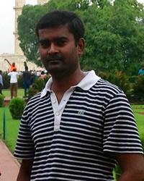  Taken from Joshua Project
Please pray :  - That the caste system in India will be abolished.  - That the Kurmi will realize that the Lord is offering them the right to be a special people, royal priests & holy conquerors of the Almighty.  - That the Holy Spirit will prepare their hearts to be receptive to the Gospel.  “Your faithfulness continues through all generations;” (Ps 119:90) | SAAWE  Tel 083 973 4011  Patrys

Hindu Jats of India (19,2 mil)  (24th Largest Unreached People Group in the world)  DID YOU KNOW? The Jats are scattered around the world among several ethnic groups, yet retain their own identity. There is a theory that they may be the predecessors of Gypsies. Whatever their origin, in the 18th century, they became a force to be reckoned with. They have a very good self-image. “Men may come & go, but I go on forever,” is a well-known Jat proverb. They are a brave & hardworking people who possess both the desire and ability to rule. They served in the British-India army during World War 1, & before that, they served as fighters in the Persian Army. In time past, a Jat who did not have a horse was looked down upon by his peers. In India & Pakistan they are usually either farmers or nomadic herdsmen. Physically, the Jats are taller & heavier than most of their neighbours. Because of their larger build & their reputation for violence, they are generally feared. Regardless of their religious affiliation, all Jats observe rites of passage such as circumcision & initiation into adulthood. | 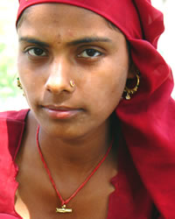  Taken from Joshua Project
Please pray:  - That the Lord will call doctors, nurses & humanitarian aid workers that will share the love of Jesus with the Jats.  - Ask God to save key Jat leaders who will boldly proclaim the Gospel to their own people.  - That the Lord will raise up prayer teams who will faithfully stand in the gap for the Jats.  “The heavens proclaim his righteousness, and all the nations see his glory.” (Ps 97:6) | SAAWE  Tel 083 973 4011  Patrys

