Arabic Speaking Algerians of Algeria(30,1 mil)  (16th Largest Unreached People Group in the world)  DID YOU KNOW? Today the vast region of North Africa is predominantly inhabited by Arab Muslims. However, this was not always the case. The territory was once dominated by the Berbers, a non-Arab people who were at one time mostly Christians. The Berbers successfully withstood numerous invasions before finally being overrun by Arabs. The Arabization of the Berbers occurred in 3 stages: contact with the Arabs, the arrival of the Bedouins & the arrival of the Andalusian refugees. Today virtually all the Berber tribes are Sunni Muslim. While the Berbers adopted the five pillars of Islam, each has modified it a little to fit their local traditions & tastes. For instance, many are very casual about prayer & others did not accept the giving of alms as it was perceived as being some type of tax. There are several Christian resources available to the Arabized Berbers but Christians among them are few. (Taken from Ethné to Ethné) | 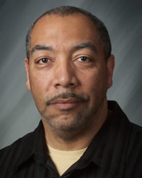  Taken from Joshua Project
Please pray :  - That God will raise up prayer teams who will begin breaking up the soil through intercession.  - That God will give mission agencies new strategies for reaching these people with the Gospel.  - That the Holy Spirit will soften the hearts of these people so that they will be receptive to the Gospel.  “All who worship images are put to shame, …. Worship Him, all you gods!”(Ps 97:7) |   SAAWE  Tel 083 973 4011  Patrys

Koreans of North Korea (25,3 mil)  (21st Largest Unreached People Group in the world)  DID YOU KNOW? The Koreans of North & South Korea share distinctive Mongolian features & are believed to have descended from a single racial group. Officially, the North Korean Constitution gives political power to the people, but real political power belongs to the Communist Party. The North Koreans have very little freedom. Before the 1900’s, Korea was an agricultural society with strong family ties. Since the late 1940’s the Communists have taken steps to industrialize the country & most urban North Koreans work in factories. Education is free & mandatory for the first 11 yrs & during the summer vacations, students must work for the state. A mixture of Confucianism, Buddhism & Shamanism were previously dominant among the Koreans, but have been repressed since 1945. A former leader, Kim Il Sung, is worshipped by the North Koreans.(Taken from Ethné to Ethné) | 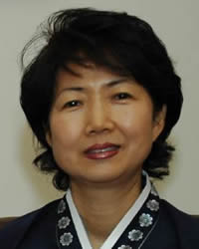  Taken from Joshua Project
Please pray :  - That the Lord will soften the hearts of the leaders to allow foreign assistance to relieve the acute shortage of food.  - For the North Koreans’ freedom – they need political as well as spiritual freedom.  - For the removal of this oppressive government.  “All the nations …. will praise your greatness.“ (Ps 86:9) | SAAWE  Tel 083 973 4011  Patrys

Northern Pashtun of Pakistan (26 mil)  (20th Largest Unreached People Group in the world)  DID YOU KNOW? The Pashtun, are a race of warriors who live primarily in Afghanistan & Pakistan. They consist of about sixty tribes, each with its own territory. They have played an important role in the history of their region & from them have come Muslim rulers, administrators, & soldiers. While many have moved out of the highlands in search of an easier life on the plains, their mountainous homeland continues to be their citadel of strength & freedom. They are elegant, colourfully attired, hospitable, considerate, fierce in hatred, & kind in friendship. Though very dedicated to their religious beliefs, they are also fond of pleasure. At the core of Pashtun society is the extended family. Each family group owns its land & lives in a fortified residence called a qala. Every qala is divided into two areas by a high wall: a general living area & the private living quarters. In 1979 the Soviets invaded Afghanistan & ± 3 mil fled to Pakistan. Currently Afghanistan torn by war between the Taliban & the national government. The majority of Pashtuns are Sunni Muslim. (Taken from Ethné to Ethné) | 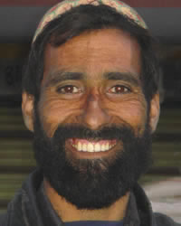  Taken from Joshua Project
Please pray :  - That God will raise up prayer teams who will break up the soil through worship & intercession.  - Pray for a greater peace & freedom for Christian workers to live & work among the Pashtuns.  - For the Pashtun children who grow up in fear & hatred of outsiders.  “ …so that all nations may know your salvation.” (Ps 67:2) | SAAWE  Tel 083 973 4011  Patrys

Northern Uzbek of Uzbekistan (27,5 mil)  (19th Largest Unreached People Group in the world)  DID YOU KNOW? They are a Turkic people located primarily in Central Asia. The Uzbeks were conquered by the Russians & when the Communists took over many of the Uzbek nomads were forced to live on collective farms. Traditionally, most Uzbeks were semi-nomadic shepherds, but today most either farm or live & work in larger towns & cities. The Uzbek mountain men love to play buzkashi, a polo-like game that last 2 – 3 days. They use a headless carcass of a goat or calf as a ‘ball’. The object of the game is to pick up the ‘ball’ & carry it to a goal that may be as far as 2 miles away. The other team tries to stop them, even using whips to attack them. Most Uzbeks are Sunni Muslim. Many of the younger generation are either atheists or non-religious. They are the largest people group in Central Asia & the most resistant to the Gospel. (Taken from Ethné to Ethné) | 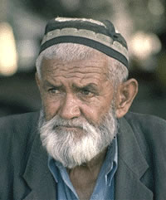  Taken from Joshua Project
Please pray:  - For wisdom & favour for the mission agencies focusing on the Uzbeks.  - That Christians in other countries will start reaching out to their Uzbek neighbours.  - For the effectiveness of the Jesus Film & Christian radio broadcasts being aired among the Uzbeks.  “.. I will beckon to the Gentiles, I will lift up my banner to the peoples.” (Is 49:22) | SAAWE  Tel 083 973 4011  Patrys

