Kurds of Turkey (6,4 mil)  DID YOU KNOW? The Kurds of Turkey live in the most rugged part of Kurdistan. Kurdistan extends over Turkey, Iran, Iraq, Armenia & Syria. In spite of their longing for a united Kurdistan, the people have not yet initiated any political or liberation movement. Since 1965, these proud & fiercely independent people have made a clear return to their roots. Kurds make their living through farming, & raising cattle & goats. Kurdish agriculture has changed little since the Middle Ages & is far behind the rest of Turkey. Their tribal structure has disintegrated due to many factors. They are oppressed by the government. Schools are ill-equipped & too few. Medical care is inadequate in towns & almost non-existent in the rural areas. They are exposed to diseases such as malaria & tuberculosis. They need the liberty to educate their children in their own language. Nearly all Kurds are Shafiite Sunni Muslim. | 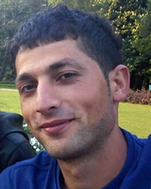  Taken from Joshua Project
Please pray :  - That the Lord will call Christian doctors who will be willing to go & share their medical expertise as well as Jesus Christ with the Kurds.  - That the Holy Spirit will prepare the hearts of the Kurds for the Gospel.  - That the Lord will change the hearts of the Turkish government so that they will allow the Kurds to educate their children in their mother tongue.  “All who worship images are put to shame, ….Worship Him, all you gods!”(Ps 97:7) |   PATRYS  083 973 4011

Vishwakarmas of India (7,7 mil)  DID YOU KNOW? Vishwakarmas are followers of Vishwakarman, the Hindu presiding deity of all craftsmen & architects, from whom they claim to have descended. Today the term Vishwakarma denotes a community or group of castes of artisans in India. They played a vital role in the Indian village economy where their communities are widely spread across the country. They considered themselves “missionaries of civilization, culture & religion” as they spread Hinduism through their art. They have contributed greatly to Indian civilization & culture as city & temple builders, engineers, architects & artists. With industrialization the traditional artisan trade has been greatly affected & has almost become extinct. This has caused an identity crises – being unable to identify with the upper or the lower castes. They also have a rather unpopular history of identifying with the communists. They practice “Brahmanism”, an ancient form of Hinduism. | 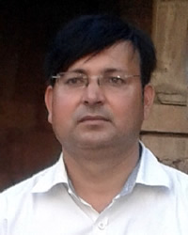  Taken from Joshua Project
Please pray :  - That they will be set free from the bondage of Brahmanism & that their minds & hearts will be open to the truth of the Gospel.  - That they will find new vocations by which they can provide for their families.  “The Lord has made His salvation known and revealed His righteousness to the nations.” (Ps 98:2) | PATRYS  083 973 4011

Tajiks of Afghanistan (10,8 mil)  DID YOU KNOW? Tajiks are the second largest group in the country. They speak Dari a dialect of Persian. One vast habitat is the rugged, mountainous Panjsher Valley north of Kabul where poor farmers & herders live in villages of flat-roofed mud brick or stone houses. One group, large & more educated, lives in Kabul where they have enjoyed economic success & political influence. Because large Tajik families are close-knit, city-dwellers are known to maintain close ties with their relatives in the countryside. Cultural traditions are guarded & observed. One such tradition is offering extraordinary hospitality – an occasion for a fine meal. Even poor farmers welcome guests with tea, bread & yogurt. They create handsome carpets, ceramics, richly embroidered costumes & men’s brightly colored caps & jewelry. Afghan Tajiks are almost entirely Muslim & Islam permeates every area of their lives. In addition to Islamic beliefs, spiritism is also widespread among them. | 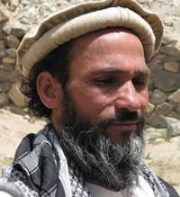  Taken from Joshua Project
Please pray :  - That their hospitality will open doors to evangelizing the Tajiks.  - Ask God to raise up prayer warriors who will pray for the salvation of the Tajiks.  That many Tajiks will come to faith in Jesus.  “Exalt the Lord our God and worship at His footstool; He is holy” (Ps 99:5) | PATRYS  083 973 4011

Mongols of China (5,7 mil)  DID YOU KNOW? The Mongols are one of China’s official nationalities. In the 13th & 14th centuries the Mongols brutally established the largest empire the world has seen, stretching from Southeast Asia to Europe. Through thousands of bitter winters the Mongols have lived in yurts, racing their horses, raising livestock & worshipping the forces of nature. The moon, stars & sun were all revered, as were rivers. In the past many Mongols were Christians, converted between the 7th & 14th centuries. Kublai Khan challenged Marco Polo to ask the Pope to send 100 men, learned in the Christian faith, to come & make the sorcerers powerless to perform their marvels, then he and his people would be baptized. The Keirats, a Mongol tribe, numbered 200 000 believers in AD 1007, while there were about 30 000 Mongol Catholics recorded in China by 1368. These numbers have been disputed & said to be grossly exaggerated. The size of the Mongol church in China has long been a matter of dispute. | 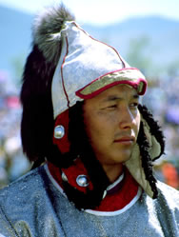  Taken from Joshua Project
Please pray:  - That the Holy Spirit will make their hearts receptive to the Gospel.  - That many Mongols will come to faith in Jesus.  - That Chinese believers will reach out to the Mongols in their vicinity.  “For the Lord is good and His love endures forever; His faithfulness continues through all generations.” (Ps 100:5) | PATRYS  083 973 4011

