Hijazi Arabs of Saudi Arabia (10,8 mil)  DID YOU KNOW? The Hijazi Arabs form the majority of the Saudi Arabian population. They speak Arabiya. Historically, agriculture & raising livestock have been the basic economic activities of Saudi Arabia. Since the development of the oil industry, however, the government has sought to diversify its industrial base. Today, the government is the largest employer in Saudi Arabia, engaging about one-third of the work force. Industry employs nearly another third. The remainder are involved in trade & other services. Education in Saudi Arabia is free, but not compulsory. About 2/3 of Saudi adults are literate, a dramatic increase from the less than 3% literacy rate in the early 1960’s. The Hijazi Arabs are practically all Muslim, but represent a variety of Islamic sects. They see themselves as the preservers of the true Islamic faith. The city of Mecca, on the Red Sea coast, is the holy place of pilgrimage that all Muslims must try to visit at least once in their lifetime. | 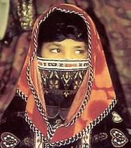  Taken from Joshua Project
Please pray :  - That the Lord will raise up intercessors who will begin breaking up the soil through prayer.  - That the Holy Spirit will prepare the hearts of the Hijazi Arabs for the Gospel.  - That the Lord will give creative strategies to mission agencies to evangelize the Hijazi Arabs.  “All who worship images are put to shame, ….Worship Him, all you gods!”(Ps 97:7) |   PATRYS  083 973 4011

Lingayat of India (9,1 mil)  DID YOU KNOW? The Lingayat people are known for wearing a linga, an object representing a god; in this case, Shiva. They are a numerous group in India. This group was formed in the 12th century by Basava a social reformer. He taught against the caste system & its regulations. Basava consented to the marriage of a Brahmin(high caste) woman & a man from an untouchable caste. This story reached the ears of the king who punished the couple by putting out their eyes & dragging them to their death behind an elephant. The Lingayat are vegetarian & refrain from alcoholic drinks. They are known to be a progressive people & there are people from many walks of life & religious expression. They have a series of initiatory rites, including lingadharane, the bestowing of the linga. This rite is usually performed within the first week of a child’s life. From this day forward, the person will wear the stone), in a box around their neck, as an act of worship of the god (Shiva). | 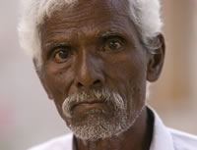  Taken from Joshua Project
Please pray :  - That they will be set free from the bondage of Shiva.  - That their minds & hearts will be open to the truth of the Gospel.  - That many will come to faith in Jesus.  “The Lord has made His salvation known and revealed His righteousness to the nations.” (Ps 98:2) | PATRYS  083 973 4011

Somali of Somalia (15,9 mil)  DID YOU KNOW? Over 16 mil live scattered across eight countries in the northeastern portion of Africa & in the Middle East. Over 5 mil live in Ethiopia. The Somali share a common language, adhere to a single faith, & share a cultural heritage that is an integral part of their nomadic lifestyle. Their name is derived from the words, “so maal”, which literally mean “Go milk a beast for yourself”. To them, this is actually a rough expression of hospitality. Somali society is based on the nuclear family, consisting of a husband, wife & children who own a herd of sheep or goats & a few burden camels. The Somali consider themselves warriors. They are a very individualistic people, sharply divided by clans who often fight resulting in many deaths. Somalis enjoy telling stories & learning history through their poetry. They are nearly all Shafiite Muslims. More than half of adults are illiterate. This is not surprising since they did not have a written script until 1972. Access to modern health services is very limited & malnutrition has claimed many lives since the1970’s. | 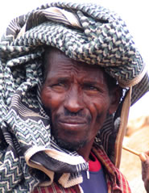  Taken from Joshua Project
Please pray :  - For an end to the long-standing conflict in Somalia.  - Ask God to raise up prayer warriors who will pray for the salvation of the Somalis.  - Ask God to bless the Gospel as it goes forth via radio & television to the Somali.  “Exalt the Lord our God and worship at His footstool; He is holy” (Ps 99:5) | PATRYS  083 973 4011

Mali of India (10 mil)  DID YOU KNOW? The Mali are traditionally known as gardeners. The word Mali is derived from the Sanskrit word ‘mala’ meaning garland. Many of them are called ‘phool’ Mali, referring to their well-known occupation of growing flowers. They are industrious workers & are known for their bravery in the disciplined forces. Generally, they are differentiated according to their occupations. Those pursuing gardening are known as Baghban, those who cut & sell grass as Sasia Mali & those growing flowers as Phool Mali. They are also known for the preparation of the marriage crown both for the bride & groom. Marriage is forbidden between members of the same sect & 1st or 2nd cousins. Unlike some Indian traditions, marriage of widows is permitted. The Mali are mainly Hindus & Devi is their principle deity. Devi is believed to require appeasement through offerings & the goddess incites fear among her followers. | 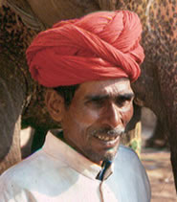  Taken from Joshua Project
Please pray:  - That the Holy Spirit will make their hearts receptive to the Gospel.  - That they will embrace Jesus who does not instill fear, but is merciful, forgiving & loving.  - That many Mali will come to faith in Jesus Christ.  “For the Lord is good and His love endures forever; His faithfulness continues through all generations.” (Ps 100:5) | PATRYS  083 973 4011

