Laccadive Mappilla of India (9 mil)  DID YOU KNOW? They live in die Lakshadweep Islands off the southwestern coast of India. They migrated from the Kerala coast. They came as Hindus, but later converted to Islam. The Laccadive Mappilla’s economy is based on the coconut trees which cover the Islands. The coconut supplies coir (the husky fiber, which can be used to make ropes or mats) and copra (coconut meat). Each island has various mosques & one or two schools for religious education. The government has made efforts to establish high schools & primary schools for girls. Monogamy prevails among the Laccadive Mappilla, in spite of the fact that Islam allows a man to have up to four wives. A man has little authority over his children. Divorce is easy & common; over half of their marriages end in divorce. They belong to the Shafite School of the Sunni branch of Islam. Every child has to read the Koran completely in Arabic at least once, but the meaning is not explained to them. | 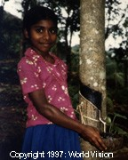  Taken from Joshua Project
Please pray :  - For a breakthrough in the lives of the Laccadive Mappilla.  - For the effectiveness of the Jesus film among these people.  - That the Holy Spirit will awaken a hunger for Jesus in the hearts of the Laccadive Mappilla & that many will turn to Jesus.  “All who worship images are put to shame, ….Worship Him, all you gods!”(Ps 97:7) |   PATRYS  083 973 4011

Lohar of India (9,5 mil)  DID YOU KNOW? The Lohar people are nomadic smiths who travel in order to sell their goods. They are descendants of high-caste weapon makers of the Mewar kingdom in India. Unfortunately, they became poor nomads when the kingdom fell in 1568. The Lohar lead hard lives although they work hard. This is partly because most people prefer to buy goods from stores & factories, not handmade items. Many cannot read or write because of their nomadic lifestyle & because they are considered “untouchables” & are despised. There are stereotypes about nomads, such as the idea that they are thieves or corrupt gypsies. They are almost all Hindu. To them, salvation means, escaping the endless cycle of death & reincarnation. They need business to feed their families & God’s healing touch. | 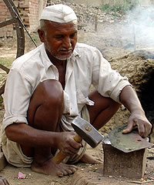  Taken from Joshua Project
Please pray :  - For their careers; that their business success increases, or that they become sedentary & receive the education they need.  - That more audio & video resources will be created in their language as few can read.  - That they will be open to God & his love.  “The Lord has made His salvation known and revealed His righteousness to the nations.” (Ps 98:2) | PATRYS  083 973 4011

Mahar of India (9,5 mil)  DID YOU KNOW? The Mahar people were historically a part of the Untouchable caste, the lowest caste in the Hindu social system. This caused them to face extreme discrimination & legal restrictions, such as when they were allowed to be in the city, whether they were allowed to spit on the ground, & how loud they were allowed to talk. Around 1900 they began fighting for their rights which culminated in the conversion of about 500 000 Mahar to Buddhism in 1956. Those who converted are no longer associated with the Mahar people. They are often employed in low skilled labour such as masons, railway workers/truck drivers. In rural areas some farm. The Mahar people are primarily Hindu. A small number are Muslims & a small number are Christians. Christian Mahars often face even further persecution or discrimination than what they experienced previously as Hindus. | 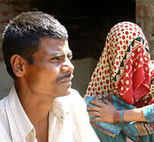  Taken from Joshua Project
Please pray :  - That God will begin restorative justice amongst the Mahar, both socially & economically.  - That God will establish a thriving church amongst the Mahar people & will give the current Christians the strength to persevere & continue evangelizing.  - That the Holy Spirit will soften the hearts of the Mahar people to be receptive to the Gospel.  “Exalt the Lord our God and worship at His footstool; He is holy” (Ps 99:5) | PATRYS  083 973 4011

Jawa Banyumasan of Indonesia (9,2 mil)  DID YOU KNOW? Most Jawa Banyumasan people make their living from farming, but compared to other Indonesian people groups, they are fairly advanced in this field. Besides having fertile land, they use the land well, even more so now that they have modern equipment. The industrial sector is also experiencing rapid growth. Besides heavy industry, small industries are also growing well. The majority of the Jawa Banyumasan are Muslim, but 80% are nominal Muslims (abangan). The other 20% are serious Muslims (santri) who strictly follow Islamic teachings & are faithful in worship. Some also follow animistic beliefs & believe that there are spirits that come from the unseen world. Places that are often considered sacred include graves, mountains, caves & seas. They often hold ceremonial meals or ritual feasts, which include use of mantras & offerings to spirits. The purpose is to protect their area from calamity. | 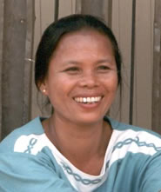  Taken from Joshua Project
Please pray:  - That Christian engineers will assist these people in building more dams & better irrigation systems so that they can increase their agricultural production.  - That the Holy Spirit will make their hearts receptive to the Gospel.  - That many will come to faith in Jesus Christ.  “For the Lord is good and His love endures forever; His faithfulness continues through all generations.” (Ps 100:5) | PATRYS  083 973 4011

