Han Chinese of Taiwan (13,3 mil)  DID YOU KNOW? The Han Chinese are the largest ethnic group in the world. Many have immigrated to other countries, & today they reside in nearly every nation of the world. Wherever they’ve gone they have set up businesses. Many have maintained their culture & language. One of the primary reasons they have kept their own languages & customs is because they have a deeply ingrained belief in the superiority of their culture. The Han Chinese are known for their politeness & will go to great lengths to avoid disputes. However, once a dispute begins it is very difficult to stop, because they place a high value on ‘saving face’. They generally maintain their traditional Chinese religion, which is a mixture of Buddhism, Confucianism & Taoism. They are very superstitious & consult horoscopes. They also believe in a pantheon of spirits. In spite of this it has little effect on their everyday lives. In fact many of them are non-religious. | 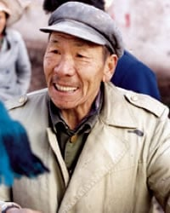  Taken from Joshua Project
Please pray:  - That the Holy Spirit will prepare their hearts for the Gospel.  - That the Lord will use Christian businessmen to share the Gospel with the Han Chinese.  - That all Christians will reach out to Han Chinese in their vicinity.  “All who worship images are put to shame, ….Worship Him, all you gods!”(Ps 97:7) |   SAAWE  PATRYS 083 973 4011

Koli of India (12,5 mil)  DID YOU KNOW? The term Koli means fisherman. According to legend the Koli claim to be descendants from the Black Dwarf that came forth from the body of King Vena. Other occupations they practice are labourers, agriculturists, water carriers, boatman & animal husbandry, but there are also Koli who have advanced themselves. They live mostly in villages & towns of Gujarat & Uttar Pradesh. They live the simple life of agriculturalists. Nearly all Koli are Hindu while a few practice Islam. They worship Guar Mati & Holi Mata & believe in ghosts & spirits. The Koli cremate their dead & practice death pollution for eleven days. | 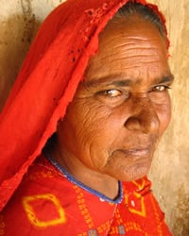  Taken from Joshua Project
Please pray :  - That the Holy Spirit will prepare the hearts of the Koli to receive the Gospel.  - That God will send film teams that will show the Jesus film so they can see the life & death of Jesus.  - That many Koli will come to faith in Jesus.  “The Lord has made His salvation known and revealed His righteousness to the nations.” (Ps 98:2) | SAAWE  PATRYS 083 973 4011

Saudi Arabs of Saudi Arabia (11,9 mil)  DID YOU KNOW? The traditional homeland of the Bedouin Arabs is the Arabian Desert. The Bedouin fall into two basic social classes. One class is known as the “true” Bedouin, & they live as nomadic shepherds. The other group has embraced farming & is the fellahin & live a more settled life on the edge of the desert. The “true” Bedouin have been known for raiding any caravans that cross their paths while journeying across barren deserts. They move into the desert during the rainy winter season & back to the desert’s edge during the hot, dry summers. The nomads have no permanent home, but live in portable black tents made from woven goat’s hair. The women do most of the work, while the men socialize & make plans for the group. Dairy products are the main food source for the Bedouin. Most meals consist of a bowl of milk, yogurt or rice. Meat is only served on special occasions. Although the Bedouin once considered it degrading to have manual jobs, this has changed in recent years. They are almost all Sunni Muslims. | 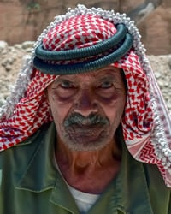  Taken from Joshua Project
Please pray:  That the Lord will raise up intercessors who will continuously pray for the salvation of the Saudi Arabs.  - That the Lord will call people who are willing to endure the harsh living conditions to reach these people with the Gospel.  - That their traditional Muslim culture will soften, creating open doors for the Gospel to be preached among them.  “Exalt the Lord our God and worship at His footstool; He is holy” (Ps 99:5) | SAAWE  PATRYS 083 973 4011

Tunisian Arabs of Tunisia (10,3 mil)  DID YOU KNOW? In the 1st few centuries after Christ, Christianity spread throughout North Africa. A strong church was established in Tunisia. However, when Arab invaders arrived in the 7th century an empty shell of a church was all that existed. Islam spread rapidly & the Christian roots of the people were forgotten. The atmosphere in Tunisia is very secular. Many Tunisians seldom go to a mosque. Women currently have more rights than in other Arab countries & hold government offices & professional careers. Agriculture, phosphate mining & tourism dominate Tunisia’s economy. What was once known as Rome’s “bread basket” still produces delicious fruits, vegetables & grains. Tunisia has a large youth population & a high rate of unemployment. Frustration, lack of opportunity & government corruption produced a revolution in Jan 2011 which spread to Egypt, Libya, Yemen, Syria & others. | 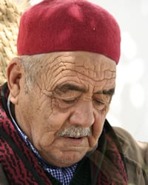  Taken from Joshua Project
Please pray:  - For the completion of the Bible translation in these people’s primary language.  - That whole families will come to faith in Jesus.  - That Tunisian Christians will reach out to their own people.  “For the Lord is good and His love endures forever; His faithfulness continues through all generations.” (Ps 100:5) | SAAWE  PATRYS 083 973 4011

