Moroccan Arabs of Morocco (14.6 million)  DID YOU KNOW? The Moroccan Arabs emerged from the Arabian desert but gradually migrated to North Africa. There are two different groups: the city dwellers and the peasants. Among the rural people, different class groups emerged. The nobility (possible descendants of Muhammad), large land barons, peasants and tenants. The Moroccan Arabs live mainly in the northern and western parts of Morocco, making up less than half the population. Most of them are peasants and their lifestyles center around it. Traditional roles exist, but are influenced by Western culture. In the cities, women never work outside their homes. The Arab community is patriarchal (male dominates) and patrician (male descendants are given preference over female descendants – all bequests come to men). Men wear cotton turbans or kepse/fesse with djellabas (long-sleeved cotton dresses). Their lives center around important ceremonies e.g. Births, Marriages, and Death. Moroccan Arabs marry only within their own group to protect their national identity. Virtually all Moroccan Arabs in this region are Muslims. They adhere to the Qur'an and the five basic "pillars" of Islam. Few Moroccan Arabs are Christians. Most Moroccan Arabs suffer from oppression. | 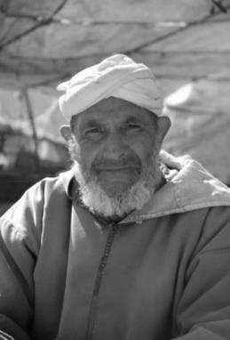  Taken from Joshua Project |  | Gonds of India (13.6 million)  DID YOU KNOW? Their origins are uncertain and are defined as a group of indigenous peoples/tribes of Central and South-Central India with little cultural uniformity between the tribes – although the religion of all Gond people centers in the cult of tribal and village gods, along with ancestral worshipping. The majority speak dialects of Gondi, an unwritten language of the Dravian language family. Nowadays, some speak Hindi, Marathi, or Telugu, depending on the dominant language in their region. The Gonds are mainly farmers and primitive farming methods are still in use. They love hunting and love venison. They live in small feudal villages near riverbanks and forests. The villages consist of about 25-30 huts and are about 2-4 km apart. The villages are regularly moved behind newly debunked land, to cultivate. Sacrifices are offered after harvest collection. The size of the crop determines the size of the sacrifice – a goat, pig or chicken. Girls get married early – between 13 and 15 years old. Young lovers who elope are common practice – a marriage takes place later. Pre-arranged marriages also take place and bigamy is permissible. Marriages between persons of the same town/clan are prohibited. The Gonds believe evil spirits are the cause of sickness/harm and that their sacrifices will keep the spirits away. The village priest sacrifices the sacrificial animal in view of all the inhabitants. After the ceremony, there is a meal attended by the men. The sacrificial animal's skin is stuffed with hay and hung above the town's entrance to keep the evil spirits away and secure the inhabitants. | 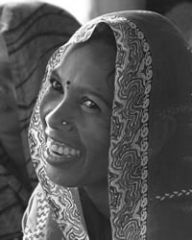  Taken from Joshua Project
Please pray:  - That the Lord will raise up intercessors who, through constant prayers, will break the powers that bind these people.  - Ask God to give Moroccan Arab believers the confidence to share the love of Christ with their friends and families so that the Holy Spirit will do mighty works among them and that many will come to faith.  - Pray that the hearts of Moroccan Arabs will soften toward Christians so that they will be receptive to the Gospel.  "Tell the nations of his power, all the peoples of his mighty deeds." (Ps 96:3) |   SAAWE  PATRYS  083 973 4011
 |  |  | Please pray:  - That the Gonds will be set free from their fear of evil spirits.  - That the Holy Spirit will prepare their hearts to be receptive to the Gospel.  - That many will come to faith in Jesus.  "As waters cover the seabed, so shall the mighty presence of the Lord be known everywhere on the earth." (2:14) | SAAWE  PATRYS  083 973 4011
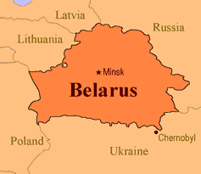  Central Khmer of Cambodia (14 million)  DID YOU KNOW? Khmer civilization once ruled much of Southeast Asia. In the 1200s, the Thais and Vietnamese defeated the Khmers and expelled them to Cambodia, where most live today. Today, they are referred to as Cambodians. They have been mainly Buddhists since the 13th century, but elements of Hinduism and Animism are mixed with Buddhist beliefs. In 1969/70, Cambodia was invaded by the United States and Vietnam during the Vietnam War. In addition, a civil war broke out between the Cambodian government and communist rebels known as the Khmer Rouge. During the reign of the Khmer Rouge, +/- 3 million Khmers died, another 3 million were forced into the countryside as slave laborers – Cambodia was almost totally destroyed. There was famine, the currency was abolished, religion was crushed to death, school education was cancelled, and medical care was banned, people who could read and write were massacred... all just to establish an ideal rural community. Many Khmers fled to Thailand and Laos. Many men died and an unbalanced sex relationship arose – today women still do men's work. The women wear colorful skirts to give color to their unhappy living conditions. Serious evangelism stumbling blocks are the centuries of commitment to their previous belief systems that are not easily overcome. | 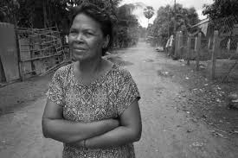  Taken from Joshua Project
 |  |  | Hui of China (13.4 million)  DID YOU KNOW? The Hui is officially a minority group in China. Their high cheekbones and round eyes make them look different from the Han Chinese. In the 13th century, the neighboring country of Mongolia sent some of their people to settle and farm in various places in China while ready for attack. As craftsmen, scholars, officials, and spiritual leaders, the Hui spread throughout China. These Mongols were the ancestors of the Hui Chinese. One of the greatest mass killings in history occurred from 1855-1873, when about 1 million Hui Chinese were decimated in Yunnan. The Hui are forbidden to eat pork, but they violate this rule by calling it mutton. Almost all Hui are Sunni Muslims and many visit Mecca for their annual pilgrimage. Islam first came to China in the 7th century AD. Missionary work began under the Hui in Ningxia in 1885. Later, a large church was built there. A few Hui Muslim leaders converted and were baptized in 1934 by an American missionary known as Hai Chun Sheng. There are currently some growing churches, but most Hui Chinese have yet to hear the Gospel. Recently, a mission team secretly distributed 35,000 gospel tracts and cassette tapes to the Hui. Most Christians in China are Han Chinese. | 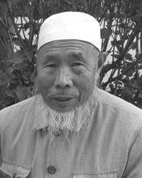  Taken from Joshua Project
Please pray:  - That the Lord will send intercessors & missionary workers to work and bless the Khmers.  - For the steady growth of the church under the Khmers, that they will continue to have a burning heart for God and a passion for the souls of their countrymen.  - That the Khmers will heal from the tragedies caused by the Khmer Rouge, and that this past suffering will prepare them for the love and forgiveness found only in Jesus Christ.  “ ... So that people will praise you forever." (Ps 45:18) | SAAWE  PATRYS  083 973 4011 |  | Please pray:  - That the Lord will set up prayer teams that will continually pray for the salvation of the Hui.  - That the Hui will be drawn more and more to the person of Isa (Jesus) when they read the Quran and will long to learn more about Isa.  - That the Han Christians would have a desire to reach out to the Hui Chinese as well.  "I came that they might have life... " (John 10:10) | SAAWE  PATRYS  083 973 4011

