AFGHANISTAN – President: Mullah Baradar | 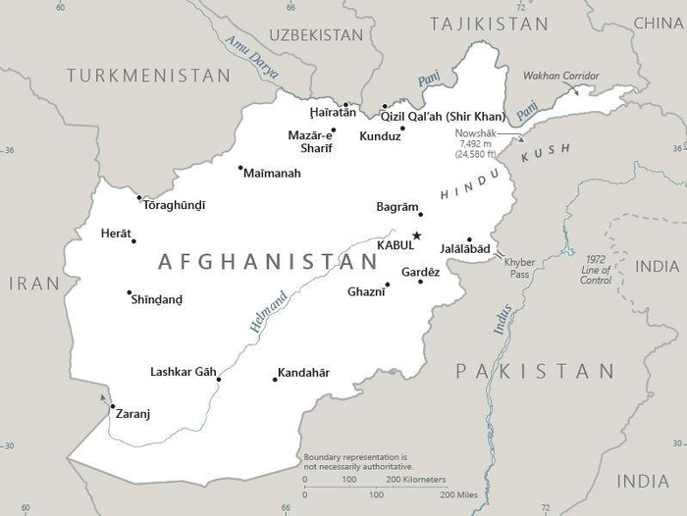  Taken from CIA World Fact Book
Population: 40,8 mil
Religion: Muslims 99%; Christians 0,05%; Indigenous 3,8%
Official languages: Pashtu & Dari; Literacy 38%
Conflict has dominated the long history of Afghanistan, due to the strategic position of the country. In the 1990s the fundamentalist Taliban came to the fore & implemented strict violent Sharia law. During this time the Afghan church shrunk so much that it was almost erased & Christians went underground. During Hamid Karzai’s government there were attempts to improve the economy, infrastructure, health care & education systems. With the withdrawal of foreign troops the Taliban declared a ‘victory’ over the “foreign invaders”. Believers are being targeted by the Taliban.
Please pray :  - For the safety of the foreign workers & Christians who are still in the country.  - For women’s rights to be improved.  - For healing of those who have had to witness the violence, who have lost loved ones & who are experiencing deep pain.  “In that day the Root of Jesse shall stand as a banner for the peoples; the nations will rally to Him, and his place of rest will be glorious.” (Is 11:10) |   SAAWE  PATRYS 083 973 4011

CHINA – President: Xi Jingping | 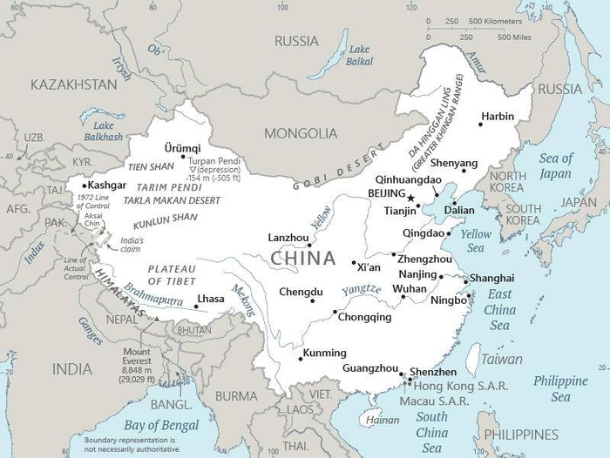  Taken from CIA World Fact Book
Population: 1,45 billion
Religion: Atheists 74,9%; Buddhists 18,2%; Christians 5,1%;
Muslims 1,8%
Official language: Mandarin; Literacy 96,4%
China, the world’s largest nation, has a history & culture that dates back 4000 years. “The People’s Rep of China” was founded in 1949 & based on Communist doctrine under Mao Zedong. Mao’s government tried to get rid of everything that was anti-communistic – including Christianity. In spite of the terrible opposition & persecution the Chinese Church has grown incredibly over the past 4 decades. The Church is now moving from persecution to relative freedom & from poverty to growing wealth. This new position can bring a turning point for this religion as it exchanges the ‘cross’ for comfort. In spite of all the challenges, God is busy positioning China to being the biggest sending nation of the world.
Please pray :  - That the Church in China will not be confused by the different theologies that come from the West.  - Praise the Lord for the continued growth of the local church.  - That the church will find new ways of reaching the children, being prevented by law, of hearing the Gospel.  “Declare his glory among the nations, his marvelous deeds among all peoples.” (Ps 96:3) | SAAWE  PATRYS 083 973 4011

INDIA – President: Ram Nath Kovind | 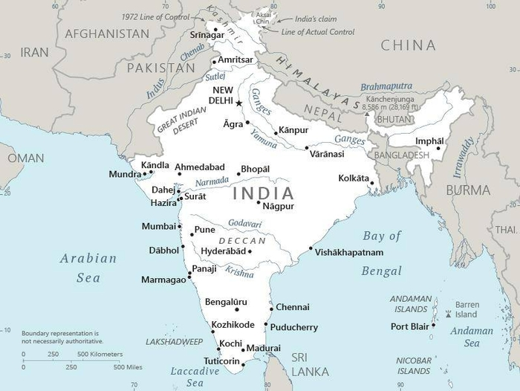  Taken from CIA World Fact Book
Population: 1,4 billion
Religion: Hindus 80,5%; Muslims 14,2%; Christians 2,3%
Official language: Hindi & English
Literacy 71,2%
India is the world’s largest democracy & 2nd largest nation. It is also one of the world’s oldest civilizations & the most ethnic diverse country. India has the most unreached peoples worldwide – 2300 peoples (87% of the population). The constitution makes provision for religious freedom, but anti-conversion laws apply in six states in India. This is to counter the large number of Dalits (untouchables) who are turning to the Christendom. The Prime Minister, Mr Modi’s election campaign included Hindutva. This is a form of rightwing ideology that calls people to come in line with strict Hinduism. His promises of social & economic upliftment of the poor might be an answer to prayer.
Please pray :  - That thousands of unreached peoples will be reached by local Indian missionaries.  - That the nationalist movement that wants to enforce Hinduism will fail & that the Church will stand out as the answer for those who are seeking the truth.  - For the many Indians caught up in slavery, child labour, alcoholism, drug abuse & human trafficking.  “Many nations will be joined with the Lord in that day and will become my people.”(Zech 2:11) | SAAWE  PATRYS 083 973 4011

IRAN – President: Ibrahim Raisi | 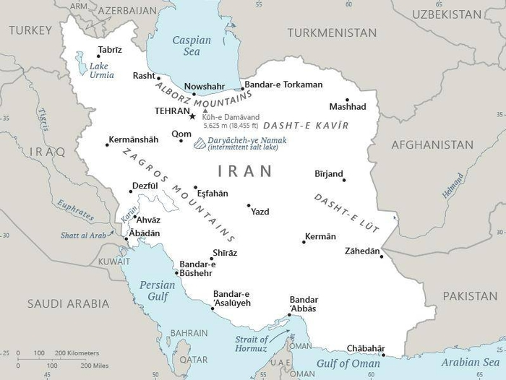  Taken from CIA World Fact Book
Population: 86 mil
Religion:
Muslims 99,4%; Christians 1,9% - Evangelical 0,52%
Official language: Persian
Literacy 86,8%
Iran’s history dates back to 550 BC & was known as Persia until 1935. Today Iran is an important role player in the Muslim world & worldwide. It has 9% of the world’s oil reserves & the 2nd most natural gas. Iran’s development of nuclear power facilities was the focus point of its most recent history & Iran’s leaders have openly declared that they want to destroy Israel & America. Former Pres Ahmadinejad declared that he was preparing the way for the 12th Imam., a kind of messiah for the Shia Muslims. Under very strict Islamist law almost all Christian activity is unlawful & many church leaders have been imprisoned & charged as being a threat to the state.
Please pray:  - That God will prevent Iran from developing nuclear weapons.  - That the leadership of Iran will meet Jesus & will move away from the apocalyptic plans to destroy Israel & the West.  - That Jesus will be revealed to those who are expecting the 12th Imam.  “ ..ten men from all languages … (will) say ’Let us go with you, because we have heard that God is with you.’”(Zech 8:23) | SAAWE  PATRYS 083 973 4011

