TOGO – President: Faure Gnassingbé | 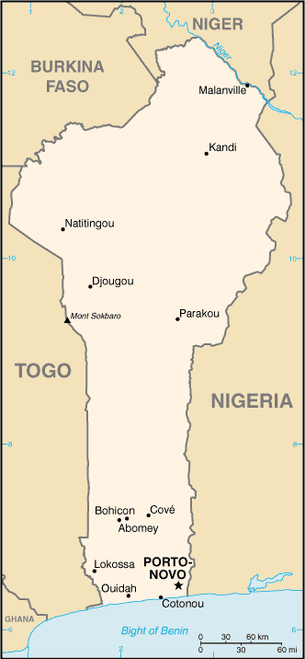  Taken from CIA World Fact Book
Population: 8,6 mij
Religion:
Indigenous: 51%; Christians 29% - Evangelicals 9%
Muslim 20%
Official language: French; Literacy: 53%
DID YOU KNOW? It was a German colony from 1884 to 1914 & after that a French colony until independence in 1960. Eyadema Gnassingbé ruled from 1967 to 2005 & was the longest ruling dictator. From the 16th to the 18th century the coastal region was a major treading centre for slave trading earning Togo & the surrounding region the name “The slave coast”. The economy consists of sub-sistance farming with coffee, cocoa & cotton being the main produce. The country was non-Christian from 1960 to 1990, but since then there has been religious freedom.
Please pray:  - That the powers of darkness will be broken through prayer – idolatry, secret societies & Islam.  - For Bible translations – the completion of the whole Bible in local languages.  - For ministries working in schools, because many schools have no Christian witness.  - For an end to illegal children trafficking – 300 000.  "Tell the nations of his power, all the peoples of his mighty deeds." (Ps 96:3) |   SAAWE  PATRYS 083 973 4011

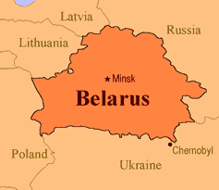  MOZAMBIQUE – President: Adriano Maleiane | 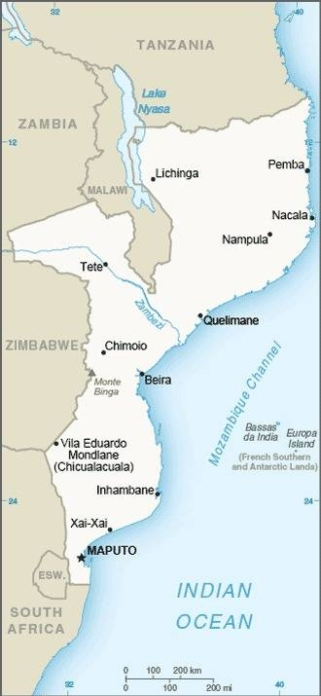  Taken from CIA World Fact Book
Population: 32,85 mil
Religion: Christians 46,5% - Evangelicals 11%
Ethnic 32%; Muslims 18,6%; Non-Religious 2,8%
Official Language: Portuguese
Literacy 46,5%
DID YOU KNOW? It was a Portuguese colony for 470 yrs. Received its independence in 1975, but a civil war broke out that lasted from 1977 to 1992. It is one of the world’s poorest countries – 80% are subsistence farmers. The country has fertile ground & great mineral riches which are unutilized. More than 1 mil died between 1990 & 2010 due to war, hunger, floods Aids & malaria. The Christian religion has tripled since 1985.
Please pray:  - For the salvation of the unreached Animistic peoples of the Zambezi valley & the Muslims.  - For youth & children’s work, emergency relief, medical work & business development.  - Pray for Bible translation projects in 17 languages.  "Tell the nations of his power, all the peoples of his mighty deeds." (Ps 96:3) | SAAWE  PATRYS 083 973 4011

ERITREA – President: Isaias Afwerki | 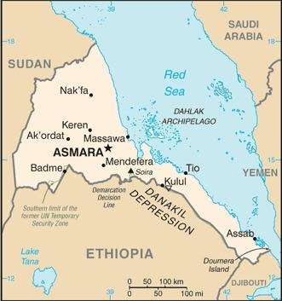  Taken from CIA World Fact Book
Population: 3,6 mil
Religion:
Muslims 48%
Christians 46% - Evangelical 1,7%
Non-religeous 4%
Official language: Tigrinya, Tigre, Arabic & English
Literacy 56,7%
Eritrea was an Italian colony between 1890 & 1941. When Eritrea became a province of Ethiopia in 1963, a gorilla war for independence followed. It ended in 1991. Development was hampered by a border war with Ethiopia between 1998 & 2000. The president has placed so many restrictions on the UN & foreign NGOs that they have all withdrawn & have totally isolated the country. There is cruel persecution & the country is no 9 on the WWL of persecution.
Please pray :  - For the salvation of the least evangelized peoples: Tigra, Tigraway, Afar, Saho & Beja.  - For political & religious freedom.  - For Economic development & reconstruction of the country.  “Many nations will be joined with the Lord in that day and will become my people.”(Zech 2:11) | SAAWE  PATRYS 083 973 4011

ETHIOPIA – President: Sahle-Work Zewde | 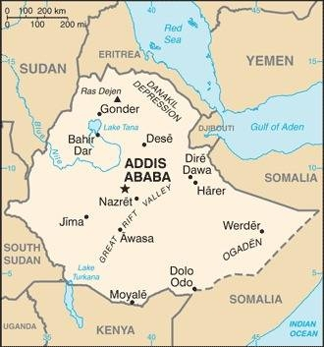  Taken from CIA World Fact Book
Population: 120,2 mil
Religion:
Christians 60% - Evangelicals 19,6%; Orthodox 39,5%
Muslims 34,1%; Traditional 3,7%
Official language: Ahmaric
Literacy 35,9%

It is one of the oldest nations. It was an Amhara dominated kingdom from 1896 to 1974 & a Marxist government from 1991, with persecution of especially the evangelical Christians. Coffee is their main export product. 78% of the population struggle to survive on less than US$2 per day, due to the wars, droughts & famine. Tribal groups are caught up in darkness by evil powers & Muslims are making a huge attempt to promote Islam.
Please pray:  - That Muslims, Animists & Orthodox peoples will turn to Jesus.  - For the 1,5 mil Aids orphans & for more home assistant workers.  - For better harvests, wise economic government & that foreign help will be utilized correctly.  “ ..ten men from all languages … (will) say ’Let us go with you, because we have heard that God is with you.’”(Zech 8:23) | SAAWE  PATRYS 083 973 4011

