Kapu of India (13,8 mil)  (30th Largest Unreached People Group of the world)  DID YOU KNOW? The Telugu word Kapu means protector. They are also referred to by their caste title Naidu which means leader. They were primarily a military/agrarian community who took up military service & participated in cultivations during peace time. Kapus who engaged in trade were referred to as Balija. Modern day Kapus have banded together to fight for their political rights in the caste system. They have also organized agricultural unions to protect their way of life. A significant number of Kapus have today diversified into industry, arts & academia. However, substantial segments are still farmers. Kapus are primarily Hindu but live among many Muslims. In 1710 a Roman Catholic missionary established one of the first mission stations in the region & nearly 300 people came to faith. Today, 30 major denominations are represented in the state. The church has struggled long & hard against nominalism. | 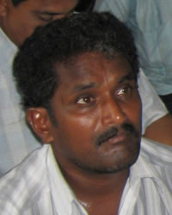  Taken from Joshua Project
Please pray :  - That the Holy Spirit will prepare their hearts for the Gospel. Only 0,02% are Christian.  - That the Lord will call more missionaries to work among the Kapu.  - That nominal Christians will rededicate themselves to Christ & share their faith with their own people & other tribes.  “Proclaim his glory to the nations, his mighty deeds to all peoples”. (Ps 96:3) |   SAAWE  Patrys Tel 083 973 4011

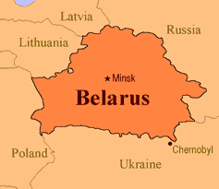  Azeris of Iran (16,9 mil)  (31st Largest Unreached People Group in the world)  DID YOU KNOW? In Iran the term “Azeri” is used formally for these people; however informally, Azeris & other Turkic speaking Iranian populations are referred to as “Tork” (Turk). There are more Azeris in Iran than in Azerbaijan itself. Despite some friction in the past, Azeris in Iran came to be well represented at all levels of political, military & intellectual hierarchies, as well as the religious hierarchy. The living conditions of Azeris in Iran closely resemble that of Persians. Iran & Azerbaijan do not offer easy access to Christian workers. Despite living on two sides of an international boarder, the Azeris form a single ethnic group. However, northerners & southerners differ due to nearly 2 centuries of separate social evolution, but their language unifies them. They are Shi’ite Muslim. Only 1,5% are Christian. | 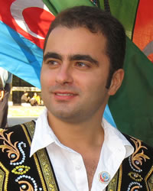  Taken from Joshua Project
Please pray :  - That they will increasingly be drawn to Isa (Jesus) as He is referred to in the Koran. Pray for growing desire to find out more about this Man.  - Pray that Iranian believers will carry the good news of Jesus to the Azeris.  - That Azeris won’t be overlooked by the movement of the Spirit in Iran.  “Therefore the nations will praise You for ever…..” (Ps 45:17) | SAAWE  Patrys Tel 083 973 4011

Kumhar of India (18,6 mil)  (32nd Largest Unreached People Group in the world)  DID YOU KNOW? According to old Indian mythology the Kumhar are offspring of Lord Brahma also known as Prajapati. Therefore they are also known as Prajapati. Ancient Indian culture cannot be deciphered without acknowledging Kumhar. They can be found throughout India by different surnames eg Verma, Kumhar etc. They claim to be the first inventors of the wheel/cycle. They use it to make earthen utensils. Historically their main way of earning income has been earthen pots & agriculture & they still do this today. Some even export their items around the world. They are very honest people & make their livelihood by hard work. They are generally Hindu & pray to the Lord Shiva & Goddess Mother (Mata). They believe in god, are highly spiritual, lovable, honest & hardworking. | 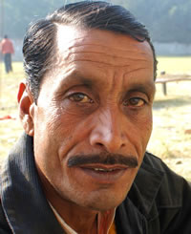  Taken from Joshua Project
Please pray :  - That the Kumhar will be set free from the bondage of Lord Brahma or Prajapati & realize that the Lord Jesus Christ is offering them freedom & the right to be a special people.  - That the Holy Spirit will prepare their hearts to be receptive to the Gospel. Only 0,01% are Christian.  “Your faithfulness continues through all generations;” (Ps 119:90) | SAAWE  Patrys Tel 083 973 4011

Bhil of India (14,5 mil)  (33rd Largest Unreached People Group in the world)  DID YOU KNOW? There are 2 divisions of Bhil: the Central or “pure” Bhil, & the Eastern or part-Rajput Bhil. The Central Bhil live in the mountain regions of India. The Bhil primarily work as peasant farmers, field labourers & village watchmen. They are experts in handling bows & arrows. In fact, the name “Bhil” was derived from the word billee, which means “bow”. The men usually carry their bows & arrows with them. The city boys are distinctive from other Hindus because they tie rags around their heads, wear earrings, & carry swords or guns. The Central Bhil are usually shy & love their independence. Festivals, dance, drama & music are a large part of their culture. They usually marry within their own classes. If they do marry someone of another class, the person of the lower class must convert to the higher, leaving behind all family ties. Almost all Central Bhil practice ethnic religions that have been highly influenced by Hinduism. Ancestral worship is also practiced. Shamans are called upon to offer sacrifices to the many gods & mud idols. | 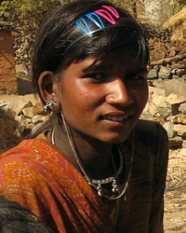  Taken from Joshua Project
Please pray:  - That the Lord will raise up prayer teams who will faithfully stand in the gap for the Bhil.  - For the effectiveness of the Jesus Film among them.  - That their hearts will be receptive to the Gospel. Only 0,77% are Christian.  “The heavens proclaim his righteousness, and all the nations see his glory.” (Ps 97:6) | SAAWE  Patrys Tel 083 973 4011

