Teli of India (22,1 mil)  (26th Largest Unreached People Group of the world)  DID YOU KNOW? Traditionally they were oil-pressers. They derive their name from the Hindi word ‘tel’ which means oil. However many of today’s mills are owned by other communities. Their mother tongue varies from state to state. They perceive their cast position as Vaisya - the third highest class of traders in the Hindu caste system. Some place themselves in the Kshatriya or second highest class of warriors. They have taken to trade & agriculture as their occupation. Those who are landless work as labourers on farms, industrial sites or as hand-cart pullers, load carriers, sharecroppers & metal workers. The Teli favour formal education for both boys & girls, but literacy levels remain low. Monogamous & adult marriages are common. The Teli live in nuclear families. Apart from doing all the domestic chores, the women contribute to the family income. They worship all the Hindu gods & goddesses as well as their ancestors & have a strong belief in evil spirits. | 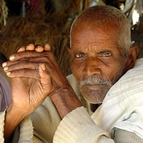  Taken from Joshua Project
Please pray :  - That they will be set free from Hinduism, ancestral worship & the belief in evil spirits.  - For a mighty work of the Holy Spirit among them & that many will come to faith in Jesus Christ. Only 0,02% are Christian.  “Proclaim his glory to the nations, his mighty deeds to all peoples”. (Ps 96:3) |   SAAWE  Patrys Tel 083 973 4011

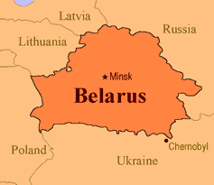  IraqiArabs of Iraq (16,8 mil)  (27th Largest Unreached People Group in the world)  DID YOU KNOW? The Iraqi Arabs descended from a people group cluster called the Levant Arabs. Although the Iraqi Arabs have settled in towns or villages, they have held on to their tribal affiliations. Their fortress like villages can be easily defended. Individual flat roofed homes called “town houses” are elaborately decorated. The rooms usually have carpeting & when entering the house, one must leave his shoes at the door. Social life is extremely important to them. They like to share a daily coffee time. To preserve their people, they are only allowed to marry those inside their own group. Islam has greatly influenced the lives of the Iraqi Arabs. In 1968 Islam was established as the state religion of Iraq. Only 0,5% are Christian. | 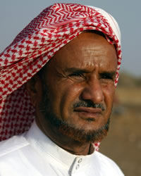  Taken from Joshua Project
Please pray :  - For peace & stability in Iraq & for the rebuilding of the country.  - That the Lord will reveal Himself to the Iraqi Arabs through dreams & visions.  - That the Holy Spirit will awaken a hunger in the hearts of the Iraqi Arabs for a true Messiah.  “Therefore the nations will praise You for ever…..” (Ps 45:17) | SAAWE  Patrys Tel 083 973 4011

Kunbi of India (15,5 mil)  (28th Largest Unreached People Group in the world)  DID YOU KNOW? Alternate names for the Kunbi are Reddi & Desai. They are a prominent community from Gujarat. The majority of the Kunbi communities are non-vegetarian. The Kunbi community has social divisions such as clans, lineage, subcastes & sects. These social divisions regulate marital alliances. Cross-cousin marriages are allowed, but widows are not allowed to remarry. They have primarily been landlords & landholders. Their traditional occupation is settled cultivation, animal husbandry & labour. Both men & women smoke a homemade cheroot which causes a high incidence of mouth & throat cancer. They are Hindus & worship many deities. Only 0,05% are Christian. | 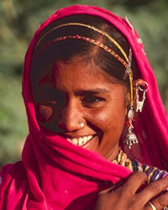  Taken from Joshua Project
Please pray :  - That they will be set free from the smoking habit ruining their health.  - That the Holy Spirit will prepare their hearts to be receptive to the Gospel.  - That many of them will come to faith in Jesus and, because they are a prominent community, that they will influence many other communities & casts.  “Your faithfulness continues through all generations;” (Ps 119:90) | SAAWE  Patrys Tel 083 973 4011

Muslim Rajputs of Pakistan (15,6 mil)  (29th Largest Unreached People Group in the world)  DID YOU KNOW? The name Rajputs is derived from the Sanskrit word rajputra, meaning ‘son of a ruler’. They constitute a class of nobility. The Rajputs rose to political importance in the ninth & tenth centuries. In India the Rajputs have been a ruling class which owned vast tracts of land. The Rajputs converted to Islam due to many reasons including physical or economic duress, pragmatism & patronage. Despite differences in faith, there have been instances where both Muslim & Hindu Rajputs have united together against threats from external ethnic groups. Until recently marriages between Muslim & Hindu Rajputs have taken place. | 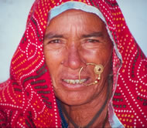  Taken from Joshua Project
Please pray:  - That the Lord will raise up prayer teams to continually pray for the salvation of the Rajputs of Pakistan.  - That the Rajput will increasingly be drawn to the person of Isa (Jesus) as they read the Koran, & will hunger to find out more about this Man.  - That the Rajputs will humble themselves before Jesus Christ even though they are a proud people.  “The heavens proclaim his righteousness, and all the nations see his glory.” (Ps 97:6) | SAAWE  Tel (011) 396-1225

