ALGERIA – Colonised by France (1830-1962) | 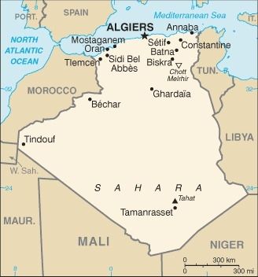  Taken from CIA World Fact Book
Population: 45,3 mil
Religion: Muslims 97%; Christians 3%;
Official language: Arabic; Literacy 81%
DID YOU KNOW? There was a bloody war for independence between 1954 & 1962 killing between 500 000 & 1,5 mil Algerians. Christianity became rooted in Algeria by the 2nd century AD. The strong Christian presence gave way to Islam after the Arab invasion in the 8th century. Christianity came back in the late 15th century when Spain conquered the coastal areas; however, Spanish rule lasted only briefly when the Ottomans conquered the country in 1525. After France gained control of Algeria Catholic missionaries came with French settlers & established churches. The growth of the Algerian Church over the past decade is an answer to prayer.
Please pray :  - Pray for deep healing repentance, restitution & restoration from the wounds of slavery & colonialism.  - Thank God that the message of the Gospel is spreading in Algeria.  - For God’s favour & protection over the believers in Algeria.  “Blessed are those whose help is the God of Jacob, whose hope is in the Lord their God “.(Ps146:5) |   SAAWE  Patrys 083 973 4011

BURKINA FASO – Colonised by France (1896-1960) | 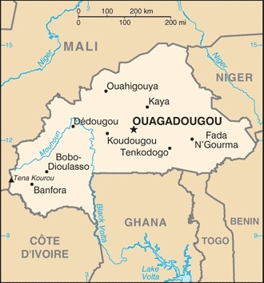  Taken from CIA World Fact Book
Population: 22 mil
Religion: Muslims 50%; Christians 20%;
Official language: French; Literacy 39,3%
DID YOU KNOW? In the 1890s, during the European scramble for Africa, French Upper Volta was invaded by France & colonized after a war between 1895 & 1904. In 1960 it gained independence & was renamed in 1984 as Burkina Faso meaning “Land of honest men”. Christianity came with the French Colonists in 1896. Burkina has never suffered civil war or religious conflict. Muslims, Christians & animists are neighbours, live together & inter-marry. Some people say that the population is 50% Muslim, 20% Christian, & 100% animist. Idols, charms & secret societies have more control in Burkina Faso than in most West African countries. The occult shows its power even in some churches. Christianity increased steadily across recent decades & continues to increase.
Please pray :  - For deep healing, repentance, restitution & restoration from the wounds of slavery & colonialism.  - For the new government that they will reflect the country’s name “Land of honest men”.  - For the occultic powers to be broken.  “It is He… who brings princes to nothing, and makes the rulers of the earth as emptiness“ (Is 40:22-23) | SAAWE  Tel (011) 396-1225

CHAD – Colonised by France (1900-1958) | 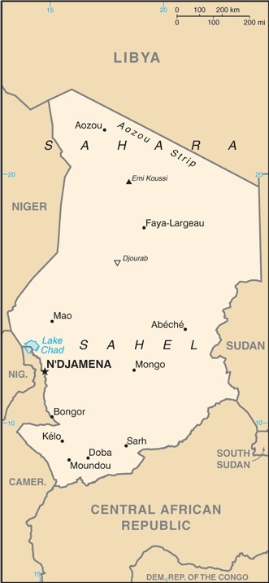  Taken from CIA World Fact Book
Population: 17,3 mil
Religion: Muslims 58,8%; Christians 38,5%;
Official language: Arabic & French; Literacy 22,3%
DID YOU KNOW? THE French exploited the colony & recruited people for forced labour & men as combatants. Chad is a textbook case of violence & a military state. Armed violence has become an occupation for many men. From 1500-1900 Arab slave raids were widespread & Chad became an important source of slaves. The Protestants came to the south of Chad in the 1920s. French officials advised against the spread of the Christian Faith. Chad is one of the few Muslim nations that welcome missionaries. Violence near Darfur, at hands of other Muslims, caused some to question Islam & left them open to the love & witness of Christians. Chad has more unreached peoples within their borders than any other African country. It is one of the poorest countries due to war, famine, epidemics, droughts & floods.
Please pray :  - For deep healing, repentance, restitution & restoration from the wounds of slavery & colonialism.  - That modern-day slavery & trafficking will end.  - That Christians will reach out to Muslims around them.  - That the Lord will reveal Himself to the unreached peoples.  "You rule… In Your hands are power & might, so that none is able to withstand You.” (2 Chron 20:6)) | SAAWE  Tel (011) 396-1225

DJIBOUTI – Colonised by France (1862-1977) | 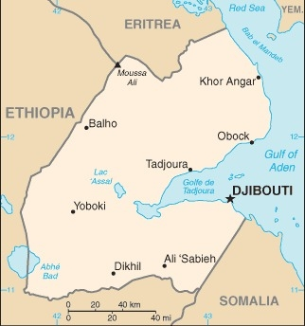  Taken from CIA World Fact Book
Population: 1 mil
Religion: Sunni Muslims 94%
Christians 6% (Mainly foreign-born residents)
Official language: French & Arabic; Literacy 42,2%
It is Africa’s 3rd smallest state & a haven of calm in a stormy region. It is an important trade centre for both the Arabian Peninsula & Eastern Africa. Djibouti was once part of the Eastern slave trade route & small numbers of enslaved Africans were sold from the east coast to other areas including the Persian Gulf & India until slavery was abolished in 1889. The country received its independence in 1977 & was named after its capital. Civil war destabilized the country from 1991 – 1994. Djibouti occupies a strategic geographic location between the Red Sea & the Gulf of Aden. Its ports handle 95% of Ethiopia’s trade as well as for other countries. Christianity came with the Catholic church in 1883, the Reformed church of France in 1940 & the Ethiopian Orthodox Tewahedo church also has members there. Proselytizing of Muslims is prohibited.
Please pray:  - For deep healing, repentance, restitution & restoration from the wounds of slavery & colonialism.  - That God will reveal Himself to the unreached Afar people.  - Ask God to bless Djibouti & pray as the Holy Spirit leads you.  - “Salvation belongs to our God, …...” (Rev 7:10) | SAAWE  Tel (011) 396-1225

