MONGOLIA -Pres: Ukhnaagiin Khϋrelsϋkh | 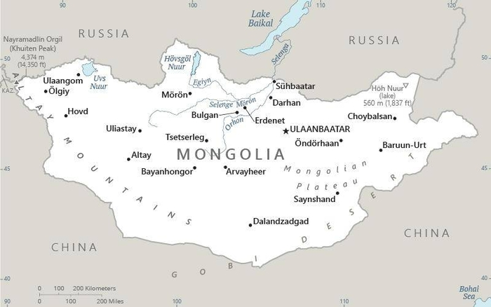  Taken from CIA World Fact Book
Population: 3,3 mil
Religion: Buddhists 51.7%; Non Rel 40.6%; Muslims 3.2%; Christians 3%; Official language: Mongolian; Literacy 99,2%
DID YOU KNOW? Buddhism is the “official” religion of Mongolia & practiced by nearly 60% of the people. The close connection with Tibetan Buddhism goes back more than 500 years. The communist invasion of 1939 nearly eradicated Buddhism, destroying temples & killing monks. There was only one monastery in use with just 100 monks (lamas) in 1990. The majority of Mongolians live across the border in China. Alcoholism is a persistent problem, as is their status as an ethnic minority. Abuse within families & a high divorce rate add to their sense of isolation. Contemporary religious practice involves worship of idols of Buddha. There is the belief that the more expensive the statue you can afford the better the protection, favour & good luck you will enjoy. Another characteristic of Mongolian worship is animism. The connection between man & nature is fundamental; trees, mountains & animals are considered sacred. (Taken from Buddhist World Prayer Guide)
Please pray :  - That the Christian community will be empowered to share their faith.  - For release from alcoholism & the restoration of families.  - For liberation from shamanistic & occult practices.  Don't go after false gods; they cannot help you or save you, for they are not real. (1Sam 12:21) |   SAAWE  Patrys 083 973 4011

JAPAN – Prime Min: Fumio Kishida | 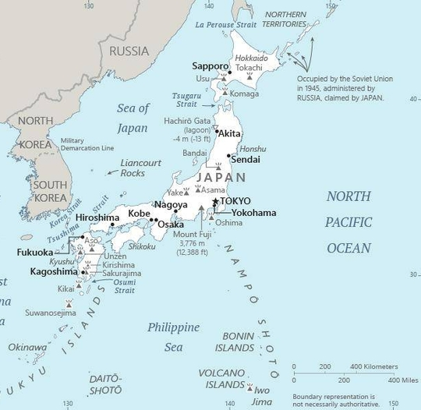  Taken from CIA World Fact Book
Population: 125,7 mil
Religion: Shinto 69%; Buddhists 66,7%; Christians 1,5%;
Official language: Japanese; Literacy 99%
DID YOU KNOW? While Japan has traditionally been classified as a Buddhist nation, the reality is that it has become increasingly post-religious. Some practices are continued: visiting & maintaining ancestral graves, wearing of good luck amulets & registering birth at the local Buddhist temple. The majority of Japanese citizens, particularly those under age 50, do not identify as followers of any religion. In this highly competitive society it is often considered “weak’ to be religious. One result of this ennui is a high suicide rate, especially among young people. More than 30 000 take their own lives each year. Many will pick aspects of Shintoism, Buddhism, & the occult or animism & develop a “personal faith” without concern for contradictions. Japan has a rapidly aging population. (Taken from Buddhist World Prayer Guide)
Please pray :  - For more Christian nursing homes, hospices & Christian health workers from other countries to fill positions.  - That God will remove the spirit of delusion that leads to worship of the occult  - For a new generation of Christian leaders to be developed in Japan.  …. From every part of the world they will turn to him; (Ps 22:27) | SAAWE  Patrys 083 973 4011

VIETNAM – Prime Min: Pham Minh Chinh | 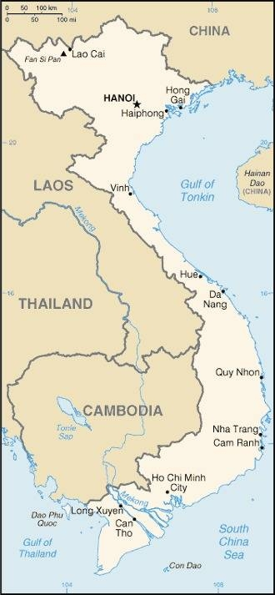  Taken from CIA World Fact Book
Population: 98,2 mil
Religion: Folk Religions 45%; Buddhists 16,4%; Christians 8,2%;
Official language: Vietnamese; Literacy 95.7%
DID YOU KNOW? Vietnam is one of the few communist nations left in the world. Although the economy has integrated capitalistic principles to fuel its growth, the majority of the population still suffer with continued oppression & increasing social problems. The Vietnamese still worship ancestors as well as a spiritual mixture of Buddhism, Taoism & Confucianism. As the country has become more prosperous there is a growing middle class that embraces materialism. A growing, witnessing Church is emerging from years of persecution. In both Catholic & Protestant Churches there is a growing missionary vision. There are 119 different people groups in Vietnam & the churches are ministering to many of these. The Vietnamese diaspora is seeing many people coming to faith & bringing the Gospel back to Vietnam. Another positive is a discipleship movement among women. (Taken from Buddhist World Prayer Guide)
Please pray :  - For the continued maturing of the Vietnamese church so that Jesus might be known throughout the nation.  - That Jesus followers will communicate the Good News in a way that Vietnamese Buddhists can fully understand & embrace.  - That the people will abandon ancestor worship & find the truth in the living God.  …..he has put eternity into man's heart,…. (Ecc 3:11) | SAAWE  Patrys 083 973 4011

CAMBODIA – Prime Minister: Hun Sen | 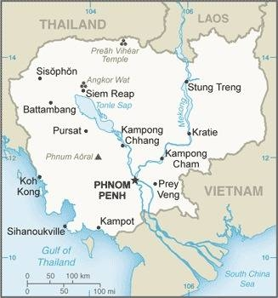  Taken from CIA World Fact Book
Population: 16,9 mil
Religion: Buddhists 93%; Christians 3%; Muslims 3%
Official language: Khmer; Literacy 80.5%
DID YOU KNOW? Therevada Buddhism has been the national religion of Cambodia since the 15th Century. Every village has a temple, some just a drab structure, that is supported & maintained by everyone in the village, even the poorest. Temples in the city are larger, ornate & have impressive idols of Buddha. But the worship is the same. Despite the devotion Cambodians remain poor & suffer much due to the ills of the past under the Khmer Rouge. Opportunities for education is very limited; Crime is rampant, human trafficking, orphanages for profit & the sex trade are widespread. The word for happiness & peace in the Khmer language is “sok”. Cambodians strive to achieve “sok” by placating spirits & wearing amulets. (Taken from Buddhist World Prayer Guide)
Please pray:  - That Christians will lead the way in healing the wounds still remaining from the Khmer Rouge genocide.  - That Cambodian Buddhists will come to know that Jesus is the Prince of Peace & the only way to achieve “sok”.  - For the deliverance & salvation of the children in bon-dage to forced labor, human trafficking & the sex trade.  I revealed myself to those who did not ask for me: I was found by those who did not seek me….. (Is 65:1) | SAAWE  Patrys 083 973 4011

