CENTRAL AFRICAN REPUBLIC – Colonised by France (1894 -1960) | 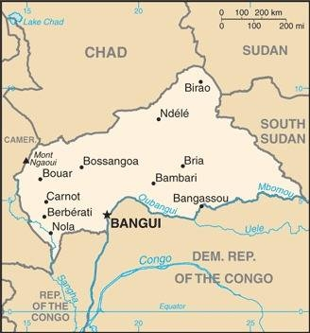  Taken from CIA World Fact Book
Population: 4.9 mil
Religion: Christians 89%; Muslims 9%;
Official language: French; Literacy 37.4%
DID YOU KNOW? The Region was the site of much slave trading activity in the 19th cent & was heavily economically exploited in the early 20th cent. The poverty of CAR today is attributed to the raids & kidnappings carried out by rival tribes in league with European slavers in the centuries before. The early tribes were so traumatized that they found it safer to remain in small groups rather than develop the larger communities vulnerable to raiders. With its natural wealth the CAR should be thriving & ranked as one of the world’s richest nations, but instead it suffers from abject poverty & competition between rival warlord. The Catholic Church arrived in 1894 & the Protestants in 1920. In 2012 Christians started chasing Muslims away from their country. As Christianity is often mixed with animistic beliefs, there is limited grasp of Biblical truth
Please pray :  - For healing of the wounds caused by slavery & colonialism.  - For the different tribes to repent to one another for all the war, fighting, bloodshed & injustice of the past.  - That Muslim refugees will have encounters with Jesus & turn to Him.  He defends widows and orphans. He loves even the strangers living among us. (Deut 10:18 ERV) |   SAAWE  Patrys 083 973 4011

COMOROS – Colonised by France (1841-1975) | 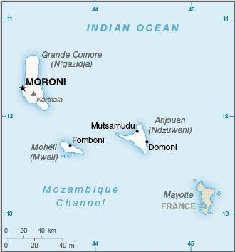  Taken from CIA World Fact Book
Population: 906 000
Religion: Muslims 98%: Christians 2%;
Official language: Arabic & French; Literacy 58,8%%
DID YOU KNOW? The Arabs first used these islands as a trading outpost between Africa & other countries along the Indian Ocean & developed a thriving economy based on the sale of spices & slaves. In 1841 the islands were absorbed into the French empire. The Comoros economy was dependent on the export of tropical crops. Most profits were diverted to France. Development was further limited by the colonial government’s practice of concentrating public services on Madagascar, causing the migration of large numbers of Comorians to Madagascar. Independence came in 1974 for 3 of the Comoros Islands, while Mayotte voted to stay part of France. Since independence the Comoros have experience political instability. 23,5% of the people live in extreme poverty. In the 1930s the Capuchins established a Catholic Mission.
Please pray :  - For healing of the wounds caused by slavery & colonialism.  - For the Gospel to infiltrate every island, regardless of restrictions & mounting persecution.  - That God will reveal himself to the unreached people of the Comoros.  …. From every part of the world they will turn to him; (Ps 22:27) | SAAWE  Patrys 083 973 4011

REPUBLIC OF CONGO – Colonised (1880- 1960) | 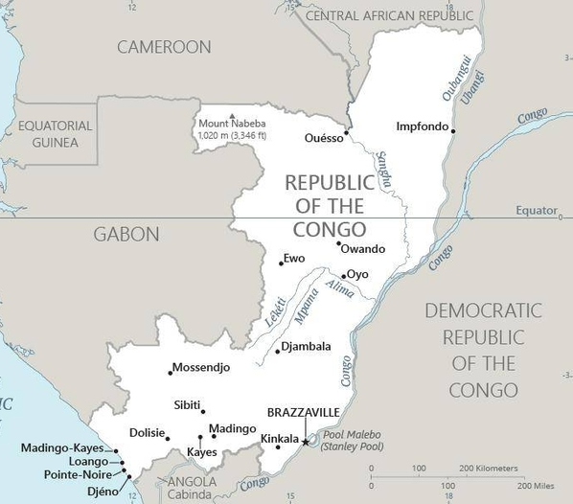  Taken from CIA World Fact Book
Population: 5,7 mil
Religion: Christians 88,5%; Muslim 1,6%; Other 8.1; Non Rel 11,3%; Official language: French; Literacy 77%
DID YOU KNOW? After seizing control in 1880, there were many revolts against the French due to French policy of maltreating the local population through harsh forced labour. It became independent in 1960. 25 yrs of experimentation with Marxism was abandoned in 1990 & a democratically elected government was installed after a bloody civil war (1997-2001). This country is one of Africa’s oil rich states but is still very poor. Slavery was commonly practiced by most Congolese societies long before the arrival of Europeans. The vast majority of US Americans are descendants of the 400 000 black slaves brought to the New World prior to 1860. Portuguese explorers , French & Swedish missionaries brought Christianity to Congo. The majority of Congolese identify as Christian, but hold a superficial belief in basic Christian ideas combined with animistic rituals & idols. False beliefs & practices are rampant within the Church.
Please pray :  - For healing of the wounds caused by slavery & colonialism.  - The Congo has past troubles, but future potential – pray for righteous leaders.  - For a pure Gospel, devoid of syncretism & heresy, to be proclaimed.  …..he has put eternity into man's heart,…. (Ecc 3:11) | SAAWE  Patrys 083 973 4011

CôTE D’IVOIRE– Colonised by France (1842-1960) | 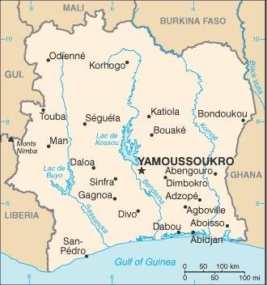  Taken from CIA World Fact Book
Population: 27,6 mil
Religion: Muslims 42,9%; Christians 33,9%; Animists 3,6%
Official language: French; Literacy 89,9%
DID YOU KNOW? Côte D’Ivoire profited a lot from the Ivory trade in the 17th century – hence the name, Ivory Coast. Like other nations in West Africa, Côte D’Ivoire was affected by slave trade, but its lack of protected harbours along the coastline barred the Europeans from developing permanent trade stations. Slave trade was abolished in 1905. European Chocolate companies brought cocoa to West Africa to grow it where labour was cheap or free. Coffee & cocoa production made the country an economic powerhouse in the 1960s & 1970s. Most cocoa farmers earn very little per day, so they use child labour, called “chocolate slaves”, to keep their prices competitive. Approximately 2,1 mil children in the Ivory Coast & Ghana work on cocoa farms – some are trafficked & some are sold by relatives. Missionaries arrived at the coast in the 17th cent but did not win large numbers of converts until the 19th century.
Please pray:  - For healing of the wounds caused by slavery & colonialism.  - For the Gospel to penetrate into the unevangelized sectors of a predominantly Muslim North.  - Ask God to bless Côte D’Ivoire.  I revealed myself to those who did not ask for me: I was found by those who did not seek me….. (Is 65:1) | SAAWE  Patrys 083 973 4011

