LAOS -Pres: Thongloun Sisoulith | 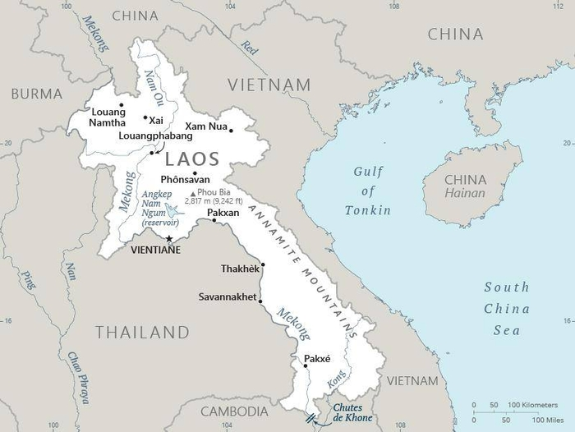  Taken from CIA World Fact Book
Population: 7,5 mil
Religion: Buddhists 64,7%; Non Rel 31,4%; Christians 1,7%; Official language: Lao; Literacy 87%
DID YOU KNOW? Buddhists in this SE Asian nation are driven by attempts to appease the spirits & “make merit”. Since most of the population live in rural, agrarian villages, this results in blindly following traditions. At weddings the guests tie white cotton strings onto newly-weds wrists to bless them & ward off evil. When a child is born the villagers come together to tie “blessed” cotton strings onto the infant’s wrists to keep all 32 good resident spirits in place. Once a year the village runs yards of string from the temple to every home. Despite this, & even in the face of government persecution, the Christian church in Laos is growing rapidly. Native Laotions lead almost all churches & evangelism efforts. However, most congregations lack a trained pastor. (Taken from Buddhist World Prayer Guide)
Please pray :  - That local Christians will make disciples of their many Buddhist neighbours.  - For leadership training for the many house church leaders.  - That in the face of increasing persecution Jesus followers will rely totally on God.  Don't go after false gods; they cannot help you or save you, ….  (1Sam 12:21) |   SAAWE  Patrys 083 973 4011

NEPAL – Pres: Bidhya Devi Bhandari | 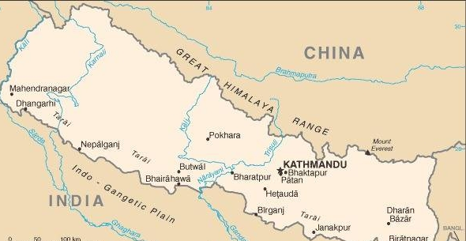  Taken from CIA World Fact Book
Population: 30,4 mil
Religion: Hindus 81,4%; Buddhists 9%; Christians 1,4%;
Official language: Nepali; Literacy 67,9%
DID YOU KNOW? Buddha was born at Lumpini, Nepal. Even though Nepal has been primarily a Hindu country in the past, Buddha is equally honoured along with Shiva & other Hindu gods. In 2008 the Hindu monarchy was ended. This led to opportunities for Christian ministry. However, religious conversion has been criminalized which is specifically directed at Christian missions. Thousands of Nepalese live in the high mountains of Nepal in extreme poverty. Families traditionally sends one son to the military & one to serve as a Buddhist monk. Daughters are sold to an “employment broker” who takes them to India for the sex trade. Christianity is seen as foreign which undermines traditional culture & values & appeals only to the lower castes. Despite these views we are seeing growing strength among Nepalese Christians. However, persecution remains & is intensifying. (Taken from Buddhist World Prayer Guide)
Please pray :  - For perseverance for Christian believers in the face of persecution & that their contribution to the nation’s wellbeing will be appreciated.  - That lamas & heads of Buddhist households will have dreams & visions of Jesus.  - For workers who will travel from village to village in the high mountains, telling stories about Jesus to whole families & that they will turn to Him.  …. From every part of the world they will turn to him; (Ps 22:27) | SAAWE  Patrys 083 973 4011

INDIA – Pres: Dioupadi Murmu | 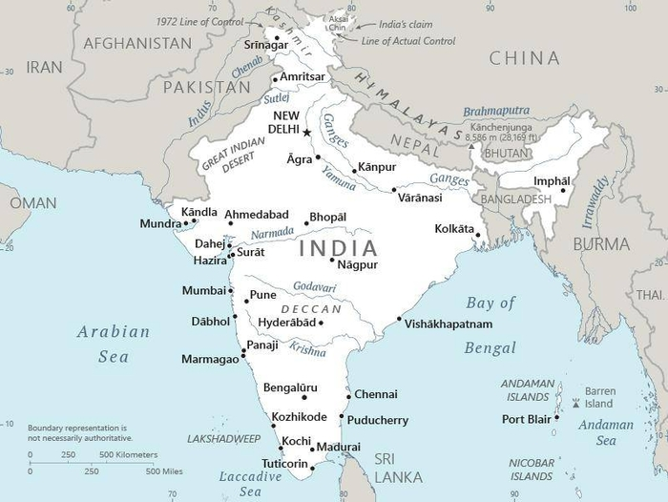  Taken from CIA World Fact Book
Population: 1410 mil
Religion: Hindus 80,1%; Christians 2,3%; Buddhists less than1%;
Official language: Hindi & English; Literacy 77%
DID YOU KNOW? Buddha was born in Nepal but received enlightenment in India. In the midst of a morally strict Hindu society he preached “the Middle Way”. This was an effort to find common ground between the ascetics of Hinduism & the practices of greed & exploitation. Buddhism is called a reform movement of Hinduism. Today, Hindus in India are finding Buddha’s teachings attractive & are converting. 25% of the population are regarded as “the untouchables” & have always been oppressed due to the caste system. Women & children suffer the most. Estimates are that 35 mil children are orphans, 11 mil are abandoned (90% of these are girls) & 3 mil live on the streets. The Church in India is highly diverse. The Catholic church is the largest (20 mil) & is respected for their work among the poor. Persecution of Christians has steadily increased in recent years with few repercussions for persecutors as 80% of believers are from the lower castes. (Taken from Buddhist World Prayer Guide)
Please pray :  - That the “untouchables” would come to realize that Jesus accepts all people & will continue to turn to Him.  - That churches, especially in rural areas, will stand strong amidst Hindu persecution.  - For training of pastors, teachers, evangelists & missionaries.  See to it that no one takes you captive by philosophy and empty deceit,…. (Col 2:8 ESV) | SAAWE  Patrys 083 973 4011

THAILAND – King Maha Vajiralongkom | 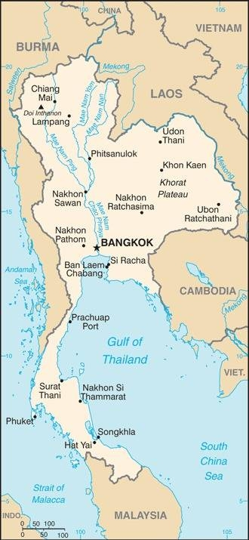  Taken from CIA World Fact Book
Population: 71,5 mil
Religion: Buddhists 94,6%; Muslims 4,3% Christians 1%;
Official language: Thai; Literacy 94%
DID YOU KNOW? As a “works based” religion Buddhism has many traditions to follow to overcome their karma. Prominent are the 12 Traditions which is associated with the moon cycle & focuses on a temple ritual in which every village family is expected to participate. Ie offering monks special sticky rice, giving robes to monks or money for penance. Thai houses, government buildings & Buddhist temples all have a “spirit house”. These are miniature houses set on a pillar in the yard. Gifts of fruit & flowers are prepared & taken to this house, where they lift their hands to demonstrate respect & the gift is placed in front of the tiny house. These actions are designed to bring merit to counter any bad thoughts or actions of the previous month. By honouring the spirits & the traditions the people hope to be reborn into a higher state of enlightenment. (Taken from Buddhist World Prayer Guide)
Please pray:  - That the eyes of Thai Buddhists will be opened to see that fruit, flowers & sticky rice can never cleanse their hearts or earn enough merit to change their karma.  - That they will come to know the true Saviour, Jesus Christ.  I revealed myself to those who did not ask for me: …(Is 65:1) | SAAWE  Patrys 083 973 4011

