EGYPT (Colonised by Britain 1882-1956) | 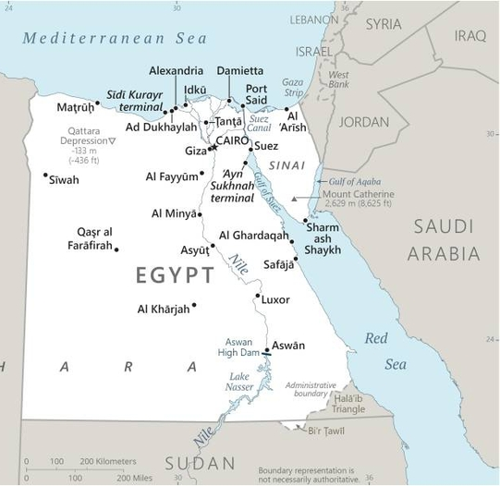  Taken from CIA World Fact Book
Population: 106,1 mil
Religion: Muslims 90%; Christians 9%; Agnostic 1%.
Official language: Arabic; Literacy 75,3%
DID YOU KNOW? The Suez Canal was completed in 1869. Britain seized control of Egypt’s government in 1882 to protect its investments. In 1919 nonviolent demonstrations erupted condemning British occupation & the colonial administration of Egypt. The British were completely expelled from Egypt in 1956. Slavery existed in Egypt until the early 20th century. During the Islamic history of Egypt, slavery was mainly divided in 3 categories: male slaves used for soldiers & bureaucrats, female slaves used for sexual slavery as concubines, & female slaves & eunuchs used for domestic service in harems & private households. Today Egypt is terrorized by Islamic extremists. Many Christians believe that Christianity was brought to Egypt by the Apostle Mark. For 1000 years Egypt was a majority Christian country, even after the Arab Muslim conquest in AD 640. Christians still live in a precarious situation regarding religious freedom & persecution. Conversion is illegal & some are imprisoned for “despising Islam” or under false pretexts.
Please pray :  - For a deep healing from the wounds caused by slavery & colonialism.  - That Jesus will reveal Himself to many Muslims disillusioned by Islamic State.  - For a government that serves God’s purposes, restrains evil punishes crime & enables peaceful & quiet living.  Don't go after false gods; they cannot help you or save you, for they are not real. (1Sam 12:21) |   SAAWE  Patrys 083 973 4011

GAMBIA (Colonised by Britain 1821-1965) | 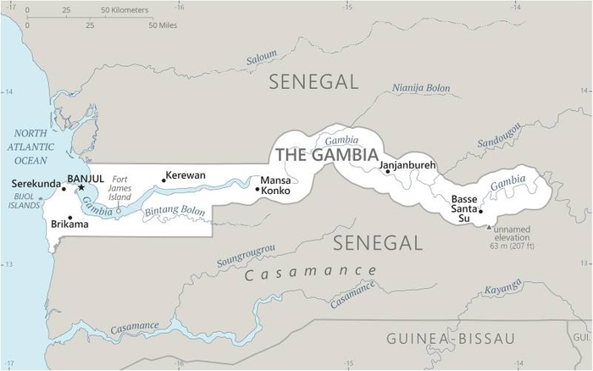  Taken from CIA World Fact Book
Population: 2,5 mil
Religion: Muslims 90%; Christians 5%;
Official language: French; Literacy 83,1%
DID YOU KNOW? Gambia is the smallest country in mainland Africa. In 1455 the Portuguese became the first Europeans to enter the Gambia River. They were looking for gold, but instead they found slaves – war captives that the Mandinka people were anxious to sell, especially for firearms. By the 1600s, the Portuguese, Spanish & English were fully engaged in the transatlantic slave trade. Slaves were taken to Mexico & the Caribbean. About 5000 slaves a year were shipped to America from Gambia during the 17th & 18th centuries. Gambia was fused together with present-day Senegal to form Senegambia, the first British colony in Africa. It gained independence in 1965. This nation is one of the poorest in the world. Malaria, blindness & other illnesses ail the population. Christianity came to the country with the Portuguese in 1456.
Please pray :  - For a deep healing from the wounds caused by slavery & colonialism.  - For the many Muslims to come to know Christ as Saviour & Lord.  - For local missionaries reaching out to unreached tribes up the Gambia River.  …. From every part of the world they will turn to him; (Ps 22:27) | SAAWE  Patrys 083 973 4011

GUINEA (Colonised by France 1849-1958) | 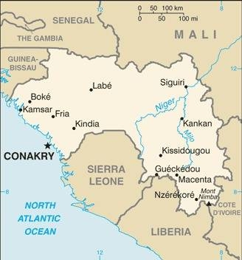  Taken from CIA World Fact Book
Population: 13,8 mil
Religion: Muslims 88%; Ethnic 8%; Christians 3%;
Official language: French; Literacy 30,4%
DID YOU KNOW? The Portuguese presence in Guinea dates from the 15th century when they developed a slave trade that would continue to affect Guinea until the mid-19th century.
Guinea became a French protectorate in 1849. It proclaimed its independence as the republic of Guinea in 1958. Since then Guinea has been troubled by violence, power hungry leaders & coups over many years. The political history has proven fatal for the nation’s economy & today Guinea is one of the poorest countries in West Africa. In spite of having several natural resources, the majority of inhabitants live on less than a dollar per day. Portuguese traders first explored the area in the mid-15th century & missionaries occasionally visited the coastal region in their wake. The constitution & other laws protect religious freedom & allow individuals to choose, change & practice religion as they desire.
Please pray :  - For a deep healing from the wounds caused by slavery & colonialism.  - That God will meet the needs of the spiritually & physically poor people of Guinea in a holistic way.  - For the unreached Guineans living in remote areas to hear a clear presentation of the Gospel.  …..he has put eternity into man's heart,…. (Ecc 3:11) | SAAWE  Patrys 083 973 4011

GUINEA-BISSAU (Colonised by Portugal 1446-1974) | 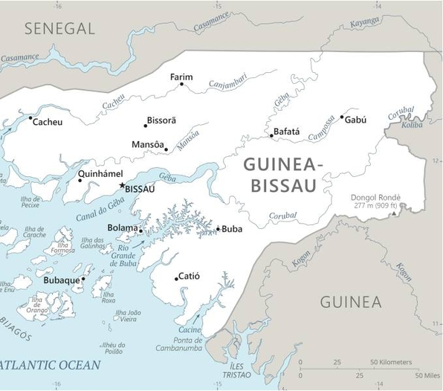  Taken from CIA World Fact Book
Population: 2,1 mil
Religion: Muslims 46%; Folk Rel 31%; Christians 19%;
Official language: Portuguese; Literacy 52,9%
DID YOU KNOW? With the cooperation of some local tribes, the Portuguese entered the slave trade & exported large numbers of Africans to the Western Hemisphere via the Cape Verde Islands. Portugal claimed Guinea-Bissau in 1446. Guinea-Bissau won the war of independence in 1973. The complex relationship between the political elite & the military has since contributed to a series of coups & no president has fulfilled his term in office. Political instability continues, severe poverty & violent conflict combine to burden the population. The influence of drug shipments leads to corrupt police, army & government leaders. Guinea-Bissau is today recognized as a crucial hub for trafficking cocaine from South America to Europe. Christianity arrived in Guinea-Bissau with Portuguese traders & missionaries from the Catholic church in the 15th century. There is a high level of syncretism between Islam, Catholicism & African traditional religions.
Please pray:  - For a deep healing from the wounds of slavery & colonialism.  - For righteous leaders to steer the country to stability & progress.  - That God will meet the needs of the spiritually & physically poor people.  I revealed myself to those who did not ask for me: I was found by those who did not seek me….. (Is 65:1) | SAAWE  Patrys 083 973 4011

